CHRONOLOGY OF CONTEMPORARY SEDIMENTATION AND POLLUTANTS ACCUMULATION IN THE BOTTOM SEDIMENTS OF THE SEA OF AZOV

Andrey Kuznetsov, Southern Federal University, ankuznecov@sfedu.ru

Yury Fedorov, Southern Federal University, fedorov@sfedu.ru

Abstract. Bottom sediments formed in the water bodies under the technogenic impact are important environmental factors affecting water quality and hydrobiota. Usually they consist of natural and technogenic material and differ from natural formations by their morphology, chemical and lithological composition, physicochemical and biochemical properties. In the present paper we use the term “sediment layer of anthropogenic impact” to define the sediment layer containing technogenic material and/or chemical pollutants. The determination of its location in the sediment cores, its thickness and accumulation chronology is an important scientific problem. In the paper the results of layer by layer study of Cs-137, Am-241, Pb-210 specific activities as well as concentrations of petroleum components, lead and mercury in 48 sediment cores of the Sea of Azov and the Don River are examined. The sediment core layers are dated by radiological methods. In all the sediment cores the peak of Cs-137 specific activity related to the Chernobyl accident was detected. In the Sea of Azov, this peak is located in the upper sediment layer up to 10 cm thick, however, in the delta and in the near-delta part of the Don River, where the sedimentation rates are more important, it is found at 20 to 40 cm depth. Also in certain sediment cores the second peak of Cs-137 related to the global nuclear fallout of the 1960s was found. The most of petroleum components, lead and mercury quantities are concentrated in the upper sediment layer formed in the last 50 to 70 years, i.e. in the period of the most important anthropogenic pressure. So, this complex approach based on the data on the vertical distribution of technogenic radionuclides and common pollutants in the sediment cores made it possible to identify and delineate the sediment layer of high anthropogenic impact as well as to assess the duration of this impact.

Key words: Sea of Azov, sedimentation rate, pollutant, petroleum components, heavy metals, lead, mercury, radioisotopes, sediment cores.

I. Introduction
The sediments of the Sea of Azov are represented mostly by natural and technogenic or technogenic material differing from the natural one by morphology, chemical and lithological composition, physicochemical and biogeochemical properties [1]. Therefore, such formations are classified as “technogenic silt” that is a new genetic type of bottom sediments. According to the opinion in the reference [2], this approach makes it possible to distinguish the technogenic sediments themselves being the products of technogenic sedimentogenesis and polluted natural sediments, however that is not easy. Sometimes polluted sediments containing high quantities of heavy metals, pesticides, radionuclides and other pollutants may be ecologically more dangerous than some relatively inert technogenic material. Hereafter we use the term “sediment layer of anthropogenic impact” to define the layer of bottom sediments directly or indirectly affected by human activity and enriched by technogenic material and/or contaminants. This definition is similar to the definition of technogenic ground formulated in the reference [3] where the genetic complexes of anthropogenic sediments in artificial water bodies as well as anthropogenic and natural sediments in natural water bodies are considered. In the present research we try to localize the sediment layers of anthropogenic impact in the sediment cores, to determine its thickness and accumulation chronology that is a significant scientific and environmental problem related to such important applied issues as the calculation of pollutants quantities accumulated in bottom sediments, the assessment of their role in the pollution of near-bottom waters due to the pollutants remobilization, the determination of normal background concentrations and their temporal perturbations under the influence of natural or anthropogenic processes, the development of the bottom sediments monitoring system etc.

II. Materials and methods
Previously in the uppermost layer of bottom sediments of the Sea of Azov and main rivers of its drainage basin the content and composition of technogenic material and the concentrations of different pollutants were determined [1]. These investigations were very important, however their results are not sufficient for the localization of the sediment layer of anthropogenic impact and analysis of its formation chronology. The present paper considers the results of complex many-years (from 1995 to 2015) studies carried out in the Sea of Azov, the Strait of Kerch, the Don River and the Kuban River and based on the uniform common methodology [4-12]. During the period of these studies five scientific expeditions were carried out in summer and autumn, 48 sediment cores from 20 to 100 cm long were extracted by a 1 m long gravity corer and split longitudinally into 241 samples [4]. The sampling points locations are depicted in fig. 1.
In the samples the concentrations of principal petroleum components (aliphatic, mono- and di-aromatic hydrocarbons (HC), polycyclic aromatic hydrocarbons (PAH) and asphaltic components (AC): resins and asphaltenes) as well as heavy metals (total mercury and lead) were determined. The choice of the ingredients was not casual. For the considered region, petroleum components, lead and mercury are the most common and typical contaminants due to the functioning of large industrial centers of Russia and Ukraine, high concentration of population, municipal and transport facilities, port complexes and intense navigation. By now, the volumes of petroleum products and other cargos shipped through the Azov - Don waterway have increased 2 to 3 times compared with the late 1990s. This undoubtedly augments the risk of emergencies associated with oil spills such as the series of ship wreckages in November 2007 during the heavy storm in the Strait of Kerch accompanied by a spill of 1.3 thousand tons of heavy fuel oil. The complex comparative analysis of the data on the vertical distribution of these ingredients makes it possible to exclude the influence of natural background of hydrocarbons of contemporary biologic origin and metals present in the sediment particles.
In order to date the studied samples, the specific activities of radionuclides ¹³⁷Cs, ²⁴¹Am and ²¹⁰Pb were measured there. Cesium-137 and Americium-241 are technogenic radionuclide, their presence in the environment and formation of specific activity peaks in sediment cores are related to the above-ground tests of thermonuclear weapons in 1950s and 1960s and to the accident at the Chernobyl Nuclear Power Plant in 1986. Unlike ¹³⁷Cs, ²⁴¹Am is formed directly in bottom sediments due to the decay of ²⁴¹Pu. So with time the specific activity of ²⁴¹Am increases progressively while the specific activity of ¹³⁷Cs decreases. Lead-210 is a natural radionuclide. It is permanently generated in the atmosphere as a result of decay of radioactive gas Radon-222, and then it precipitates on the earth surface. In the sediment cores the specific activity of Lead-210 decreases exponentially until the radioactive equilibrium with the parent radionuclide Radium-226. As the half-life of Pb-210 isn’t very long (22.3 years), this method is suitable only for dating sediments formed during the last century [13, 14].

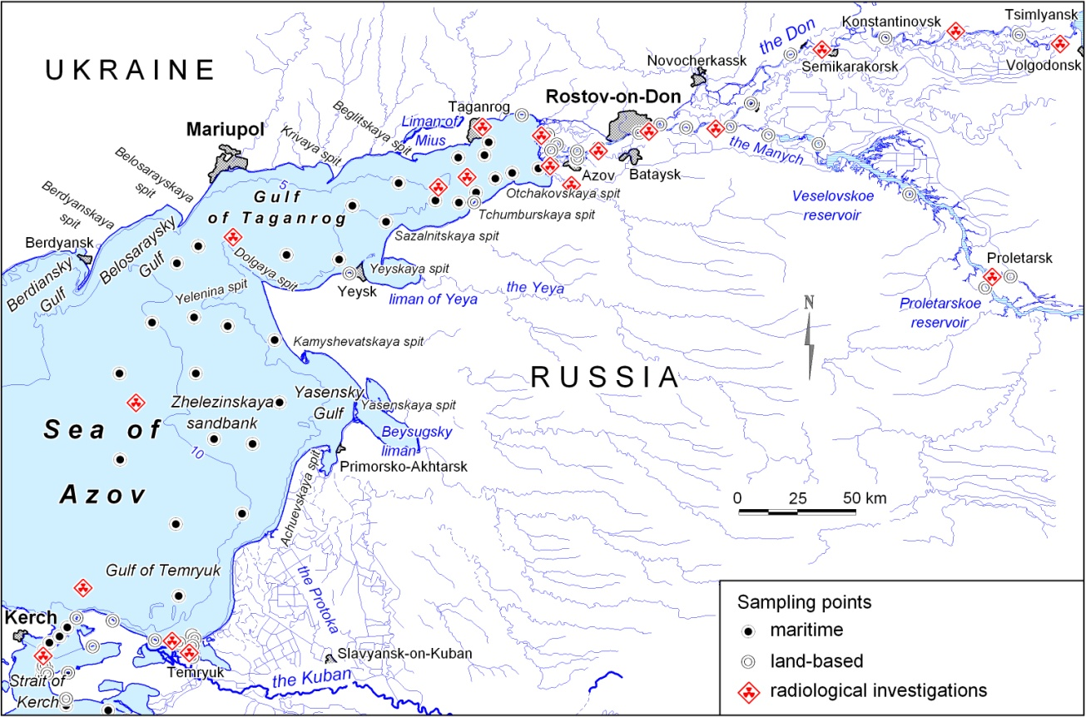
Fig. 1. Sampling points in the Sea of Azov and in the Lower Don River basin.

In total more than thousand determinations of the abovementioned ingredients were made up. The petroleum components were extracted and studied with the use of thin-layer chromatography, infrared and luminescence photometry [6-8]. The presence of hydrocarbons of contemporary biological origin was also identified. The heavy metals were studied by the atomic absorption spectroscopy [9, 10]. The specific activities of the radionuclides were measured by the method of direct gamma spectrometry [11, 12].

III. Results and discussion
According to the results of the study, in the uppermost sediment layer the maximum specific activity of Cesium-137 (103.3 Bq/kg of dry weight (d.w.)) was detected in the southern part of the Sea of Azov adjacent to the Strait of Kerch. This fact may be accounted for the isotope sorption by silty sediments from the near-bottom higher salinity waters entering from the Black Sea. The minimum values occurred in the mouth areas of the Don River and the Kuban River. In general, the sediment cores extracted in central and south-eastern parts of the Sea of Azov were characterized by higher specific activities of Cesium-137 and Americium-241 than ones taken in the Golf of Taganrog. A well-defined upper peak of ¹³⁷Cs specific activity relating to the Chernobyl accident was found in all the studied sediment cores. In the deeper parts of the Sea of Azov and of the Gulf of Taganrog, in the hydrodynamic conditions favorable for the sediment precipitation and accumulation, this peak was detected at 5-10 cm sediment core depths (51-116 Bq/kg). In the shallow eastern part of the Gulf of Taganrog the maximum ¹³⁷Cs specific activity was fixed in the superficial layer (35-79 Bq/kg). In the delta and in the near-delta part of the Don River the peak is located at 20-40 cm depth (14–43 Бк/кг) suggesting the highest sedimentation rates. In most sediment cores the second peak of ¹³⁷Cs activity was also found in deeper layers. It may be associated with global fallout from aboveground testing of thermonuclear weapons in 1950s and 1960s. This peak is not as distinct as the first one due to radioactive decay and probably lateral and vertical migration.
The maximum specific activity of Americium-241 (18.0 Bq/kg) was detected in the deeper part of the Sea of Azov. Significant activities of Am-241 are detected in most sediment cores. In some of them two peaks are found. Obviously the upper peak corresponds to the Chernobyl fallout and the other located in the deeper sediment core layers corresponds to the global radioactive fallout of 1960s. Am-241 is a decay product of Pu-241 (half-life is about 14 years). It accumulates over time since the fallout of plutonium isotopes, as its half-life is 30 times longer than the half-life of Pu-241. The level of ²⁴¹Am pollution of bottom sediments is relatively high due to ²⁴¹Pu significant contribution to the global fallout and its almost total decay into ²⁴¹Am. Vertical distribution of Am-241 specific activity in the sediment cores is similar to that one of Cs-137, but its deeper peak corresponding to the period of global radioactive fallout of 1960-s is much more distinct and often even more important than the peak corresponding to the accident in Chernobyl.
The specific activity of Lead-210 decreased with the sediment core depth from 240–727 Bq/kg in the superficial layer to 179–288 Bq/kg at 50 сm depth. However regular stirring-up of shallow sea sediments and multitude of terrigenous sources of Lead-210 complicate the use of this data for the dating purposes. Exponential character of decrease of the ²¹⁰Pb specific activity wasn’t often evident because of distorting influence of the isotope import with the fluvial run-off, coastal erosion material, and in consequence of the ²²⁶Ra and ²²²Rn decay. In order to eliminate this factors we have applied the method of multiple regression analysis to the balance equation that includes all the above mentioned sources of ²¹⁰Pb isotope [7].
According to the results of radiological analysis, the highest sedimentation rates are in the delta and near-delta parts of the Don River (5 to 14 mm of wet matter per year). The lowest rates are characteristic for the shallow eastern part of the Gulf of Taganrog (1 to 2 mm of wet matter per year) in spite of considerable sediment runoff of the Don River. That’s because of low depths (2 to 5 m) and high hydrodynamic activity of water column favoring regular stirring-up and carrying out of sediments. In the deeper central and southern parts of the Sea of Azov the sedimentation rates rise up to 4 mm per year. The results of the sediment precipitation rates determination by the method of sediment traps prove these estimates for the eastern and north-eastern parts of the Sea of Azov (2 to 3 mm of wet matter per year). However, in the shallow Gulf of Taganrog the rates of observed sediment precipitation are much higher than the sedimentation rated determined by the radiological methods. This may be accounted for the regular remobilization of sediments under storm conditions.
Now let us consider the vertical distribution of common pollutants in the studied sediment cores. The total concentrations of petroleum components in the uppermost sediment layer varied from 0.05 to 1.21 mg/g d.w. The highest values were detected in the Don River and the Kuban River deltas (on average 0.51 and 0.47 mg/g d.w. respectively), in the south-eastern and central parts of the Sea of Azov (on average 0.33 and 0.22 mg/g d.w. respectively).
The most of petroleum components were concentrated in the upper sediment layers formed in the last 50 to 70 years, i.e. in the period of high anthropogenic pressure. In the Gulf of Taganrog, the thickness of this layer is about 10 to 15 cm, in the dipper sectors of the sea it raises up to 20 cm and even reaches 30 to 50 cm in the lower parts and deltas of the Don River and the Kuban River (fig. 2). These differences are accounted not only for the pollution chronology but also and mostly for the different sedimentation rates. In the Don River and the Kuban River sediments the resins and asphaltenes being the conservative indicators of chronic oil pollution prevail over hydrocarbons. On the contrary, in the Gulf of Taganrog and in the principal part of the Sea of Azov, except for the impact zones surrounding the industrial centers and port terminals, the hydrocarbons dominate. A huge part of them consists of contemporary metabolic products of aquatic organisms.
In most sediment cores taken in the Gulf of Taganrog and the Gulf of Temryuk the highest concentrations of oil components were detected at 5-10 cm sediment core depths (fig. 2). This sediment layer is located under the peak of ¹³⁷Cs specific activity relating to the Chernobyl accident and may be dated at 1955 to 1985. In the Don River sediments such layer was also found, but in the reason of higher sedimentation rates its thickness rises up to 30 cm. In the central part of the Sea of Azov the highest concentrations were detected in the uppermost sediment layer being formed during the last 15 years.
The analysis of variations of oil components concentrations in the most polluted upper sediment layer along the transect “the Don River - the Gulf of Taganrog - the Sea of Azov” shows that macromolecular asphaltic components transported in suspensions precipitate principally in the Don River delta. Unlike them, hydrocarbons migrating both in dissolved and suspended forms accumulate mainly in the bottom sediments of eastern part of the Gulf of Taganrog, i.e. outside the delta, in the area where the gradients of physical and chemical conditions are the most important. The silty sediments of the dipper central part of the Sea of Azov are also characterized by high concentrations of hydrocarbons.
The concentrations of lead in the sediment cores varied from 12 to 43 µg/g d.w., on average 18 µg/g. It was found out that in the Gulf of Taganrog lead reacts actively with organic matter while in the principal part of the Sea of Azov their concentrations didn’t correlate. The highest concentrations of lead were detected in the upper sediment layers up to 20 cm sediment core depth. In the deeper layers they usually dropped rapidly. A direct correlation (with coefficients ranging from 0.30 to 0.94) is found between the radioactive Lead-210 specific activity and total lead concentration. This means that the decay of ²²²Rn isn’t the only source of ²¹⁰Pb precipitating from the atmosphere. The Lead-210 is also present in the coal dust and coal ash transported with air masses and surface run-off.

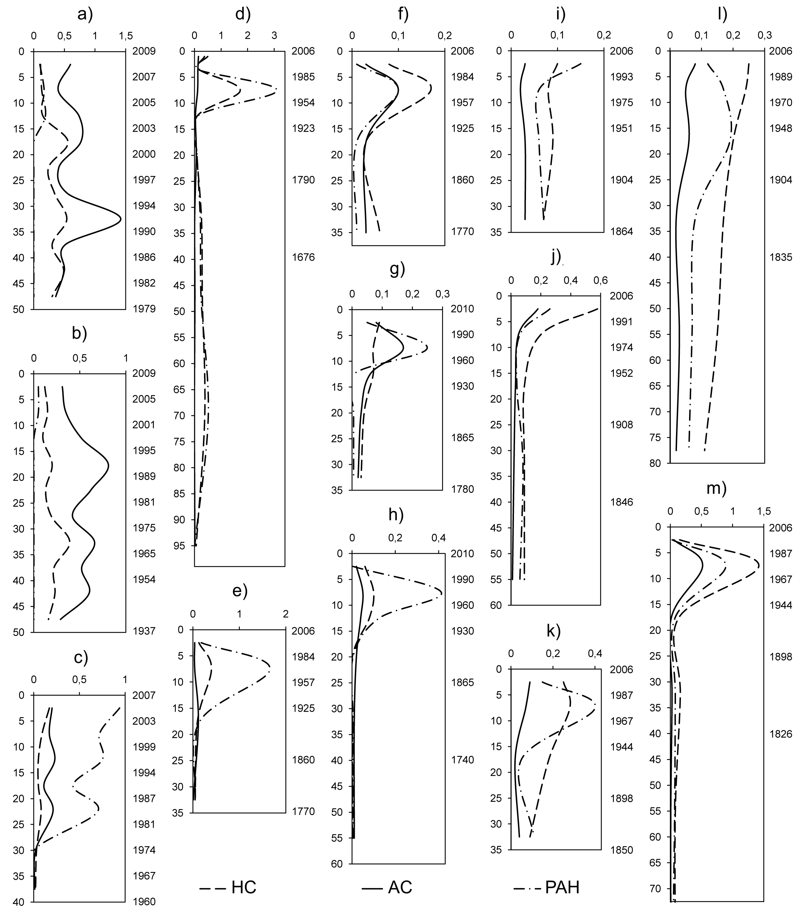
Fig. 2. Distribution of concentrations of aliphatic, naphthenic, mono- and di-aromatic hydrocarbons (HC, mg/g of dry weight); polycyclic aromatic hydrocarbons (PAH, μg/g of dry weight) and asphaltic components (AC, mg/g of dry weight) in the most representative sediment cores: a) near-delta part of the Don River; b) upper part of the Don River delta; c) lower part of the Don River delta; d), e) eastern part of the Gulf of Taganrog; f) central part of the gulf; g), h) western part of the gulf; i) mouth of the Gulf of Taganrog; j) central part of the Sea of Azov; k) southern part of the Sea of Azov; l), m) Gulf of Temryuk. The concentrations are on the abscissa axis, the sediment core depths are on the left ordinate axis (cm), the dating scales are on the right ordinate axis (years).

The concentrations of mercury in the sediment cores varied from 0,025 to 0,28 µg/g d.w., on average 0,067 µg/g. In most cases they decrease with sediment core depth. However, in some sediment cores, as it was found out for the petroleum components, the maximum values were fixed in the deeper sediment layers formed between 1955 and 1985. In all the sediment cores the content of mercury closely correlates with the content of organic carbon [15].

I. Conclusion
So the comparative analysis of the data on the vertical distribution of petroleum components, heavy metals, technogenic radionuclides Cs-137 and Am-241 and natural radionuclide Pb-210 in the sediment cores of the Sea of Azov, the Don River and the Kuban River made it possible to locate the layer of anthropogenic impact and to date it. This superficial sediment layer contains the most of petroleum components, lead and mercury quantities. Its thickness varies from 15 to 50 cm. According to the results of radiological dating, these sediments were formed in the last 50 to 70 years, i.e. in the period of high anthropogenic pressure. Moreover, the most polluted sediment layers were formed in 1970s and 1980s.

IV. Acknowledgment
The study was supported by the Russian Foundation for Basic Research (project no. 15-05-04977).

V. References
[1] Yu.P. Khrustalev, “Geochemistry of the Sea of Azov Bottom Sediments”, in Geoecological investigations and subsurface mineral protection. Scientific and technical information, iss. 4. Moscow: Geoinformmark, 1998, pp. 3-14.
[2] A.Yu. Opekunov, “Aquatic Technogenic Sedimentogenesis”, Proceedings of VNIIOkeangeologia, vol. 208. St.-Petersburg: Nauka, 2005, pp. 208-278.
[3] F.V. Kotlov, “Geological Environment Change under the Influence of Human Activity”. Moscow: Nauka, 1978.
[4] Yu.A. Fedorov, V.V. Sapozhnikov, A.I. Agatova, N.V. Arzhanova, A.A. Belov, A.N. Kuznetsov, N.M. Lapina, E.B. Loginov, L.M. Predeina, T.B. Semochkina, N.I. Torgunova, “Multidisciplinary Ecosystem Studies in the Russian Part of the Sea of Azov (July 18-25, 2006)”, Oceanology, vol. 47, no 2, pp. 294-297, April 2007.
[5] Yu.A. Fedorov, I.V. Dotsenko, A.N. Kuznetsov, A.A. Belov, E.A. Loginov, “Regularities of C_{org} Distribution in Bottom Sediments of the Russian Part of the Sea of Azov”, Oceanology, Vol. 49, Iss. 2, pp. 211-217, 2009.
[6] Y.A. Fedorov, A.G. Stradomskaya, A.N. Kuznetsov, “Regularities in the Transformation of Oil Pollution in Watercourses Based on Long-Term Observational Data”, Water Resources, vol. 33, no. 3, pp. 300-309, June 2006.
[7] A.N. Kuznetsov, Yu.A. Fedorov, P. Fattal, “Study of Sedimentation Rates and Oil Components’ Accumulation in the Sediment Cores of the Sea of Azov and the Don River Using the Method of Radioisotopes”, Proceedings of the 12th International Multidisciplinary Scientific GeoConference SGEM 2012, vol. 3. Sofia: STEF92 Technology Ltd., pp. 973-978, June 2012.
[8] A.N. Kuznetsov, Yu.A. Fedorov “Oil Components in the Mouth Area of the Don R. and in the Sea of Azov: Results of Many-Year Studies”, Water Resources, vol. 41, No. 1, pp. 55-64, February 2014
[9] Yu.A. Fedorov, N.M. Khansivarova, O.A. Berezan, “About the Peculiarities of Mercury Distribution and Behavior in the Bottom Sediments of the Lower Don River and the Gulf of Taganrog”, Bulletin of Institutions of Higher Education. Northern Caucasus Region. Natural Sciences, iss. 3, pp. 76-81, June 2001.
[10] Yu.A. Fedorov, N.M. Khansivarova, L.M. Predeina, “Peculiarities of Mercury and Lead Distribution in the Bottom Sediments of the Gulf of Taganrog and the Sea of Azov”, Water management, vol. 5, iss. 6, pp. 51-58, December 2003.
[11] Yu.A. Fedorov, A.N. Kuznetsov, M.E. Trofimov, “Sedimentation Rates in the Sea of Azov Inferred from Cs-137 and Am-241 Specific Activity”, Doklady Earth Sciences, vol. 423, no. 1, pp. 1333-1334, December 2008.
[12] Yu.A. Fedorov, A.N. Kuznetsov, “Radionuclides in bottom sediments of the Sea of Azov”, Proceedings of the 15th International Multidisciplinary Scientific GeoConference SGEM 2015, vol. 1. Sofia: STEF92 Technology Ltd., pp. 707-712, June 2015.
[13] G. Faure, “Principles of Isotope Geology”, USA: John Wiley and Sons Ltd, 1987.
[14] V.M. Kuptsov, “Absolute geochronology of ocean and sea bottom sediments”. Moscow, 1986.
[15] I.V. Dotsenko, Yu.A. Fedorov, A.V. Mikhailenko, “About correlation between mercury and organic matter concentrations in the bottom sediments along the transect “the Don River - the Sea of Azov”, Bulletin of Institutions of Higher Education. Northern Caucasus Region. Natural Sciences, iss. 3, pp. 96-102, June 2015.

