MAPPING BIOCHEMICAL FIELDS IN THE UPPER LAYER OF THE BLACK SEA BY THE ADAPTIVE BALANCE OF CAUSES METHOD

Inga P. Lazarchuk, Marine Hydrophysical Institute, lazarchuk.syst.analysis@mhi-ras.ru
Igor E. Timchenko, Marine Hydrophysical Institute,

Abstract. A simple ecosystem model of the upper layer of the north-western shelf of the Black Sea (NWS of BS) was considered. Estimates of phytoplankton, zooplankton, bioresources and oxygen concentrations were used as the basic biochemical characteristics of the ecosystem. The ecosystem was affected by external conditions: the seasonal temperature and chlorophyll-a concentrations. The adaptive balance of causes method was used to construct ecosystem model equations. The equations had the property of dynamic adaptation to variable external influences.
Аpplying this model we illustrated the two-step method of modeling marine ecosystems processes, using adaptive models. On the first step, dynamics of water masses movement was calculated by a numerical model. On the second step, the ecosystem model made the local adjustment of ecosystem variables to each other, taking into account the available estimates of advection and diffusion of substances. In this simulation advection and diffusion calculated by the hydrodynamic model presented external forces relative to the ecosystem substances in the local volume. Maps of annual spatial and temporal variability of fields of phytoplankton, zooplankton, oxygen and biological resources concentrations in the upper layer NWS of BS were made. It was shown, that using data about the dynamics of marine environment in the adaptive models of ecosystems enable to detail the maps of biochemical fields.

Key words: adaptive balance of causes method, marine ecosystem

I. Introduction
Applied problems of monitoring the state of the marine environment for the use of its resources require the construction of diagnostic and prognostic maps of biochemical components of marine ecosystems, according to observations. The main source of these data, satellite observations are a component of the ecosystem, obtained by remote sensing of the sea surface. Therefore adaptation of model estimates of biochemical components of marine ecosystems, calculated on a relatively simple integral model, to satellite observations is one of the most of perspective directions using satellite information.
For mapping the fields of biochemical components of marine ecosystems are usually applied numerical models of high resolution in which the concentration of biological objects and chemical substances are calculated by the equations describing the transport and diffusion of substances in the sea [1]. In this paper, the possibilities of a two-step mapping biochemical fields by the method of adaptive balance of causes (ABC-method) that has the property of local adaptation of the model variables of the ecosystem are shown [2, 3]. In the first step are carried out calculations of currents by hydrodynamic models to construct estimates of advection and diffusion in grid nodes covering the study area. On the second step these estimates and satellite observations are used as external sources of influence in special models of the marine ecosystem. Since the task of a detailed description of biochemical processes in this paper is not intended as a conceptual model of the upper layer of the marine ecosystem have chosen the simplest scheme of causality, including the concentration of phytoplankton, zooplankton, bioresourses and dissolved oxygen.

II. Adaptive Balance of Causes Method
Adaptive Balance of Causes method (ABC-method) was developed in the Marine hydrophysical institute and successfully used by the authors in the modeling of ecological-economic systems [3 - 5]. System principle of the adaptive balance causes [3] postulates the desire of all natural systems to a state of dynamic equilibrium with each other and attached to them external influences. The existence of equilibrium is due to the balance of positive and negative feedbacks, which are formed inside the system by causal relationships between processes. On the basis of this principle, in [3] proposed an adaptive balance the effects of the method for modeling of complex systems, which is constructed on two system concepts:
1. There is a universal modular equation expressing the rate of change of any of the processes modeled in the form of managed balance sheet growth trends and the decreasing of the process, which provides the internal balance of positive and negative feedback in each of the equations.
2. Combining modular equations to the system of dynamic equations of model should ensure the simultaneous pursuit of solutions of these equations to the stationary state of the system in which the intra-relationship between the development processes are adapted to each other and to external influences, exerted on the system.
To provide balance of feedbacks, to the right part of the universal modular ABC-method equation must have two basic function of causes 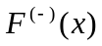 и 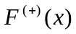. These functions impede both growth and decay of the simulated process , directing its scenario to sustainable steady-state value

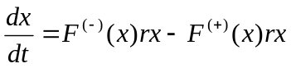. (1)

It is sufficient to require that with increasing basic function 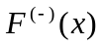 is monotonically decreasing, and basic function 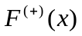 monotonically increasing. In order to ensure the overall balance is necessary to put an additional condition for the normalization of the basic functions of causes

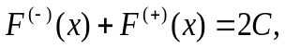 (2)

где С – current capacity of environment according to variable of the system, r_{i} – parameters characterizing of the rate of change of variables.
In the ABC-method it is assumed that the current capacity of the environment is an average of the variability interval variable as the twice value of it sets the upper bound of the values

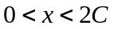 (3)
Taking into account the condition of balance (2) total modular equation of ABC-method takes the form

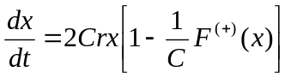. (4)

Since as a function 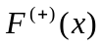 any monotonically increasing function can be used, it is advisable to choose the most simple of them: 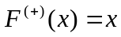. In this case, the modular equation of the ABC- method coincides with Verhulst equation [6] when С = 0,5.
The technique for combining modular equations (4) to the system to build ecosystem model is principle. The ABC-method introduce a suggestion that all influences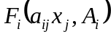, exerted on the variable, must be taken into account additively in the argument base function of causes of the modular equation (4). Therefore, the total system of equations of the ecosystem model constructed by ABC-method takes the form

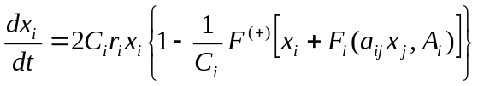, (5)

where a_{ij} – coefficients variables’ influences on each other. In this case, intervals of variation of the variables is (0, 2С_{i}).
In common case, functions 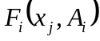 is the sum the sum of intra 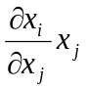 and external 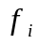 influences

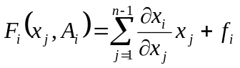. (6)

If we assume that intersystem relation is linear, i.e. 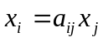, then

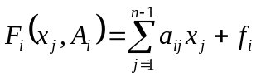. (7)

In this case, the system of equations of ecosystem model written by ABC method takes the form:

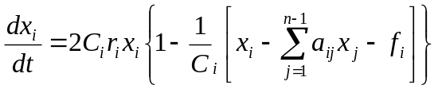, 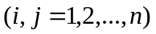, 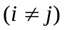, (8)

The restriction of the limits to growth of variables depends not only on the current capacities of the natural environment in relation to the variables, but also on the intra-factors action. For example, the zooplankton concentration increase depends on the availability of all necessary resources: phytoplankton, oxygen, chemicals and other growth factors. At each time moment one of these factors is limited, because this type resources growth of concentration is a minimal amount comparing to the other resources. Therefore management agents should present in marine ecosystem models The management agents monitor and control the dynamics of resource provision of living organisms and the conditions of chemical reactions [3].
As a rule, the management agents are logical operators that switch functions of causes by the prescribed rules. One of the convenient expressions for a management agent can serve as a formula

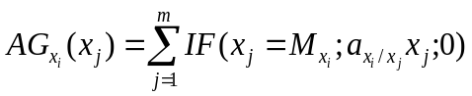, (9)
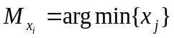, (i, j = 1, 2, … , m).

Such switching functions of sources and sinks in the process of solving the equations of the ecosystem model increase the demands on the stability of the solution algorithms. Therefore, the stability of adaptive models of the second order, which is provided by negative feedback , is very useful when using the management agents growth of concentrations of ecosystem living objects.

III. Аdaptive model of the Black Sea upper layer ecosystem
We call the ecosystem models adaptive if at the presence of external influences a model tends to the state of dynamical equilibrium with them. A mutual adaptation of the model values to each other and to the external influences occurs in the adaptive models, and a set of equations of the model “monitors” varying external influences keeping a state of dynamic balance with them.
As a conceptual model of the upper layer of the marine ecosystem have chosen the simplest scheme (Fig.1) of cause-effect relationships of processes taking place in the North-Western shelf of the Black Sea (NWS BS).

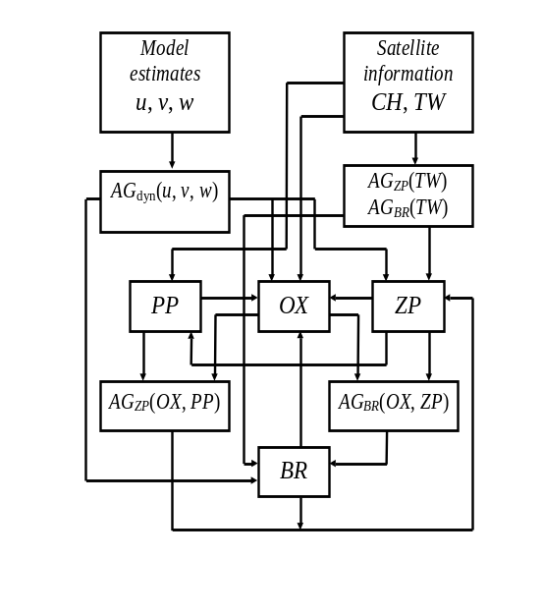

Fig. 1. Conceptual model of the upper layer of the sea ecosystem.

It includes the concentration of phytoplankton РР, zooplankton ZP, bioresource BR and dissolved oxygen OX. In addition to the structure of the model consists resource limitation agents of aquatic organism concentration in the food chain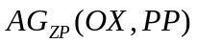 and 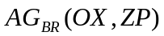. Advection and diffusion estimates obtained from calculations of the currents velocity components u, v by the hydrodynamic model, the satellite observations data on sea surface temperature TW and chlorophyll-a concentration СН are used as the external influences. Therefore, the model includes agents taking into account the dynamics of oxygen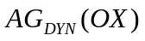, zooplankton 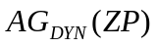 and bioresource 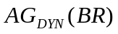 concentrations. Also agents, taking into account the influence of the seasonal cycle of sea temperature on the concentrations of zooplankton AG_{ZP}(TW) and bioresource AG_{BR}(TW), are used in the Black Sea upper layer ecosystem model.
In accordance with the conceptual model (Fig.1) the system of equations of the ecosystem model is constructed by the adaptive balance of causes method. This system has the property of dynamic adaptation to changing external influences:

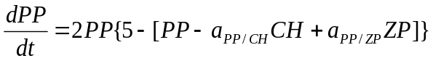,
,
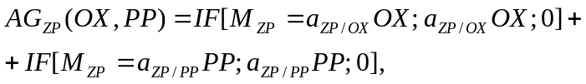 (10)
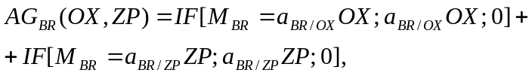
,
.

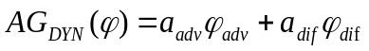. (11)

For the comparison of scenarios to be easier, model variables were represented in dimensionless form and were reduced to the common interval of variability (0,10). It should be noted that phytoplankton advection and diffusion are indi-rectly taken into consideration in the equation (10) because the satellite measurement data on СН chlorophyll-a concentration, formed under effect of advection and diffusion, had been used as an external influence source in this equation. Through system of equations of the model this influence is also extended to other model variables. However, it is insignificant due to the fact that the influence of previous resource factors decreases with each transition to the new reaction. This is the cause of diffusion and advection inclusion in all other model equations. Current velocities and turbulent exchange coefficients, taken from the calculations by the hydrodynamic model, introduce an additional data on environment dynamics, therefore the management agents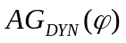in the system (10) are the additional sources of influences on the substance concentration changes.

IV. Mapping biochemical fields in the upper layer of the Black Sea
The adaptive ecosystem model considered above is applyed to map phytoplankton, zooplankton, bioresource and oxygen concentrations for the NWS BS region. To initialize the model the literature data, which have approximate estimations of average values of corresponding concentration fields, are used.
Based on the data characterizing the dynamics of the biomass of phytoplankton and edible zooplankton in 1954 – 2007s in the northwestern Black Sea shelf [7, 8], as estimates of the average values taken concentrations: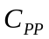= 6 g/m³ и 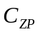= 0.2 g/m³. The highest indicators of phytoplankton obtained on the shallow north-western part of the Black Sea, where the species of phytoplankton well supplied with nutrients coming from the waters of the Danube, the Dnieper, the Southern Bug, Dniester, and also due to intensive water exchange and closeness of the bottom where the regeneration of nutrients is. Also a special feature of this area is the presence of hydrological fronts formed by contact of river and sea waters [9]. Spatial distribution of planktonic organisms associated with the proliferation of fresh water in the area of hydrological fronts, blooming areas, microorganisms spreading and wind regime. The redistribution of zooplankton significantly affects circulation arising in ebbs and surges winds [10].
Observations on the concentration of bioresource is highly fragmented and confined mainly the estuarine areas of the Danube and the Dnieper. For an approximate estimation of 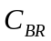 value the results of edible and gelatinous zooplankton biomass monitoring in these regions [8] are used. Relying on these data and also on the materials of [11] the value was adopted as an estimation of bioresource concentration average value = 0.1 g/m³.
Literary sources contain a great number of data on oxygen concentration for the BS NWS region [12, 13]. It is noted that summer is a period of the lowest absolute oxygen content in the entire water column and water area of the region, which is due to increase of temperature and, consequently, rates of biochemical processes. Therefore the value equivalent to 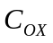= 7 ml/l was adopted as an estimation of average annual oxygen concentration.
To map layer ecosystem fields in the BS NWS region there were used maps of chlorophyll-a concentrations fields and sea surface temperature, constructed according to satellite observations for the year 2012 (Fig.2, a, b), and maps of horizontal current field in the sea upper layer, constructed according to the data of the region hydrodynamic modeling [14] (Fig. 2, c – the longest arrow corresponds to 30 cm/s velocity), for each node of a square grid (which covered this region) with 5 km step (4004 nods). Calculations of fields of the ecosystem carried out for the year (366 calculation time steps – days). To illustrate used 228 day falling on mid-August, is characterized by increased values of sea surface temperature and chlorophyll а budget.

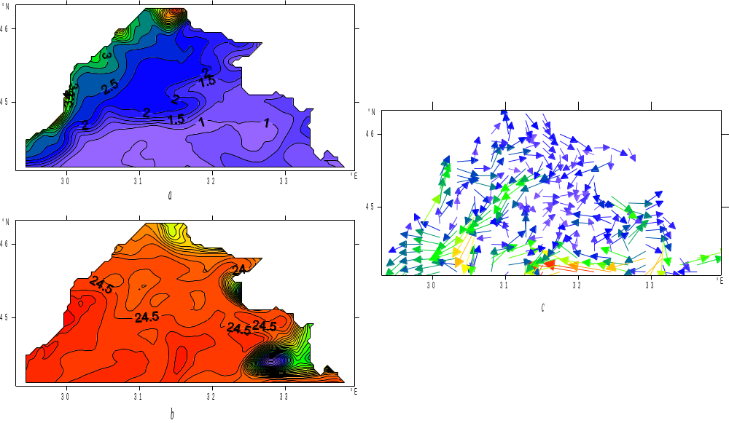

Fig. 2. NWS BS maps, obtained on 228 days of the year (mid-August)
according satellite observations:
a – chlorophyll-а (mg/m³), b – sea surface temperature (°С);
according numerical simulation data: c – currents.

Calculations of ecosystem variables were carried out in two stages. Initially, the model equations (10) were solved in each nod of the grid domain with no regard for advection and diffusion. As a result, the scenarios of within-year variation of all ecosystem parameters, by which the charts of substance concentration spatial distributions for each day were constructed subsequently, had been calculated. These data, alongside with the calculations of horizontal currents, were used to obtain the advection and diffusion assessments in each node of grid domain for each day of experiment. Advection and diffusion were calculated by standard finite-difference formulas.
At the second stage the local adaptation of model variables to the obtained advection and diffusion assessments was performed by means of model (10). These assessments were included into the management agents (11had the meaning of time intervals during which the advective and diffusive supplements to the concentrations of substances. Thus, the assessments of advection and diffusion have served as additional sources of external influences in the ecosystem model equations.
In Fig. 3, а map of phytoplankton concentration, constructed without taking into account the marine environment dynamicsпо by the temporal scenarios calculated in the nods of grid domain, is given. The structure of isolines on this map basically follows the one from Fig. 2, а (the map of chlorophyll-a concentration constructed according to the satellite data).
The map of oxygen concentration represented in Fig. 3, б demonstrates that it was sufficiently affected by satellite data on sea surface temperature and phytoplankton concentration. The map of sea surface temperature (Fig. 2, б), constructed by satellite data, contains a notable anomaly in the area of south-western coast of the Crimea, and this anomaly is due to anticyclonic gyres. This anomaly clearly manifested itself in the oxygen concentration field (Fig. 3, б).
A dominant role in the formation scenarios of zooplankton and bioresource concentrations play the minimum oxygen concentrations. Therefore it should be expected that the oxygen field anomaly will manifest itself in the maps of zooplankton and bioresource concentrations. The maps of these fields, represented in Fig. 3, c, d confirm this statement. The greatest zooplankton and bioresource concentrations are observed in the Danube estuary coastal regions and the lowest concentrations – in the area of oxygen field anomaly near the south-western coast of the Crimea.

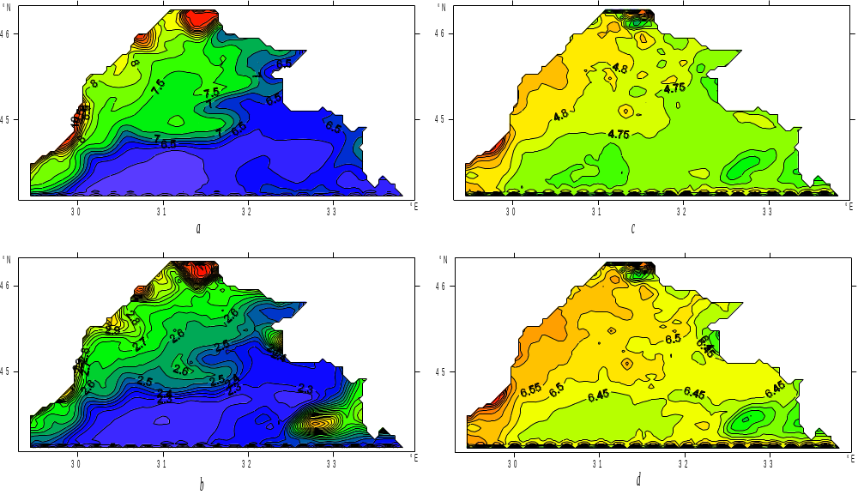

Fig. 3. Maps ecosystem fields, calculated without taking into account the dynamics of the marine environment
228 computing days (mid-August):
a – phytoplankton (dimensionless units), b – oxygen (dimensionless units),
c – zooplankton (dimensionless units), d – bioresource (dimensionless units).

The map of phytoplankton concentration, which was calculated taking into account the marine environment dynamics on the mid-August (the 228th day of computations is represented in Fig. 4, а. This field appeared to be more changeable in comparison with the one given in Fig.3, а, which was obtained at the first stage. Local inhomogeneities of chlorophyll-a field, which had been observed on the chart of its concentrations in Fig. 2, а near the north-western coast of the BS NWS water area, , were not visible in the chart of phytoplankton concentration (Fig. 3, а), constructed excluding the water dynamics. Taking into account the dynamics, they explicitly manifested themselves in Fig. 4, а.
This conclusion also extends to other ecosystem fields constructed with regard to advection and diffusion. This is evidenced by the results of the comparison of appropriate oxygen (Fig. 3, b and 4, b), zooplankton (Fig. 3, c and 4, c) and bioresource (Fig. 3, d and 4, d) concentrations. Thus, marine environment dynamics sufficiently affects the results of ecosystem field modeling using the Adaptive Balance of Causes method.
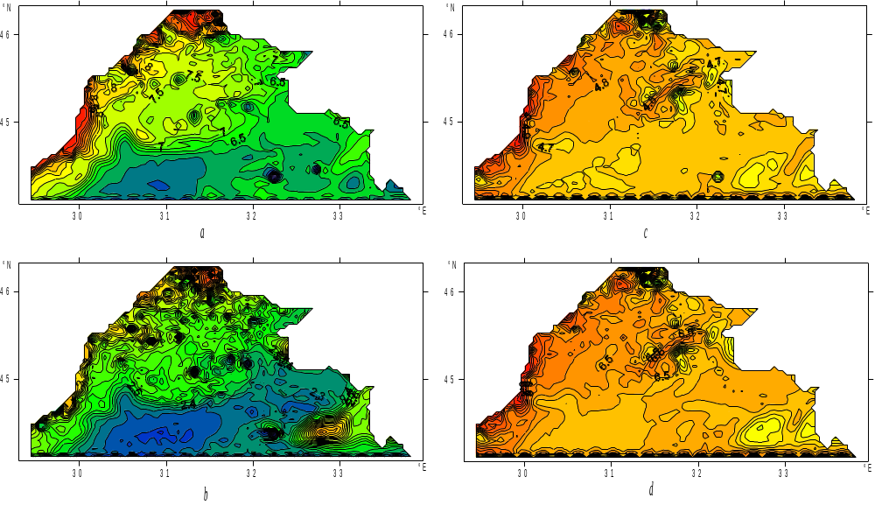

Fig. 4. Maps ecosystem fields calculated with advection and diffusion
228 computing days (mid-August):
a – phytoplankton (dimensionless units), b – oxygen (dimensionless units),
c – zooplankton (dimensionless units), d – bioresource (dimensionless units).

V. Conclusions
In the simple model of the ecosystem of NWS BS illustrates a two-step method of mapping fields of the upper layer of the sea ecosystem, which allows in a separate phase of the complex calculations of the transport processes and the diffusion of substances carried by hydrodynamic models and use the results as the external influences in adaptive ecosystem model. The equations of the method of adaptive influences balance adjustment provided fields phytoplankton concentrations of zooplankton, Life and oxygen to satellite data and to estimate the advection and diffusion, calculated according to the results of numerical modeling of the marine environment. ABC model of the marine ecosystem has been used for mapping intra spatial and temporal variability of phytoplankton concentrations fields, zooplankton, oxygen, biological resources in the upper layer NWS BS adapted to satellite observations of chlorophyll concentration and sea temperatures and surface. Thus, according to satellite data spatio-temporal dynamics of the ecosystem for this year's conditions were restored. It is shown that taking into account the dynamics of the marine environment and the agents of the resource limitation in adaptive ecosystem models allow us to detail maps of biochemical fields.

VI. References
[1] G. K. Korotaev, T. Oguz, V. L. Dorofeyev, S. G. Demyshev, A. I. Kubryakov, et al, “Development of Black Sea nowcasting and forecasting system”, Ocean Sci., no. 7, pp. 629-649, 2011.
[2] I.Е. Timchenko, Е.М. Igumnova, I.I. Timchenko, System Management and ABC-technologies of sustainable development, Sevastopol, ECOSI-Gidrofizika, 2000, 225 p. (in Russian).
[3] V.A. Ivanov, E.M. Igumnova, I.E. Timchenko, Coastal Zone Resources Management, Kyiv, Akademperiodika, 2012, 304 p.
[4] I.E. Timchenko, V.A. Zhorov, E.M. Igumnova, I.P. Lazarchuk, “Dynamic model of integrated processes in the ecosystem of the northwest shelf of the Black Sea”, Physical Oceanography, vol. 17, issue 4, pp. 223-241, 2007 (Translated from Morskoi Gidrofizicheskii Zhurnal, No. 4, pp. 48-69, 2007).
[5] I.E. Timchenko, I.K.Ivashchenko, E.M. Igumnova, I.P. Lazarchuk, “Estimation of the space distributions of the parameters of marine ecosystems by the method of adaptive balance of causes Sea”, Physical Oceanography, vol. 21, issue 5, pp.338-352, 2012. (Translated from Morskoi Gidrofizicheskii Zhurnal, No. 5, pp. 50–65, 2011)
[6] J.D Murray. Mathematical biology II: Spatial models and biomedical applications, 3rd edition. Springer, 2008, 736 p.
[7] D. Nesterova, S. Moncheva, A. Mikaelyan, A. Vershinin, V. Akatov et al. “The state of phytoplankton”, State of the Environment of the Black Sea (2001– 2006/7),Istanbul, Turkey, 2008, pp.173-200.
[8] T. Shiganova., E. Musaeva, E. Arashkevich, L. Kamburska, K. Stephanova et al. “The State of Zooplankton”, State of the Environment of the Black Sea (2001– 2006/7),Istanbul, Turkey, 2008, pp. 201- 246.
[9] L. V. Grigorieva, L.G. Senichkina. “Phytoplankton of the Black sea: the current state and prospects of research ”, Ecology of the sea, vol.45, pp.6-13, 1996. (in Russian).
[10] V. I. Belyaev, N.V. Konduforova “ Mathematical modeling of ecological systems of shelf ”,Kyiv.: Naukova dumka, 1990, 240 p. (in Russian).
[11] V.S. Latun,.“The impact of fisheries on the sustainability of the Black Sea ecosystem”, Stability and evolution of oceanographic characteristics of the Black Sea ecosystem, Sevastopol, ECOSI-Gidrofizika, 2012, pp. 331-353 (in Russian).
[12] V.А. Emelyanov, А.Yu. Mitropolskiy, Е.I. Nasedkin A. A. Pasynkov, Yu. D. Stepanyak, et al, Geoecology Ukrainian Black Sea shelf, Kyiv, Akademperiodika, 2004, 296 p. (in Russian).
[13] I.G. Orlova, M.Yu. Pavlenko, V.V. Ukrainskiy, Yu.I. Popov, Hydrological and hydro-chemical indicators of the northwest shelf of the Black Sea, Chief Ed. I.D. Loeva, Kyiv, KNT, 2008,616 p. (in Ukrainian)
[14] 7. http://www.myocean.eu/ (date: 03 of June 2013).

