The regularity of heavy metals distribution and behavior in the bottom sediments on the profile “Northern Dvina River – White Sea”

Alina Zimovets, Southern Federal University, mir-zagadka@yandex.ru

Yury Fedorov, Southern Federal University, fedorov@sfedu.ru

Asya Ovsepyan, Southern Federal University, ovsepleat@yandex.ru

Vyacheslav Savitskiy, Southern Federal University, alecporto@yandex.ru

Abstract. A study was conducted to investigate the level of heavy metals in bottom sediments of the Northern Dvina mouth area and the White Sea in various seasons since 2004. Of greatest interest for the study was presented as such heavy metals as Hg, Pb, Cd, Cu, Ni, Zn, Cr, which belong to the priority group of toxic elements. The heavy metals concentrations were determined with atomic absorption spectrometer. Also the grain-size composition, concentrations of organic carbon and values of hydrogen ion exponent (pH) and redox potential (Eh) in bottom sediments were determined. It was found that the levels of heavy metals in sediments significantly changed in the lateral radial direction. There is a tendency to increased concentrations of some heavy metals downstream of the river. The high concentrations of heavy metals were found within the influence of cities and towns. So the extremely high mercury concentrations were found in the sediments of small and shallow channels crossing the Arkhangelsk city. The study of heavy metal concentrations in the bottom sediments along the profile “the Northern Dvina - Dvina Bay - White sea” showed that the marginal filter contributes to the coprecipitation with suspended metals of anthropogenic genesis. These processes greatly reduce the contamination risk of the White Sea. Thus, the impact of the river on the ecosystem of the White Sea outside the marginal filter is significantly less.

Key words: White Sea, Northern Dvina River, heavy metals, bottom sediments, marginal filter

I. Introduction
The Northern regions of the Earth are among the most vulnerable to various kinds of anthropogenic impacts. Quite severe physical-geographical conditions of these regions determine the slow exchange of matter and energy in ecosystems, and, therefore, pollutants that come here, to a small extent exposed to transformations and excretion, and their accumulation causes long-term complications of the ecological situation. Feature of sediments is their ability to accumulate heavy metals, and in the case of changes in physical and chemical and hydrodynamic conditions of the environment to return them into the water.
Heavy metals are among the priority pollutants of the environment, and this fact concerned the international community, resulting in the adoption of international conventions on the restriction of the use of different metals in industry and agriculture [1].
The Northern Dvina River mouth area flowing into the White Sea is a marginal filter. Here both natural processes and anthropogenic factors play an important role. Marginal filters are the first stage of purification from water contaminants coming from river runoff [2]. The content of some heavy metals in bottom sediments may be regarded as an indicator of types, duration and intensity of anthropogenic influence. In this regard, it is relevant to the purpose of the present study – the study of the distribution and behavior of heavy metals on the profile “Northern Dvina River – White Sea”.

II. Methods and materials
The data collected during a series of complex missions carried out by collective of Southern Federal University and the P. Shirshov Institute of Oceanology RAS since 2004 in the mouth area of the Northern Dvina River, Dvina Bay and the White Sea formed the basis of materials for this research [3-12]. Samples of atmospheric condensation, river water, bottom sediment and soil in order to determine their content of heavy metals priority group were selected during research expeditions. This priority group include the metals rendering the greatest toxic effect on alive organisms – Hg, Pb, Cd, Cr, Ni, Cu and Zn. The main physical and chemical indexes (redox potential, hydrogen ion exponent, temperature, etc.), contents of gases and organic matter were defined in parallel sizes. Lithological description and granulometric composition of bottom sediments were produced. Likewise, meteorological and hydrological observations were conducted.
The study of the heavy metals contents in the bottom sediments is of greatest interest to the authors. This landscape component represents the depositing environment for accumulation of substances of various genesis. However, when a mechanical force or a change of hydrological and hydrochemical situation at the boundary “water – bottom sediments” these sediments enriched with pollutants, can be a source of secondary pollution of waters caused by remobilization of contaminants. In this regard, it was interesting to observe the distribution and behavior of heavy metals in bottom sediments on the transect “Northern Dvina River –White Sea”. Six stations located in the river estuarial area and five stations on the water area of the White Sea are chosen for creation of a profile ”the Northern Dvina River – the White Sea”. The total length of the transect ”Northern Dvina River – White Sea” was 520 km (fig. 1.).
Sampling, preparation and determination of heavy metals content in bottom sediments was carried out under techniques previously approved on water objects of Russia [7-9]. The samples of bottom sediments along the profile “river-sea” were collected in the estuarine area of the Northern Dvina River from aboard the research vessel “Iceberg-2” (2006-2008) and on the high seas aboard the research vessel “Professor Shtokman” (64th round, August, 2004). The total number of definitions was more than 300.

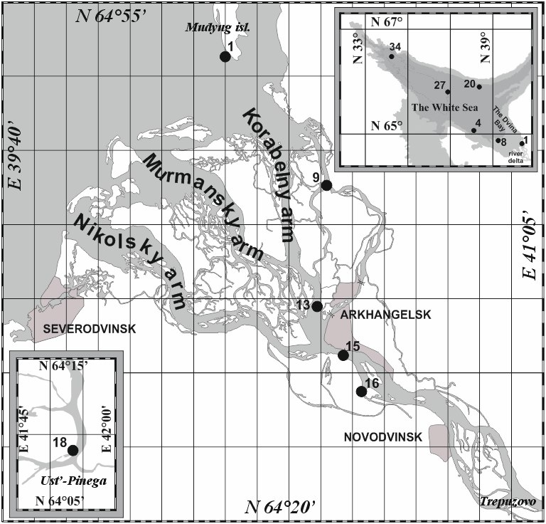
Station number | Name of station | The distance from the edge of the Delta, km | Geographical coordinates
18 | the Ust’-Pinega | 135 | 64°09.192'; 41°54.608'
16 | the port of Bakaritsa | 51 | 64°28.85'; 40°36.514'
15 | the top of the Delta | 46 | 64°31.398'; 40°33.182'
13 | the island Solombala | 39 | 64°34.575'; 40°30.08'
9 | the port of Ekonomia | 20.4 | 64°40.737'; 40°29.693'
1 | the island Mudyugsky | 0 | 64°51.3'; 40°15.0'
34 | the southern part of the Dvina Bay | 60 | 64°50.56'; 39°10.23'
27 | the North-Western part of the Dvina Bay | 126 | 65°02.45'; 38°00.22'
20 | the pool of the White sea | 160 | 65°54.20'; 38°15.71'
4 | the pool of the White sea | 214 | 65°48.58'; 36°45.90'
8 | the Kandalaksha bay | 380 | 66°29.10'; 34°06.16'
Fig. 1. The schematic map of sampling stations
In the transect “Northern Dvina River – White Sea” the content of heavy metals also varied widely (table 1).

Table 1. The content of heavy metals in upper layer of bottom sediments (0-5 cm) on the profile “Northern Dvina River – White Sea” (made according to [10-11])
Cu | Ni | Pb | Zn | Cd | Cr | Hg
14.5-54.0  33.5 | 37.0-56.0  43.0 | 5.3-12.2  9.4 | 1.8-13.0  7.8 | 0.3-5.0  1.8 | 5.1-8.5  6.2 | 0.018-0.37  0.11
Above the line – spacing changes of concentrations, below the line is the mean value

In a copper concentration distribution on the transect “Northern Dvina River – White Sea” are allocated a maximum on the area near the river mouth at station 16 (54.0 µg/g dry weight) and the minimum – in the river delta at st. 9 (14.5 µg/g dry weight). A tendency to decrease the copper content in bottom sediments (from 54.0 to 14.5 µg/g dry weight) at advance from st. 16 to st. 9 is found. Further, the concentration of copper will increase to 27.0 µg/g dry weight.
The content of nickel, maximal for all studied profile “Northern Dvina River – White Sea”, is revealed on st. 15 (56.0 µg/g dry weight) and the minimal on st. 16 (37.0 µg/g dry weight). In general, close values of the nickel content in the bottom sediments is characterized both for a pre-estuarial area of the river and delta (st. 18 – st. 9 (37.0-40.0 µg/g dry weight)). There is a trend of increasing nickel content in the surface layer of bottom sediments while advancing to the seaward part of the delta at st. 1 (48.0 µg/g dry weight).
The maximum concentration of Pb in the studied profile found in station 15 (12.0 µg/g dry weight), and the minimum concentration at st. 18 (6.0 µg/g dry weight). At an average the transect “Northern Dvina River – White Sea” the lead content of 9.4 µg/g dry weight most stations were characterized by concentrations closed to this value (fig. 2). While advancing to the marine edge of the delta, the concentration of lead is increased by st. 1 to 10.0 µg/g dry weight.
In distribution of Zn on the profile “Northern Dvina River – White Sea” is possible to allocated the maximum in st. 13 (13.0 µg/g dry weight) and minimum in st. 9 (1.8 µg/g dry weight). The metal concentrations are slightly reduced while advancing from the peak of pre-estuarial area (st. 18) from 7.0 to 5.5 µg/g dry weight (st. 16). The increase in zinc content up to 9.6-13.0 µg/g dry weight were detected in the river delta (st. 15 and st. 13). At the river mouth seaside metal concentration decreases slightly to 9.8 µg/g dry weight on st. 1.
The uniform distribution is characterized for the chromium distribution in the surface layer of bottom sediments at the stations which confined to the transect “Northern Dvina River – White Sea”. The small extrema is selected in this transect: maximum metal concentration was reached on st. 15 (7.2 µg/g dry weight), and the minimum on st. 18 (5.1 µg/g dry weight). At the wellhead seaside chromium concentration reaches 6.3 µg/g dry weight.

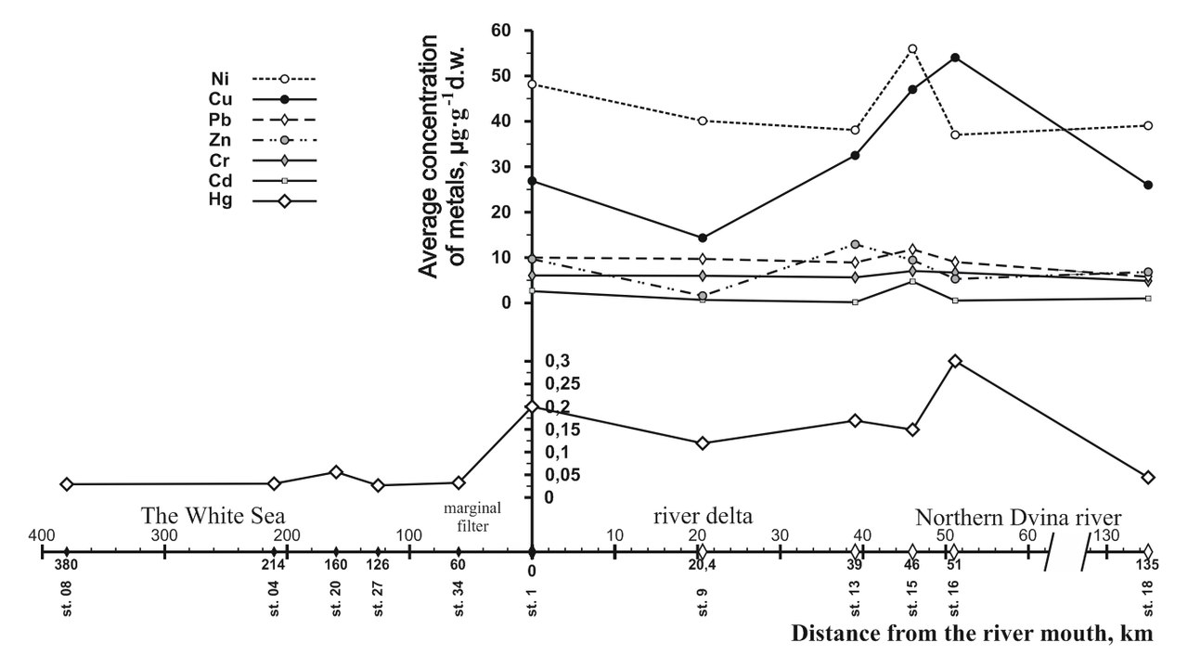
Fig. 2. The distribution of heavy mettals in upper layer of bottom sediments (0-5 cm) on the profile «Northern Dvina River-White Sea»

The minimum content of Cd (0.3 µg/g dry weight) was discovered on st. 13 (0.3 µg/g dry weight), and the maximum on st. 15 (5.0 µg/g dry weight), that most likely due to the influence of motor transport emissions. At the same time, the bottom sediments localized in the mixing zone in the marine environment (st. 1) was characterized by elevated cadmium concentrations (2.9 µg/g dry weight with an average value of 1.3 µg/g dry weight).
Total mercury content in the section “Northern Dvina River – White Sea” varied in the range 0.018-0.4 µg/g dry weight at the peak of the river estuary area (st. 18), from 0.04 to 0.4 (mean 0.16) µg/g dry weight in the delta (st. 1), from 0.02 to 0.4 µg/g dry weight (mean 0.11) in the delta area (st. 9, 1, 34). The mercury content in bottom sediments were studied directly in the White Sea (fig. 2). The total mercury concentration on marine st. 27, st. 20, st. 4 and st. 8 changed from 0.018 to 0.095 µg/g dry weight (on average 0.038 µg/g dry weight). There has been a clear reduction of the total mercury in a direction from the peak of the delta to sea edge and seaward of it (fig. 2) [11].
The studies revealed that the profile “Northern Dvina River – White Sea” (from st. 18 to st. 1) the curve of the heavy metal content distribution has a zigzag shape. Each of the investigated metals is characterized by peculiarities in the distribution of the studied transect. So, three pronounced peaks higher concentrations (fig. 2) have been allocated for Hg by authors [11]. The first peak corresponds to st. 16, where the gravitational barrier presented in silt sediments accumulated a considerable part of Hg coming from the area of Novodvinsk. The second peak is formed after passing through the gravitational barrier at the station 13. The third peak is located in the Dvina Bay in the area of Mudyugsky isl. (fig. 2). This is the main part of the marginal filter. Here, in the range of salinity 1-15 PSU is a mixture of river water with the sea. Active process of co-precipitation of mercury with suspended material extends to st. 34.
Such distribution is characterized also by Cu. However, for these metal two peaks in profile is characterized. The absence of a peak at the st. 13 most likely due to the source of metal income on the st. 15, where the road and railway bridge over the Northern Dvina River. It is worth noting that for the other metals except Zn, the peak shifted to high concentrations of st. 15. Increasing concentrations at the st. 1 in the Dvina Bay is typical for all pollutants, which once again confirms the theory of co-precipitation of metals with suspended solids.
On the example of mercury, the authors discussed the mechanism of the Northern Dvina River marginal filter activity [11]. So, the river area from st. 15 to st. 9) can be attributed to the gravitational zone that at high tide has a certain influence processes that are typical for the sea-river mixing zone. The latter is located mainly between st. 9 and st. 1. It is characterized by the prevalence of physical and chemical processes, especially coagulation and flocculation, over gravity, rapid removal of mercury from water in the composition of organic mineral complexes predominant and transformation in river water dissolved organic forms of mercury in inorganic. Here sediments are presented sandy silts and silty sands. In the area between the st. 1 and st. 34 there is a change of clayey and sandy-silty sediments from the mouth part of the estuary on pelit-silty and pelitic mud from the central part of the Dvina Bay. This area of marginal filter can be attributed to the biological zone with the enlightenment of water and high content of biogenic elements. Here bioextraction of mercury is added to the processes of sorption. According to data [12], redistribution ratio dissolved and suspended in water forms of mercury is observed in the above-described barrier zones.
From water derived up to 95% of migrating in suspension form of mercury and up to 90% dissolved form. The marine part of the profile (st. 27 – st. 8) is characterized by relatively low and uniform distribution of the total mercury content in bottom sediments and predominantly politic form of their composition. The variation of the total mercury concentration in all this vast area is insignificant, with the exception of article 20, located in the basin near the border with the White Sea Throat where there is the great influence of the Barents Sea waters [13].

III. Conclusion
In the analysis of the distribution of metal concentrations in the upper layer of bottom sediments (0-5 cm) on the transect “Northern Dvina River – White Sea” chronic contamination of river and marine ecosystems have not been identified. Pollution has local character. It found in bottom sediments in areas of impact influence of the facilities and transport of the Arkhangelsk agglomeration.
The marginal filter “Northern Dvina River – White Sea” contributes coprecipitation with a suspended matter of the main part of pollutant of anthropogenic genesis that reduces risk of penetration of pollutants into waters of the White Sea.

IV. Acknowledgment
This study supported by the grant of the President of Russian Federation MK-6241.2016.5 and G/k № 1334

V. References
[1] Minamata Convention on Mercury [Minamatskaya konventsiya o rtuti]. URL: http://mercuryconvention.org/Portals/11/documents/Booklets/Minamata_convention_Russian.pdf (accessed April 24, 2016)
[2] Lisitzin A.P. “Marginal filter of the oceans”, Oceanology, 1994, Vol. 5, pp. 735-747.
[3] A.A. Zimovets, Yu.A. Fedorov, A.E. Ovsepyan, A.V. Mikhailenko and I.V. Dotsenko, “About the features of the mercury levels formation in precipitation of the Azov Sea and White Sea”, Vol. I. Ecology and Environmental Protection, Albena, Bulgaria, pp. 19-24 [15th International Multidisciplinary Scientific GeoConference, SGEM 2015, Ecology, Economics, Education and Legislation Conference Proceedings].
[4] A.E. Ovsepyan, Yu.A. Fedorov, A.A. Zimovets and V.A. Savitsky, “Features of accumulation of mercury in the bottom sediments of lakes in Arkhangelsk and its surrounding area”, Vol. I. Ecology and Environmental Protection, Albena, Bulgaria, pp. 353-360 [15th International Multidisciplinary Scientific GeoConference, SGEM 2015, Ecology, Economics, Education and Legislation Conference Proceedings].
[5] Yu.A. Fedorov and A.A. Zimovec, “About the principal sources of heavy metals in the Northern Dvina River Estuary”, Vol. I. Ecology and Environmental Protection, Albena, Bulgaria, 2011, pp. 171-174 [11th International Multidisciplinary Scientific GeoConference, SGEM 2015, Ecology, Economics, Education and Legislation Conference Proceedings].
[6] Yu.A. Fedorov, A.A. Zimovets, A.E. Ovsepyan and I.V. Dotsenko, “Physical and Chemical Conditions in Northern Dvina Estuary and its Impact on Compound and Migration Forms of the Mercury”, University news North-Caucasian region. Natural sciences series, 2011, № 2, pp. 86-89.
[7] Yu.A. Fedorov, D.N. Gar’kusha, A.E. Ovsepyan and A.N. Kuznetsov, “Complex ecology and geochemical expedition in Northern Dvina Estuary during the winter seasons in 2008, University news North-Caucasian region. Natural sciences series, 2005, № 3, pp. 95-100.
[8] Yu.A. Fedorov, A.A. Zimovets, A.E. Ovsepyan and M.I. Khromov, “Complex Ecology and Geochemical Expedition in Northern Dvina Estuary During the Winter Season in 2008”, University news North-Caucasian region. Natural sciences series, 2009, №. 1, pp. 110-114.
[9] Yu.A. Fedorov, A.E. Ovsepyan and V.B. Korobov, “Peculiarities of mercury distribution, migration, and transformation in the estuarine area of the Northern Dvina River”, Russian Meteorology and Hydrology, 2010, № 4, pp. 85-92.
[10] Y.A. Fedorov, A.E. Ovsepyan, I.V. Dotsenko, A.P. Lisitzin, A.N. Novigatskii and V.P. Shevchenko, “Patterns of mercury distribution in bottom sediments along the Severnaya Dvina-White Sea section”, Doklady Earth Sciences, 2011, Vol. 436, № 1, pp. 99-102.
[11] A.A. Zimovets, A.E. and Ovsepyan, Yu.A. Fedorov, “Geochemical specific features of aquatic landscapes of the Northern Dvina River mouth area”, Vol. I. Ecology and Environmental Protection, Albena, Bulgaria [16th International Multidisciplinary Scientific GeoConference, SGEM 2016, Ecology, Economics, Education and Legislation Conference Proceedings], in press.
[12] Y.A. Fedorov and A.E. Ovsepyan, I.V. Dotsenko, “Mercury in bottom sediments of the Northern Dvina River mouth area and the Dvina Bay of the White sea”, University news North-Caucasian region. Natural sciences series, 2007, pp. 31-37.
[13] Hydrometeorology and hydrochemistry of the USSR seas. Vol. 2. White Sea, In. 1. Hydrometeorological conditions / B.H. Glukhovsky. Eds. L.: Gidrometeoizdat, 1991, 240 p.

