**NUMERICAL SIMULATION OF THE SEMIDIURNAL TIDAL WAVE IMPACT ON THE BLACK SEA CLIMATIC CIRCULATION**

***Anna Lukyanova, Marine Hydrophysical Institute, annieromanenko@gmail.com***

***Andrei Bagaev, Marine Hydrophysical Institute, a.bagaev1984@gmail.com***

***Vladimir Zalesny, Institute of Numerical Mathematics, vzalesny@yandex.ru***

***Vitaliy Ivanov, Marine Hydrophysical Institute, vaivanov@inbox.ru***

**Abstract. The Black Sea is an enclosed deep marine basin, where the structure of tidal movements is dominated by the direct influence of the tidal force on the proper water body. We investigated the spatial structure of its climatic circulation under the impact of tides. We developed a program module extending the numerical general circulation model of the Black Sea which was designed in the Institute of numerical mathematics, Moscow. It allows the lunar semidiurnal harmonics ($M_{2}$) influence to be taken into account explicitly via the discrete analogues of the differential equations of motion. Our work reflects the main results of the numerical experiment on the 4x4 km horizontal grid and 40 vertical σ-levels. It was a one-year model run using the CORE atmospheric climatology forcing. We compared the first and the last weeks of simulation and found out that the characteristics of a tidal mode M2 were established at a very short period of time (7 days), which is the estimate of the model’s energy redistribution time scale. The coastal areas where the tidal impact is substantial (~10 cm) were located mainly at the shallow-shelf inlets highly influenced by the climate change. Validation of the cotidal maps showed the reliability of our model at the climatological time scale. In future we will focus on the baroclinic tidal movements and validation with the Marine Hydrophysical Institute database in order to shed new light on physical and ecological processes at the frontal zone along the Rim Current.**

*Key words: coastal dynamics, numerical modeling, Black Sea, tidal waves.*

I. Description of the model

The circulation model of the Black and the Azov Seas was developed at the Institute of numerical mathematics (INM) of the Russian Academy of Sciences (RAS). It is based on a system of primitive equations written in the spherical coordinate system with the approximations of hydrostatics and Boussinesq. The equations of the model are written in the symmetrized form, as follows:

$D_{t}u-H\left(l+ξ\right)v=\frac{-H}{ρ_{0}r_{x}}\left[\frac{∂}{∂x}\left(p-\frac{g}{2}Zρ\right)-\frac{g}{2}\left(ρ\frac{∂Z}{∂x}-Z\frac{∂ρ}{∂x}\right)\right]+\frac{1}{H}\frac{∂}{∂σ}ν\frac{∂u}{∂σ}+D_{u}u+Q_{1},$ (1)

${ D}_{t}v+H\left(l+ξ\right)u=\frac{-H}{ρ_{0}r_{y}}\left[\frac{∂}{∂y}\left(p-\frac{g}{2}Zρ\right)-\frac{g}{2}\left(ρ\frac{∂Z}{∂y}-Z\frac{∂ρ}{∂y}\right)\right]+\frac{1}{H}\frac{∂}{∂σ}ν\frac{∂v}{∂σ}+D_{u}v+Q_{2},$ (2)

$\frac{∂}{ ∂σ}\left(p-\frac{g}{2}Zρ\right)=\frac{g}{2}\left(ρ\frac{∂Z}{∂σ}-Z\frac{∂ρ}{∂σ}\right),$ (3)

$\frac{-∂ς}{∂t}+\frac{1}{r_{x}r_{y}}\left[\frac{∂}{∂x}\left(Hr_{y}u\right)+\frac{∂}{∂y}\left(Hr_{x}v\right)\right]+\frac{∂ω}{∂σ}=0,$ (4)

$D_{t}T=\frac{1}{H}\frac{∂}{∂σ}ν_{T}\frac{∂T}{∂σ}+D_{T}T+\frac{∂R}{∂σ},$ (5)

$D_{t}S=\frac{1}{H}\frac{∂}{∂σ}ν_{S}\frac{∂S}{∂σ}+D_{S}S,$ (6)

$ρ≡ρ\left(T,S,Z\right)=\tilde{ρ}\left(T+\overline{T},S+\overline{S},ρ_{0}gZ\right)-\tilde{ρ}(\overline{T,}\overline{S},ρ_{0}gZ)$ (7)

In (1) – (7) *x* – longitude, *y* – latitude*, $r_{x}{, r}_{y}$* –metric coefficients $r_{x}=R_{E}cosy,$ $r_{y}=R_{E},R_{E}-$ the Earth’s radius; $Z=Hσ,$

$l=2\tilde{Ω}\sin{y} ,ξ=\frac{1}{r_{x}r_{y}}\left(\frac{∂r_{y}}{∂x}v-\frac{∂r_{x}}{∂y}u\right),$ (8)

*l –* Coriolis parameter, $\tilde{Ω}$– the Earth angular velocity. $D_{t}$– transport operator written in the symmetrized form:

$D_{t}φ≡D_{t}\left(u\right)=H\frac{∂φ}{∂t}+\frac{1}{2r_{x}r_{y}}\left[\frac{∂}{∂x}\left(Hr_{y}uφ\right)+Hr_{y}u\frac{∂φ}{∂x}+\frac{∂}{∂y}\left(Hr_{x}vφ\right)+Hr_{x}v\frac{∂φ}{∂y}\right]+ +\frac{1}{2}\left[\frac{∂}{∂σ}\left(ωφ\right)+ω\frac{∂φ}{∂σ}\right],$ (9)

***u***= (*u, v, ω*) – velocity vector in a σ-coordinate system ω – velocity in a σ – system, *w* – vertical velocity in a z – system,

$ω=w-\left[\left(1-σ\right)\frac{∂ς}{∂t}+\frac{u}{r_{x}}\frac{∂Z}{∂x}+\frac{v}{r_{y}}\frac{∂Z}{∂y}\right].$ (10)

In (10) T, S - potential temperature and salinity deviations from the mean values $\overline{T}$ and $\overline{S}$, *R*- the penetrative radiation flux, ρ – density deviation , $ν,ν_{T},ν_{s}$– coefficients of vertical turbulent viscosity and diffusion. In (1), (2) $Q_{1}$ and $Q_{2}$– zonal and meridional components of the tidal force, respectively. The system of equations is accompanied with the set of boundary and initial conditions, given in [1, 2].

The numerical algorithm for solution of the problem is based on the technique of a multicomponent splitting [3]. The linear subsystem of shallow water equations including tidal influence is computed at a separate splitting stage.

II. Description of the formulae of tidal influence

Components of the tidal force $Q_{1}$ и $Q_{2}$ in $\frac{cm}{\sec^{2}}$ are defined as:

${ Q}_{1}=-5.3*{10}^{-5}cosφsin\left(F_{M_{2}}t+2λ+Φ_{M_{2}}\right),$ (11)

${ Q}_{2}=-5.3*{10}^{-5}*cosφsinφ\cos\left(F_{M_{2}}t+2λ+Φ_{M_{2}}\right),$ (12)

where $λ∈\left[0,2π\right],φ∈\left[0,π\right]$– geographical coordinates of the considered point, $F_{M_{2}}$ = 0.00128 $\frac{rad}{sec}$– frequency of the lunar semidiurnal tidal harmonic $M_{2}$, $Φ_{M_{2}}$ =0 – phase, $t$– mean solar time [3]. Mean solar time in seconds is calculated from the local time $t_{0}$ and longitude λ as follows:

$$t=t_{0}-240*λ.$$

Formulae (11), (12) are found by the method of harmonic representation of the tidal potential [4], which is the approximation and allows neglecting the coordinates of tidal celestial bodies.

III. Description of the experiment

The spatial resolution of the model is $\left(0°3^{'}\right)×\left(0°2^{'}24''\right)$ in the longitude and latitude respectively. 40 σ – layers are nonuniformly distributed over the depth. Input data including bottom topography, boundary and initial conditions are the same as in [2].

For the computation of atmospheric forcing in the model we use the CORE Normal Year data with the resolution 1.825° on the longitude (192 points) and a nonuniform latitude grid (94 points) [5].

The model simulation was performed for one year with a 5-minute time step. The main aim of the experiment was to verify the model.

Harmonic constants $М_{2}$ were calculated using the least square method according to the data of the sea level obtained after a 7-day calculation with the output resolution of 45 minutes.

*Verification of the model*

According to the results of a numerical experiment, in the structure of circulation there is a pronounced Rim Current localized in the area of the continental slope (Fig. 1a, b). The circulation field gets intensified in winter (Fig. 1a) and weakened in summer (Fig. 1b), which corresponds to the used wind field.

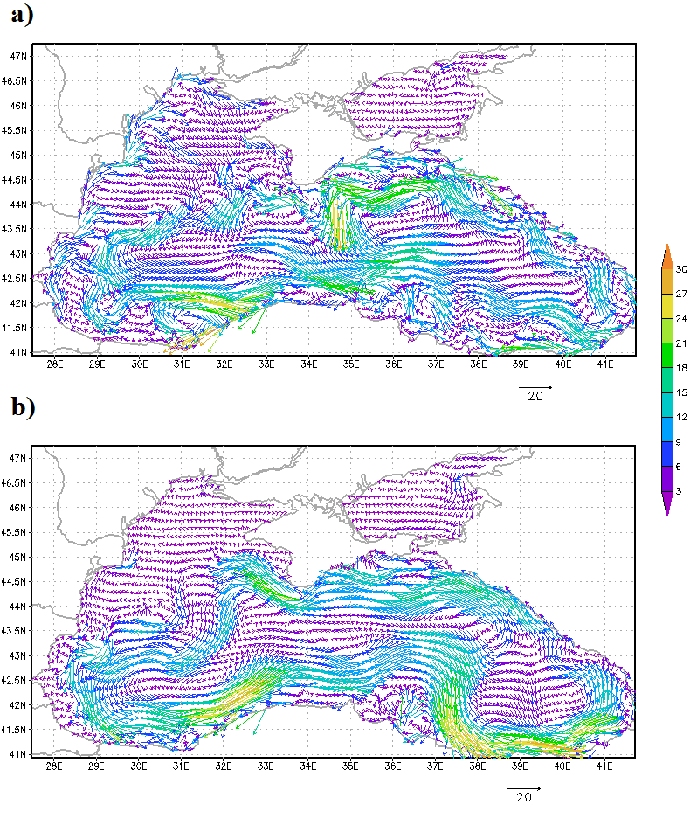

*Fig. 1. Monthly mean velocity field, depth - 5m: a) – February, b) – August. The scale of velocity vectors is shown under the maps, in cm/s. Every second latitudinal point and every fourth longitudinal point are plotted. Magnitude colour scale is given on the right.*

The structure of the circulation agrees well with the existing concept of the circulation patterns in the Black Sea [6]. Two large-scale cyclonic gyres in the eastern and the western parts of the sea are poorly reproduced by the model due to the coarse spatial resolution of the applied atmospheric forcing (Fig. 2).

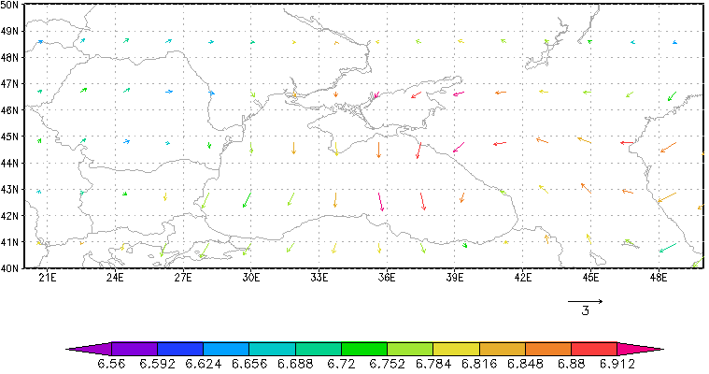

*Fig. 2. Mean annual wind circulation field according to the CORE data (m/sec). Magnitude colour scale is given below the map.*

The dynamic level of the sea surface is distributed evenly throughout the experiment and corresponds to the cyclonic circulation (Fig. 3). In the eastern part of the basin there is a stable area of minimal level values, as in [7]. The results of the model agree well with the results from [1, 2]. 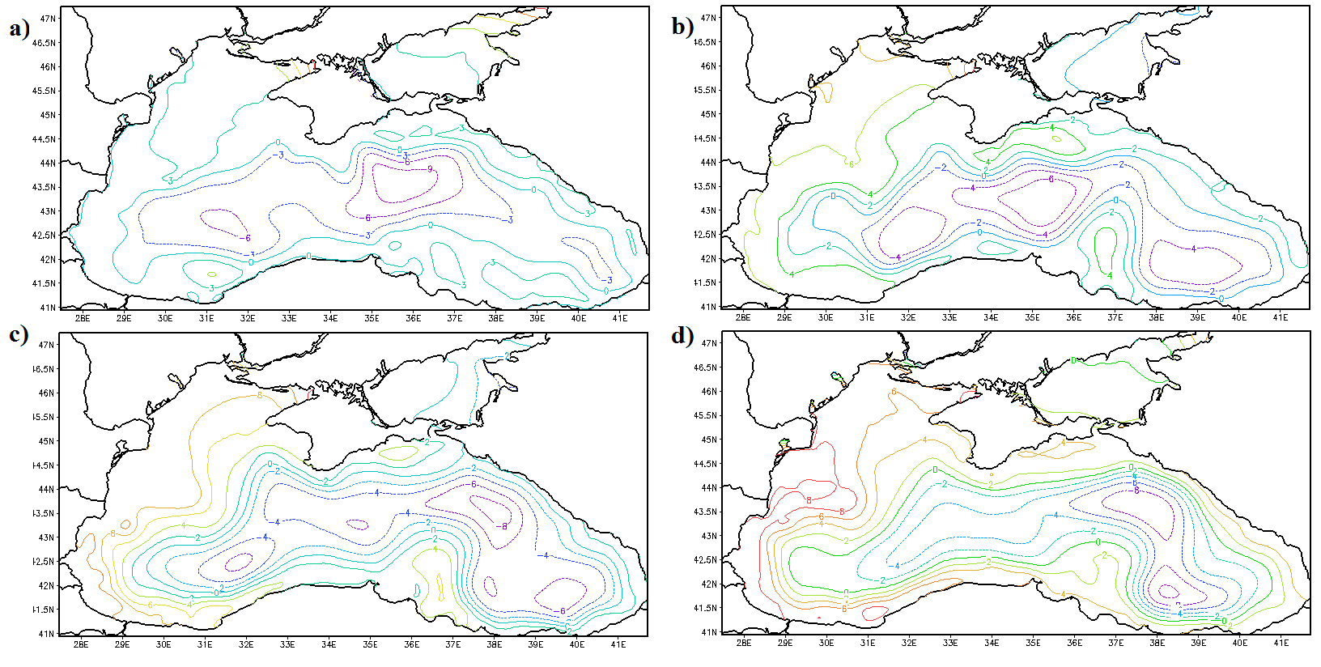*Fig. 3. Mean monthly topography of the sea level (in cm): a) February; b) May; c) August; d) November.*

The Cold Intermediate Layer (CIL) is visible at the depths of 40-100 m. It is well reproduced by the model during the all period of the calculation (Fig.4). In February the CIL is renewed and, consequently, it appears at the depths of 0 – 50 m (Fig. 4a). In August (Fig. 4b) the CIL is positioned at the depths of 20 – 80 m, with its core (T<7.5°C) found at 25 – 50 m.

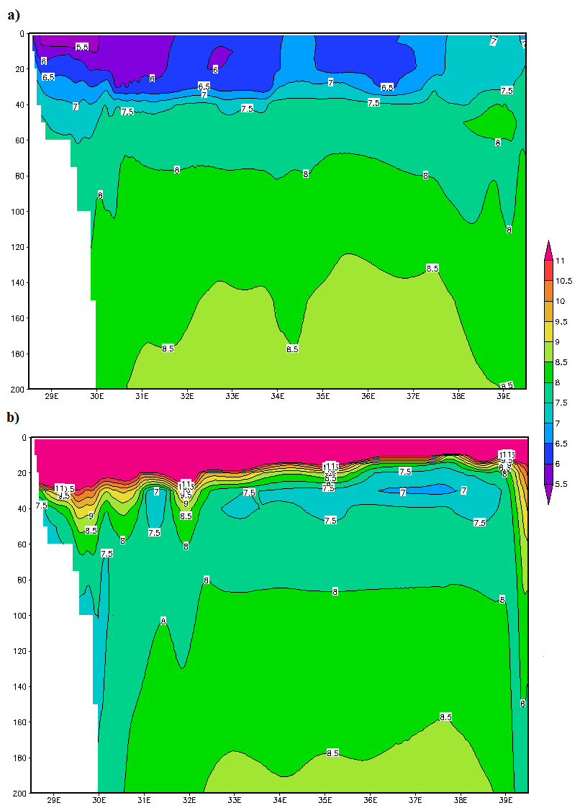

*Fig.4. Monthly mean temperature field in °C on the latitudinal cross-section at 43.7°N, a) February, b) March. Magnitude colour scale is given below the map.*

IV. Results. Concerning the tides

In the barotropic run with no account of the wind the amplitude and the phase of the tidal harmonics $M_{2}$ are established at the second week of the calculations (Fig. 5). Maximum amplitudes of the tidal lunar semidiurnal harmonic are up to 6 – 8 cm, according to the model, and are located in the area of the Karkinit Bay.

The influence of the baroclinity of the sea water and wind on the changes in harmonic stable waves $М_{2}$ is remarkable. In the following experiments of the circulation of the Black and the Azov Seas, the model of the INM RAS took into account the baroclinity of the marine water and the wind. In such cases, the maps of harmonic characteristics of the waves during the computational year differed insignificantly: the nodal point was shifted, the $M_{2}$ amplitudes changed by 0.5-1cm (Fig. 6a, 6b).

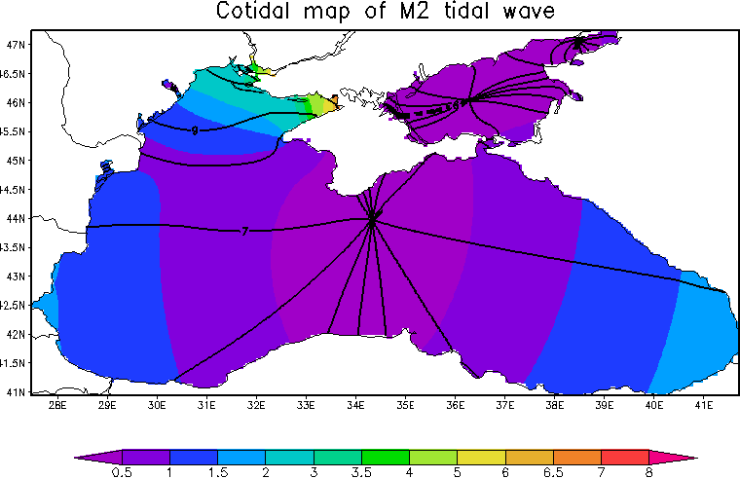

*Fig. 5. Harmonic characteristics of the tidal harmonics ${ М}_{2}$. Cotidal lines are black (in hours), equal amplitudes are coloured (the scale is in cm).*

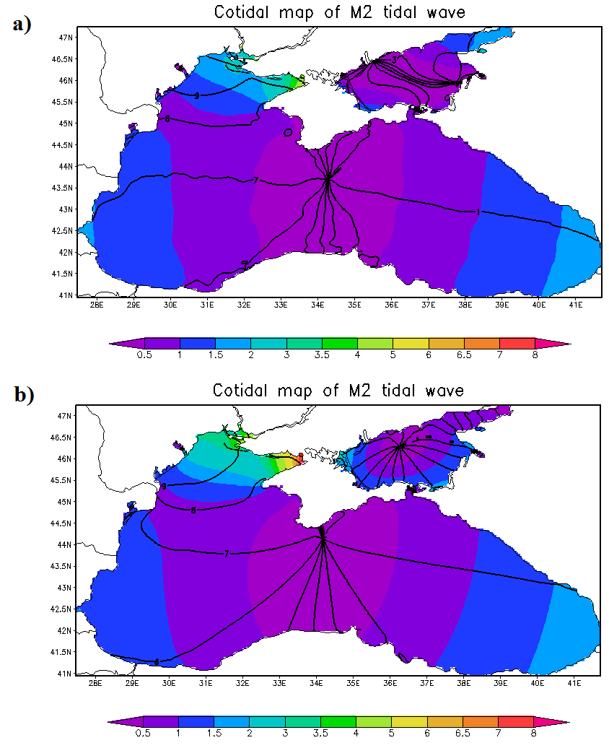

*Fig. 6. Harmonic characteristics of the tidal harmonics $М_{2}$: a) baroclinic model with the wind influence; b) barotropic model with the wind influence. Cotidal lines are black (in hours), equal amplitudes are coloured (the scale is in cm).*

*Comparison with the observations data*

In order to validate the tidal characteristics given by the model, we compare it with the in-situ observations [8, 9]. Field observations analyzed the oscillation spectrum of the Black Sea according to the prolonged sets of studies at 23 stations. The comparison of the amplitudes of the lunar semidiurnal harmonics resulting from the model with the field research showed fine quantitative agreement (table 1).

Table 1. Comparative table of the $М_{2}$ amplitudes according to the results of the modelling and field observations.

|  |  |  |
| --- | --- | --- |
| Location | Observations data, cm | Modelling results, cm |
| Prorva | 0.9-1.7 | 1-1.5 |
| Odessa | 2-3 | 2-3 |
| Yalta | 0.1-0.5 | 0-0.5 |
| Batumi | 2.3-2.8 | 1.5-2 |

Tidal oscillations of the sea level from both sources (field data and data obtained from numerical modelling) are appeared as sharp delta-shaped peaks, corresponding to the frequency of the tidal harmonic $M_{2}$ (Fig. 7). The values of spectral maximums taken from the field data and from the modelling results are of the same order [9].

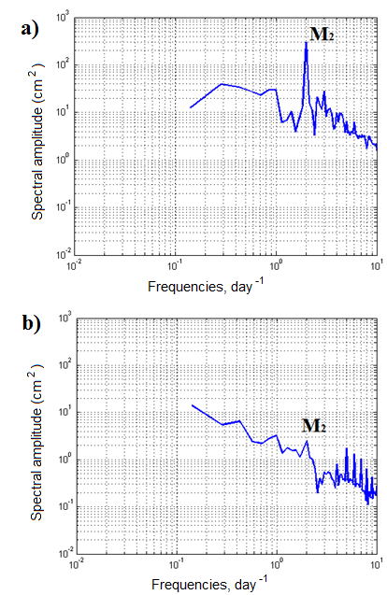

*Fig.7. Oscillation spectrums of the Black Sea level (a – Batumi, b– Yalta) in logarithmic scale. $M_{2}$ marks the spectral peaks, relevant to the lunar semidiurnal harmonics.*

Cotidal maps resulting from the numerical modelling were compared to the theoretical and the field data [9-11] and revealed fine agreement with those.

We can notice some peculiarities, which are appeared, when we consider points in different sea domains: shelf, continental slope, open sea. We took these points in north-western and Caucasian areas of the Black Sea on the lines, which are perpendicular to the coast for the each area (fig. 8) and considered their kinetic energy spectra. The spectra were calculated from the data on the kinetic energy oscillations at the depth of main pycnocline (75 m).

Fig.9 represents the power spectral energy for north-western and Caucasian areas of the Black Sea. These spectra in all points have M2 tidal wave peaks near 2 day-1 frequencies. In the regions of continental slope and open sea well-marked peaks are seen with frequencies close to 1.4 day-1 and energy that sufficiently exceed those of tidal maxima. We assume that these are inertial oscillations of the basin.

The right panel of Fig. 9 corresponds to the area with narrow Caucasian shelf, with two peaks that are absent from the left panel spectra. Their frequencies of 3 and 2.75 day-1 correspond to a baroclinic Poincare wave, previously described in [12] according to the interpretation of in-situ measurements and previous theoretical studies. Such a conclusion is supported by the fact that the peaks are absent from the left panel due to the flatness of the northern-western shelf; they are almost absent from the top-right spectrum due to the location of the sampling point over the shallow area. Presence of those high-frequency baroclinic oscillations over the steep Caucasian shelf demonstrates an important ability of the model to redistribute additional energy generated by the tidal force into the internal waves of a complex nature with properties close to those observed in-situ.

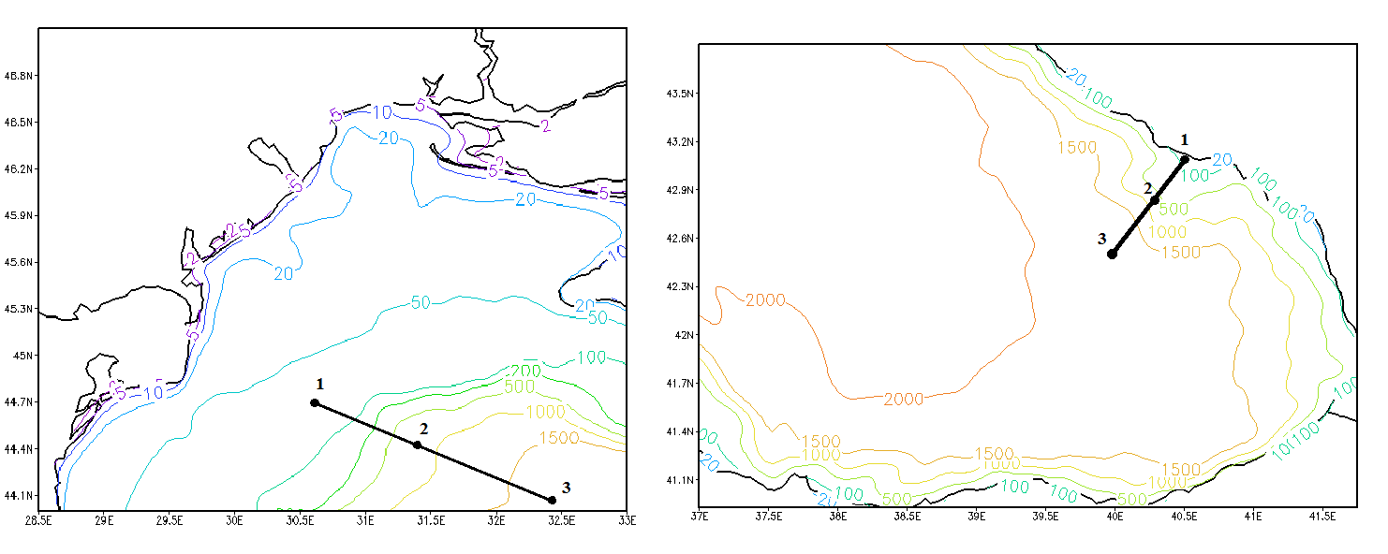

*Fig.8. Approximate positions of the considered points (1 – shelf domain, 2 – continental slope domain, 3 – open sea domain). Left panel – north-western area of the Black Sea, right panel – south-eastern area of the Black Sea (Caucasus).*

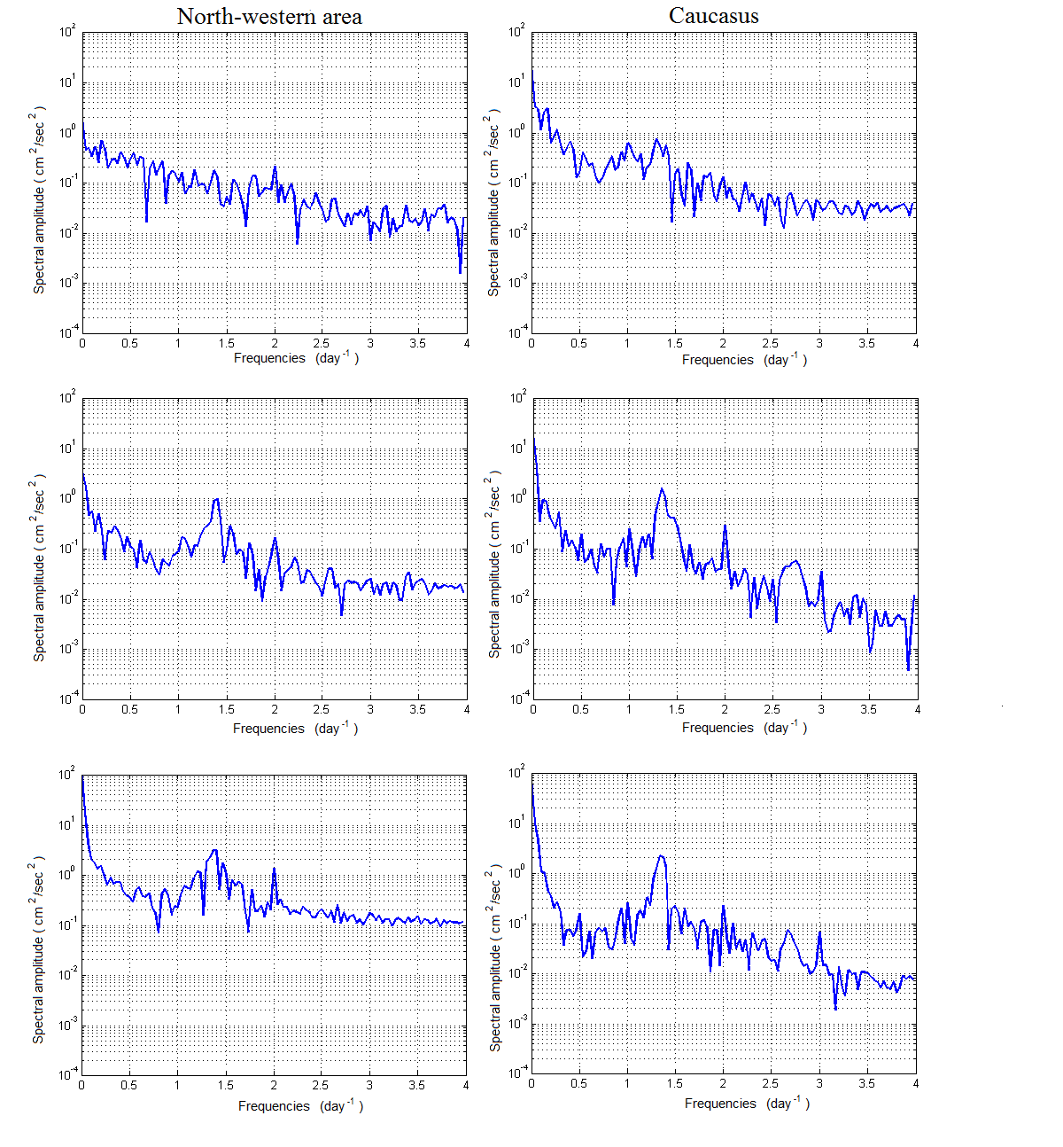

*Fig.9. Kinetic energy density spectra in semilogarithmic scale obtained from the numerical experiment for 4 weeks in April. Top – shelf region, middle – continental slope region, bottom – open sea region. Left panel –north-western area, right –Caucasus area.*

V. Conclusions

The circulation model of the Black and the Azov Seas with account of lunar tidal forces was presented. Model shows good agreement with the coastal long-term measurements and theoretical understandings. Possibilities, which are become available with use of the numerical modelling, allow us to compute tidal influence with higher spatial resolution in relation to the in-situ measurements. First of all, this is actually to the coastal regions.

Furthermore, the model outputs make it possible to investigate the physics of tides and specialties of the energy distribution in different sea regions.

VI. References

[1] V.B. Zalesny, N.A. Diansky, V.V. Fomin, S.N. Moshonkin and S.G. Demyshev “Numerical Model of the Circulation of the Black Sea and the Sea of Azov,”. *Russ.J.Numer.Anal. Math. Modelling*, № 6, vol. 25, pp. 581-609, 2012.

[2] V.B. Zalesny, A.V. Gusev, S.N. Moshonkin, “Numerical Model of the Hydrodynamics of the Black and the Sea of Azov with Variational Initialization of Temperature and Salinity,” *Izvestiya. Atmospheric and Oceanic Physics*, № 5, vol. 49, pp. 699-716, 2013.

[3] G.I. Marchuk, *Methods of Computational Mathematics*. Saint Petersburg: Lan, 2009. (In Russian).

[4] V.I. Agoshkov, M.Y. Assovsky. “*A Study of the Tidal Wave $M_{2}$ with the Method of Harmonic Analysis Based on Numerical Computation on the Full Model of the Ocean Dynamics*,” Moscow, 2010, unpublished. (In Russian).

[5] Geophysical Fluid Dynamics Laboratory: <http://data1.gfdl.noaa.gov/>, last revised on 12.05.2016.

[6] V.A. Ivanov, V.N. Belokopytov, *Oceanography of the Black Sea*. Sevastopol: MHI NASU, 2011. (In Russian).

[7] G.K. Korotaev, V.N. Eremeev. *Introduction into Operational Oceanography of the Black Sea*. Sevastopol: ECOSI – Gidrofizika, 2006. (In Russian).

[8] I.P. Medvedev, E.A. Kulikov, A.B. Rabinovich, “Tides in isolated seas: the Baltic, the Black and the Caspian”, in proceeding of “*Marine Research and Education: MARESEDU-2015*”, 2015. (In Russian).

[9] I.P. Medvedev, E.A. Kulikov, “Spectrum of Mesoscale Sea Level Oscillations in the Northern Black Sea: Tides, Seiches, and Inertial Oscillations”, *Oceanolog*y, № 1, vol. 56, pp. 10-17, 2016.

[10] Defant A. *Physical Oceanography, v.2*. New York: Pergamon Press, 1961.

[11] V.P. Yastreb, T.V. Khmara, “Comparative characteristic of tidal wave motions in seas of the Mediterranean type”, *Ecological safety of coastal and shelf zones and complex exploitation of shelf resources*, iss. 12, pp. 60-69, 2005. (In Russian).

[12] Bagaev A., Ivanov V., Zima V. Statistical analysis of mesoscale variability of the marine environment at the Crimean shelf in summer conducted with in situ data // *Ecology, economics and computer science. Coll. Articles: ed. G.G. Matishov et al. V. 2: System analysis and modeling of economic and ecological systems*, Southern Federal University, 2015, Pages: 569-580. (In Russian).