[**REFRAMING THE CLIMATE CHANGE CONVERSATION: USING VALUES, EXPLANATORY CHAINS AND METAPHOR TO INCREASE PUBLIC UNDERSTANDING OF CLIMATE CHANGE**](http://emecs-sc2016.com/edit_art.php?id=288)

***Mark Scallion, National Audubon Society-Pickering Creek Audubon Center,*** [***mscallion@audubon.org***](mailto:mscallion@audubon.org)

***Samantha Pitts, National Audubon Society-Pickering Creek Audubon Center,*** [***spitts@audubon.org***](mailto:spitts@audubon.org)

**Abstract. Sea level rise caused by climate change is a significant threat to communities in the Chesapeake Bay watershed. Audubon, in conjunction with NNOCCI, has crafted a locally applicable methodology for successfully sharing climate messages with the public.**

**If enough voices are trained in proven climate communication techniques, the discourse around climate change will change to be productive, creative and solutions focused. Climate communicators and scientists frequently encounter two pitfalls. The first is assuming people have any understanding of climate science. Although studies indicate many feel it is an important issue, many are largely misinformed about the causes and ramifications of climate change. The second is the tendency to talk about climate in the context of unproductive cultural models. A good example of this is graphically highlighting the dire situation that is faced by polar bears, humans or other species, which lead people to quickly disengage from the issue as “too big and scary to deal with.”**

**Through the use of solid explanatory chains, good climate communicators can fill cognitive gaps and avoid unproductive cultural models. Skilled framers direct the conversation towards helpful cultural models and explain climate issues through step-by-step cause and effect and strategically deployed explanatory metaphors. Skilled framers start the conversation with solutions in mind.**

*Keywords: Climate Change, Communications, Cultural Models Explanatory Metaphors, Explanatory Chains, Chesapeake Bay, Salt Marsh*

I. CLIMATE CHANGE, BIRDS AND THE CHESAPEAKE BAY

The vast tidal marshes of the Chesapeake Bay region are an international ecological treasure. Nowhere in the Bay are these marshes more abundant and dominant on the landscape than in southern Dorchester County, Maryland, especially at the Blackwater National Wildlife Refuge. Identified as a Globally Important Bird area, these salt marshes provide essential habitat to a suite of specialized, at-risk birds that evolved to flourish in this unique landscape, such as saltmarsh and seaside sparrows, clapper rail and black rail. Migratory waterfowl, other birds and terrestrial species, including the iconic American bald eagle and the endangered Delmarva Fox Squirrel make their homes in the marshes and the bordering mixed pine and hardwood forests. For generations, people have also made homes and livelihoods in or nearby the marshes, creating a uniquely rich culture and history that is integral to the region’s story and way of life. People and wildlife continue to share this unique, dynamic landscape where land and water intertwine.

Worldwide sea levels have risen approximately six inches over the past century, but a combination of factors including land subsidence and erosion has doubled the Chesapeake Bay's relative sea level rise during the same period. Scientists forecast accelerating rates of sea level rise as a result of the continuing build-up of carbon dioxide and other greenhouse gases in the earth’s atmosphere. These gases trap heat, causing thermal expansion in the oceans and melting glaciers and polar ice at increased rates. The best available recent science indicates that Chesapeake waters are very likely to rise by more than three feet by the end of this century.

Maryland is particularly vulnerable to sea level rise because of its geographic location, elevation and geology. With thousands of miles of coastline and acres of low urban and rural areas, the State is highly vulnerable to sea level rise and coastal storms. The Chesapeake Bay region is frequently subjected to tropical storms and nor’easters. These major storms can produce high tidal surges, heavy wave action, and torrential rainfall [1].

II. AUDUBON’S CLIMATE CHANGE CONCERN

In September of 2014 the National Audubon Society released its Birds and Climate Report, highlighting the significant threats to birds and humans caused by climate change. Audubon scientists used three decades of citizen-scientist observations from the Audubon Christmas Bird Count and the North American Breeding Bird Survey to define the “climatic suitability” for each bird species—the range of temperatures, precipitation, and seasonal changes each species needs to survive. Then, using internationally recognized greenhouse gas emissions scenarios, they mapped where each bird’s ideal climatic range may be found in the future as the climate changes. Of the 588 North American bird species Audubon studied, more than half are likely to be in trouble. Our models indicate that 314 species will lose more than 50 percent of their current climatic range by 2080. Of the 314 species at risk from global warming, 126 of them are classified as climate endangered. These birds are projected to lose more than 50 percent of their current range by 2050. The other 188 species are classified as climate threatened and expected to lose more than 50 percent of their current range by 2080 if global warming continues at its current pace [2].

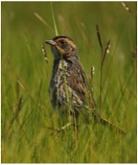  
*Fig 1. The Saltmarsh Sparrow (Ammodramus caudacutus) is expected to be the next endangered bird species in the United States Atlantic Flyway, due to climate change.*

On the Atlantic Coast of Maryland on the Eastern Shore of the Chesapeake Bay, lies the Delmarva Peninsula with an elevation near sea level. One of the notable habitats is salt marsh, including one of the largest contiguous stretches of salt marsh on the East Coast of North America. The unique wildlife habitat that salt marsh provides is home to a unique assemblage of birds that evolved in this habitat and are found nowhere else. These species include four birds on the American Bird Conservancy's and Audubon Society’s Watch List: Black rail, saltmarsh sparrow, and seaside sparrow, in the highest category, and clapper rail, just below.

Southern Dorchester County is identified as an Important Bird Area for these salt marsh birds because it supports significant breeding populations of these imperiled birds. However, within the boundaries of the Blackwater National Wildlife Refuge, 5,000 acres of marsh have been lost since the late 1930’s from a combination of factors including destruction by nutria, an introduced species, land subsidence, and rising sea levels. Sitting low in the landscape, Dorchester County’s tidal marshes are at the epicenter of our changing climate's impact on the Bay. The deposition of new sediment, growth of root systems, and other processes help marshes build elevation.

Dorchester's marshes do not appear to be building elevation at a rate that will keep today’s tidal marsh above the rising level of the Chesapeake Bay. The predicted loss of tidal marsh poses a threat to the region’s human inhabitants as well as to salt marsh dependent birds and other wildlife. Change on a substantial scale is virtually certain.

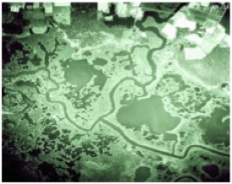

*Fig. 2 Blackwater National Wildlife Refuge 1938*

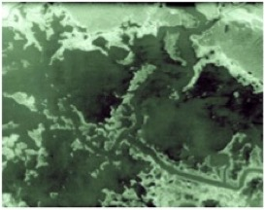

*Fig. 3 Blackwater National Wildlife Refuge 1974*

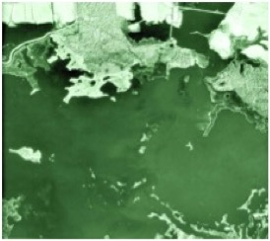

*Fig. 4 Blackwater National Wildlife Refuge 1989*

Salt marsh species depend on the two different vegetation zones determined largely by flooding frequency in tidal marshes. “Low” marsh is tidally flooded twice daily, while “high” marsh is irregularly flooded at a less than daily rate. Smooth cordgrass (Spartina alterniflora) dominates low marsh. High marsh, depending on salinity, may have meadow cordgrass (Spartina patens), spike grass (Distichlis spicata), smooth cordgrass (Spartina alterniflora/short form), black needlerush (Juncus roemerianus), or Olney three-square (Scoenoplectus americanus). High marsh vegetation is essential nesting habitat for birds that breed only in salt marsh. We also consider transitional marsh (the upper boundary of tidal marshes that includes woody vegetation) important since rising sea levels are actively transforming it into high marsh [1].

III. THE NEED FOR BETTER COMMUNICATION ABOUT CLIMATE CHANGE

Audubon’s work on the Eastern Shore of Maryland is based at Pickering Creek Audubon Center about 30 miles north of the South Dorchester Important Bird Area. The eight person staff of the Center excels in communicating with the public in formal and informal settings and connecting people to birds, wildlife and the Chesapeake Bay. The 400-acre campus of Pickering Creek Audubon Center, situated directly on a Chesapeake Bay tributary, provides a unique setting to connect people with nature in that it is a combination of working farm as well as natural and created habitats. In addition to educating thousands and thousands of students each year at the center, the creation of and management of wildlife habitat at the center is at the core of the Center. Most recently, the Center created a new 17-acre wetland complex that is beneficial to a wide variety of water and grassland birds. This shallow freshwater wetland complements over 70 acres of existing created wetlands at the Center. In addition to the new wetlands, a new 25-acre scrub meadow that is targeted at helping Audubon’s priority grassland species American Woodcock and Grasshopper Sparrow was installed in 2014. Each of these projects serves as a “classroom” to connect both landowners and school students to the methods and benefits of large-scale habitat projects.

Over four years ago, armed with Audubon’s Birds and Climate Report and a new strategic plan for the nationwide organization which focused on addressing the needs of threatened bird species, Pickering Creek Audubon Center staff launched its climate work with several areas of emphasis.

Through participation in the Maryland and Delaware Climate Change Education Assessment and Research (MADE CLEAR) project Audubon is sharing these successes with statewide partners and working towards implementing climate change curriculum more broadly across Maryland. Anecdotal evidence from partners, which represent most of the environmental education leaders in the state, is that effective climate programming is still largely absent in Maryland’s public schools.

Pickering Creek Audubon Center worked with business and faith leaders to meet with the group’s membership where they are (at a church meeting, or at a monthly Rotary meeting for example) and provide them with a 40-minute presentation about saltmarshes, saltmarsh priority bird species, sea level rise and climate change. This was followed by a tour of the Blackwater National Wildlife Refuge and marsh grass planting, which demonstrates a community-level solution while connecting people to a place they love that is being heavily impacted by sea-level rise. This effort engaged hundreds of people with salt marshes and the wildlife they support, who would otherwise not been introduced to the importance of saltmarshes and how a landscape that they are actually part of will be effected by climate change.

This engagement effort demonstrated to Pickering Creek staff how relevant and intentional communication about climate change can work to increase comfort with and public discourse about climate change.

IV. THE PROCESS

During fall of 2014 Samantha Pitts and Mark Scallion participated in a National Network of Ocean and Climate Change Interpretation (NNOCCI) Study Circle. NNOCCI and the MacArthur Award Winning Frameworks Institute lead a collaborative effort with the New England Aquarium, the Association for Zoos and Aquariums, the Woods Hole Oceanographic Institution, the National Aquarium in Baltimore, Monterey Bay Aquarium, the New Knowledge Organization in partnership with Penn State University and the Ohio’s Center for Science and Industry. With support from the National Science Foundation Climate Change Education Partnership program, NNOCCI’s goal is to establish a national network of professionals who are skilled in communicating climate science to the American public. A NNOCCI Study Circle is a cross-disciplinary learning group made up of peers with expertise from fields of professional interpretation, climate and ocean sciences and communications and cultural sciences. Through a series of facilitated in-person meetings, webinars, conference calls and practical activities, participants build knowledge of ocean and climate science and communications and cultural sciences. They apply lessons learned to communications or educational opportunities in the context of their work environment through several cycles of development, practice, sharing and reflection. As a result of the training, outreach materials that we use to connect community leaders to salt marshes, sea level rise and climate change were significantly updated. Thanks to our involvement in the National Network of Ocean and Climate Change Interpreters (NNOCCI) Pickering Creek Audubon Center has crafted a locally applicable methodology for successfully sharing climate messages with the public [3].

The team of Samantha Pitts and Mark Scallion of Audubon with Coreen Weilminster of the Chesapeake Bay National Estuarine Research Reserve, each a NNOCCI trained facilitator, has successfully presented a full day climate framing workshop, based on NNOCCI and Frameworks research, to four different groups of community leaders in Maryland.

The purpose of the workshop offered by Pickering Creek Audubon Center is to share the valuable skills learned through NNOCCI training with climate leaders in Maryland. More skilled framers and communicators that are closely involved in addressing climate issues can play a vital role in changing the public conversation on climate change in Maryland and the Chesapeake Bay watershed. Leaders communicating effectively about climate change will lead to local policy change, as it will change what policy makers are hearing from their constituents. Getting their networks to speak openly and clearly about and act on behalf of the climate threat will ultimately lead to policy solutions. Right now, many leaders aren’t taking action on climate change because they aren’t hearing from their constituents that it’s a priority issue – the goal is to help those talking to the general public about climate change to speak about it in memorable and repeatable ways so that the public leaders will then begin to hear from their constituents more clearly and consistently. FrameWorks and NNOCCI have taken significant time to research and test climate messages that resonate with people and ‘stick.’ The theory is that if enough voices are trained in proven climate communication techniques, the discourse around climate change will change to a productive, creative and solutions focused conversation, with more people empowered to search for solutions.

As climate communicators and scientists, two pitfalls frequently appear. The first is assuming the people being spoke to have any understanding of climate science. Although studies indicate that many feel it is an important issue, the majority are largely misinformed about the causes of climate change and the clear ramifications of climate change. Focusing the message on fossil fuels being the root cause of climate change and connecting it to our activities as a society is important in accomplishing this. The second is the tendency to talk about climate in the context of unproductive cultural models. A good example of this is graphically highlighting the dire situation that is faced by polar bears, humans or other species. Although these eventualities may be true, their overwhelming nature lead people to disengage from the issue as “too big and scary to deal with.”

Cultural models are widely held beliefs that shape how people think. Cultural models are cognitive short cuts created through years of experience and expectation. They are things taken for granted and largely automatic assumptions that occur in the brain without even thinking. Cultural models are typically widely shared across a society and are durable and long lasting. The use of cultural models is triggered by associated information that connects people with long held cultural models. People rely on cultural models to interpret, organize and make sense out of all sorts of stimuli, including experiences, feelings, thoughts and communications as scientists [4].

For example when speaking to youth in Pickering Creek’s environmental education programs and asking them about what is the cause of climate change, the greatest threats to wildlife, or any other major topic, the default answer from students is pollution. Pollution is widely held as the root of all environmental problems. When there are so many sources, quantities and types of pollution, though that answer may be true, the student’s actual understanding of the kind of pollution, who is responsible, why it is a problem, and what that person can do to help solve it, is completely lost due to their cultural model. Everyone can hold many different cultural models- some of which may even conflict with one another- that influence how they think about a given topic. So what cultural model is currently operating in ones thoughts, what state of mind they are in, influences how one reacts to information they are hearing. It is important to note that cultural models that are widely held in North America maybe significantly different from those held in other geographies.

As communicators, it is important to evoke cultural models that will lead audiences to a productive line of thought, one that will encourage them to feel hopeful and be ready to take action at a scale that is effective for the problem at hand.

Once a communicator understands the cultural models that are at work around nature and climate in the home geography they can begin to strategically frame climate messages so they effectively resonate with people, stay with them and encourage a sense of hopefulness and direct activity towards community level solutions.

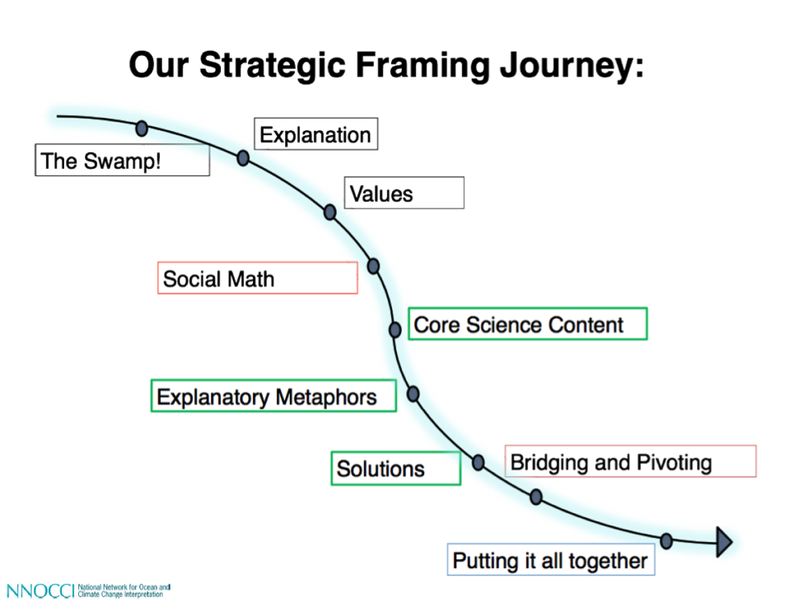

*Fig. 5. Many pieces are needed to navigate effective climate communication [5]*

Strategic framing is a research-based approach that is proven to:

* bridge the gap between scientist understanding and public understanding
* help the public understand the mechanisms of climate change
* show the public how they can be a productive part of the climate change story
* leave the people you are communicating with a sense of hope [6].

Strategic framing is not specific to climate communications and is used in many industries and political campaigns to affect people’s thinking about objects or issues. There are four basic elements of strategic framing:

*Tone*

Tone establishes the issue as explanatory and reasonable and for ‘everyone,’ not just those who already agree with the point of view being expressed. Knowledge should be shared in a productive, inclusive nonconfrontational way.

*Values*

Values remind people of what’s at stake or what they already care about that the issue connects to. People should feel comfortable in bringing the issue home and linking it with their daily life. Starting with values makes people care. Framing in communication is the practice of selecting the most effective communication- conversations that lead to people taking appropriate action. When leading with values that people hold, they are more likely to pay attention to what a communicator has to say. Values also drive what people will consider doing. So selecting a value that encourages a civic mindset will open up the audience to examining solutions that require action on their part. Thinking carefully about the language we use will help evoke cultural models and lead to productive action driven responses, avoiding patterns of thought that lead nowhere or worse entrench an audience in negative, unproductive attitudes.

*Explanatory Chains And Metaphors*

Explanatory chains and metaphors enhance peoples’ understanding of processes and mechanisms in ways that help them to think through productive solutions. They work to simplify the message as well as link all the parts of the message together. An Explanatory Metaphor is a bridge between expert and public understandings that helps members of the public think more productively about a topic. FrameWorks defines an Explanatory Metaphor as a research-­driven, empirically tested analogy that captures and distills a concept through reference to existing patterns of assumption and understanding. By pulling out salient features of the familiar topic and mapping them onto the less familiar topic, Explanatory Metaphors can help people organize information into a clearer picture in their minds. This has the potential to make people better critical thinkers and more careful media consumers who are ultimately better situated to think about an issue and what should be done about it. On the basis of this theoretical perspective, FrameWorks has built a robust, reliable protocol for determining what an effective Explanatory Metaphor looks like and how it behaves [6].

Through the use of explanatory chains that specifically do not leave any gaps, good climate communicators can fill cognitive gaps and avoid unproductive cultural models. Skilled framers direct the conversation towards helpful cultural models and explain how the issue works through step-by-step cause and effect and strategically deployed explanatory metaphors. Skilled framers start the conversation with solutions in mind, starting the explanation with the burning of fossil fuels. Though NNOCCI training is founded on communicating with the public, and not necessarily with those who know the minute details of climate science and government solutions to address it, those closely involved with climate issues can benefit greatly from framing training since they are the individuals either making up decision making bodies or are those tasked with educating them. Just because one may know and present a lot of information about climate change, doesn’t mean they have communicated the information effectively enough for it to ‘stick’ with the audience or have secured a solution-focused outcome.

*Solutions*

Solutions present people with ways they can join others to bring forward systemic change that addresses the root cause of the problem. It is important for people to realize they can be part of the solution and put them on track to be thinking about community level solutions.

V. CONCLUSION

As a result of participating in Audubon’s NNOCCI style trainings, climate communicators are significantly better equipped to speak to their coworkers, supervisors, key constituents and the public about climate change. Specifically, they:

* have a deeper understanding about how the public, including their key constituents, think about climate change,
* understand what most Americans do and do not understand about climate change,
* are more comfortable with the indisputable science behind climate change,
* are able to clearly talk about the burning of fossil fuels as the primary driver behind climate change,
* have the ability to focus conversations about climate on things their constituents care about,
* link together a story about the cause, implications, and solutions around climate change that connect with values that are important to their constituents,
* are able to link all of this to what is going on in Maryland, will and
* become more effective climate communicators who can link their important work to values that are held dear by many citizens in the region

The training is designed to cue hopeful thinking about communicators’ capacity to make a positive difference. It’s not just about getting people to learn facts about climate science; it’s about facilitating productive cognitive engagement and stimulating conversations with supervisors and key constituents that set the stage for further engagement and action. The skills these communicators learn, practice and perfect enable hopefulness and a sense of efficacy in their work – the sense that by working together with partners and constituents, they can make a meaningful difference.

VI. ACKNOWLEDGMENTS

Pickering Creek Audubon Center thanks the National Network for Ocean and Climate Change Interpretation for their invaluable training. The Frameworks Institute’s superb research tremendously helped inform our work. Our training partner, Coreen Weilminster from the Chesapeake Bay National Estuarine Research Reserve contributed great talent and knowledge to our workshops. Thanks to Susanna Scallion for editing assistance. Thanks to the Audubon Climate Team, Dr. Wayne Bell, the Chesapeake Audubon Society, MADE CLEAR as well as several private donors for supporting this work.

VI. REFERENCES

[1] Lerner, J.A., Curson, D.R., Whitbeck, M. and Meyers, E.J., “Blackwater 2100: A strategy for salt marsh persistence in an era of climate change”, 2013, The Conservation Fund (Arlington, VA) and Audubon MD-DC (Baltimore, MD).

[2] “Audubon Climate Change,” accessed May 17, 2016.

<http://climate.audubon.org/article/audubon-report-glance>

[3] “Apply for a 2016 NNOCCI Study Circle” accessed May 17, 2016

http://climateinterpreter.org/features/apply-fall-2016-nnocci-study-circle

[4] Andrew Volmert, Getting to the Heart of the Matter: Using Metaphorical and Causal Explanation to Increase Public Understanding of Climate and Ocean Change, 2014, The Frameworks Institute, pp 3-4, 11-13

[5] “Strategic Framing Journey Slide” accessed May 17, 2016

<http://climateinterpreter.org/sites/default/files/discussion_files/strategic_framing_journey_slide_0.pdf>

[6]“Why change the conversation” accessed May 17, 2016

<http://climateinterpreter.org/sites/default/files/discussion_files/lesson_1_-_why_change_the_conversation_ppt_0.pdf>