**Nutrient dynamics in eelgrass (*Zostera marina*) meadow**

**and the variation of nutrient contents of eelgrass**

***Toshimasa Asahi, Kagawa University, asahi@ag.kagawa-u.ac.jp***

***Kazuhiko Ichimi, Kagawa University***

***Kuninao Tada, Kagawa University***

Abstract. Nutrient dynamics in seagrass beds and nutrient demands of seagrass biomass are not clear, although nutrient uptake of seagrass has been experimentally studied in the laboratory. We conducted the field observations and the bottom sediment core incubations to estimate nutrient fluxes in the seagrass, *Zostera marina* meadow. DIN (nitrate, nitrite and ammonium) concentrations were always low particularly during the *Z. marina* growing season (from spring to summer), and water exchanges caused by tidal currents hardly supplied nutrient demand for *Z. marina*. Sediment pore water also supplied insufficient nutrients to *Z. marina*, because pore water had less volume than the water column, although DIN concentrations of pore water were 10-100 fold higher than those of the water column. Nutrient flux from sediment to water column estimated by the sediment core incubation experiments showed a similar rate with tidal water exchange. Thus, our results suggested that *Z. marina* adapted for low nutrient concentrations and each nutrient source in the *Z. marina* meadow slightly contributed but could not support *Z. marina* growth. We found that another nutrient source, for example, precipitation, supplied high DIN to the *Z. marina* meadow. After rainfall, the DIN concentration of seawater in the *Z. marina* meadow increased 2-5 times higher. Moreover, nitrogen content of eelgrass also increased 2-3 times higher during several days. Those results suggested that *Z. marina* was usually exposed to a low nutrient concentration but could uptake abundant nutrients from temporary nutrient supplies such as precipitation.

*Key words: Zostera marina, nutrient, seagrass meadow*

1. Introduction

It is well known that eelgrass (*Zostera marina*) meadows have a great role in the coastal ecosystem but are often degraded due to artificial eutrophication. In Japan, in spite of much efforts to revive *Z. marina* meadows, they hardly worked due to the lack of information about *Z. marina* nutrient demand and utilization. Most studies according to *Z. marina* nutrient utilization were conducted by laboratory experiments. It is very important to understand the nutrient dynamics and the nutrient demand in *Z. marina* meadows.

We investigated the nutrient dynamics in a small inlet (420,000 m2), Ikushima Bay, where *Z. marina* covered almost the whole area and had no inflow river. Ikushima Bay is connected to Bisan-seto, located in the eastern part of the Seto Inland Sea, Japan (Fig. 1). Bisan-seto is one of the largest *Z. marina* habitats in Japan. The water movement of Ikushima Bay is simply regulated by tidal current. Since it involves simple water movement, it is easy to know the nitrogen budget in Ikushima Bay. Our objective was to confirm the nutrient dynamics in the *Z. marina* meadows.

II. Nitrogen budget

We measured nutrient fluxes between offshore water and Ikushima Bay. In spring, the *Z. marina* growing season, dissolved inorganic nitrogen (DIN) inflow from offshore water was estimated to be 8 mg N m-2 day-1. We also measured nutrient flux from sediment to the water column by a core incubation method. DIN inflow from sediment was estimated at 7 mg N m-2 day-1. Our results indicated that the *Z. marina* meadow in Ikushima Bay was functioning as a DIN sink.

Then, we estimated nitrogen demand of *Z. marina* by its growth rate, nitrogen content and standing stock. The nitrogen demand of *Z. marina* in spring was estimated at 160 mg N m-2 day-1 (Fig. 2). Even if our estimation of nitrogen demand of *Z. marina* was overestimated, the nitrogen demand of *Z. marina* (160 mg N m-2 day-1) was significantly higher than the DIN influx into Ikushima Bay. This result indicated that DIN inflow to the *Z. marina* meadow was not balanced with the nitrogen demand of *Z. marina*, and there were other nitrogen sources in sediment or temporary nitrogen discharges to Ikushima Bay.

III. Pore water nutrient

Another nitrogen source, underground nitrogen pools, which could be uptaken from the root of *Z. marina*, may be important [1]. We measured the annual sediment pore water DIN concentrations. During spring and summer, when *Z. marina* was growing, the mean pore water DIN concentration was 50 µM. Then, the pore water DIN concentration increased with the standing stock of *Z. marina* decreasing in autumn. During winter, when almost all *Z. marina* disappeared, the pore water DIN concentration was increased by 67 µM. DIN decrease of pore water during spring and summer might be due to the uptake by *Z. marina.* However, water volume of the pore water was 4-5 digit lower than that of the water column. Although the pore water DIN concentrations were higher than those of the water column, we concluded that pore water DIN scarcely contributed to *Z. marina* growth.

IV. Nitrogen uptake of eelgrass

Seagrasses show high nutrient uptake affinities [2], and *Z. marina* could utilize intermittent nutrient supply such as rainfall and freshwater discharge. We measured the variation of nitrogen content of *Z. marina* in the short term such as a few days. After rainfall, the nitrogen content of *Z. marina* increased from 14 to 35 mg N g dw-1 with the increasing water column DIN concentration over a few days. This result suggested that *Z. marina* could immediately uptake DIN for intermittent nitrogen supply.

It was revealed that each nitrogen source could not sustain the *Z. marina* nitrogen demand alone in Ikushima Bay, although there were various nitrogen pools and discharges into the bay. Our results suggested that *Z. marina* utilized multiple nitrogen sources so as to conform to the situation.

V. Acknowledgment

This research was partly supported by the Environment Research and Technology Development Fund (S-13) of the Ministry of the Environment, Japan.

VI. References

[1] F.T. Short, “The seagrass, *Zostera marina* L. plant morphology and bed structure in relation to sediment ammonium in Izembek Lagoon, Alaska,” *Aquatic Botany*, vol. 16, pp. 149-161, 1983

[2] B.W. Touchette, and J.M. Burkholder, “Review of nitrogen and phosphorus metabolism in seagrasses,” *Journal of Experimental Marine Biology and Ecology*, vol. 250, pp. 133-167, 2000

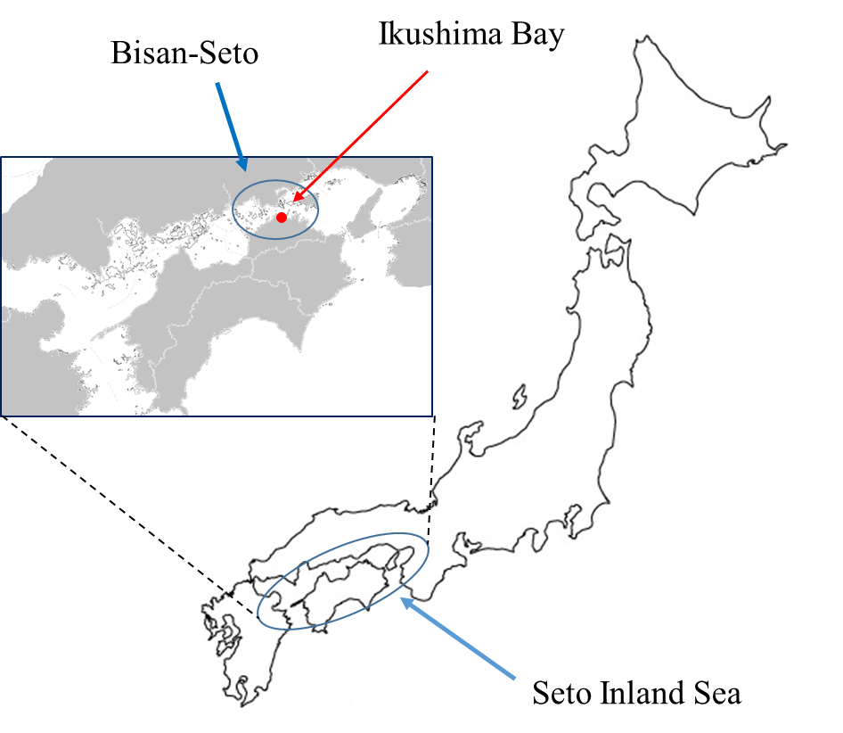

*Fig. 1. Study site. Ikushima Bay is connected to Bisan-Seto, Seto Inland Sea.*

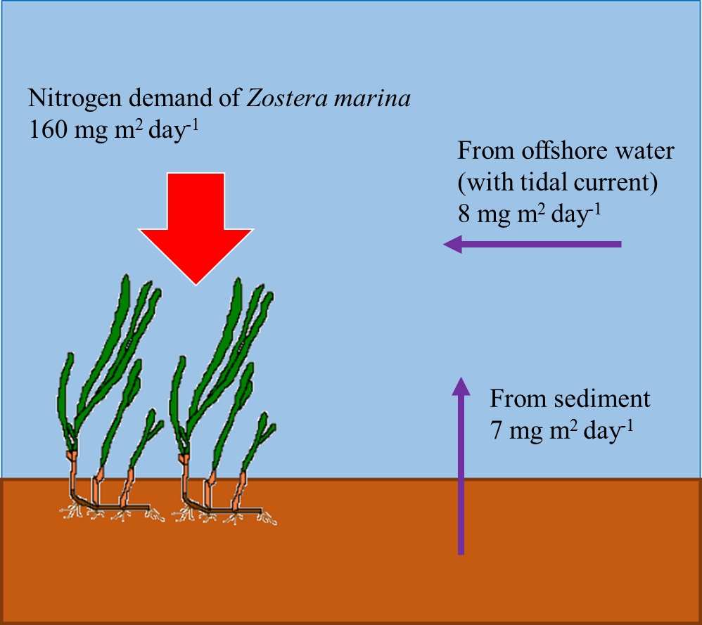

*Fig. 2. Nutrient dynamics of* Zostera marina *meadow in Ikushima Bay. Nitrogen demand of* Z. marina *was significantly higher than DIN influx into the water column.*