**Seasonal Variation of Transportation of**

**Asari Clam, Ruditapes philippinarum, Larvae in Hiroshima Bay.**

***Satoru Takahashi, National Institute of Advanced Industrial Science and Technology,***

***s-takahashi@aist.go.jp***

***Masami Hamaguchi, National Research Institute of Fisheries and Environment of Inland Sea, masami******@fra.affrc.go.jp***

Abstract. Hiroshima Bay is located in western part of the Seto Inland Sea, and there is high productivity of Asari clam. However, the landings amount of the clam was rapidly decreased and production areas came to be limited in the northern part (bay head). Here, the clam has the planktonic larval stage. Then, it is important to reveal the transportation process of larvae to clarify the habitat connectivity of the clam. Therefore, in this study, we try to clarify the transportation process of the clam larvae in the Hiroshima Bay by numerical model experiments. As a result of model experiments, in June (rainy and heating season), the larvae are transported to southward in western area of Hiroshima Bay. In November (dry and cooling season), distribution of larvae is limited in the northern area of Hiroshima Bay. These results are corresponding to the field observation results. In the Seto Inland Sea, it is said that there is spawning time of the clam twice a year (spring and autumn). However, in a recent Hiroshima Bay, the density of the larva in spring is very low than that in autumn. These facts suggest that the production of the clam is limited in the northern area of Hiroshima Bay because the density of the larva is low in spring when the larvae can extend to the south.

*Key words: Asari clam, decrease in landing amount of clam, transportation of larvae,* *habitat connectivity, numerical model experiment.*

I. Introduction

Seto Inland Sea is semi-enclosed inland sea located in western part of Japan and the tidal flats develop. The landings amount of Asari clam (Ruditapes philippinarum) in this sea became the maximum in 1986 and this amount was about 1/3 of the entire Japan (shown in Fig.1). However, the landings amount rapidly decreased to 1/20 in the 1990's. Hiroshima Bay is located in western part of the Seto Inland Sea, and there is high productivity of Asari clam. However, the landings amount of the clam was rapidly decreased as well as the entire Seto Inland Sea and production areas came to be limited in the northern part (Fig. 2). Under these situations, various plans for the resource recovery were tried. However the amount of landings did not increase so much.

Here, the clam has the planktonic larval stage during three to four weeks. During this stage, it is considered that the clam larvae disperse about 20km-30km. Then, it is important to clarify the habitat connectivity of the clam to achieve the sustainable production. Therefore, in this study, we try to clarify the transportation process of the clam larvae in the Hiroshima Bay by numerical model experiments as the first step to clarify the habitat connectivity of Asari clam.

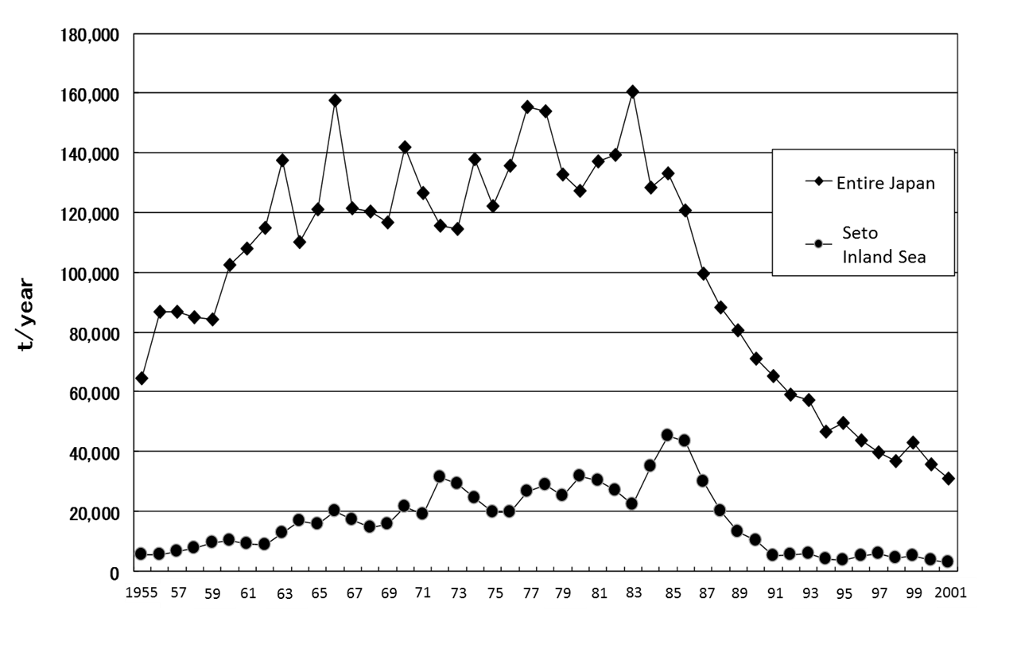

Fig.1 Time series of landings of Asari clam

II. Description of Numerical Model

Model domain is shown in Fig.2. The horizontal grid size is 500m x 500m, and model domain is vertically sliced to 12 levels (thickness of each level : 1m, 2m, 2m, 2m, 3m, 5m, 5m, 10m, 10m, 20m, 20m, 20m). Using conventional notation, the governing equation on the Cartesian coordinate are as follows:

where *t* is time, is the horizontal gradient, *U* is the horizontal current velocity (*u*, *v*) of *x* and *y* directions, *w* is the vertical current velocity of *z* direction, f is Coriolis parameter (2ω sin φ, ω is angular velocity of earth rotation and φ is latitude (34˚N)), *P* is pressure, *ρ* is density, *ρ0* is the referential density, g is the gravitational acceleration (980 cm sec-1), *AH* and *AV* are the horizontal and vertical eddy viscosity, *KH* and *KV* are the horizontal and vertical eddy diffusivities, respectively (the Smagorinsky viscosity and diffusivity; refer to Mellor (1998) for equations **[1]**), *T* is water temperature, *S* is salinity.

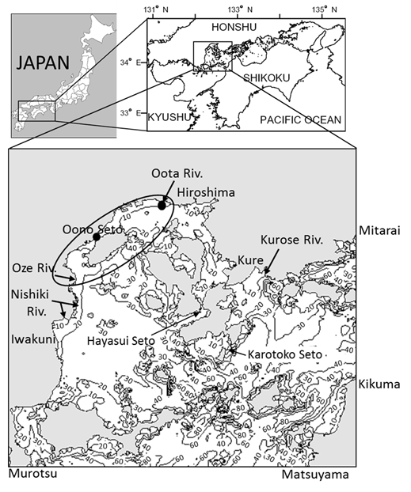

Fig.2 Depth distribution of model domain. The numeral shows depth in meter.

Area enclosed with the ellipse is main production area of Asari clam.

Two black circles are release points of the larva particle.

4 tidal components (M2, S2, K1 and O1) were given on open boundary using the harmonic constants at Matsuyama, Murotsu, Mitarai and Kikuma (Japan Coast Guard: 1992 **[2]**). Open boundary condition and initial condition of water temperature and salinity were given using Senkaiteisen data provided by Hiroshima and Ehime Prefecture. Wind stress and sea surface heat flux were calculated by using the data that the Hiroshima meteorological observatory had observed, to be given at the surface of the model sea. The river discharge from four rivers located around Hiroshima Bay (Oota Riv., Kurose Riv., Oze Riv., Nishiki Riv.) was considered (river discharge data was provided by the Ministry of Land, Infrastructure and Transport, Japan.). To calculate the stationary current field, the data averaged between from 2003 to 2012 were applied. Here, the clam larvae mainly occur in June and November in Hiroshima Bay. Then, model experiments were carried out under the condition in June and November.

To verify the reproducibility of the model, the observed water level, temperature and salinity were compared to the calculated one respectively. Fig. 3 shows the time series of the observed water level (broken line) and the calculated one (solid line). After beginning tow tidal cycle (spin up period), the phase and the amplitude of the calculated water level are almost corresponding to that of the observed water level respectively. The calculated water temperature distribution is corresponding to the observed one, although the absolute value is a little high in the head of a bay (figure is omitted in this paper). The calculated salinity distribution is corresponding to the observed one, although the absolute value is a little low in the head of a bay (figure is omitted in this paper). These results suggest that the reproducibility of the model is good.

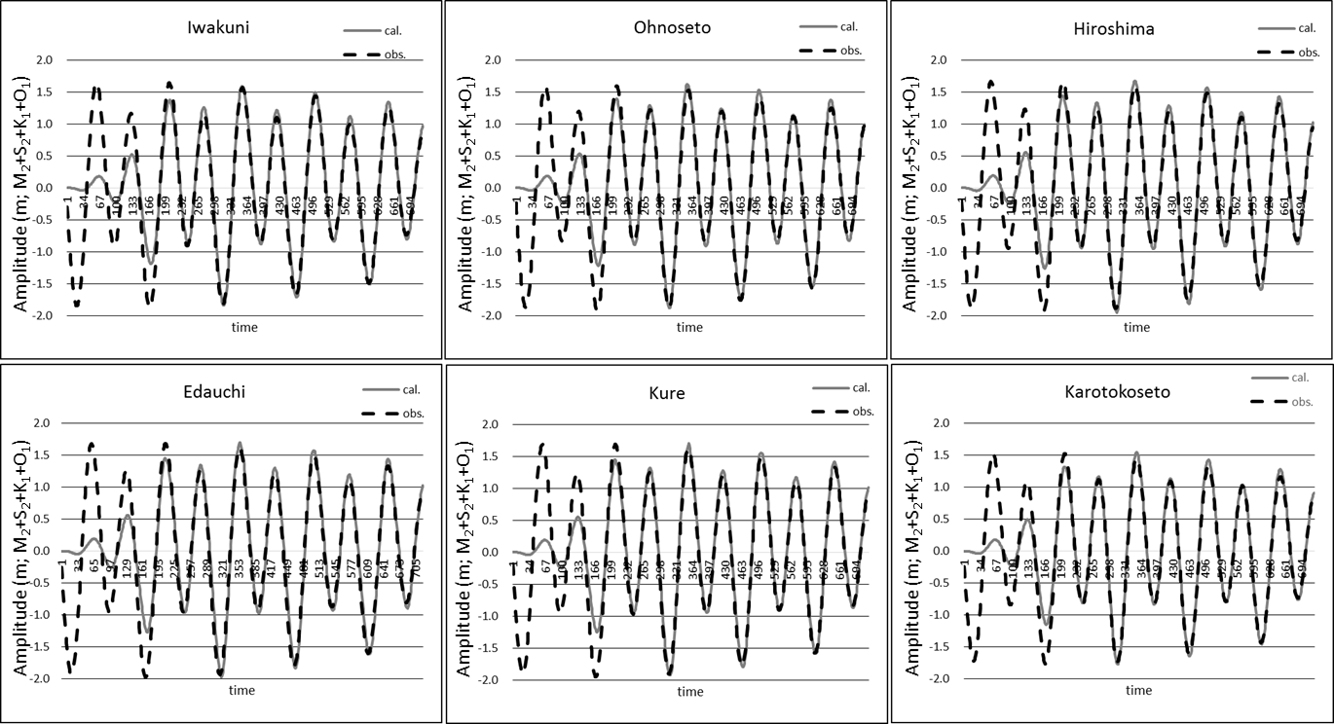

Fig.3 Time series of the observed water level (broken line)

and calculated one (solid line)

III. Larva trace experiment

In the calculated current field, the particle (larva) trace experiments were carried out by using the Euler Lagrange method. The larvae were released from the mouth of Oota River and the coast of Oono where the mother clams are living. Release was executed every 1 hour during 6 hours at the ebb of the spring tide. Here, in Hiroshima Bay, it is considered that the larvae float in the surface layer during first about five days, and in about 5m depth afterwards (private letter). Then, three cases were calculated. Case 1: The larvae float only in surface layer (2m depth). Case 2: The larvae float in 2m depth during first three days, and in 5m depth afterwards. Case 3: The larvae float in 2m depth during first five days, and in 5m depth afterwards. The larva is traced for 30 days, because the Asari larva floats during three to four weeks.

Results of experiments in June: Fig.4 shows the distribution of residual current at 2m and 5m depth and Fig. 5 shows tracks of larvae during 30 days of Case1 and Case3 respectively. A large amount of fresh water is supplied to the bay head by the river discharge from Oota River and stratification develops because June is a rainy and heating season. The density current develops, and southward current according to the west shore is caused. Moreover, the estuary circulation develops around the north shore (Fig.4). By these currents, most larvae are transported to the south in Case 1 (left panel of Fig.5). In Case 2, the larvae stay in bay head because larvae sink down to 5m depth after three days, and are transported toward the mouth of Oota River by the estuarine circulation (figure is omitted in this paper). In Case 3, it is suggested that a number of larvae reach to outside of the estuarine circulation while they are in the surface layer (about five days), and are transported to the south (right panel of Fig.5).

Results of experiments in November: Fig.6 shows the distribution of residual current at 2m and 5m depth and Fig. 7 shows tracks of larvae during 30 days of Case1 and Case3 respectively. The density current does not develop because November is a dry and cooling season. Current direction in 2m depth is almost corresponding to that in 5m depth, although current velocity in 5m depth is slower than that in 2m depth (Fig. 6). This fact suggests that the tidal residual current is predominant, and westward current develops in the central part of the bay. By these currents, the larvae are transported to the west, and do not extend to the south (Fig.7). And there is no difference between the results of Case1, Case2 (figure is omitted in this paper), and Case3.

Fig. 8 shows the habitat connectivity of Asari clam collected from fisheries grand and tidal flats in Hiroshima Bay **[3]**. This connectivity was estimated by molecular analysis. The thickness of the arrow line shows intensity of connectivity. The habitat connectivity in west half area of the bay is strong. And Hamaguchi (2013) **[3]** concluded that the clam larvae were transported to the western habitat by the current. These facts are corresponding to the larva trace experiment result of Case 3 in November (right panel of Fig.7), that is, the distribution of Asari larvae is limited in the northern part of the bay. Furthermore, these facts are compatible with the result of Case3 in June (right panel of Fig.6) because the larvae do not reach to the coast of Yashiro Island, although the larvae are transported to the south in the western area of the bay. Fig. 9 shows distribution of Asari larvae in November 2012 **[3]**. The size of the circle shows the amount of the larva. The amount of the larva is large in the northern part of the bay where the amount of adult clam is large. And this result is corresponding to the calculated result of Case3 in November (Fig. 7). These facts suggest that the calculation condition of Case 3 is practical and the calculated results are appropriate.

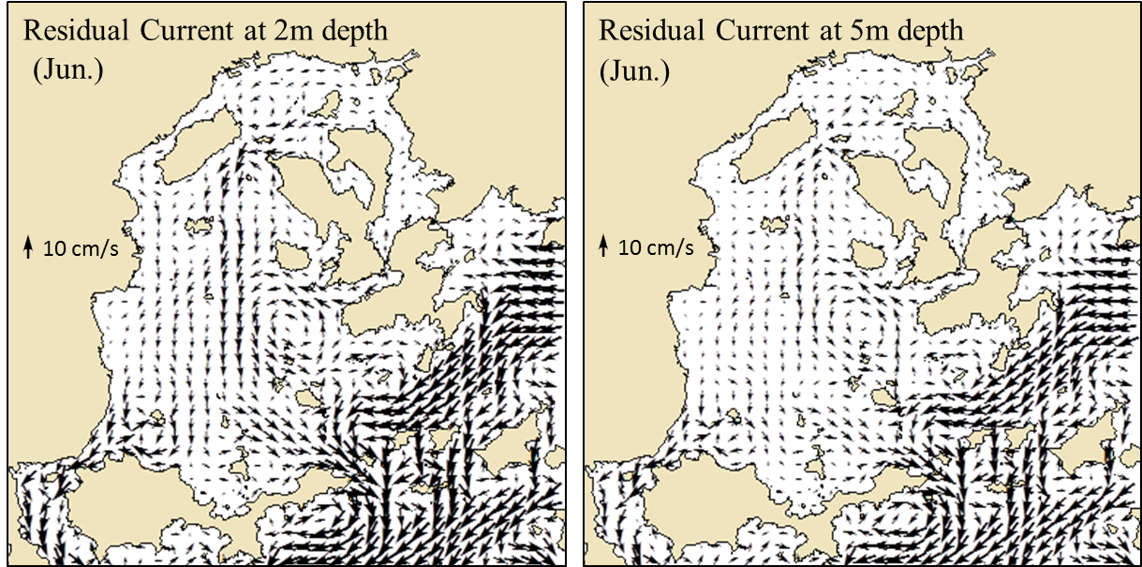

Fig. 4 Distribution of residual current at 2m depth and at 5m depth in June.

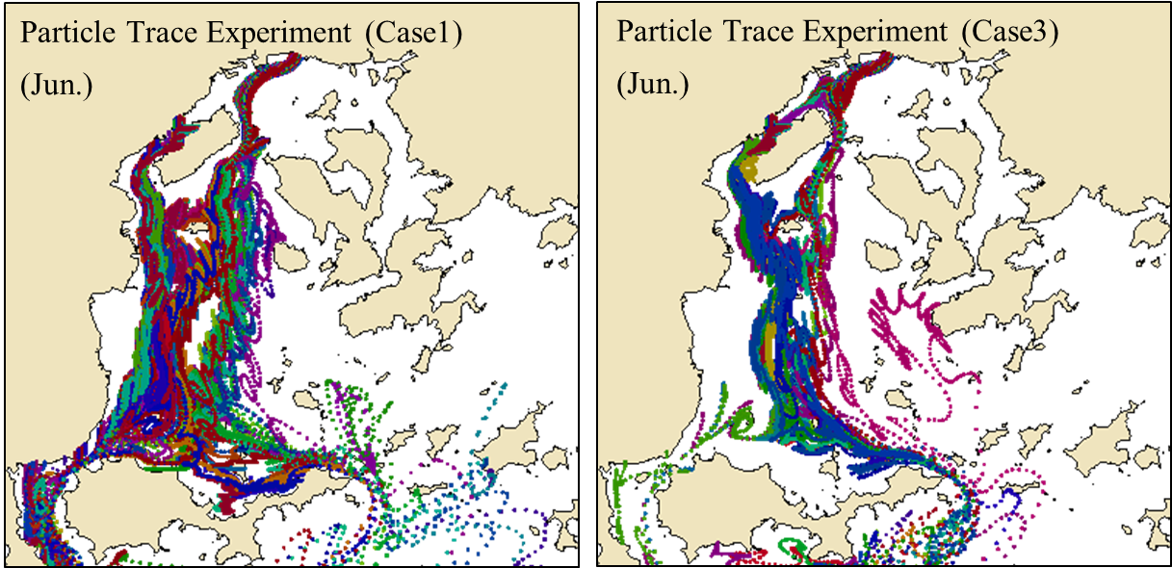

Fig. 5 Tracks of Asari larva of Case1 and of Case3 in June.

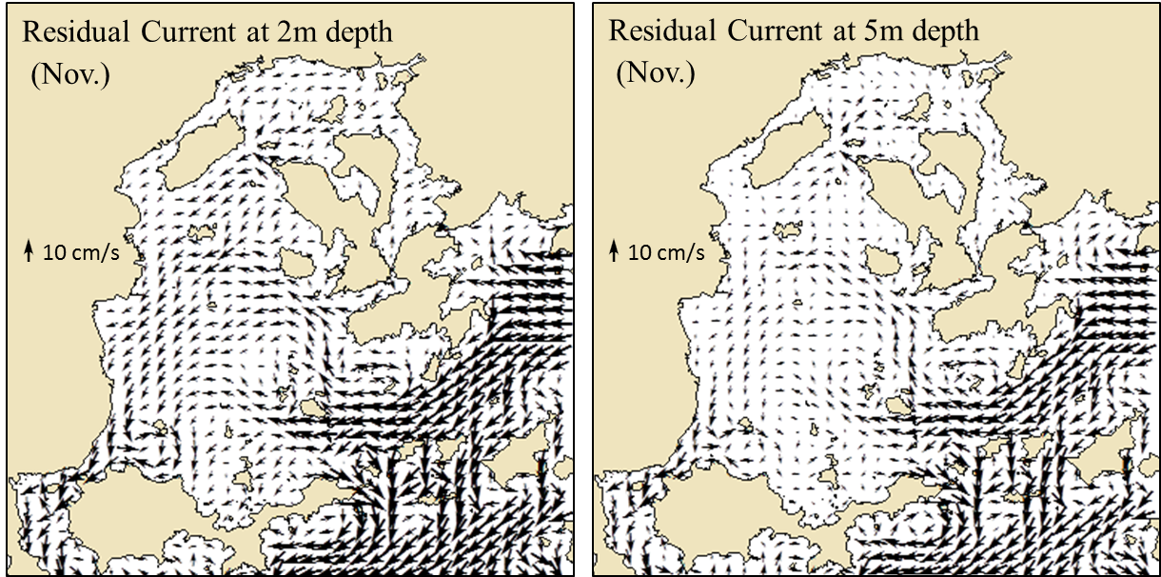

Fig. 6 Distribution of residual current at 2m depth and at 5m depth in November.

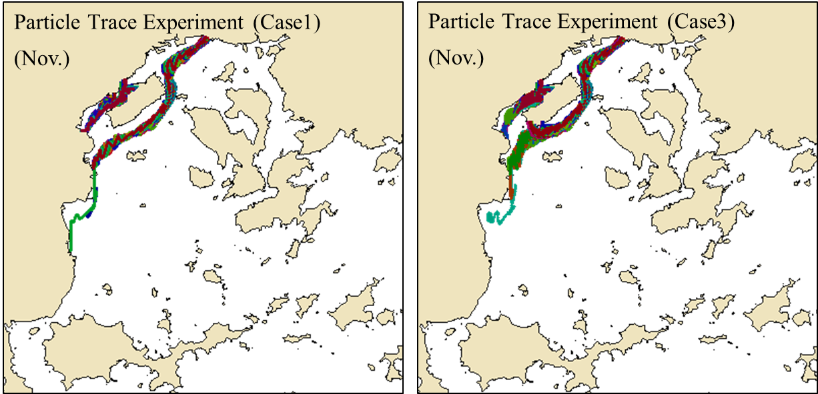

Fig. 7 Tracks of Asari larva of Case1 and of Case3 in November.

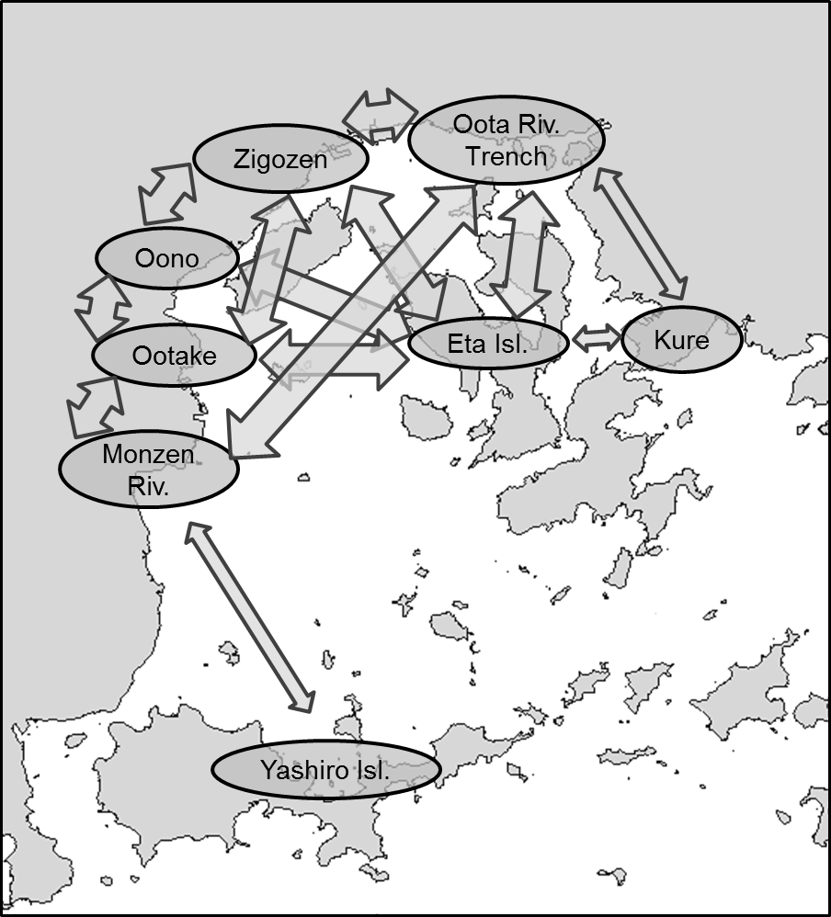

Fig. 8 Close relative relation of Asari clam in Hiroshima Bay.

(after Hamaguchi, 2013 **[3]**)

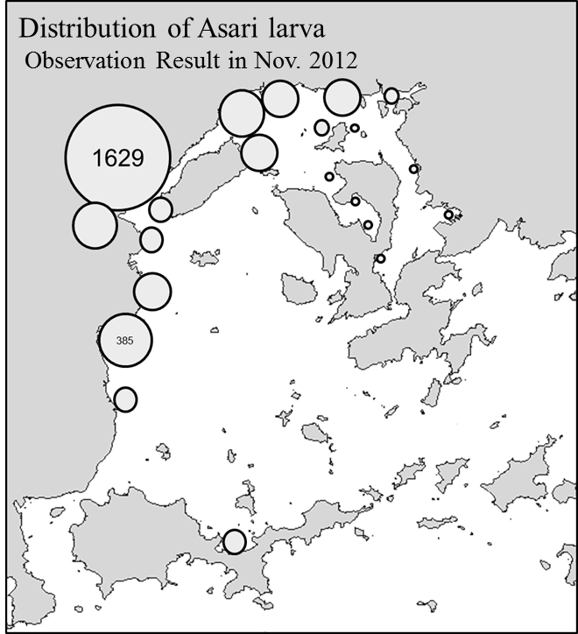

Fig. 9 Distribution of Asari larva in November 2012. (after Hamaguchi, 2013 **[3]**)

IV. Discussion and conclusion

In this chapter, we discuss why the production area of Asari clam is limited only in the northern part of Hiroshima Bay. As a result of the larva trace experiments in Hiroshima Bay, the larvae are transported to southward in the western part of the bay by the density current in June. On the other hand, the larvae are transported to the west, and do not extend to the south in November. Fig. 10 shows the density of the larva in spring and in autumn at the coast of Oono in 2012 (Hamaguchi, 2013 **[3]**). The density of the larva in June is very low than that in November. This fact suggest that, the production of the larva has not occurred so much in June, although that has occurred in November in Hiroshima Bay. This tendency continues still (private letter). Therefore, if the same phenomenon is repeated in the Hiroshima Bay recently, it is considered that the production of Asari clam is limited in the northern area of the bay because the density of the larva is low in June when the larvae can extend to the south. However, the cause of low density of the larva in June is unknown, although it is expected that the nutrients are insufficient. This problem will be continuously examined.

Hamaguchi et al (2005) [4] suggests that the habitat connectivity derived from both the larval dynamics by numerical model experiment and the molecular analysis play a very important role to sustainable fisheries production or the conservation of marine ecosystem. Method in this paper that is comparative study of the numerical model experiment of planktonic larva and the biological sampling analysis (like molecular analysis) of marine animal, will increase importance for the management of the ecosystem in near future.

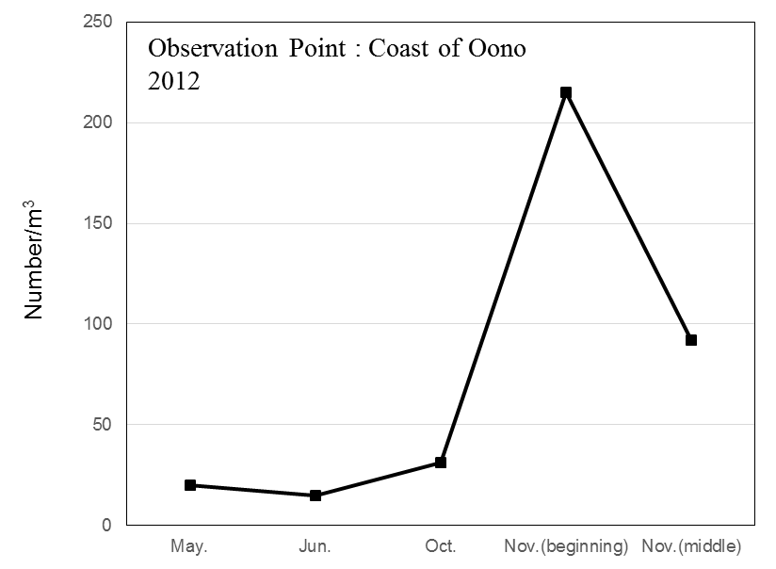

Fig. 10 Density of Asari larva at coast of Oono in 2012.

(after Hamaguchi, 2013 **[3]**)

V. Acknowledgment

Authors express their sincere thanks to Prof. T. Fujii of Japan International Research Center for Agricultural Sciences and Dr. A. Ito of Nat. Res. Inst. of Fisheries and Environment of Inland Sea for their helpful suggestions. This study is a part of the project study of Agriculture, Forestry and Fisheries Research Council "Techniques for sustainable development of coastal fishing by the restoration of ecological network” (Project manager: Prof. H. Sudo of Fisheries Research Agency).

VI. References

[1] Mellor, G. L. “Users Guide for A Three-Dimensional, Primitive Equation, Numerical Ocean Model”, Program in Atmospheric and Ocean Sciences, Princeton University, 1998.

[2] Japan Coast Guard, “Tidal Harmonic Constants Table – Japanese Coast”, 1992.

[3] Hamaguchi, M. “Progress report for project study of Agriculture, Forestry and Fisheries Research Council. -Techniques for sustainable development of coastal fishing by the restoration of ecological network-” 2013. (in Japanese)

[4]　Hamaguchi, M., Nagai, S., and Yasuda, N. “New methods to analyze meta-population dynamics. Gekkan Kaiyo, 37, 125-132, 2005. (in Japanese)