**Suspended matter concentration alongside**

**the northern coastline of Kaliningrad region**

**(South-Eastern part of THE Baltic Sea)**

***Ekaterina Bubnova, Immanuel Kant Baltic Federal University, Kaliningrad, Nevskogo str., 14,*** [***bubnova.kat@gmail.com***](mailto:bubnova.kat@gmail.com)

***Victor Krechik, Immanuel Kant Baltic Federal University, Kaliningrad, Nevskogo str., 14,*** [***myemail.gav@gmail.com***](mailto:myemail.gav@gmail.com)

***Vadim Sivkov, Immanuel Kant Baltic Federal University, Kaliningrad, Nevskogo str., 14,*** [***sivkov@kaliningrad.ru***](mailto:sivkov@kaliningrad.ru)

**Abstract. South-Eastern part of the Baltic Sea undergoes strong man-caused impact due to high level of shore usage. Suspended matter is an important carrying agent for pollutants. The Kaliningrad region has both the abrasion shore (Sambian peninsula) and the massive accumulative body (Curonian Spit), which is World Heritage site. The interannual and seasonal distribution of suspended matter concentration along the northern shore of Kaliningrad region against the hydrological conditions were studied. The research was made on five-year (2011-2015) monthly (April - October) data-array, consisting of surface and bottom water samplings. Two types of interannual and seasonal distribution of suspended matter concentration (SMC) revealed: Sambian type is defined by vertical gradient of SMC with descending of concentration from surface to bottom, while Curonian type – by horizontal gradient of latter.**

*Key words: suspended matter, coastal zone, the Baltic Sea*

1. INTRODUCTION

In recent times, the coastal zone of the Baltic Sea to the north of the Kaliningrad region of the Russian Federation (fig. 1) increasingly used for commercial purposes (e.g. waterworks building, recreation, fishery, oil exploration, etc.). At the same time, it is directly adjacent to the Curonian Spit which is a UNESCO natural and cultural heritage. Thus, there are increasing risks of negative impacts of marine natural management on the environment and growing urgency of research in this sea area.

Suspended in seawater mineral and organic particles (suspended matter) significantly affect the intensity of chemical elements migration, especially in the "coastal barrier zone" [1] where suspended matter concentration (SMC) is significantly higher than in the open sea. Therefore, suspended matter is one of the essential parameters of the marine environmental quality.

Suspended matter in the open part of the Baltic Sea is in a focus of research from 1960s [2], [3], [4]. However, the coastal zone, being so important for humanity, still remains insufficiently explored. Data on the suspended matter in the Gdansk Basin of the Baltic Sea obtained during the semicentennial period of research characterize mainly open sea. Coastal erosion by wave action – is the main source of suspended matter in the studied area [5]. The vast majority of river discharge settles in Curonian and Vistula lagoons; atmosphere aerosols can be neglected. Studies on suspended matter in the coastal zone adjacent to the Kaliningrad Region are rare and fragmentary [5], [6], [7].

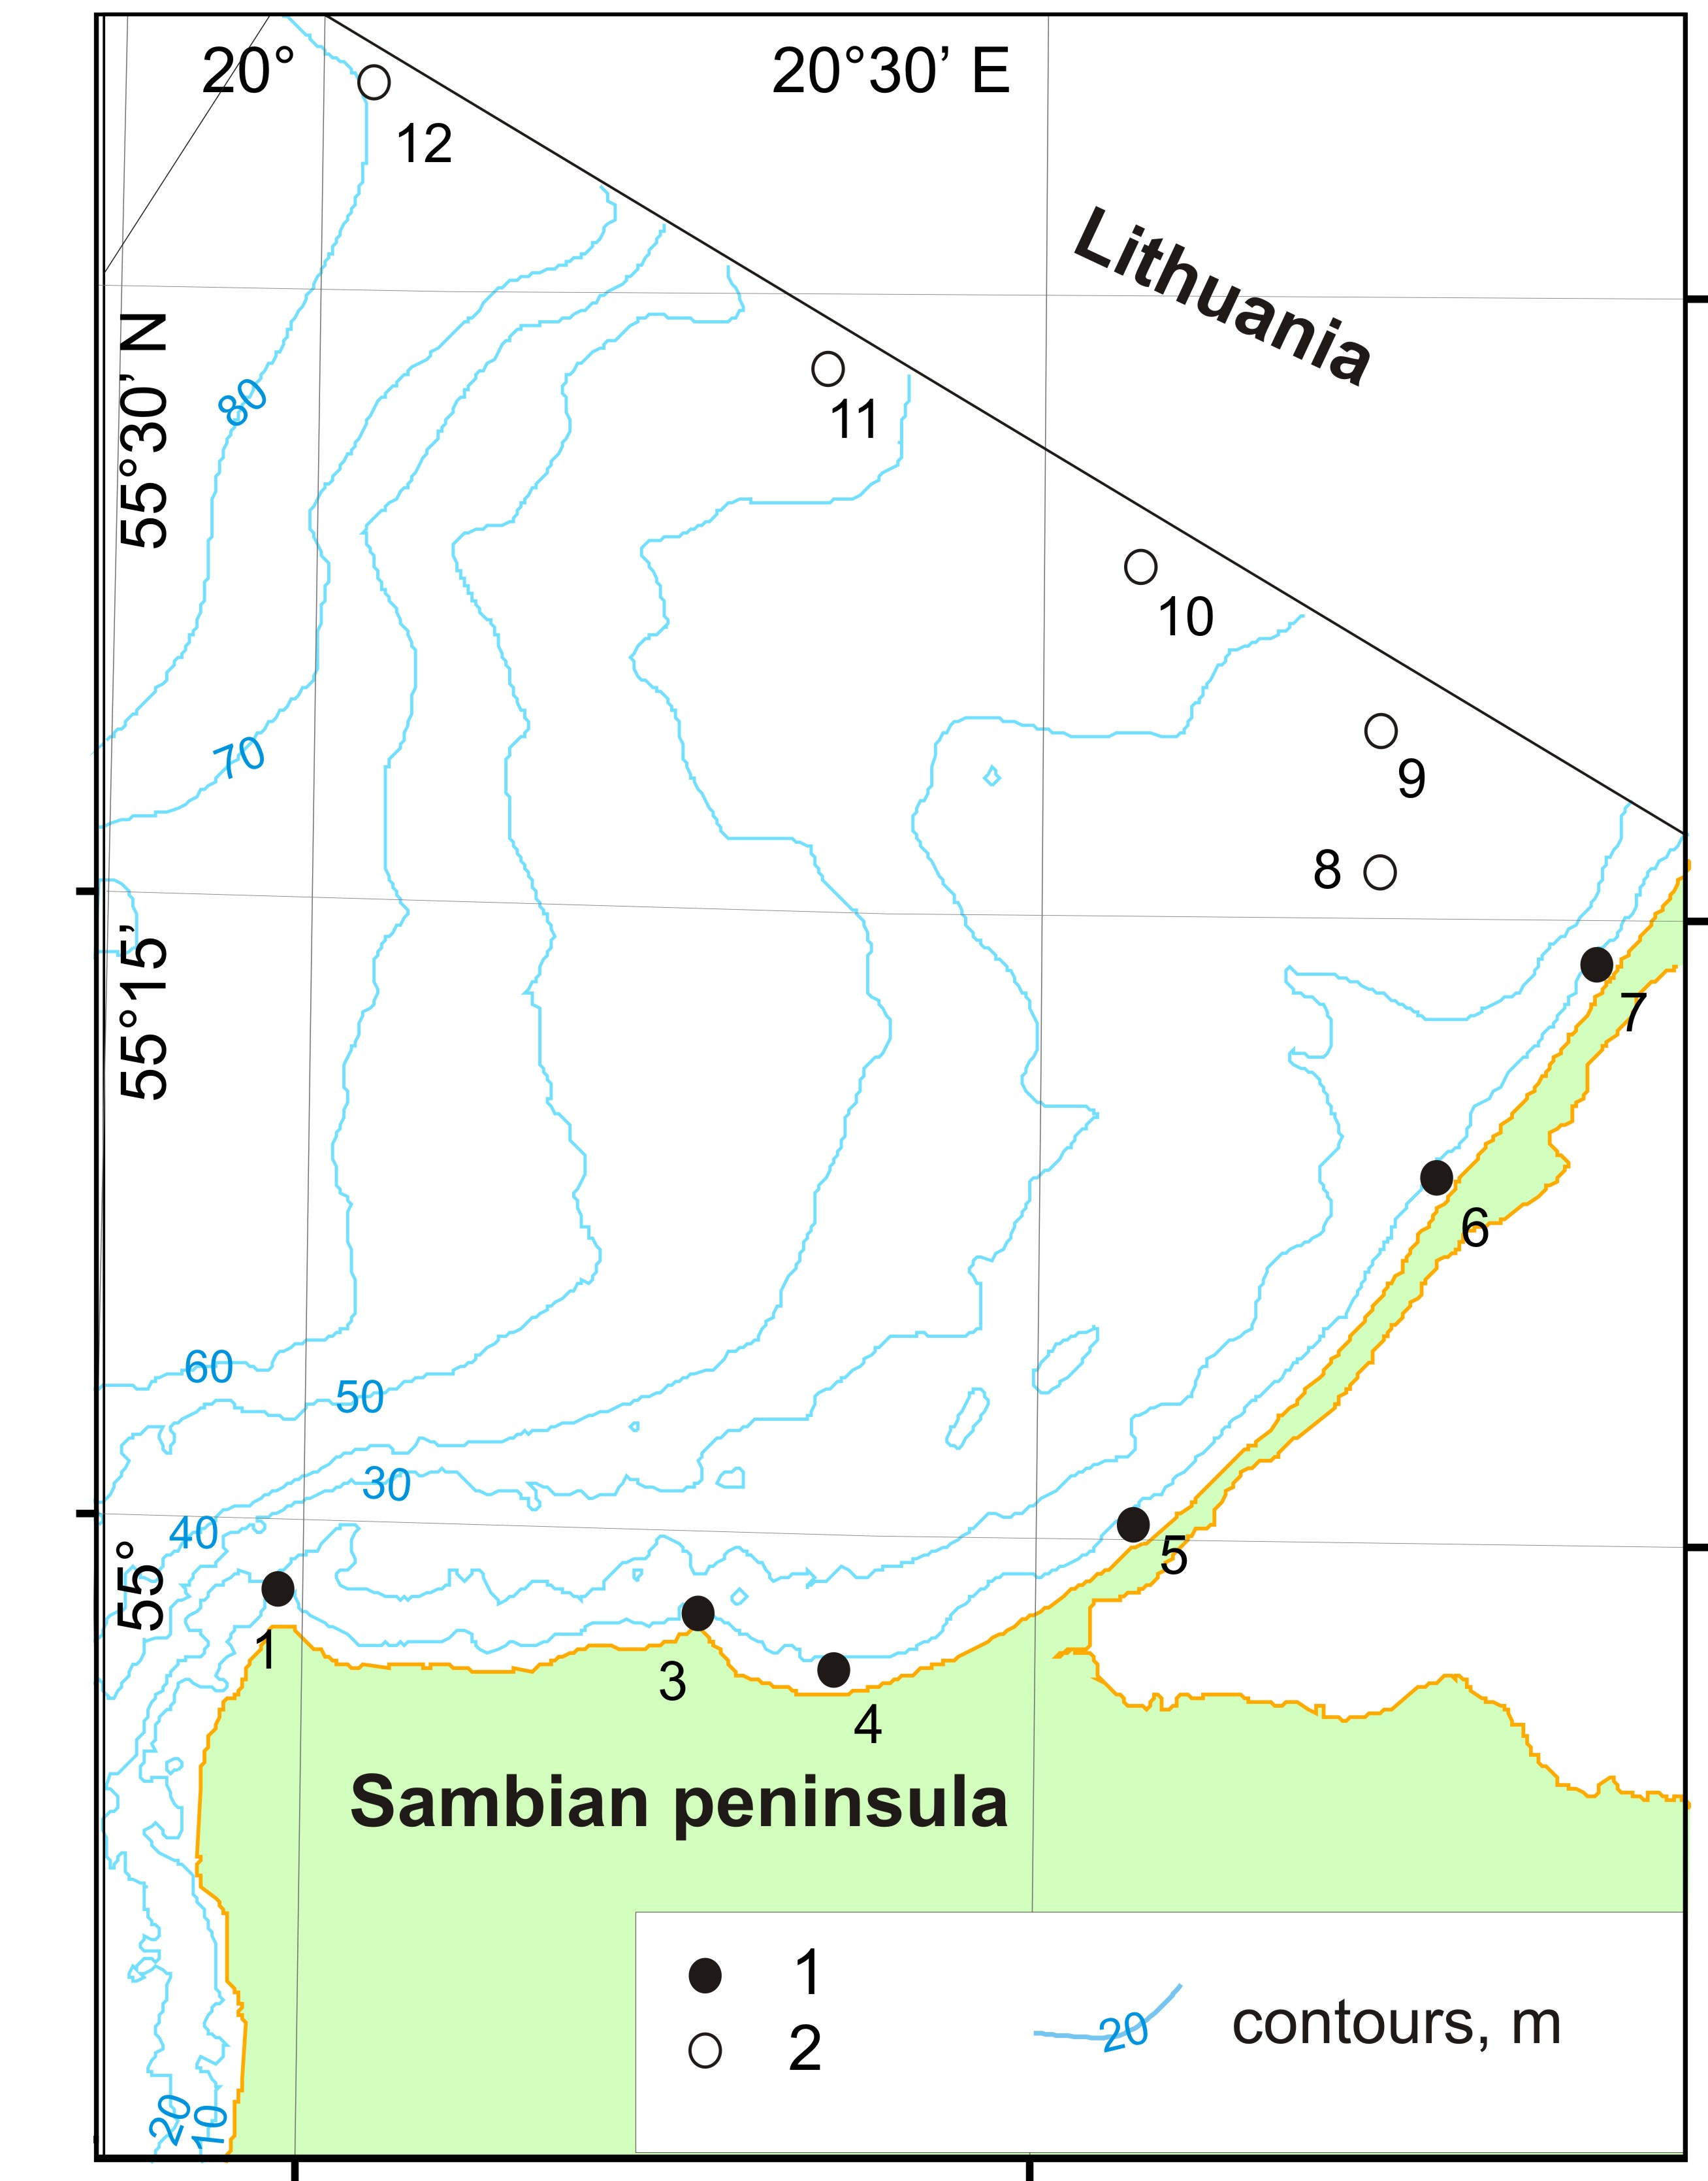

*Fig. 1. Study area and location of stationary survey points (black dots with numbers indices of LUKOIL-KMN, Ltd. environmental monitoring points). 1 – studied alongshore points; 2 – lateral profile points of suspended matter concentration [after 8]*

The aim of the present work is to summarize data on SMC obtained over the last years from northern coast of the Kaliningrad region as part of operational environmental monitoring of the marine oil production carried out by LUKOIL-KMN, Ltd.

1. MATHERIAL AND METHODS

The research was done on 5-year (2011-2015) monthly data-array, collected within spring-summer season (April to October) (fig. 1). The whole route length was about 70 km – from cape Taran to Lithuanian border. The sampling was made coastwise to the north from Kaliningrad peninsula and Curonian spit. As a result, 6 points (stations) with 2-horizonts (surface and sub-bottom) were complete. Suspended matter was then separated from water samples by the mean of pressurized ultrafiltration with a use of previously weighted nuclear filters (0.45 µm membrane diameter) to determine concentration. Interannual and seasonal averaged SMC data were calculated. The simultaneous vertical CTD-profiling (Idronaut 316 probe) was made at all 6 route points, so water density averaged sections can be plotted.

The transition from individual profiling series to the averaged seasonal profiles was performed with the method of layer-by-layer median filtering [9]. The key point of the approach is to calculate the median value for a layer with arbitrary thickness (in this study this parameter was taken as 1m).

1. RESULTS AND DISCUSSION

In general, alongshore distributions of both annual averaged surface and near-bottom SMC demonstrate similarity (fig. 2). However, surface SMC is higher than near-bottom, and annual variations are more contrast. During entire period, increased SMC values with maximum in st. 4 were recorded at the Sambian peninsula, while decreased values with minimum in st. 7 (close to Lithuanian border) were found at the middle of the Curonian Spit. Anyway, annual variability of SMC is quite high. Highest annual averaged SMC along almost whole investigated coastal zone were recorded in the 2015.

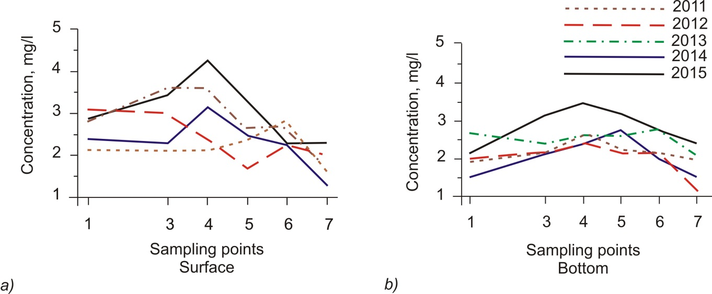

*Fig. 2. Annual averaged suspended matter concentration at stationary survey points of monitoring along northern coast of Kaliningrad Region: a) surface layer, b) near-bottom layer.*

Data discussed here are agree with previously obtained results [8]. Maximal values within both near-bottom and surface layers were localized near eastern part of the northern coast of the Sambian Peninsula (fig. 3). However, our data demonstrate that SMC maximum moved to the east – from st. 3 (near Pionerskiy harbor) to st. 4. Anyway, this evidence do not contradict an opinion that adjacent coastal area and underwater coastal slope are the main sources of suspended matter for whole considered coastal area.

The main features of the spatial distribution of suspended matter in the interannual time scale are clearly visible on the lateral profile along theLithuanian border (fig. 4, after [8]). Seaward, coastal concentration maximum of the suspended matter transforms into subsurface “tail” with the thickness 10-15 m which is visible at a distance of 50 km from the coast. Near-bottom maximum is located close to center of the Gdansk Basin beginning from a depth 50-60 m.

Our finding complete previous beliefs about suspended matter distribution in the studied area on the alongshore profiles. Interannual averaged and seasonal SMC data are shown on the hydrological section (fig. 5). For regional hydrological conditions the period from January to March is meant winter, April-June – the spring, July to September – the summer, October-December – autumn [10]. Therefore, there are two full seasons (spring and summer) and October during the time of observation.

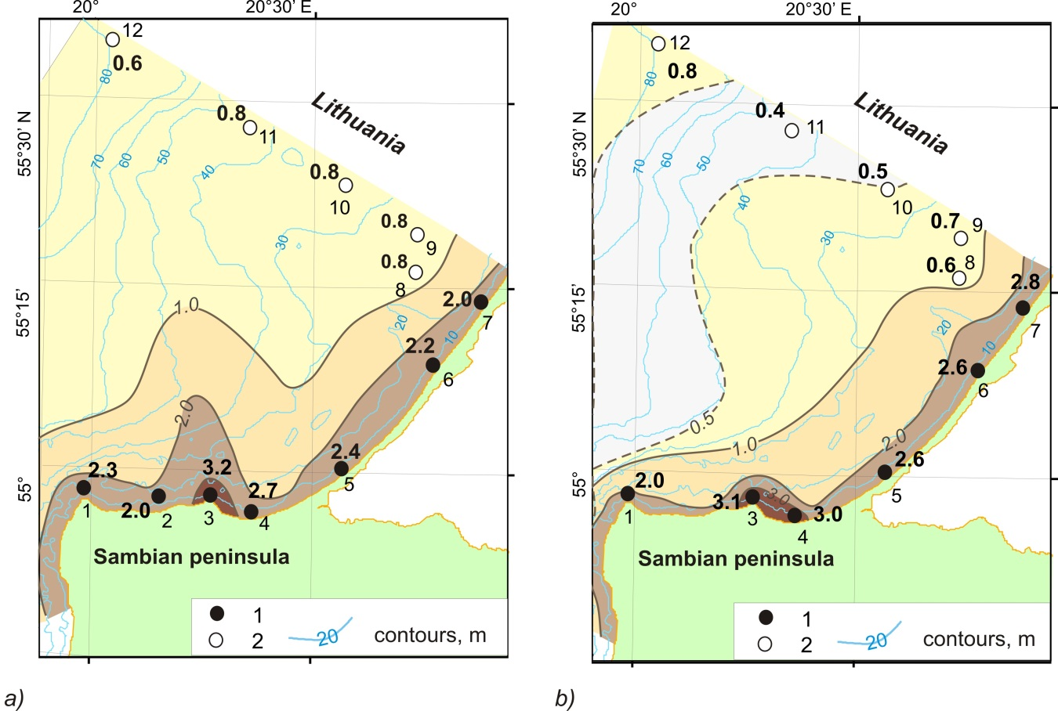

*Fig. 3. Interannual averaged (2003-2008) surface suspended matter concentration (mg/l):*

*a) surface layer (0-1 m); b) near-bottom layer (1-2 m from the sea bottom); 1 – studied alongshore points; 2 – lateral profile points of suspended matter concentration (after [8])*

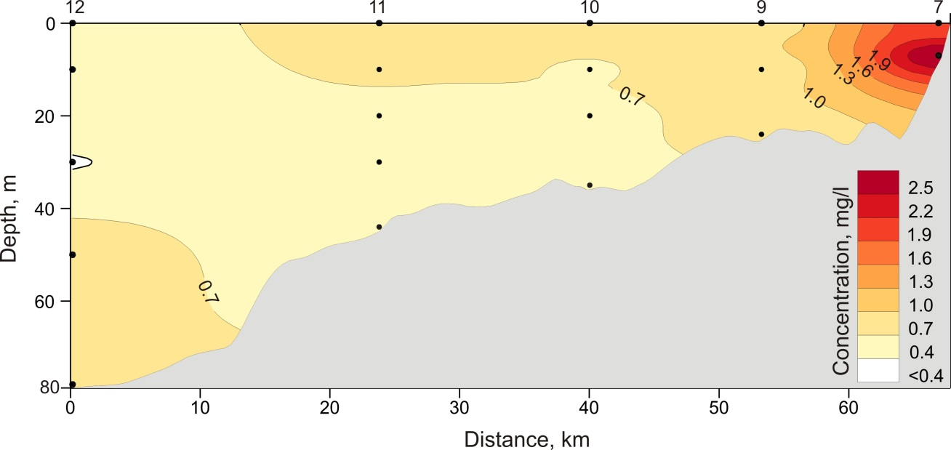

*Fig. 4. Distribution of the interannual averaged SMC on the lateral profile from middle part of Curonian Spit along the Lithuanian border (after [8])*

*(Numbers above the figure are* *LUKOIL-KMN, Ltd. monitoring points)*

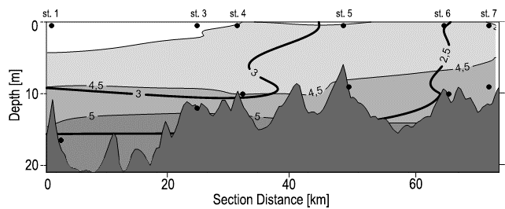

a)

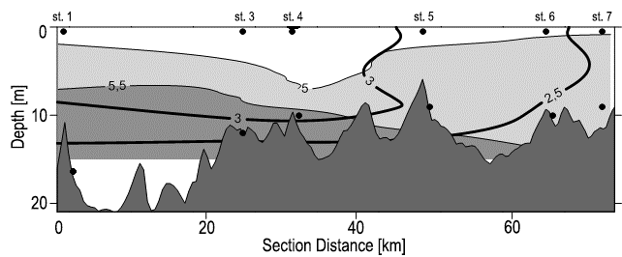

b)

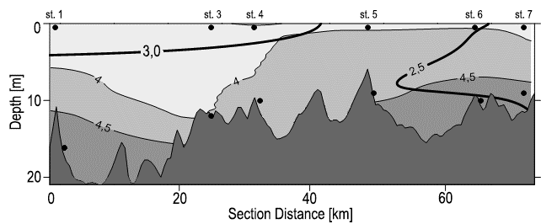

c)

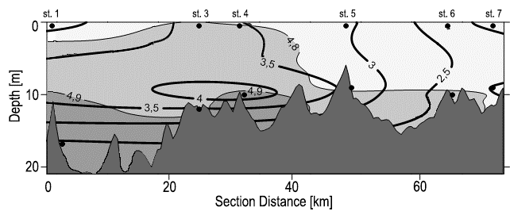

d)

*Fig. 5. Averaged SMC and in situ water density anomaly (gray gradations) alongside the northern coastline of Kaliningrad Region: a) interannual (2011-2015), b)* *spring, c) summer, d) October.*

Two types of SMC vertical distribution is revealed on interannual section:

Sambian Peninsula coastal zone is characterized by vertical stratification of SMC, while Curonian Spit coastal zone – by homogenous distribution of latter. Transition from one stratification type to another takes place near eastern part of Sambian Peninsula (between st. 4 and 5).

Vertical stratification (first type) may maintain when vertical suspended matter movements prevailed, while homogenous distribution (second type) indicate prevailing of the horizontal transport of SMC.

Interannual hydrological structure appears to be less vertically stratified over the entire section; there are no strong gradient zones which can prevent suspended matter transport.

Spring distribution of SMC follows the same pattern as interannual one, along with hydrological structure. Total summer SMC are slightly lower, than in spring. Two types of vertical suspended matter distribution are not clearly visible during summer. In autumn (October) highest SMC values are recorded (influence of beginning of the storm season). Two types of SMC distribution are clearly visible.

1. CONCLUSIONS

Two types of SMC vertical distribution is recorded on interannual and seasonal alongshore sections: Sambian Peninsula coastal zone is characterized by vertical stratification of SMC, while Curonian Spit coastal zone – by homogenous distribution of latter.

Our findings confirm that the main source of suspended matter for the northern coast area of the Kaliningrad region is located near the middle and eastern part of the northern coast of Sambian Peninsula.

1. ACKNOWLEDGEMENTS

The work was financed by the RSF grant 14-37-00047. Authors are grateful to L.D. Bashirova for language editing and help with artwork.

VI. REFERENCES

[1] E.M. Emelyanov. “Sedimentogenesis in basin of the Atlantic Ocean”, Moscow: Nauka, 1982, pp.190 (in Russian).

[2]  E.M. Emelyanov. “Geochemistry of suspended matter and bottom sediments of the Gdansk Basin and processes of sedimentation” in *Geology of the Gdansk Basin. Baltic Sea*, Kaliningrad: Yantarny skaz, 2002, pp. 220–302.

[3] E.M. Emelyanov. “Quantitative distribution of suspended matter along Kaliningrad peninsula and Curonian spit (Baltic sea)”, *Oceanological research*, no 18, 1968, pp. 203–213.

[4] V.V. Sivkov. “Suspended matter in the water”, in *Neft' i okruzhayushchaya sreda Kaliningradskoj oblasti. Tom II: More (Oil and the Environment of the Kaliningrad Region. Volume II: Sea)*, Kaliningrad: Terra Baltica, 2012, pp. 120-128.

[5] A. N. Babakov. “Dynamics of Sedimentary Substances in the Coastal Zone of the Sea”, in *Oil and the Environment of the Kaliningrad Region. Volume II: Sea*, Kaliningrad: Terra Baltica, 2012, pp. 37-59.

[6] A.B. Kozhakhmetov*,* V. M. Latschenkov. “Preliminary results of determining of background turbidity on the aggradation area of free sandy beach loads at northern coast of Sambian Peninsula”, in *Problems of geomorphology and Quaternary geology of the shelf seas,* Kaliningrad: 1989, pp. 96-99.

[7] A.I. Blazhchishin, A.N. Babakov, V.A. Tschechko. “Concentration and contamination of suspended loads of the Kaliningrad near-shore zone”, in *Problems of studying and protection of the Curonian Spit,* Kaliningrad: AB IO RAS, 1998, pp.31-58.

[8] V. Ph. Dubravin, E.V. Dorokhova, V.V. Sivkov, V.A. Smyslov, “Hydrochemical indices and suspended matter”, in *Oil and the Environment of the Kaliningrad Region. Volume II: Sea*, Kaliningrad: Terra Baltica, 2012, pp 276-291.

[9] I. M. Belkin, *Morphological and Statistical Analysis of the Ocean Stratification*, Leningrad: Gidrometeoizdat, 1991, 130 p.

[10] V. Ph. Dubravin, Zh. I. Stont, “Hydrometeorological Mode, Water Structure and Circulation,” in *Oil and the Environment of the Kaliningrad Region. Volume II: Sea*, Kaliningrad: Terra Baltica, 2012, pp. 69-105.