**KINEMATIC CHARACTERISTICS OF INTERNAL WAVES IN THE CENTRAL ATLANTIC BASED ON RESULTS 36 AND 40 CRUISE OF “AKADEMIC SERGEY VAVILOV RESEARCH VESSEL”**

***Klim Grigorenko, Institue of Arid Zones Southern Scientific Center RAS, klim\_grig@mail.ru***

***Sergei Khartiev, Southern Federal University (SFedU), khartiev@sfedu.ru***

***Alexandra Ilvitskaya, Southern Federal University (SFedU), sasha\_toyz@mail.ru***

***Anzhelika Avakova, Southern Federal University (SFedU), avakva.anzhelika@rambler.ru***

***Anna Solovieva, Institute of Arid Zones Southern Scientific Center RAS, microsol@list.ru***

Abstract. World ocean hydrodynamics has a very important influence on the global Earth’s climate [1]. In current paper comparison of internal waves forming conditions from 36-, 39- and 40-Cruise of “Akademik Sergey Vavilov” [2,3] research vessel was conducted. Atlantic ocean thermohaline structure was considered. Classification of research polygons, based on hydrology conditions differences was conducted.

Key words: internal waves, ocean expeditions, research vessels, thermohaline circulation, thermohaline structure.

It was found out, that surface layer on the stations near Dolrams and Bogdanov fracture zones has smaller salinity and higher temperature, picnocline is deeper, and has greater thickness. Because of that another internal wave hydrodynamic mode forms in comparison with stations located near Vema fracture zone (see fig.1)

I:\1\InternalWaves\2015\РФФИ_мол_нр\IGIL SO RAS\Paper\2569.tifI:\1\InternalWaves\2015\РФФИ_мол_нр\IGIL SO RAS\Paper\2577.tif

a

b

*Fig. 1. Termohaline characteristics measured in 2015: (a) station 2569*

*in the Vema FZ; (b) station 2577 in the Bogdanov fracture [4]*

Similar picture is observed near polygon Cane Gap and Romansh fracture zone in 2012. Vertical density structure on polygon Vema Channel observed in 2012 has similar to exponential vertical profile and internal waves hydrodynamic effects here differs very much from effects on another polygons (see fig.2).

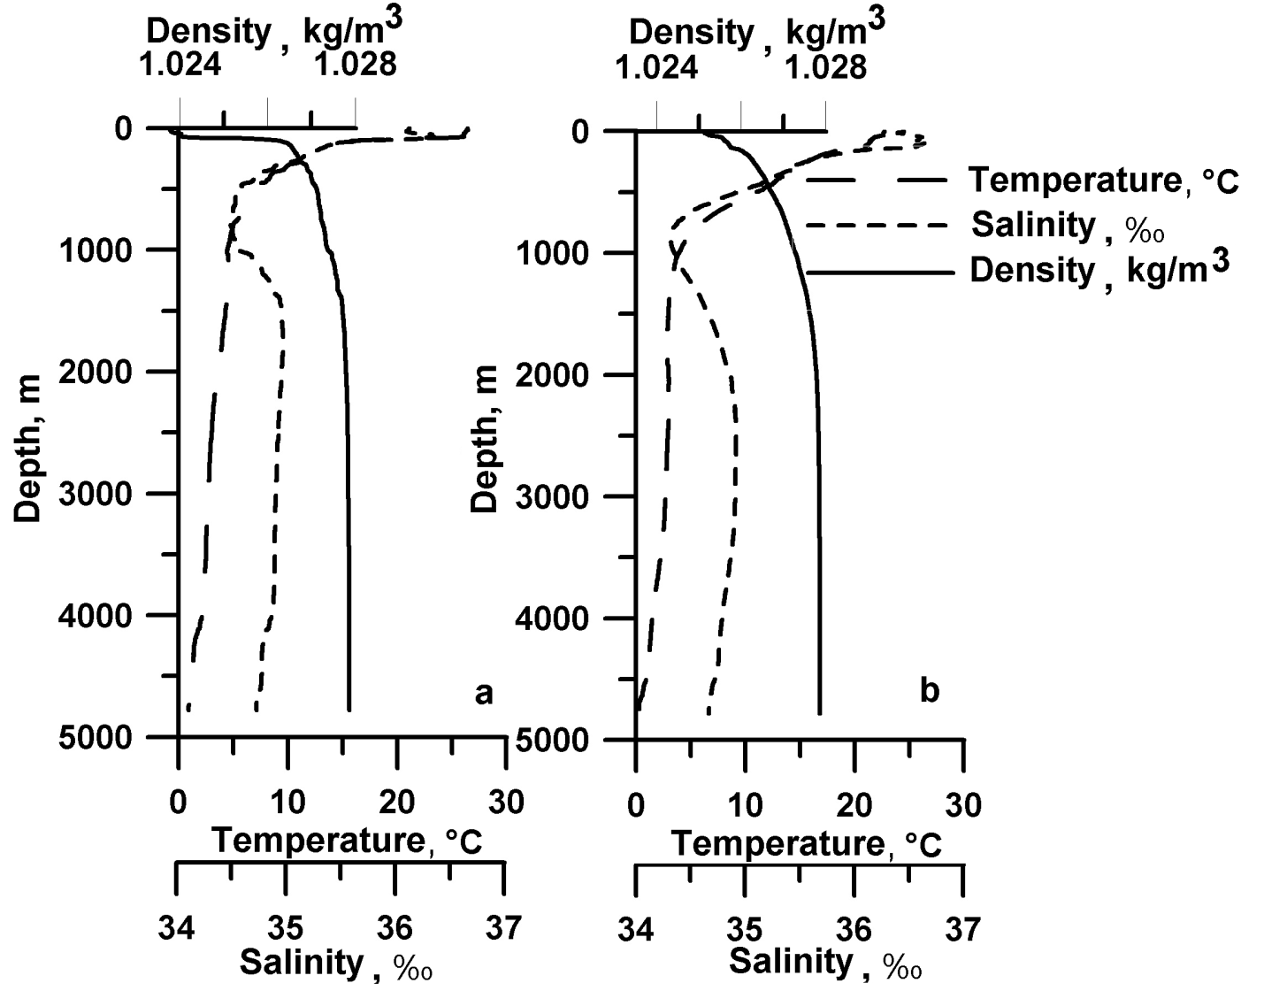

*Fig. 2. Termohaline characteristics measured in 2012: (a) station 2487*

*in the Romanch fracture zone; (b) station 2497 in the Vema Channel [2].*

Internal wave kinematic characteristics were calculated based on data from polygons Vema, Dolrums, Bogdanov and Romansh fracture zones, Cane Gap and Vema Channel, using investigated program from [5,6]. Dispersion curves were calculated. It was found out, that on the stations, where picnocline has greater thickness, greater waveway foms in high-frequency spectrum zone. Internal waves of 5 highest modes are more powerful, in other words have higher frequencies in case of the similar lengths (see fig.3).

I:\1\InternalWaves\2015\РФФИ_мол_нр\IGIL SO RAS\Paper\Dis_Cur.tif

c

b

a

*Fig. 3. Dispersive curves: (a) station 2569 in the Vema FZ (2015); (b) station 2577*

*(the Bogdanov fracture, 2015); (c) station 2551 in the Vema FZ (2014) [4].*

Internal wave kinematic characteristics in Vema Channel differs from characteristics printed on fig. 3. Brunt–Väisälä frequency maximum reaches 0,0143 Rad/s, density drop is small comparatively, drop layer expressed weakly, so internal waves forms the least powerful in comparison with the waves from another polygons (see fig.4).

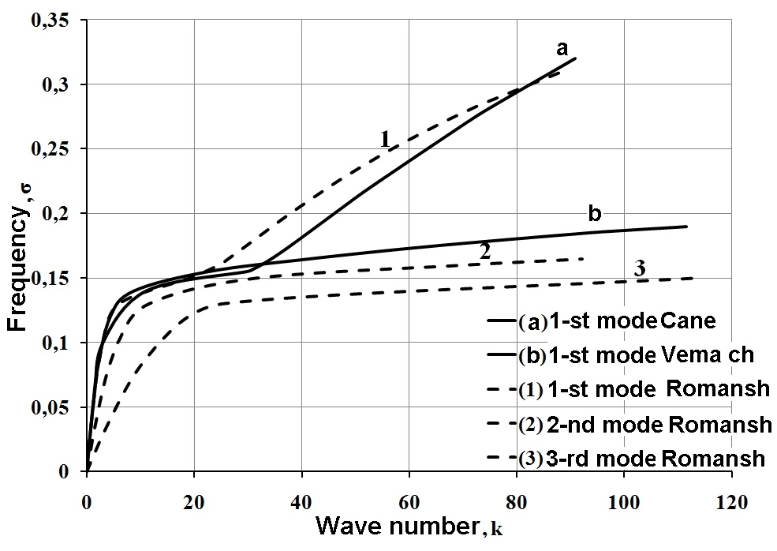

*Fig 4. Dimensionless dispersive curves calculated by data from Cane Gap (2012), Vema Channel (2012) and Western Romansh (2012) [2].*

References:

1. Morozov E.G. “Semidiurnal internal wave global field*” Deep Sea Research*, vol. 42, no. 1, pp. 135–148. 1995.
2. Grigorenko K.S., Khartiev S.M., Solovieva A.A., Ermoshkin A.V. “Kinematic characteristics of internal waves in the central Atlantic investigation according to CTD-profiling data” *Ecological Bulletin of Research Centers of the Black Sea Economic Cooperation*. Vol. 1. pp 41-50, 2015.
3. Tarakanov R.Y., Morozov E.G. “Flow of Antarctic bottom water at the output of the Vema Channel” *Oceanology*. Vol. 55. № 2. pp. 153-161. 2015.
4. K S Grigorenko, N I Makarenko, E G Morozov and R Yu Tarakanov. “Stratified flows and internal waves in the Western Central Atlantic” in press.
5. Solov'ev А.N., Khartiev S.M., Solov'eva А.А., Grigorenko K.S., Matishov D.G. “Internal gravity and sound waves characteristics investigation based on the "Arctic Climate Atlas 2004" *Bulletin SSC RAS*., vol. 6, no.1, pp. 24-32. 2010.
6. S. M. Khartiev, E. G. Morozov, K. S. Grigorenko, D. G. Matishov, A. N. Solov’eva, A. A. Solov’eva. ‘Internal Waves in a Stratified Sea with Layers of Density Inversions” *Doklady Earth Sciences*, vol. 448, no. 1, pp. 92-96. 2013.