Exp :7  Date : | IMPLEMENTATION OF PRIM’S ALGORITHM

AIM:
To implement Prim’s algorithm in C to find the Minimum Spanning Tree (MST) of a connected weighted graph.

ALGORITHM:
- Start with any vertex and mark it as visited.
- Find the minimum-weight edge connecting a visited vertex to an unvisited vertex.
- Add that edge to the Minimum Spanning Tree.
- Mark the newly selected vertex as visited.
- Repeat Steps 2–4 until all vertices are included.
- Display the selected edges and total minimum cost.

PROGRAM:
#include <stdio.h>
#define INF 999
int main()
{
int n, cost[10][10], visited[10] = {0};
int i, j, edges = 0, min, u = 0, v = 0, total = 0;
printf("Enter number of vertices: ");
scanf("%d", &n);
printf("Enter the cost adjacency matrix:\n");
for(i = 0; i < n; i++)
{
for(j = 0; j < n; j++)
{
scanf("%d", &cost[i][j]);
}
}
visited[0] = 1;
printf("Edges in Minimum Spanning Tree:\n");
while(edges < n - 1)
{
min = INF;
for(i = 0; i < n; i++)
{
if(visited[i])
{
for(j = 0; j < n; j++)
{
if(!visited[j] && cost[i][j] < min)
{
min = cost[i][j];
u = i;
v = j;
}
}
}
}
printf("%d - %d = %d\n", u, v, min);
total += min;
visited[v] = 1;
edges++;
}
printf("Minimum cost = %d\n", total);
return 0;
}

OUTPUT:
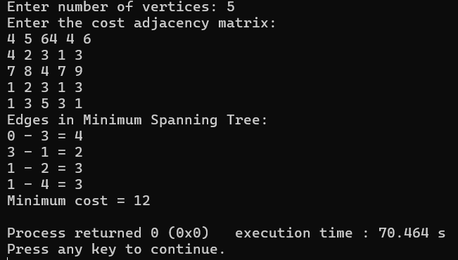

RESULT:
Thus, Prim’s algorithm was successfully implemented in C to find the Minimum Spanning Tree and its minimum cost.
Exp :8  Date : | IMPLEMENTATION OF KRUSKAL’S ALGORITHM

AIM:
To implement Kruskal’s algorithm in C to find the Minimum Spanning Tree (MST) of a connected weighted graph.

ALGORITHM:
- Read the number of vertices and edges.
- Store all edges with their source, destination and weight.
- Sort all edges in ascending order of their weights.
- Select the smallest edge.
- Check whether adding the edge creates a cycle.
- If it does not create a cycle, add the edge to the MST.
- Repeat until $V-1$edges are selected.
- Display the selected edges and total minimum cost.

PROGRAM:
#include <stdio.h>
struct Edge
{
int u, v, w;
};
int parent[10];
int find(int x)
{
while(parent[x] != x)
x = parent[x];
return x;
}
void unionSet(int a, int b)
{
parent[find(a)] = find(b);
}
int main()
{
struct Edge e[20], temp;
int n, m, i, j, count = 0, total = 0;
int a, b;
printf("Enter number of vertices: ");
scanf("%d", &n);
printf("Enter number of edges: ");
scanf("%d", &m);
printf("Enter source, destination and weight:\n");
for(i = 0; i < m; i++)
{
scanf("%d %d %d", &e[i].u, &e[i].v, &e[i].w);
}
for(i = 0; i < n; i++)
parent[i] = i;
for(i = 0; i < m - 1; i++)
{
for(j = 0; j < m - i - 1; j++)
{
if(e[j].w > e[j + 1].w)
{
temp = e[j];
e[j] = e[j + 1];
e[j + 1] = temp;
}
}
}
printf("Edges in Minimum Spanning Tree:\n");
for(i = 0; i < m && count < n - 1; i++)
{
a = find(e[i].u);
b = find(e[i].v);
if(a != b)
{
printf("%d - %d = %d\n",
e[i].u, e[i].v, e[i].w);
total += e[i].w;
unionSet(a, b);
count++;
}
}
printf("Minimum cost = %d\n", total);
return 0;
}
OUTPUT:
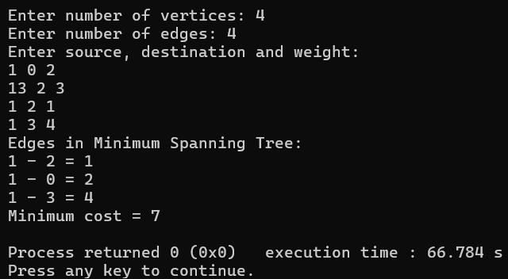

RESULT:
Thus, Kruskal’s algorithm was successfully implemented in C to find the Minimum Spanning Tree and its minimum cost.
Exp :9  Date : | IMPLEMENTATION OF DIJKSTRA’S ALGORITHM

AIM :
To implement Dijkstra's algorithm to find the shortest path from a given source vertex to all other vertices in a weighted graph using C programming.

ALGORITHM :
- Start.
- Read the number of vertices and the weighted adjacency matrix.
- Initialize the distance of the source vertex to 0 and all other vertices to INF.
- Mark all vertices as unvisited.
- Select the unvisited vertex having the minimum distance.
- Mark the selected vertex as visited.
- Update the distances of all its adjacent unvisited vertices.
The update is:
distance[v] = min(distance[v],(distance[u]+weight[u][v])
- Repeat Steps 5–7 until all vertices are visited.
- Display the shortest distance from the source vertex to every other vertex.
- Stop

PROGRAM :
#include <stdio.h>
#define MAX 10
#define INF 999
int main()
{
int graph[MAX][MAX];
int distance[MAX];
int visited[MAX];
int n, source;
int i, j;
int min, u;
printf("Enter the number of vertices: ");
scanf("%d", &n);
printf("Enter the weighted adjacency matrix:\n");
for (i = 0; i < n; i++)
{
for (j = 0; j < n; j++)
{
scanf("%d", &graph[i][j]);
if (graph[i][j] == 0 && i != j)
graph[i][j] = INF;
}
}
printf("Enter the source vertex (0 to %d): ", n - 1);
scanf("%d", &source);
for (i = 0; i < n; i++)
{
distance[i] = graph[source][i];
visited[i] = 0;
}
distance[source] = 0;
for (i = 0; i < n - 1; i++)
{
min = INF;
u = -1;
for (j = 0; j < n; j++)
{
if (!visited[j] && distance[j] < min)
{
min = distance[j];
u = j;
}
}
if (u == -1)
break;
visited[u] = 1;
for (j = 0; j < n; j++)
{
if (!visited[j] && graph[u][j] != INF && distance[u] + graph[u][j] < distance[j])
{
distance[j] = distance[u] + graph[u][j];
}
}
}
printf("\nShortest distances from vertex %d:\n", source);
for (i = 0; i < n; i++)
{
if (distance[i] == INF)
printf("To vertex %d = Not reachable\n", i);
else
printf("To vertex %d = %d\n", i, distance[i]);
}
return 0;
}

OUTPUT:
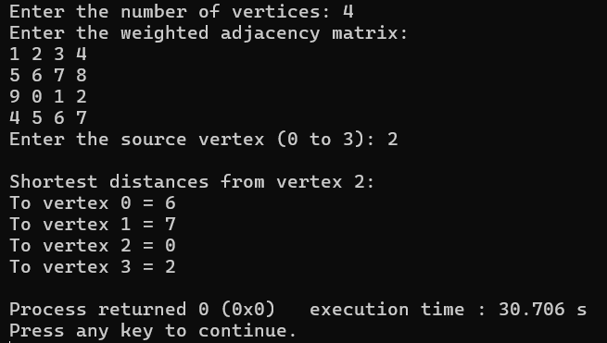

RESULT:
Thus, Dijkstra's algorithm was successfully implemented in C to find the shortest path from the given source vertex to all other vertices in the weighted graph.
Exp :10  Date : | IMPLEMENTATION OF HASHING AND COLLISION  RESISTANCE TECHNIQUES

AIM :
To implement hashing using a hash table and demonstrate collision resolution techniques such as Linear Probing and Quadratic Probing using C programming.

ALGORITHM :
A. Hashing using Linear Probing
- Start.
- Create a hash table of size m and initialize all positions as empty.
- Read the key to be inserted.
- Calculate the hash index using:
index = key % m
- If the calculated position is empty, insert the key.
- If a collision occurs, check the next position using:
index = (index+1) % m
- Continue until an empty position is found.
- Repeat the process for all keys.
- Display the hash table.
- Stop.
B. Hashing using Quadratic Probing
- Start.
- Create a hash table of size m and initialize all positions as empty.
- Read the key to be inserted.
- Calculate the hash index using:
index = key % m
- If the calculated position is empty, insert the key.
- If a collision occurs, check the next position using:
index = (hash(key) + i^2) % m
where i = 1, 2, 3, ...
- Continue until an empty position is found.
- Repeat the process for all keys.
- Display the hash table.
- Stop.

PROGRAM :
#include <stdio.h>
#define SIZE 10
int linearTable[SIZE];
int quadraticTable[SIZE];
void initialize()
{
for (int i = 0; i < SIZE; i++)
{
linearTable[i] = -1;
quadraticTable[i] = -1;
}
}
void linearProbing(int key)
{
int index = key % SIZE;
int i = 0;
while (linearTable[(index + i) % SIZE] != -1 && i < SIZE)
{
i++;
}
if (i < SIZE)
linearTable[(index + i) % SIZE] = key;
else
printf("Linear table is full!\n");
}
void quadraticProbing(int key)
{
int index = key % SIZE;
int i = 0;
while (quadraticTable[(index + i * i) % SIZE] != -1 && i < SIZE)
{
i++;
}
if (i < SIZE)
quadraticTable[(index + i * i) % SIZE] = key;
else
printf("Quadratic table is full!\n");
}
void display()
{
printf("\n--- Linear Probing ---\n");
for (int i = 0; i < SIZE; i++)
{
if (linearTable[i] == -1)
printf("Index %d : EMPTY\n", i);
else
printf("Index %d : %d\n", i, linearTable[i]);
}
printf("\n--- Quadratic Probing ---\n");
for (int i = 0; i < SIZE; i++)
{
if (quadraticTable[i] == -1)
printf("Index %d : EMPTY\n", i);
else
printf("Index %d : %d\n", i, quadraticTable[i]);
}
}
int main()
{
int n, key;
initialize();
printf("HASHING - LINEAR AND QUADRATIC PROBING\n");
printf("Enter number of keys: ");
scanf("%d", &n);
printf("Enter %d keys:\n", n);
for (int i = 0; i < n; i++)
{
scanf("%d", &key);
linearProbing(key);
quadraticProbing(key);
}
display();
return 0;
}

OUTPUT :
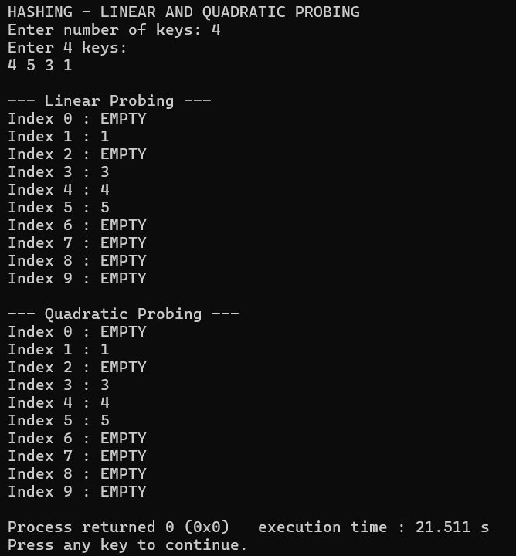
RESULT:
Thus, hashing was successfully implemented in C, and collision resolution techniques such as Linear Probing and Quadratic Probing were performed successfully.
Exp :11  Date : | IMPLEMENTATION OF HEAP

AIM :
To implement a heap data structure using C programming and perform insertion and deletion operations.

ALGORITHM :
A. Max Heap Insertion
- Start.
- Insert the new element at the end of the heap.
- Compare the element with its parent.
- If the element is greater than its parent, swap them.
- Repeat until the Max Heap property is satisfied.
- Stop.
Max Heap Property: Parent >= Children
B. Max Heap Deletion
- Start.
- Delete the root element.
- Replace the root with the last element.
- Reduce the heap size.
- Compare the root with its children.
- Swap with the larger child if required.
- Repeat until the heap property is restored.
- Stop.
C. Min Heap Insertion
- Start.
- Insert the new element at the end.
- Compare it with its parent.
- If the element is smaller than its parent, swap them.
- Repeat until the Min Heap property is satisfied.
- Stop.
Min Heap Property: Parent <= Children
D. Min Heap Deletion
- Start.
- Delete the root element.
- Replace the root with the last element.
- Reduce the heap size.
- Compare the root with its children.
- Swap with the smaller child if required.
- Repeat until the heap property is restored.
- Stop.

PROGRAM :
#include <stdio.h>
#include <stdlib.h>
typedef struct {
int *arr;
int capacity;
int size;
} MinHeap;
MinHeap* createHeap(int capacity) {
MinHeap* heap = (MinHeap*)malloc(sizeof(MinHeap));
heap->capacity = capacity;
heap->size = 0;
heap->arr = (int*)malloc(capacity * sizeof(int));
return heap;
}
int parent(int i) { return (i - 1) / 2; }
int leftChild(int i) { return (2 * i) + 1; }
int rightChild(int i) { return (2 * i) + 2; }
void swap(int *x, int *y) {
int temp = *x;
*x = *y;
*y = temp;
}
void heapifyUp(MinHeap* heap, int i) {
while (i > 0 && heap->arr[parent(i)] > heap->arr[i]) {
swap(&heap->arr[i], &heap->arr[parent(i)]);
i = parent(i);
}
}
void heapifyDown(MinHeap* heap, int i) {
int minIndex = i;
int left = leftChild(i);
int right = rightChild(i);
if (left < heap->size && heap->arr[left] < heap->arr[minIndex]) {
minIndex = left;
}
if (right < heap->size && heap->arr[right] < heap->arr[minIndex]) {
minIndex = right;
}
if (i != minIndex) {
swap(&heap->arr[i], &heap->arr[minIndex]);
heapifyDown(heap, minIndex);
}
}
void insert(MinHeap* heap, int key) {
if (heap->size == heap->capacity) {
printf("Heap Overflow: Cannot insert key\n");
return;
}
heap->arr[heap->size] = key;
heap->size++;
heapifyUp(heap, heap->size - 1);
}
int getMin(MinHeap* heap) {
if (heap->size <= 0) {
printf("Heap is empty\n");
return -1;
}
return heap->arr[0];
}
int extractMin(MinHeap* heap) {
if (heap->size <= 0) {
printf("Heap Underflow\n");
return -1;
}
int root = heap->arr[0];
heap->arr[0] = heap->arr[heap->size - 1];
heap->size--;
heapifyDown(heap, 0);
return root;
}
void printHeap(MinHeap* heap) {
for (int i = 0; i < heap->size; i++) {
printf("%d ", heap->arr[i]);
}
printf("\n");
}
void freeHeap(MinHeap* heap) {
free(heap->arr);
free(heap);
}
int main() {
MinHeap* h = createHeap(10);
insert(h, 10);
insert(h, 5);
insert(h, 20);
insert(h, 2);
printf("Heap elements: ");
printHeap(h);
printf("Minimum element: %d\n", getMin(h));
printf("Extracted min: %d\n", extractMin(h));
printf("Heap after extraction: ");
printHeap(h);
freeHeap(h);
return 0;
}
OUTPUT :
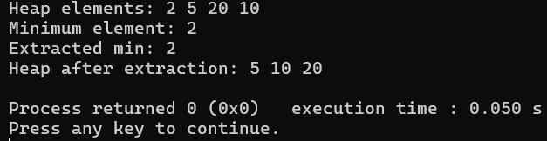

RESULT :
Thus, Max Heap and Min Heap were successfully implemented in C, and insertion, deletion, and display operations were performed successfully.
Exp :12  Date : | IMPLEMENTATION OF SORTING AND SEARCHING  TECHNIQUES

AIM :
To implement various sorting and searching techniques such as Bubble Sort, Selection Sort, Insertion Sort, Linear Search, and Binary Search using C programming.

ALGORITHM :
1. Bubble Sort
- Start.
- Read n elements into an array.
- Compare adjacent elements.
- If the first element is greater than the second, swap them.
- Repeat the process for all elements.
- Repeat the passes until the array is sorted.
- Display the sorted array.
- Stop.
2. Selection Sort
- Start.
- Read n elements.
- Find the smallest element in the unsorted portion.
- Swap it with the first element of the unsorted portion.
- Repeat until all elements are sorted.
- Display the sorted array.
- Stop.
3. Insertion Sort
- Start.
- Read n elements.
- Consider the second element as the key.
- Compare the key with the elements before it.
- Shift elements greater than the key to the right.
- Insert the key in its correct position.
- Repeat for all elements.
- Display the sorted array.
- Stop.
4. Linear Search
- Start.
- Read the array and the search element.
- Compare the search element with each array element sequentially.
- If a match is found, display its position.
- If the entire array is searched without a match, display "Element not found."
- Stop.
5. Binary Search
- Start.
- Read a sorted array and the search element.
- Set low = 0 and high = n - 1.
- Calculate:
mid = (low + high) / 2
- If array[mid] == key, the element is found.
- If key < array[mid], search the left half.
- Otherwise, search the right half.
- Repeat until the element is found or low > high.
- Stop.

PROGRAM :
#include <stdio.h>
void display(int a[], int n)
{
for (int i = 0; i < n; i++)
printf("%d ", a[i]);
printf("\n");
}
void bubbleSort(int a[], int n)
{
int i, j, temp;
for (i = 0; i < n - 1; i++)
{
for (j = 0; j < n - i - 1; j++)
{
if (a[j] > a[j + 1])
{
temp = a[j];
a[j] = a[j + 1];
a[j + 1] = temp;
}
}
}
}
void selectionSort(int a[], int n)
{
int i, j, min, temp;
for (i = 0; i < n - 1; i++)
{
min = i;
for (j = i + 1; j < n; j++)
{
if (a[j] < a[min])
min = j;
}
temp = a[i];
a[i] = a[min];
a[min] = temp;
}
}
void insertionSort(int a[], int n)
{
int i, j, key;
for (i = 1; i < n; i++)
{
key = a[i];
j = i - 1;
while (j >= 0 && a[j] > key)
{
a[j + 1] = a[j];
j--;
}
a[j + 1] = key;
}
}
int linearSearch(int a[], int n, int key)
{
for (int i = 0; i < n; i++)
{
if (a[i] == key)
return i;
}
return -1;
}
int binarySearch(int a[], int n, int key)
{
int low = 0;
int high = n - 1;
while (low <= high)
{
int mid = low + (high - low) / 2;
if (a[mid] == key)
return mid;
else if (key < a[mid])
high = mid - 1;
else
low = mid + 1;
}
return -1;
}
int main()
{
int a[100], b[100], c[100];
int n, key, position;
printf("Enter number of elements: ");
scanf("%d", &n);
printf("Enter the elements:\n");
for (int i = 0; i < n; i++)
{
scanf("%d", &a[i]);
b[i] = a[i];
c[i] = a[i];
}
bubbleSort(a, n);
printf("\nBubble Sort: ");
display(a, n);
selectionSort(b, n);
printf("Selection Sort: ");
display(b, n);
insertionSort(c, n);
printf("Insertion Sort: ");
display(c, n);
printf("\nEnter element to search: ");
scanf("%d", &key);
position = linearSearch(a, n, key);
if (position != -1)
printf("Linear Search: Element found at position %d\n", position + 1);
else
printf("Linear Search: Element not found\n");
position = binarySearch(a, n, key);
if (position != -1)
printf("Binary Search: Element found at position %d\n", position + 1);
else
printf("Binary Search: Element not found\n");
return 0;
}

OUTPUT :
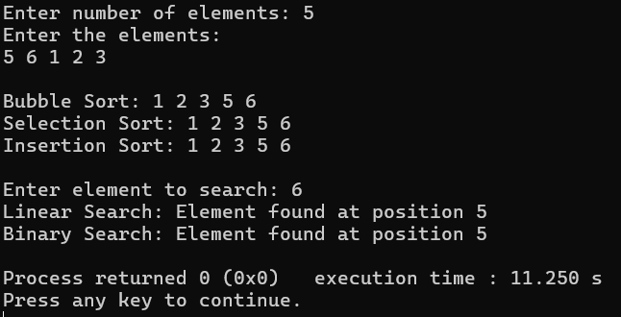

RESULT :
Thus, the sorting techniques namely Bubble Sort, Selection Sort and Insertion Sort, and the searching techniques namely Linear Search and Binary Search were successfully implemented in C programming.

