Step1:
Open Keil uVision5 app.

Step2:
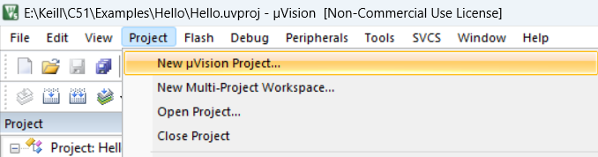
Step3:
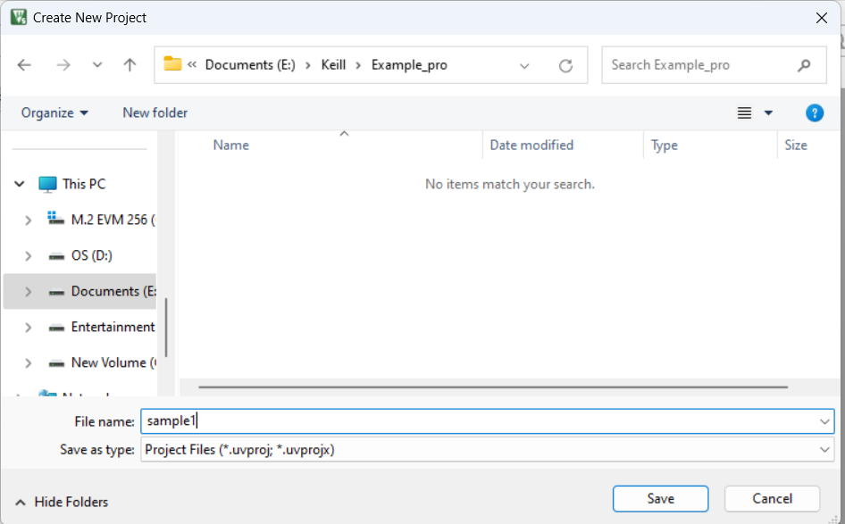

Step4:
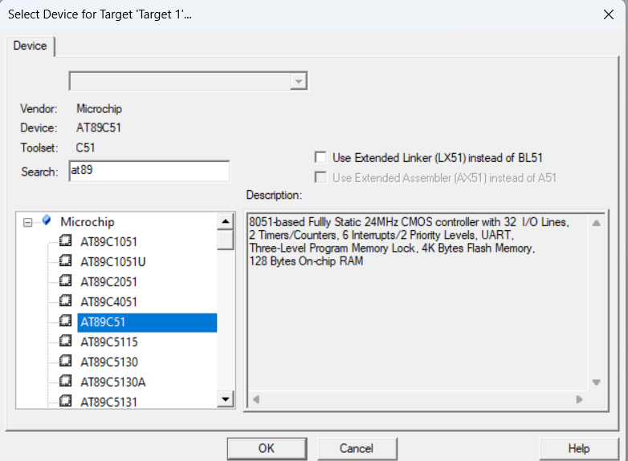
Step5:

Step6:
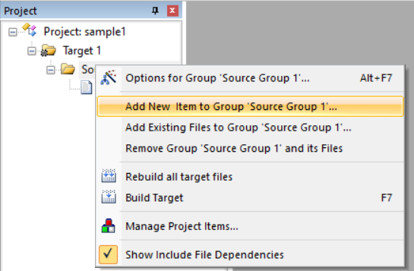

Step7:
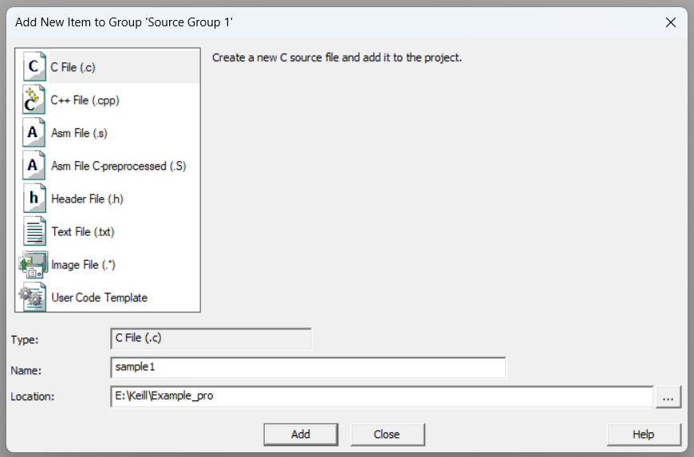
Step8:
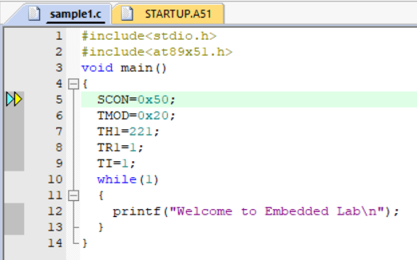
Step9:
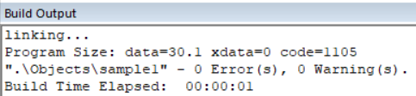

Step10:
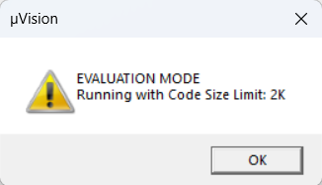
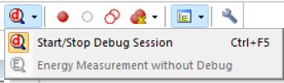
Step11:
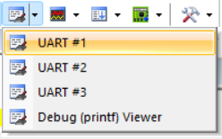
Step12:
Click run button.
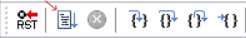
Step13:
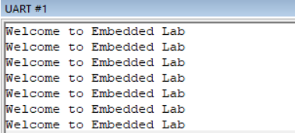
Step14:
Click stop button.
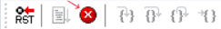

2 a.) Output:

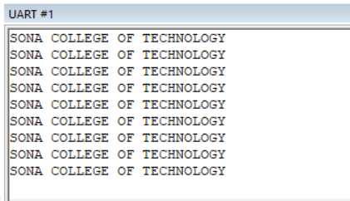

2 b.) Output:

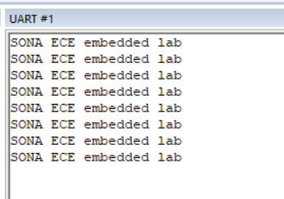

2 a.) Write a program to display the character:
“SONA COLLEGE OF TECHNOLOGY”
    - Display in the monitor.
    - Use the UART channel.
Program:
#include<stdio.h>
#include<at89x51.h>
void main()
{
SCON=0x50;
TMOD=0x20;
TH1=221;
TR1=1;
TI=1;
while(1)
{
printf("SONA COLLEGE OF TECHNOLOGY\n");
}
}

2 b.) Write the program to display the character:
“SONA ECE embedded lab”
- Display in the monitor.
- Use the UART channel.
Program:
#include<stdio.h>
#include<at89x51.h>
void main()
{
SCON=0x50;
TMOD=0x20;
TH1=221;
TR1=1;
TI=1;
while(1)
{
printf("SONA ECE embedded lab\n");
}
}

3 b.) Output:

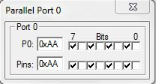

3 c.) Output:

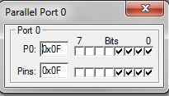

3 b.) Design a program to glow alternate LED’S in the above hardware.

Program:

#include<stdio.h>
#include<at89x51.h>
void main()
{
while(1)
{
P0=0xAA;
}
}

3 c.) Design a program to glow LSB LED’S in the above hardware.

Program:

#include<stdio.h>
#include<at89x51.h>
void main()
{
while(1)
{
P0=0x0F;
}
}

3 d.) Output:

At first time cycle
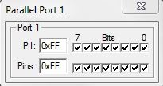

At second time cycle
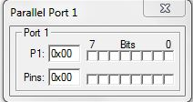

3 d.) Design a program to turn on & turn off the LED’S with time delay.

Program:

#include<stdio.h>
#include<at89x51.h>
void delay();
void main()
{
while(1)
{
P0=0xFF;
delay();
P1=0x00;
delay();
}
}
void delay()
{
int i,j;
for(i=0;i<20;i++)
{
for(j=0;j<10000;j++)
{
}
}
}

3 e.) Output:

At first time cycle
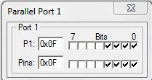

At second time cycle
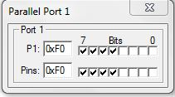

3 e.) Design a program to turn on & turn off LSB and MSB alternatively in the above hardware.

Program:

#include<stdio.h>
#include<at89x51.h>
void delay();
void main()
{
while(1)
{
P0=0x0F;
delay();
P1=0xF0;
delay();
}
}
void delay()
{
int i,j;
for(i=0;i<100;i++)
{
for(j=0;j<100;j++)
{
}
}
}

4 b i.) Output:
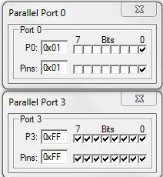
- b ii.) Output:
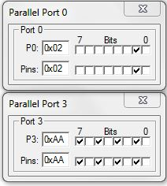
4 b iii.) Output:
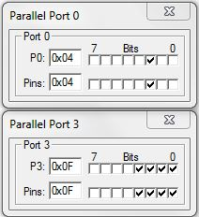
4 b iv.) Output:
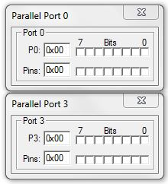

4 b.) Design a program for the following requirements:
- Switch 1 is ON
- All the LED’S must glow.
- Switch 2 is ON
- Alternate LED’S must glow.
- Switch 1 and 2 is ON
- LSB LED glows and MSB is OFF
- Both Switch is OFF
- Switch OFF all LED’s.

Program:

#include<stdio.h>
#include<at89x51.h>
void main()
{
while(1)
{
if(P0_0==1)
{
P3=0xFF;
}
else if(P0_1==2)
{
P3=0xAA;
}
else if(P0_2==3)
{
P3=0x0F;
}
else if(P0_3==0)
{
P3=0x00;
}
}
}

4 c i.) Output:

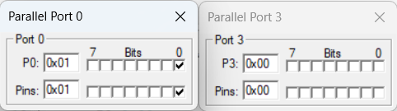

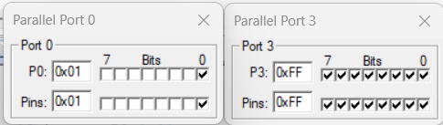

4 c ii.) Output:

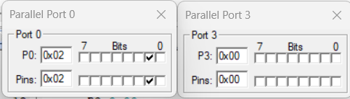

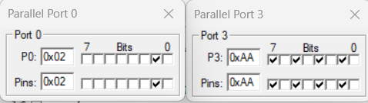

4 c.) Design a program for the following requirement:
- Switch 1 is ON
- All the LED’s must glow with time delay.
- Switch 2 is ON
- Alternate LED’s must glow with time delay.

Program:
#include<stdio.h>
#include<at89x51.h>
void delay();
void main()
{
while(1)
{
if(P0_0==1)
{
P3=0xFF;
delay();
P3=0x00;
delay();
}
else if(P0_1==2)
{
P3=0xAA;
delay();
P3=0x00;
delay();
}
}
}
void delay()
{
int i,j;
for(i=0;i<20;i++)
{
for(j=0;j<1000;j++)
{
}
}
}

4 d i.) Output:
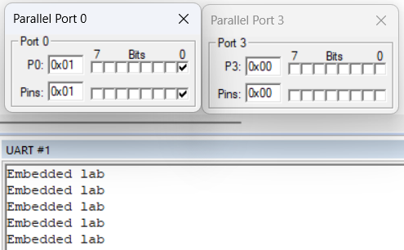
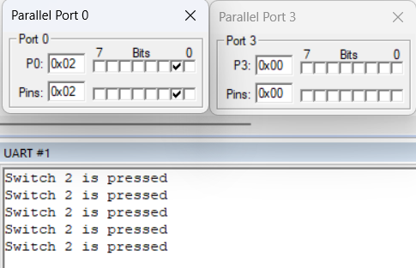
4 d ii.) Output:
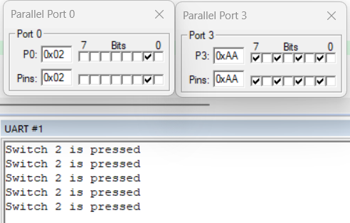
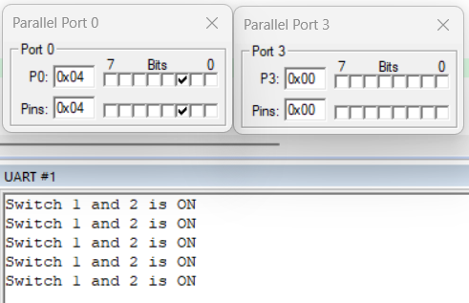
4 d iii.) Output:
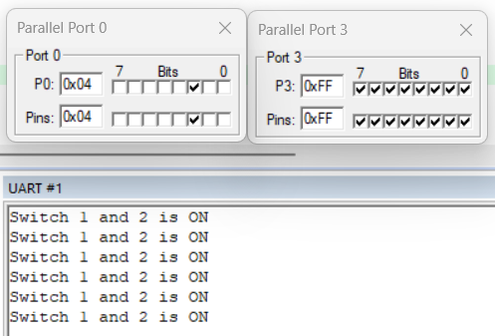

4 d.) Design a program for the following requirement:
- Switch 1 is ON
- Display the Word “Embedded Lab”.
- Switch 2 is ON
- Alternate LED’s must glow with time delay and Display
“Switch 2 is pressed”.
- Both the Switches are ON
- All the LED’s ON and OFF with time delay and Display
“Switch 1 and 2 ON”.
Program:

#include<stdio.h>
#include<at89x51.h>
void delay();
void main()
{
SCON=0x50;
TMOD=0x20;
TH1=221;
TR1=1;
TI=1;

while(1)
{
if(P0_0==1)
{
printf("Embedded lab\n");
}

else if(P0_1==2)
{
printf("Switch 2 is pressed\n");
P3=0xAA;
delay();
P3=0x00;
delay();
}
else if(P0_2==3)
{
printf("Switch 1 and 2 is ON\n");
P3=0xFF;
delay();
P3=0x00;
delay();
}
}

}
void delay()
{
int i,j;
for(i=0;i<20;i++)
{
for(j=0;j<1000;j++)
{
}
}
}

- b.) Output:

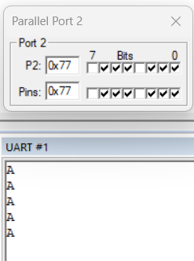

- c.) Output:

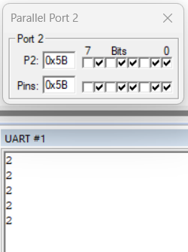

- b.) To design a program to display the character ‘A’ using 7-segment display and 89C51.
Program:
#include<stdio.h>
#include<at89x51.h>
void main()
{
SCON=0X50;
TMOD=0X20;
TH1=221;
TR1=1;
TI=1;
while(1)
{
P2=0x77;
printf("A\n");
}
}

5 c.) To design a program to display any single digit numeric number using 7-segment display and 89C51.

Program:

#include<stdio.h>
#include<at89x51.h>
void main()
{
SCON=0X50;
TMOD=0X20;
TH1=221;
TR1=1;
TI=1;
while(1)
{
P2=0x5B;
printf("2\n");
}
}

- d.) Output:

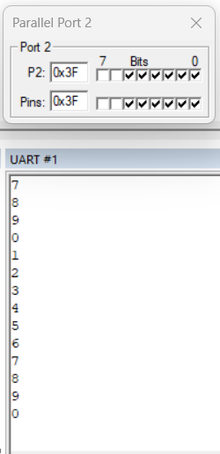

- d.) To design a program to display the counter value.
The values start from 0 to 9.

Program:

#include<stdio.h>
#include<at89x51.h>
void delay();
void main()
{
SCON=0X50;
TMOD=0X20;
TH1=221;
TR1=1;
TI=1;
while(1)
{
P2=0x3F;
printf("0\n");
delay();
P2=0x06;
printf("1\n");
delay();
P2=0x5B;
printf("2\n");
delay();
P2=0x4F;
printf("3\n");
delay();
P2=0x66;
printf("4\n");
delay();
P2=0x6D;
printf("5\n");
delay();
P2=0x7D;
printf("6\n");
delay();
P2=0x07;
printf("7\n");
delay();
P2=0x7F;
printf("8\n");
delay();
P2=0x6F;
printf("9\n");
delay();

}

}
void delay()
{
int i,j;
for(i=0;i<2000;i++)
{
for(j=0;j<2000;j++)
{

}
}
}

