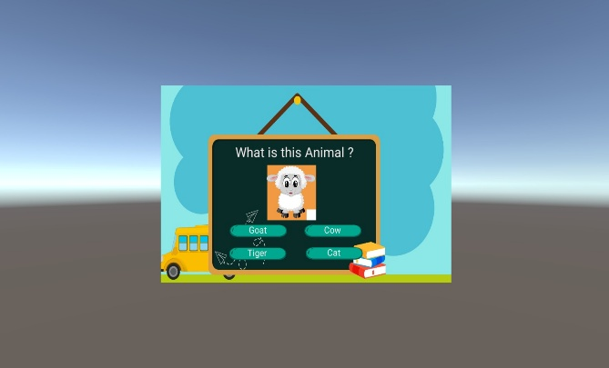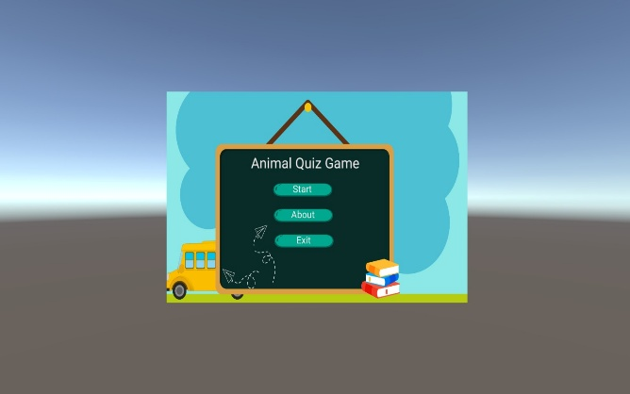

STEP1: START THE QUIZ STEP2: ANSWER THE QUESTION

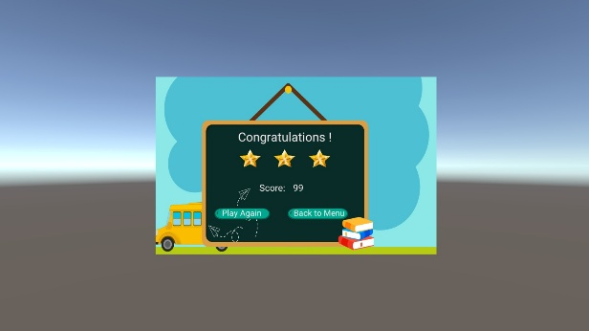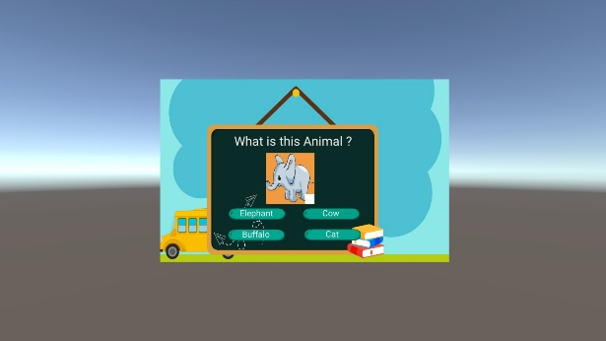

STEP 3: ANSWER THE FOLLOWING QUESTIONS STEP 4: EXAMINATION OF RESULTS