AFFILIATED TO
VEER NARMAD SOUTH GUJARAT UNIVERSITY, SURAT
PROJECT REPORT
AS A PARTIAL REQUIREMENT FOR THE DEGREE OF
BACHELOR OF COMPUTER APPLICATIONS (BCA)
BCA SEM V
A.Y. 2026-27
PROJECT REPORT ON
“ONLINE LIBRARY MANAGEMENT SYSTEM”
Submitted By
Name: ______________________________
Exam No.: __________________________
Roll No.: ___________________________
Project Guide: ______________________________

Acknowledgement
The successful completion of the Online Library Management System required guidance, support and encouragement from many people. We are grateful to the management, Principal, IQAC coordinator, Head of the BCA Department, project guide and teaching staff of SDJ International College, Vesu, for providing the academic environment and direction required to complete this project.
We sincerely thank our project guide for valuable suggestions during requirement analysis, design, implementation and testing. We also thank the teaching and non-teaching staff of the IT Department for their timely support. Finally, we thank our classmates, friends and family members for their encouragement and feedback.

Student Name (Exam Seat Number): ______________________________
Student Name (Exam Seat Number): ______________________________
Student Name (Exam Seat Number): ______________________________

Declaration
We hereby declare that the project entitled “Online Library Management System” is submitted as a partial requirement for the Bachelor of Computer Applications (BCA), Semester V, A.Y. 2026-27. The project is developed for academic purposes using PHP, MySQL, HTML, CSS, JavaScript, jQuery and AJAX.
Particular | Details
Project Title | Online Library Management System
Course | BCA
Semester | V
Academic Year | 2026-27
University | Veer Narmad South Gujarat University, Surat
Front End | HTML, CSS, JavaScript, jQuery, AJAX
Back End | PHP 7.x / 8.x
Database | library_db (MySQL / MariaDB)
Server | XAMPP (Apache + MySQL)
Application Type | Web-based library management system with book issue, return and book selling

Student Signature: ______________________ Date: ______________

I N D E X – BCA – REG
Sr. No. | Description | Page
1 | Introduction | 5
1.1 | Project Description | 5
1.2 | Project Profile | 6
2 | Environment Description | 7
2.1 | Hardware and Software Requirements | 7
2.2 | Technologies Used | 8
3 | System Analysis and Planning | 9
3.1 | Existing System and Drawbacks | 9
3.2 | Feasibility Study | 10
3.3 | Requirement Gathering and Analysis | 11
4 | Proposed System | 12
4.1 | Scope | 12
4.2 | Project Modules | 13
4.3 | Module Objectives / Functionalities / Constraints | 14
5 | Detail Planning | 15
5.1 | DFD / UML – Use Case & Activity Flow | 15
5.2 | Process Specification | 19
5.3 | Entity-Relationship Diagram | 24
6 | System Design | 26
6.1 | Database Design | 26
6.2 | User Interface | 33
7 | Software Testing & Test Cases | 41
8 | Future Scope of Enhancements | 47
9 | References | 49
10 | Appendix | 50

1 Introduction

1.1 Project Description
The Online Library Management System is a web-based application that manages the daily work of a college library. It keeps records of books, categories, authors and students in one MySQL database, and it replaces paper registers with simple web pages.
The student side supports registration (a unique Student ID is generated), login, viewing the listed books with cover pictures, checking issued books with their return date and time, updating the profile, and changing or recovering the password. Students can also buy their own copy of a book from the built-in Book Store using a cart and checkout.
The admin side provides a dashboard and full management of categories, authors and books, issuing a book to a student, updating return details with fine, searching a student by Student ID, and processing book orders.
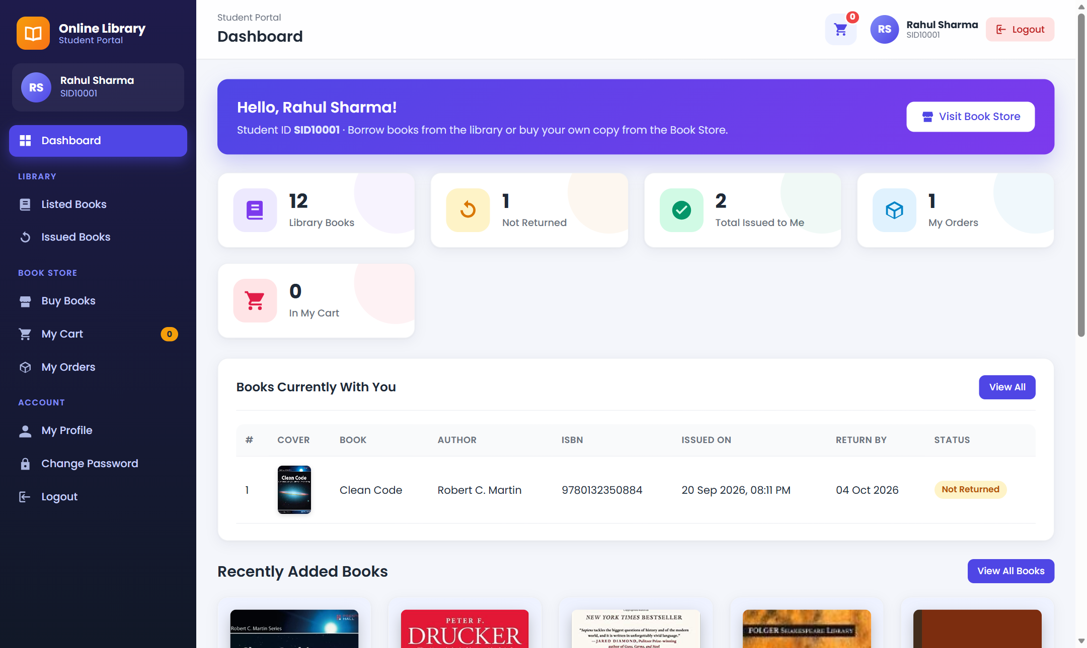
Figure 1.1: Student dashboard of the Online Library Management System

1 Introduction

1.2 Project Profile
The project is named Online Library Management System. It has two main modules, Student and Admin, and an additional Book Store (book selling) module. The fine for a late return is Rs. 5 per day and the default issue period is 14 days.
The project database is named library_db. The local URL is http://localhost/library/ for students and http://localhost/library/admin/ for the administrator. Demo accounts are provided for testing only and should be changed before any public use.
Item | Details
Project Name | Online Library Management System
Modules | Student, Admin, Book Store
Database | library_db (9 tables)
Student URL | http://localhost/library/
Admin URL | http://localhost/library/admin/
Fine / Issue period | Rs. 5 per late day / 14 days
Payment options (Book Store) | Cash on Delivery, Pay at Library Counter
Supported Browsers | Google Chrome, Mozilla Firefox, Microsoft Edge, Opera

2 Environment Description

2.1 Hardware and Software Requirements
The application runs on a normal computer that can run a local web server, PHP and MySQL. A computer with 4 GB RAM is enough for development, while 8 GB is better when the editor, browser and server run together.
Type | Minimum Requirement
Processor | Intel Core i3 or equivalent
RAM | 4 GB (8 GB recommended)
Hard Disk | 1 GB free space for XAMPP and project
Operating System | Windows 10 / Windows 11 (also Linux / macOS)
Server Software | XAMPP / WAMP / MAMP / LAMP (any one)
PHP | PHP 7.x or PHP 8.x
Database | MySQL / MariaDB with phpMyAdmin
Browser | Chrome, Firefox, Edge or Opera
Editor | Visual Studio Code or any code editor

2 Environment Description

2.2 Technologies Used
PHP is used for server-side processing, sessions, login and database work. The MySQLi extension with prepared statements connects PHP to MySQL, and passwords are stored using bcrypt hashing (password_hash).
HTML and CSS build the pages, and JavaScript with jQuery adds interactivity. AJAX is used for live book search, student and book lookup on the Issue Book page, student search, and cart updates without reloading the page.
Technology | Use in the Project
HTML5 / CSS3 | Page structure, responsive layout, sidebar, cards
JavaScript / jQuery | Menus, form checks, cart actions, image preview
AJAX | Live search, student/book lookup, cart update
PHP | Business logic, sessions, file upload, validation
MySQL / MariaDB | Stores books, students, issues, carts and orders
XAMPP | Apache web server + MySQL + phpMyAdmin

3 System Analysis and Planning

3.1 Existing System and its Drawbacks
In a manual library, the librarian writes book issue and return details in registers. Students must visit the library to know which books are available, and fines are calculated by hand.
- Searching for a book or a student record takes a lot of time.
- Registers can be lost, damaged or filled with mistakes.
- Students cannot check their issued books or return dates from home.
- Late fines are calculated manually and may be wrong.
- There is no easy way for students to buy a copy of a book.
The Online Library Management System solves these problems with a central database and separate Student and Admin panels. It is an academic project for digitalising a college library.

3 System Analysis and Planning

3.2 Feasibility Study
Technical feasibility: The system uses common and free technologies (PHP, MySQL, HTML, CSS, JavaScript) and runs on a local XAMPP server.
Economic feasibility: All development tools are open source, so there is no software cost. It also saves paper and staff time.
Operational feasibility: The pages are simple, with clear menus for students and the admin. Very little training is needed.
Schedule feasibility: The project is divided into small modules (authentication, books, issue/return, book store), so it can be completed within the semester.

3 System Analysis and Planning

3.3 Requirement Gathering and Analysis
Requirements were collected from the college library working process and the given project list.
Functional requirements: student registration with Student ID, login, password recovery, listed books, issued books with return date-time, profile update and change password. Admin requirements are category, author and book management, issue and return of books, student search and details, and change password.
Additional requirements: book cover pictures, a Book Store where students can buy books through a cart and checkout, and order processing by the admin.
Non-functional requirements: secure passwords, fast pages, simple design, and support for all modern browsers.

4 Proposed System

4.1 Scope
The scope covers the full library process from student registration to book issue, return and fine. Book records include name, category, author, ISBN, price, copies for sale and a cover picture.
The system also covers a small Book Store: cart records, orders, order items, stock control and order status (Pending, Confirmed, Dispatched, Delivered, Cancelled). Online card payment is not part of the scope.

4 Proposed System

4.2 Project Modules
Major modules are: Student, Admin, Book Store and Common/System.
- Student: register, login/logout, forgot password, dashboard, listed books, issued books, my profile, change password.
- Admin: dashboard, categories, authors, books (with picture), issue book, manage issued books, return with fine, registered students, search student, change password.
- Book Store: buy books, cart, checkout, my orders, cancel order (student) and book orders management (admin).
- Common/System: database connection, sessions, helper functions, AJAX endpoints and layout.

4 Proposed System

4.3 Module Objectives / Functionalities / Constraints
The student module gives students a simple way to find books and track what they have borrowed. The admin module puts all library control in one place. The Book Store module lets students buy books without visiting the shop.
Module | Objective | Constraint
Student | Self-service access to books and issue history | Login required; blocked students cannot log in
Admin | Manage catalogue, issues, returns, students | Only admin can access admin pages
Issue / Return | Track loans and fines | A book can be issued to only one student at a time
Book Store | Sell copies of books | Cannot buy more than stock or 5 copies of one book

Payment in the Book Store is Cash on Delivery or Pay at Library Counter. It is not a live online banking or card gateway.

5 Detail Planning

5.1 DFD / UML – Use Case & Activity Flow
The high-level flow contains Student, Admin, the web application and the MySQL database. Requests from students and the admin are processed by PHP pages and stored in MySQL.
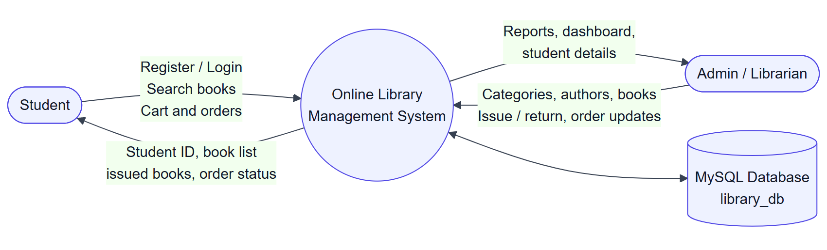
Figure 5.1: Context level (Level 0) Data Flow Diagram
The Level 1 DFD below shows the main processes and the tables each one uses.
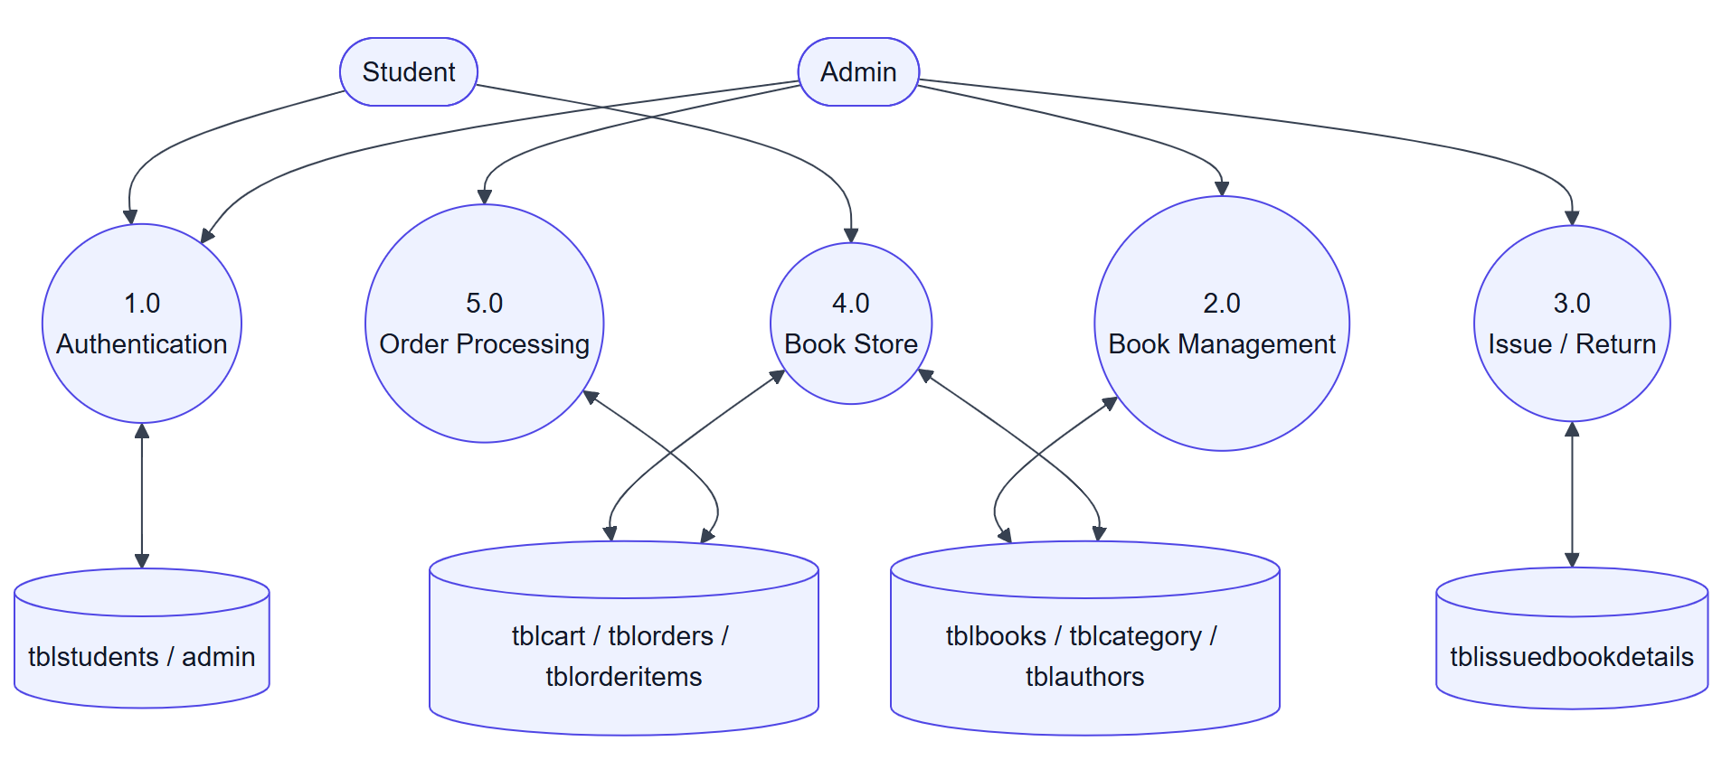
Figure 5.2: Level 1 Data Flow Diagram

5 Detail Planning

5.1 Use Case Diagram
Students and the admin use different parts of the system. Both can log in and recover or change the password.
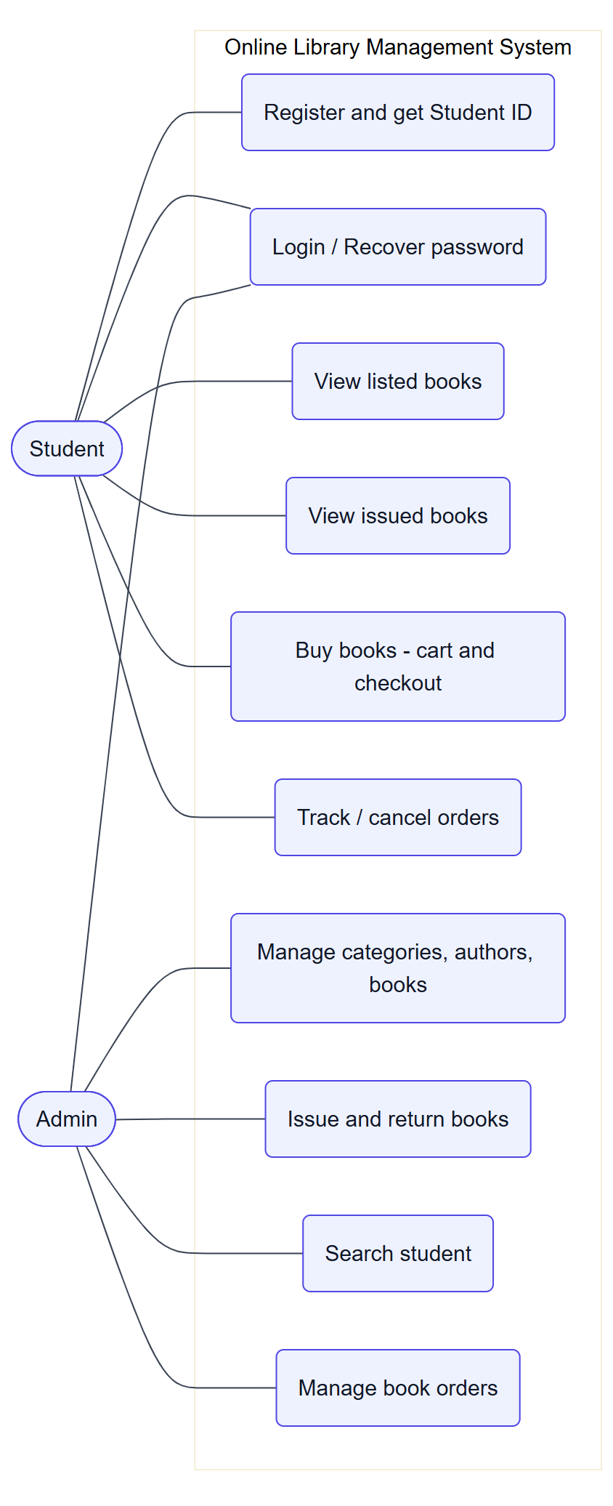
Figure 5.3: Use case diagram

5 Detail Planning

5.1.1 Student Activity Flow
Student opens the website → registers (gets Student ID) or logs in → opens the dashboard → views listed books or issued books → buys books through Buy Books → adds to cart → checks out → order is placed.
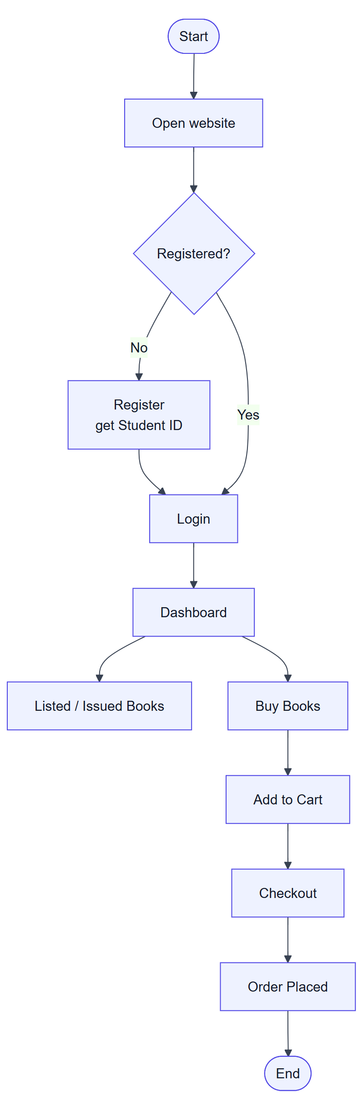
Figure 5.4: Student activity diagram

5 Detail Planning

5.1.2 Admin Activity Flow
Admin logs in → opens dashboard → manages categories, authors and books → issues a book to a student → marks the book as returned with fine → processes book orders (confirm, dispatch, deliver or cancel).
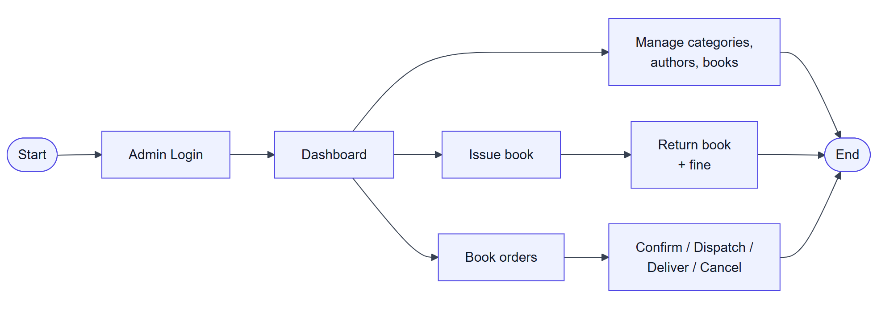
Figure 5.5: Admin activity diagram

5 Detail Planning

5.2 Process Specification

5.2.1 Process Specification – Authentication
Registration creates a student record with a unique Student ID (for example SID10001). Login checks the Student ID or email and password and creates a session. The admin has a separate login page. Logout ends the session.
Forgot password checks the registered email and mobile number and lets the student set a new password. All passwords are stored as bcrypt hashes.
Input | Process | Output
Name, email, mobile, password | Validate, check duplicate email, create Student ID | Account created + Student ID
Student ID / email + password | Verify password hash and status | Session started, dashboard
Email + mobile + new password | Match record and update hash | Password reset

5 Detail Planning

5.2.2 Process Specification – Book Management
Books are stored in the tblbooks table and linked to a category and an author. Admin pages support add, edit and delete. Book data includes name, ISBN, price, copies for sale and a cover picture (JPG, PNG, WEBP or GIF up to 2 MB).
A category or author that still has books cannot be deleted, and a book that is currently issued cannot be deleted.

5 Detail Planning

5.2.3 Process Specification – Issue and Return
The admin types a Student ID and a book ISBN. AJAX shows the student name and whether the book is available. The book is then issued with a return date (default 14 days).
When the book is returned, the system calculates the fine as overdue days × Rs. 5, saves the return date and time, and marks the record as returned.

5 Detail Planning

5.2.4 Process Specification – Cart and Checkout
Cart items are stored in tblcart with Student ID, book and quantity. Adding, changing and removing items is done with AJAX, and the stock and the 5-copy limit are checked each time.
Checkout collects the payment method, address (for Cash on Delivery) and contact number. The order is saved in a database transaction: stock is checked again, the order and order items are created, stock is reduced and the cart is emptied.

5 Detail Planning

5.2.5 Process Specification – Order Processing
Orders are stored in tblorders and tblorderitems. The admin changes the status from Pending to Confirmed, Dispatched and Delivered, and can add a remark for the student.
Delivered marks the payment as Paid. Cancelled (by the admin, or by the student before dispatch) returns the copies to stock. Delivered and Cancelled orders are final.

5 Detail Planning

5.3 Entity-Relationship Diagram

5.3.1 Database Relationships
The database library_db contains 9 tables: admin, tblcategory, tblauthors, tblbooks, tblstudents, tblissuedbookdetails, tblcart, tblorders and tblorderitems.
Parent Table | Child Table | Relationship
tblcategory | tblbooks | One category has many books
tblauthors | tblbooks | One author has many books
tblstudents | tblissuedbookdetails | One student borrows many books
tblbooks | tblissuedbookdetails | One book has many issue records
tblstudents | tblcart / tblorders | One student has cart items and orders
tblorders | tblorderitems | One order contains many items

5 Detail Planning

5.3 Entity-Relationship Diagram
The ERD shows the main entities and their relationships. Books belong to categories and authors, and appear in issue records, carts and order items.
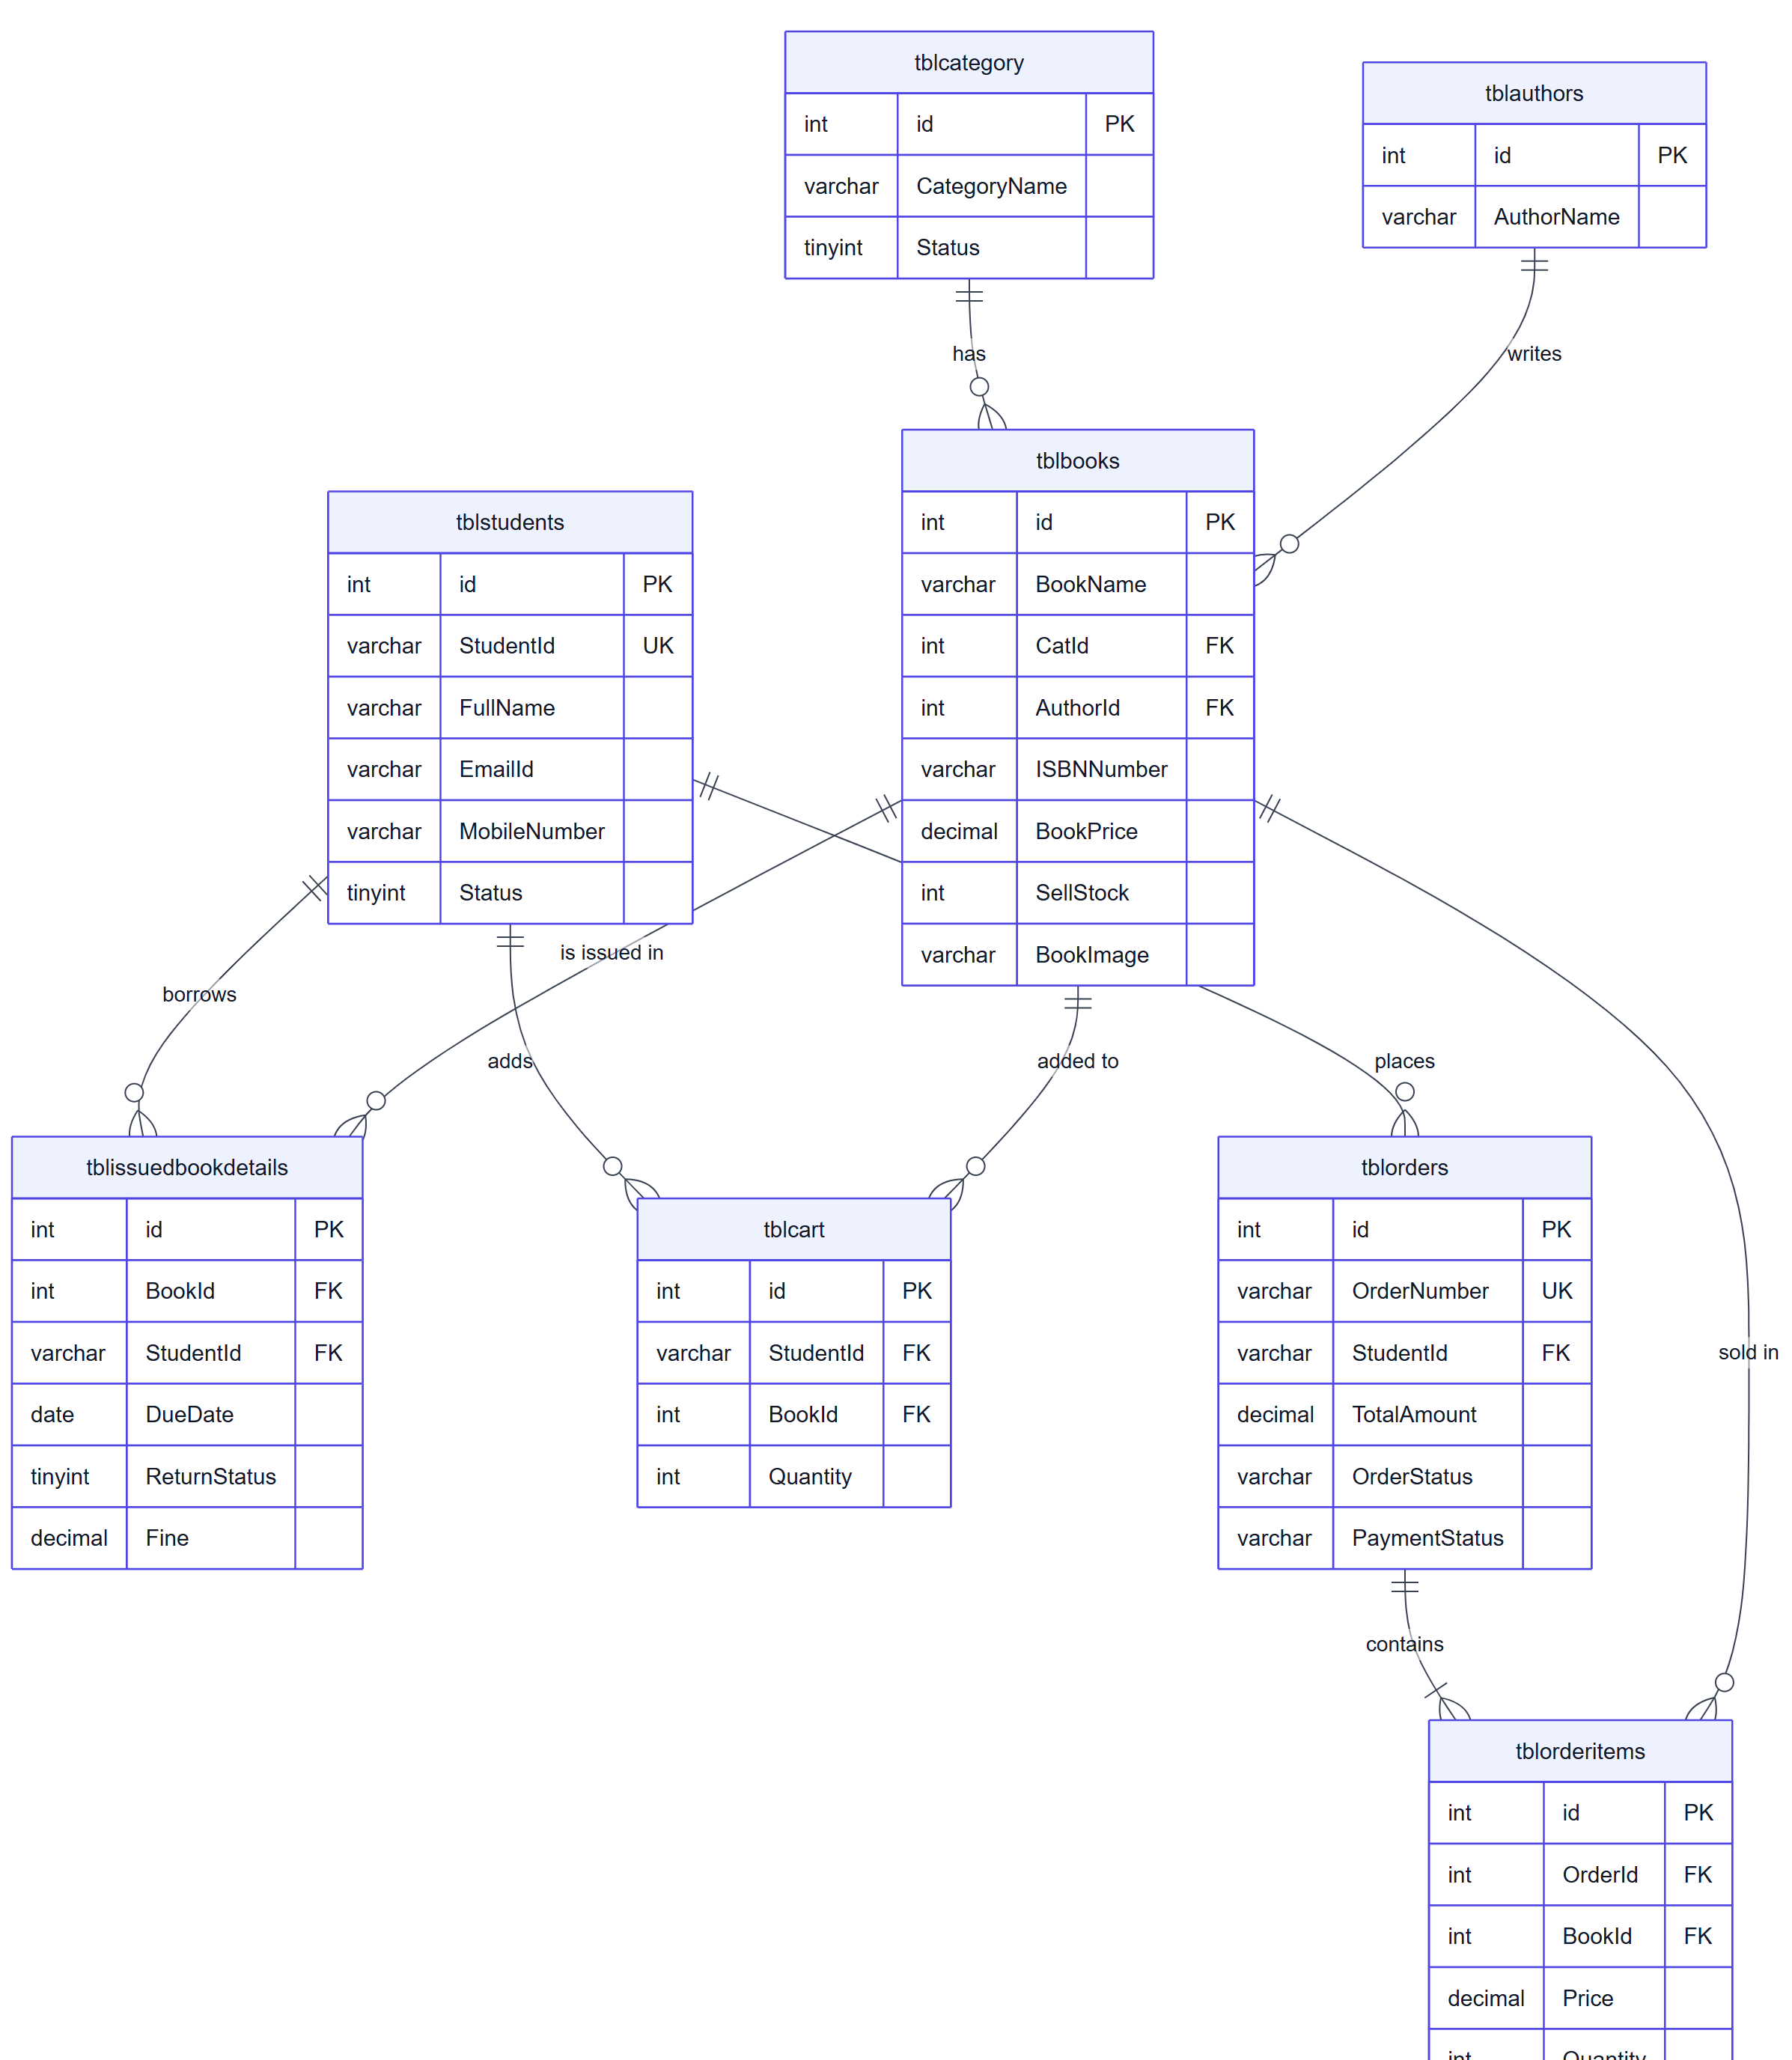
Figure 5.6: Entity-Relationship Diagram of library_db

6 System Design

6.1 Database Design – User and Role Tables
The admin table stores the administrator login. The tblstudents table stores student accounts. Both store passwords as bcrypt hashes.
Table: admin
Field | Type | Description
id | INT, PK | Admin ID
FullName | VARCHAR(100) | Admin name
AdminEmail | VARCHAR(120) | Email
UserName | VARCHAR(50), UNIQUE | Login username
Password | VARCHAR(255) | Password hash

Table: tblstudents
Field | Type | Description
id | INT, PK | Row ID
StudentId | VARCHAR(20), UNIQUE | Generated ID e.g. SID10001
FullName | VARCHAR(120) | Student name
EmailId | VARCHAR(120), UNIQUE | Email
MobileNumber | VARCHAR(15) | 10-digit mobile
Password | VARCHAR(255) | Password hash
Status | TINYINT | 1 = active, 0 = blocked
RegDate | TIMESTAMP | Registration date

6 System Design

6.1 Database Design – Book Tables
tblcategory and tblauthors are master tables. tblbooks stores each book and links to a category and an author.
Table: tblcategory
Field | Type | Description
id | INT, PK | Category ID
CategoryName | VARCHAR(150) | Name
Status | TINYINT | 1 = active

Table: tblauthors
Field | Type | Description
id | INT, PK | Author ID
AuthorName | VARCHAR(150) | Author name

Table: tblbooks
Field | Type | Description
id | INT, PK | Book ID
BookName | VARCHAR(200) | Title
CatId | INT, FK | Category
AuthorId | INT, FK | Author
ISBNNumber | VARCHAR(30), UNIQUE | ISBN
BookPrice | DECIMAL(10,2) | Price
SellStock | INT | Copies for sale
BookImage | VARCHAR(255) | Cover picture file

6 System Design

6.1 Database Design – Issue Table
tblissuedbookdetails stores every book issue. The ReturnStatus field shows whether the book has come back, and Fine stores the amount collected.
Table: tblissuedbookdetails
Field | Type | Description
id | INT, PK | Issue ID
BookId | INT, FK | Issued book
StudentId | VARCHAR(20), FK | Student
IssueDate | TIMESTAMP | Issue date and time
DueDate | DATE | Return by date
ReturnDate | TIMESTAMP | Actual return date and time
ReturnStatus | TINYINT | 0 = not returned, 1 = returned
Fine | DECIMAL(10,2) | Fine collected

6 System Design

6.1 Database Design – Cart and Order Tables
tblcart holds books a student wants to buy. tblorders stores the order and tblorderitems stores each book in the order with the price at the time of buying.
Table: tblcart
Field | Type | Description
id | INT, PK | Row ID
StudentId | VARCHAR(20), FK | Student
BookId | INT, FK | Book
Quantity | INT | Copies

Table: tblorders
Field | Type | Description
id | INT, PK | Order ID
OrderNumber | VARCHAR(30), UNIQUE | e.g. ORD2609251234
StudentId | VARCHAR(20), FK | Student
TotalAmount | DECIMAL(10,2) | Order total
PaymentMethod | VARCHAR(50) | COD / Library Counter
PaymentStatus | VARCHAR(20) | Unpaid / Paid
OrderStatus | VARCHAR(20) | Pending ... Delivered / Cancelled

Table: tblorderitems
Field | Type | Description
id | INT, PK | Row ID
OrderId | INT, FK | Order
BookId | INT, FK | Book
Price | DECIMAL(10,2) | Price when ordered
Quantity | INT | Copies

6 System Design

6.1.1 Database Table Summary
The database tables and their purposes are summarised below.
Table | Purpose
admin | Administrator login
tblstudents | Student accounts and Student ID
tblcategory | Book category master
tblauthors | Author master
tblbooks | Book master with price, stock and cover
tblissuedbookdetails | Book issue, return and fine records
tblcart | Student shopping cart
tblorders | Book order header
tblorderitems | Books inside an order

6 System Design

6.1.2 Key Book Fields
The tblbooks table includes BookName, CatId, AuthorId, ISBNNumber, BookPrice, SellStock and BookImage.
ISBNNumber is unique, so the admin can issue a book by typing only its ISBN. SellStock is the number of copies that can be sold in the Book Store; 0 means the book is not for sale. BookImage stores the cover picture file name.

6 System Design

6.1.3 Key Issue and Order Fields
For issues, the dashboard and the student pages use IssueDate, DueDate, ReturnDate, ReturnStatus and Fine to show whether a book is Not Returned, Overdue or Returned.
For orders, the pages use OrderNumber, OrderDate, TotalAmount, PaymentMethod, PaymentStatus and OrderStatus. tblorderitems copies the book name, ISBN and price, so order history stays correct even if a book is later edited or deleted.

6 System Design

6.2 User Interface – Home Page and Login
The home page has a colourful banner with the Student Login form and shows the book collection with cover pictures and an Available / Issued label.
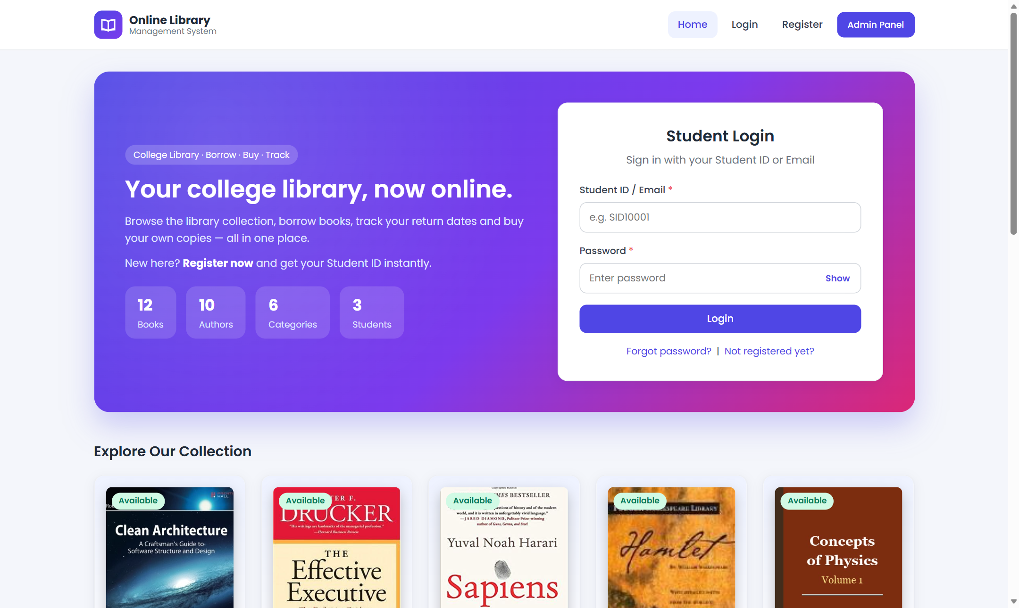
Figure 6.1: Home page with student login
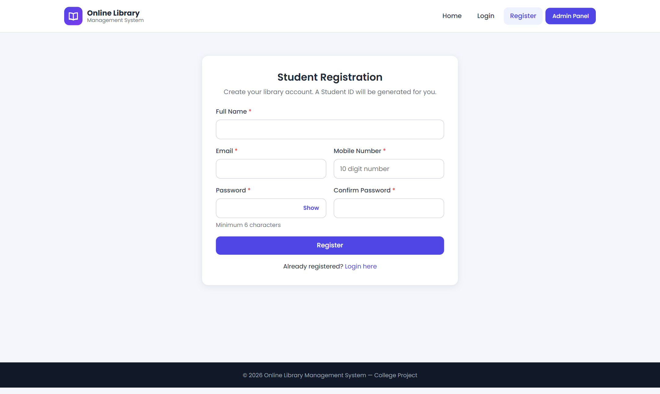
Figure 6.2: Student registration page

6 System Design

6.2 User Interface – Listed Books and Book Store
Listed Books shows every book as a card with its cover. The search box filters the cards instantly using AJAX. The Book Store shows price and stock and has an Add to Cart button.
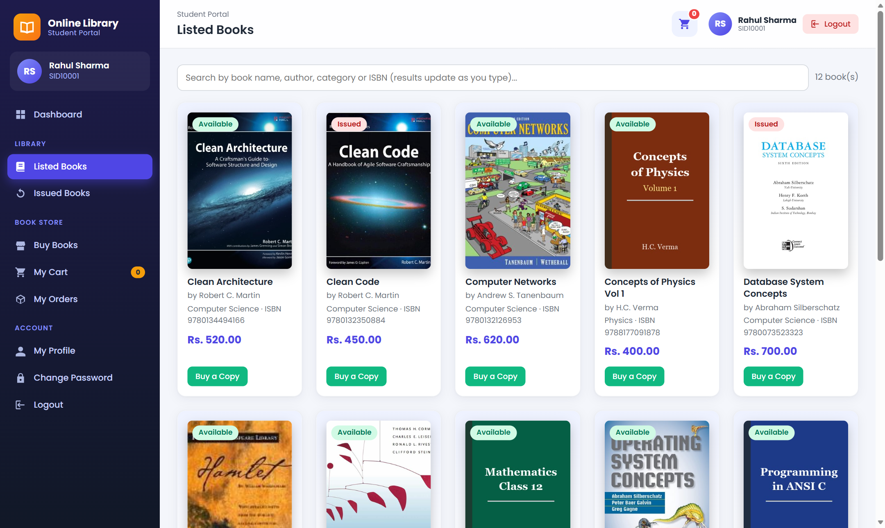
Figure 6.3: Listed books with live search
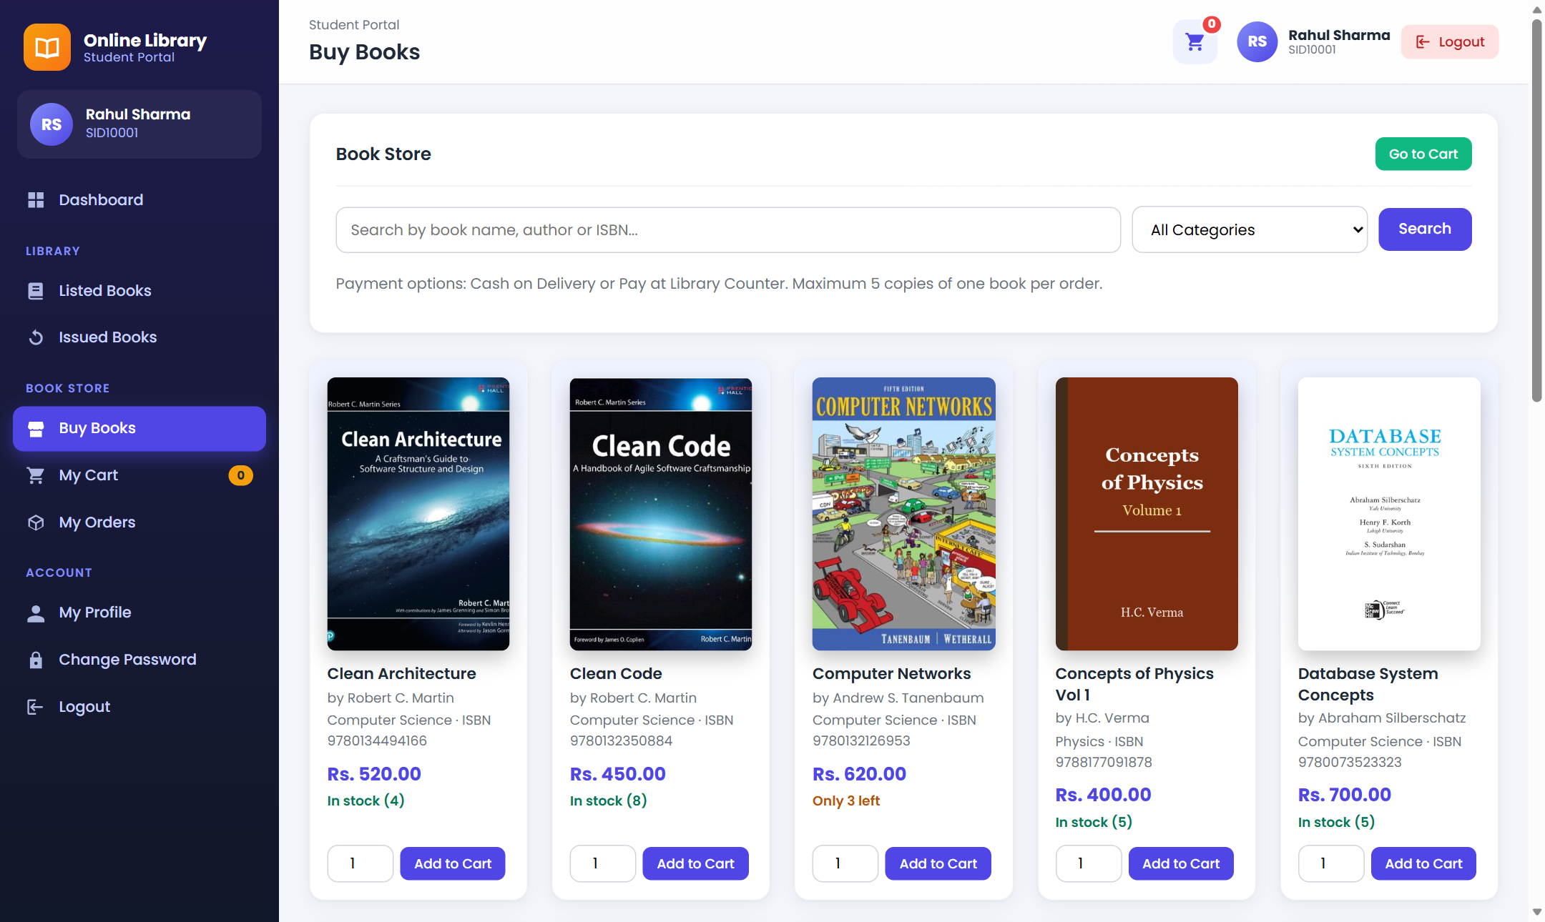
Figure 6.4: Book Store (Buy Books)

6 System Design

6.2 User Interface – Cart, Checkout and Orders
The cart updates quantities and totals without reloading. Checkout offers Cash on Delivery or Pay at Library Counter. The order page shows a progress bar.
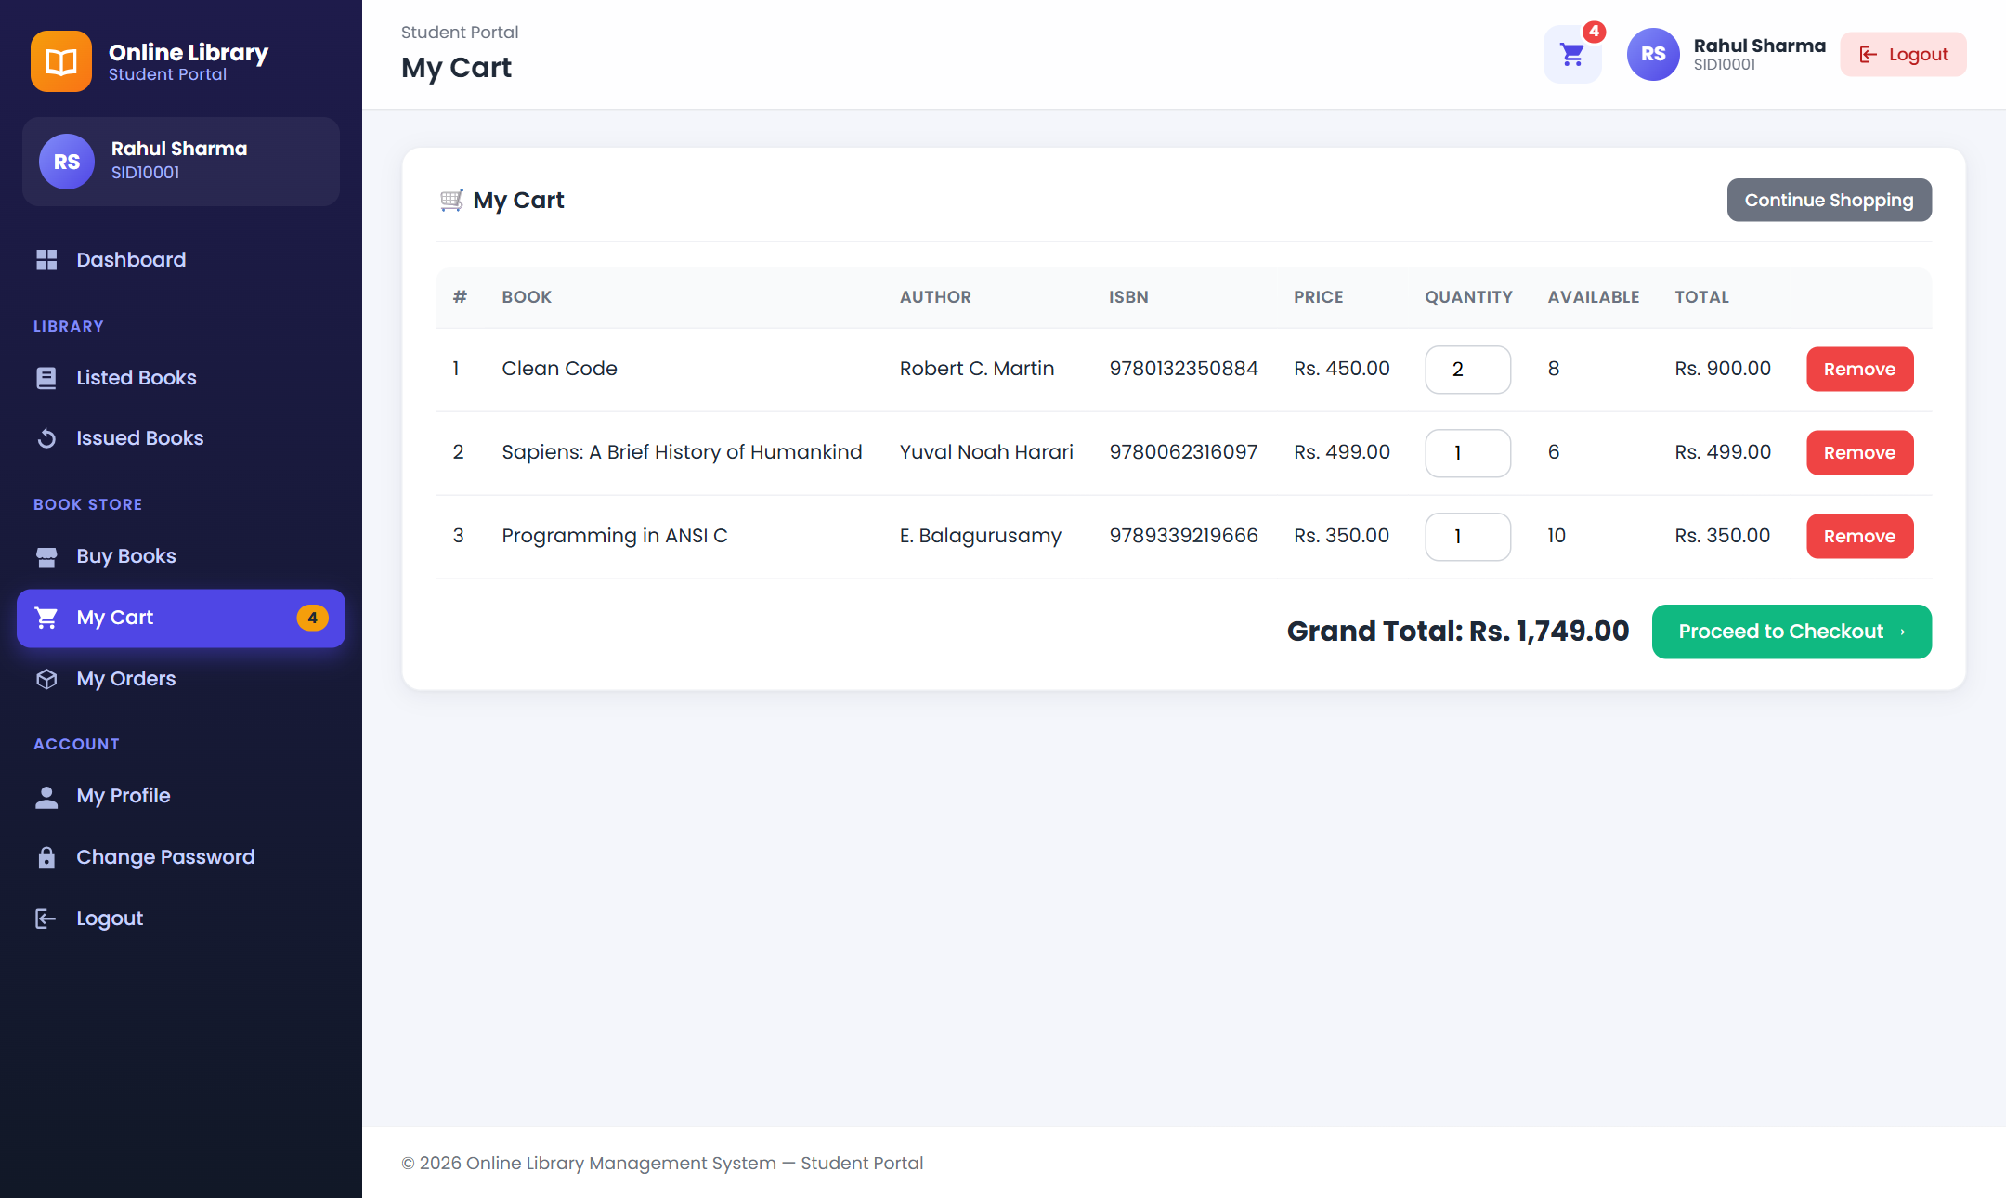
Figure 6.5: Shopping cart
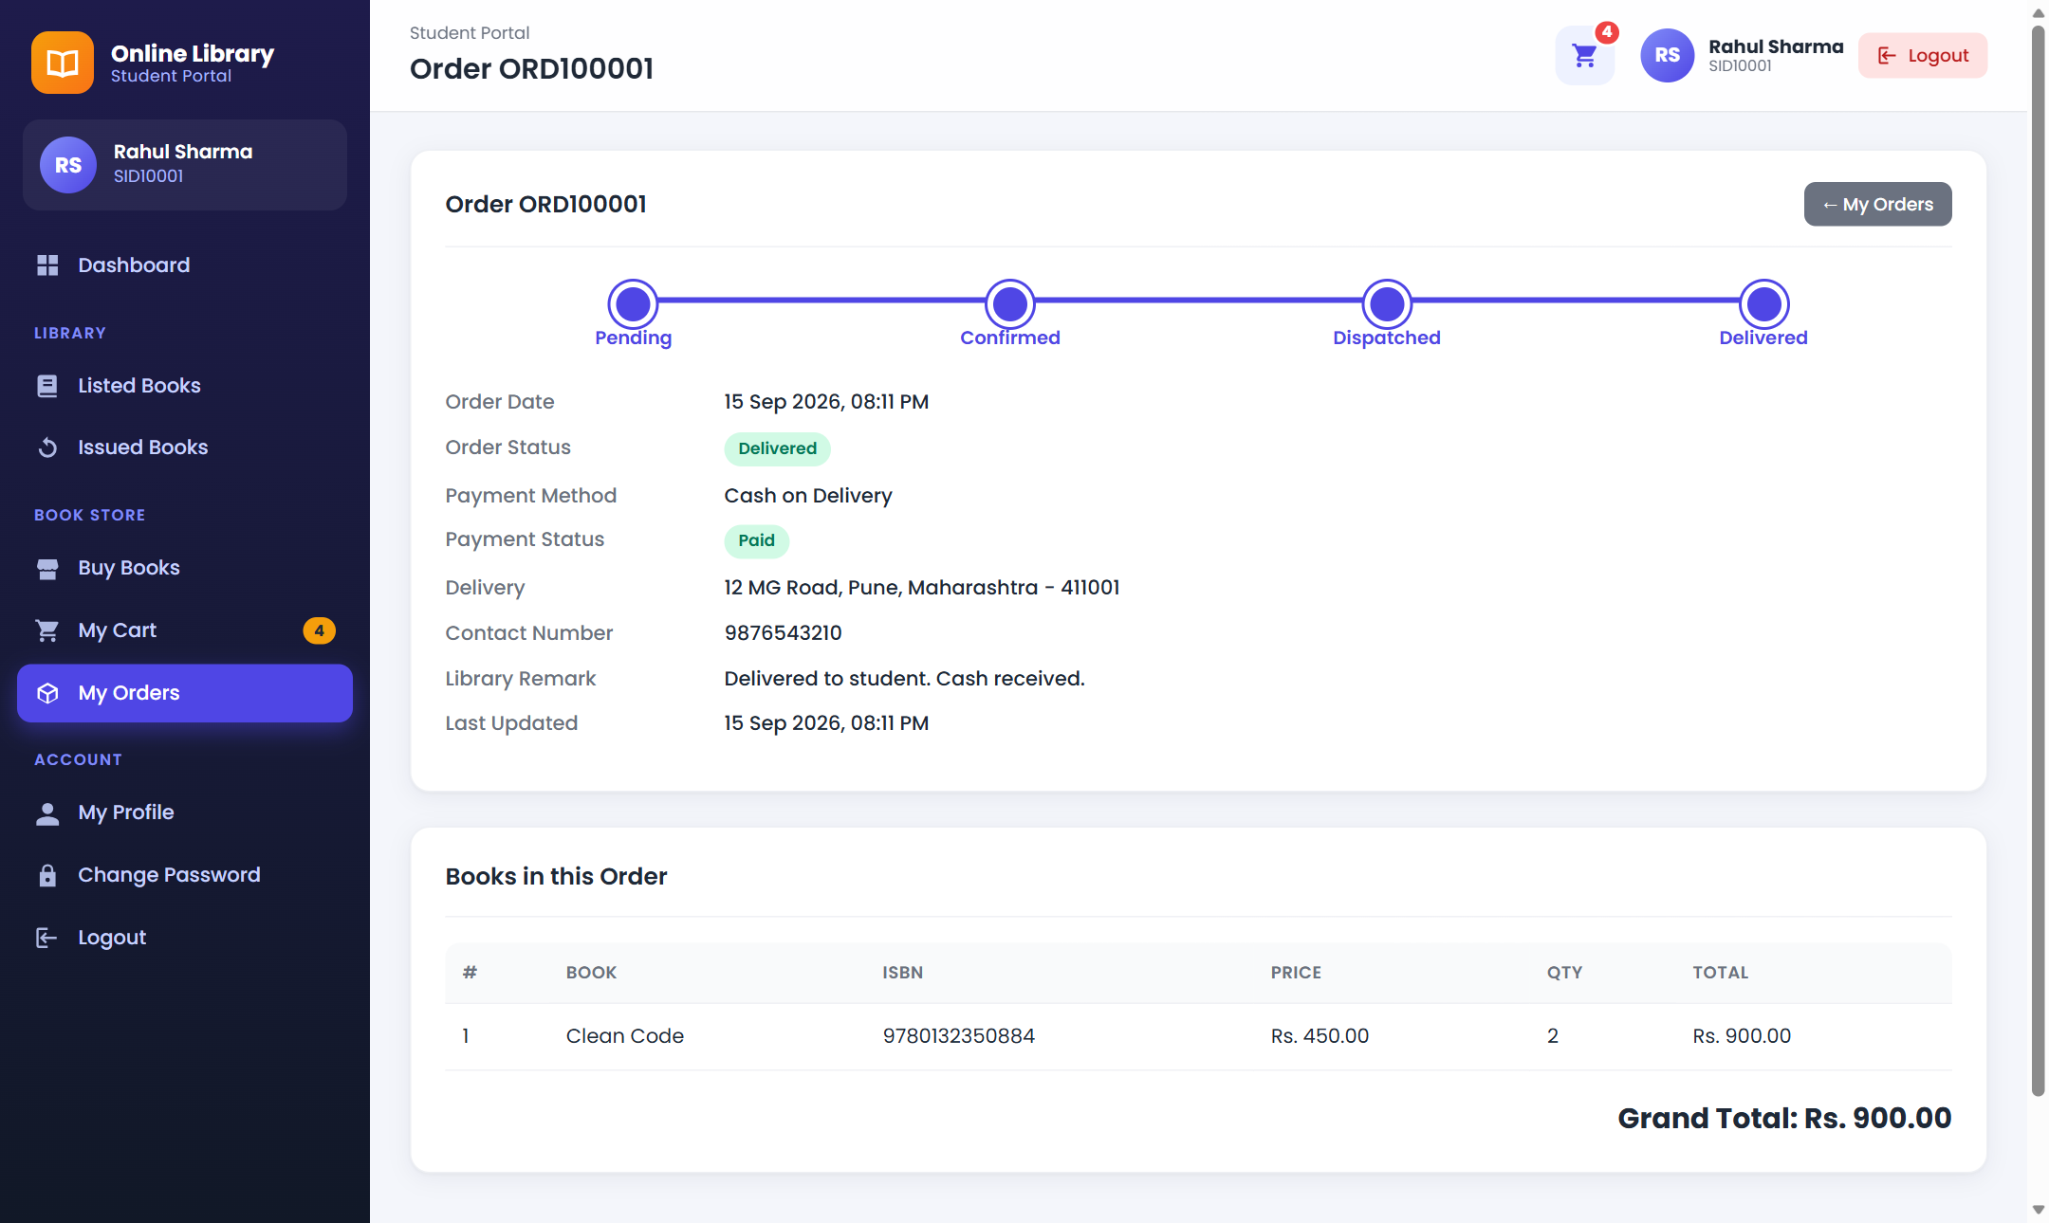
Figure 6.6: Order details with progress bar

6 System Design

6.2 User Interface – Issued Books
Issued Books shows the cover, issue date and time, due date, returned date and time, fine and status of every book issued to the student.
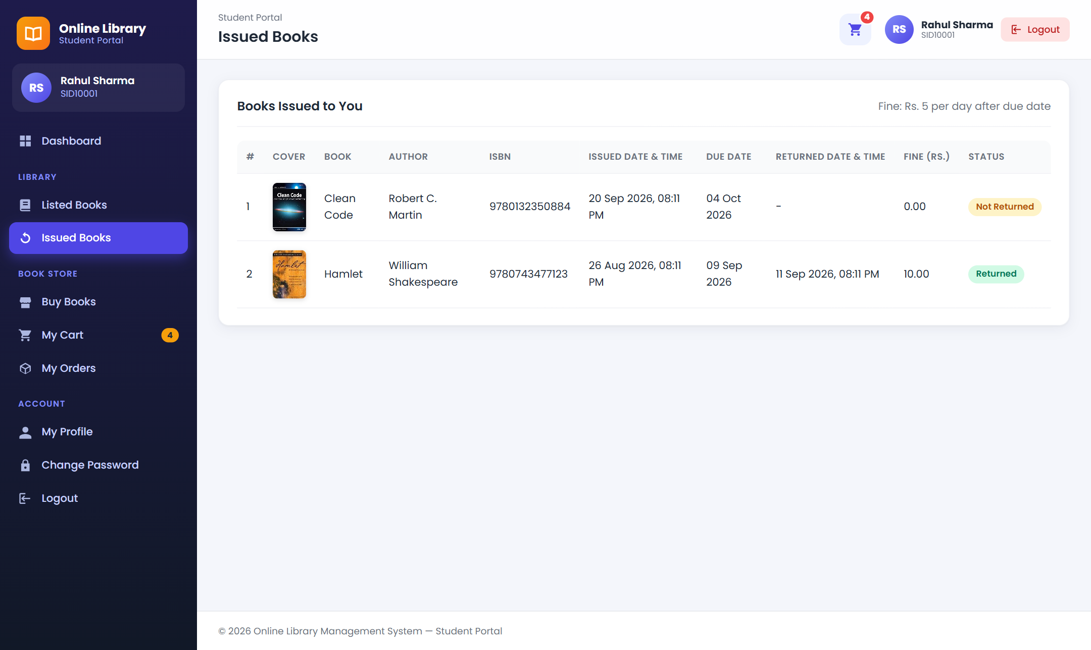
Figure 6.7: Issued books page (student)
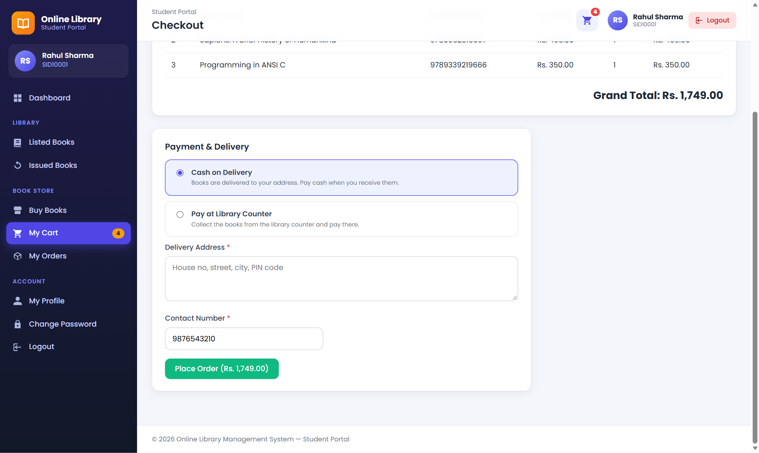
Figure 6.8: Checkout page

6 System Design

6.2 User Interface – Admin Dashboard
The admin dashboard shows a welcome banner and stat cards for total books, books on loan, returned books, students, authors, categories, orders, pending orders and sales. It also lists recent issues and recent orders.
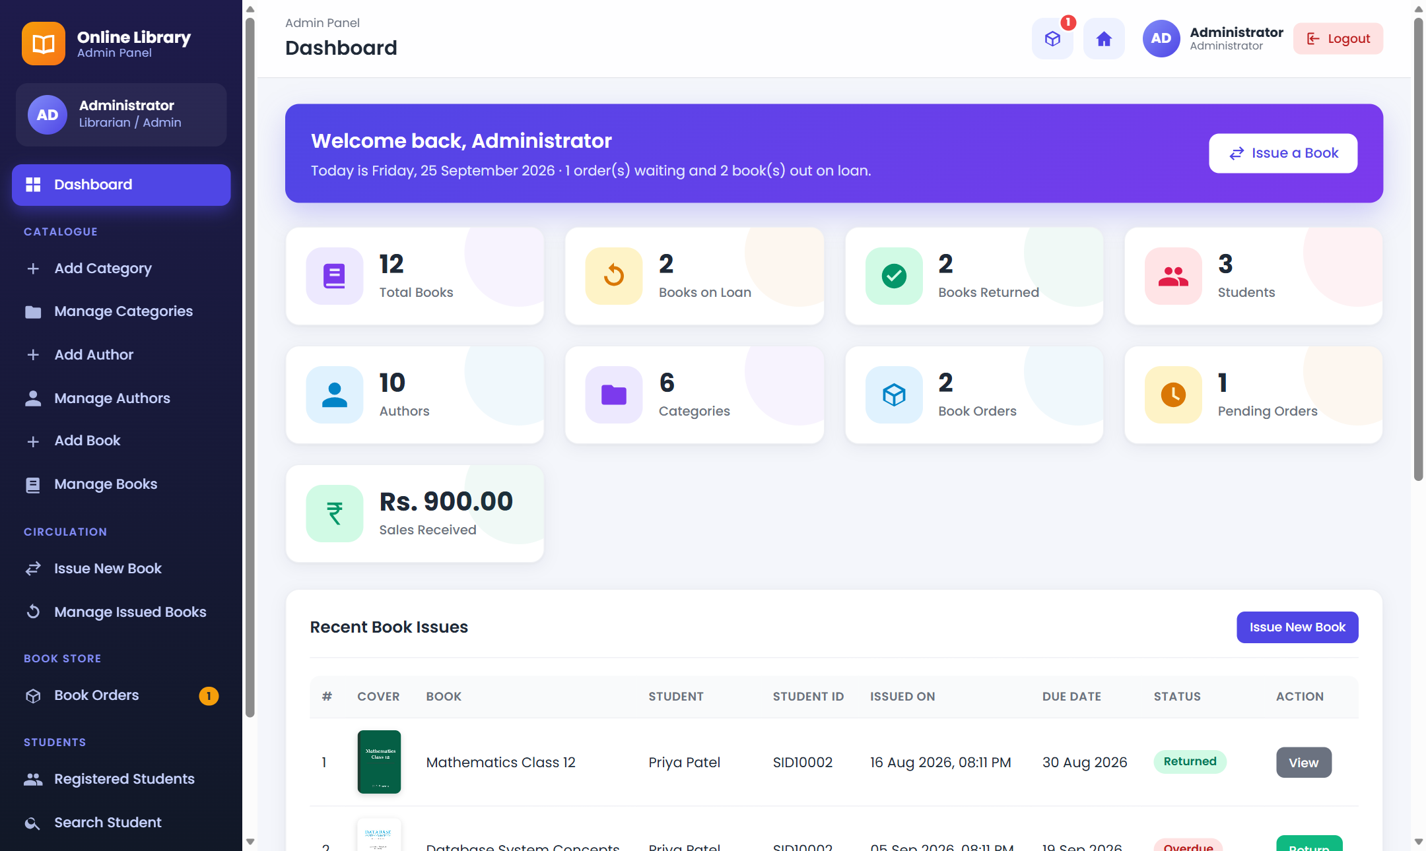
Figure 6.9: Admin dashboard
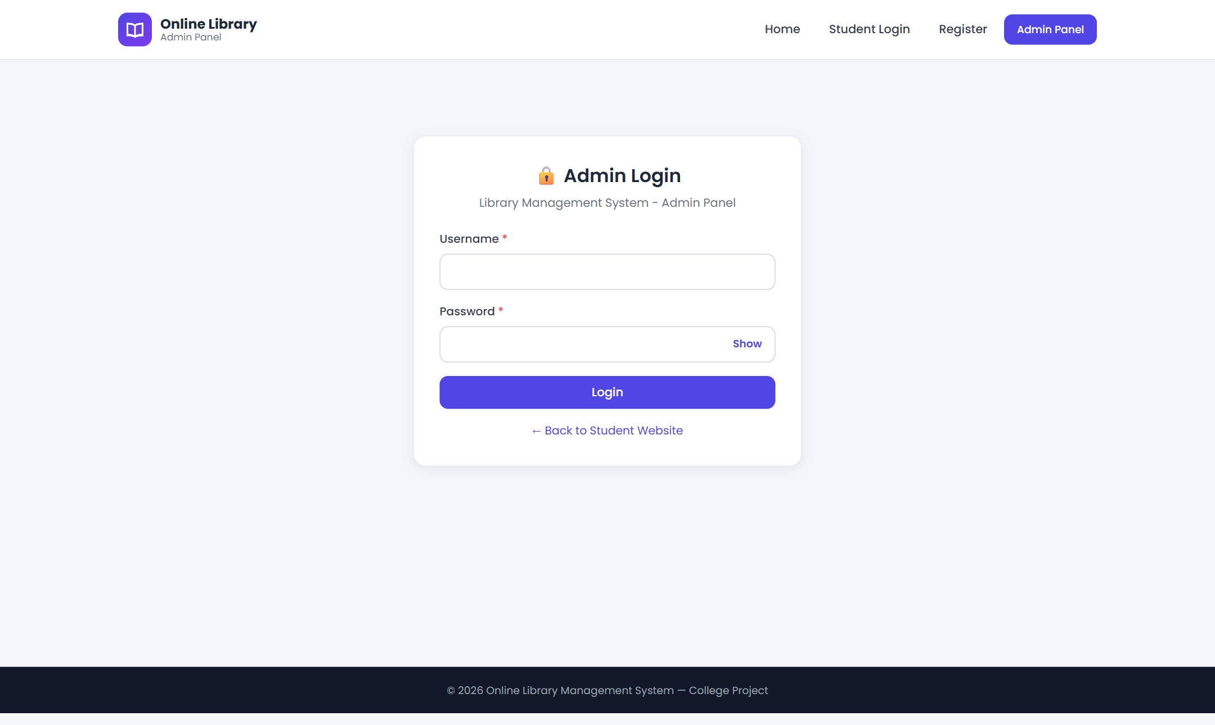
Figure 6.10: Admin login

6 System Design

6.2 User Interface – Admin Modules
The sidebar groups admin pages into Catalogue, Circulation, Book Store and Students. Manage Books shows the cover, price, copies for sale and status with Edit and Delete buttons. Add Book includes a picture upload with preview.
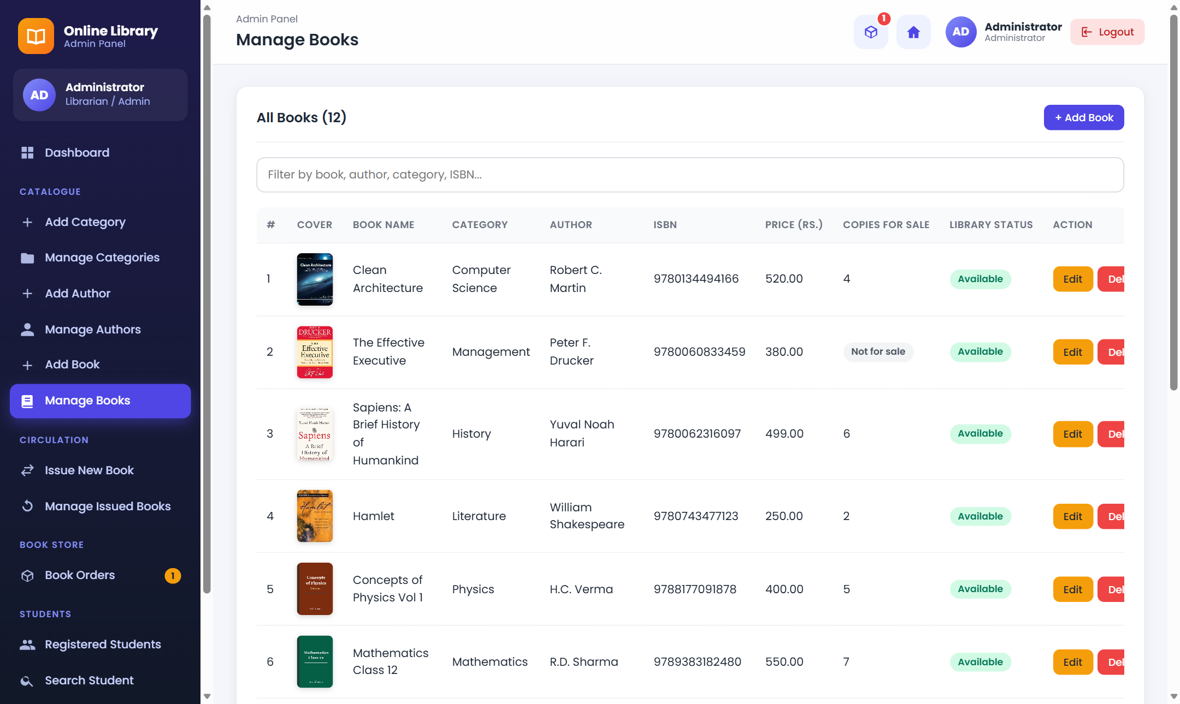
Figure 6.11: Manage books
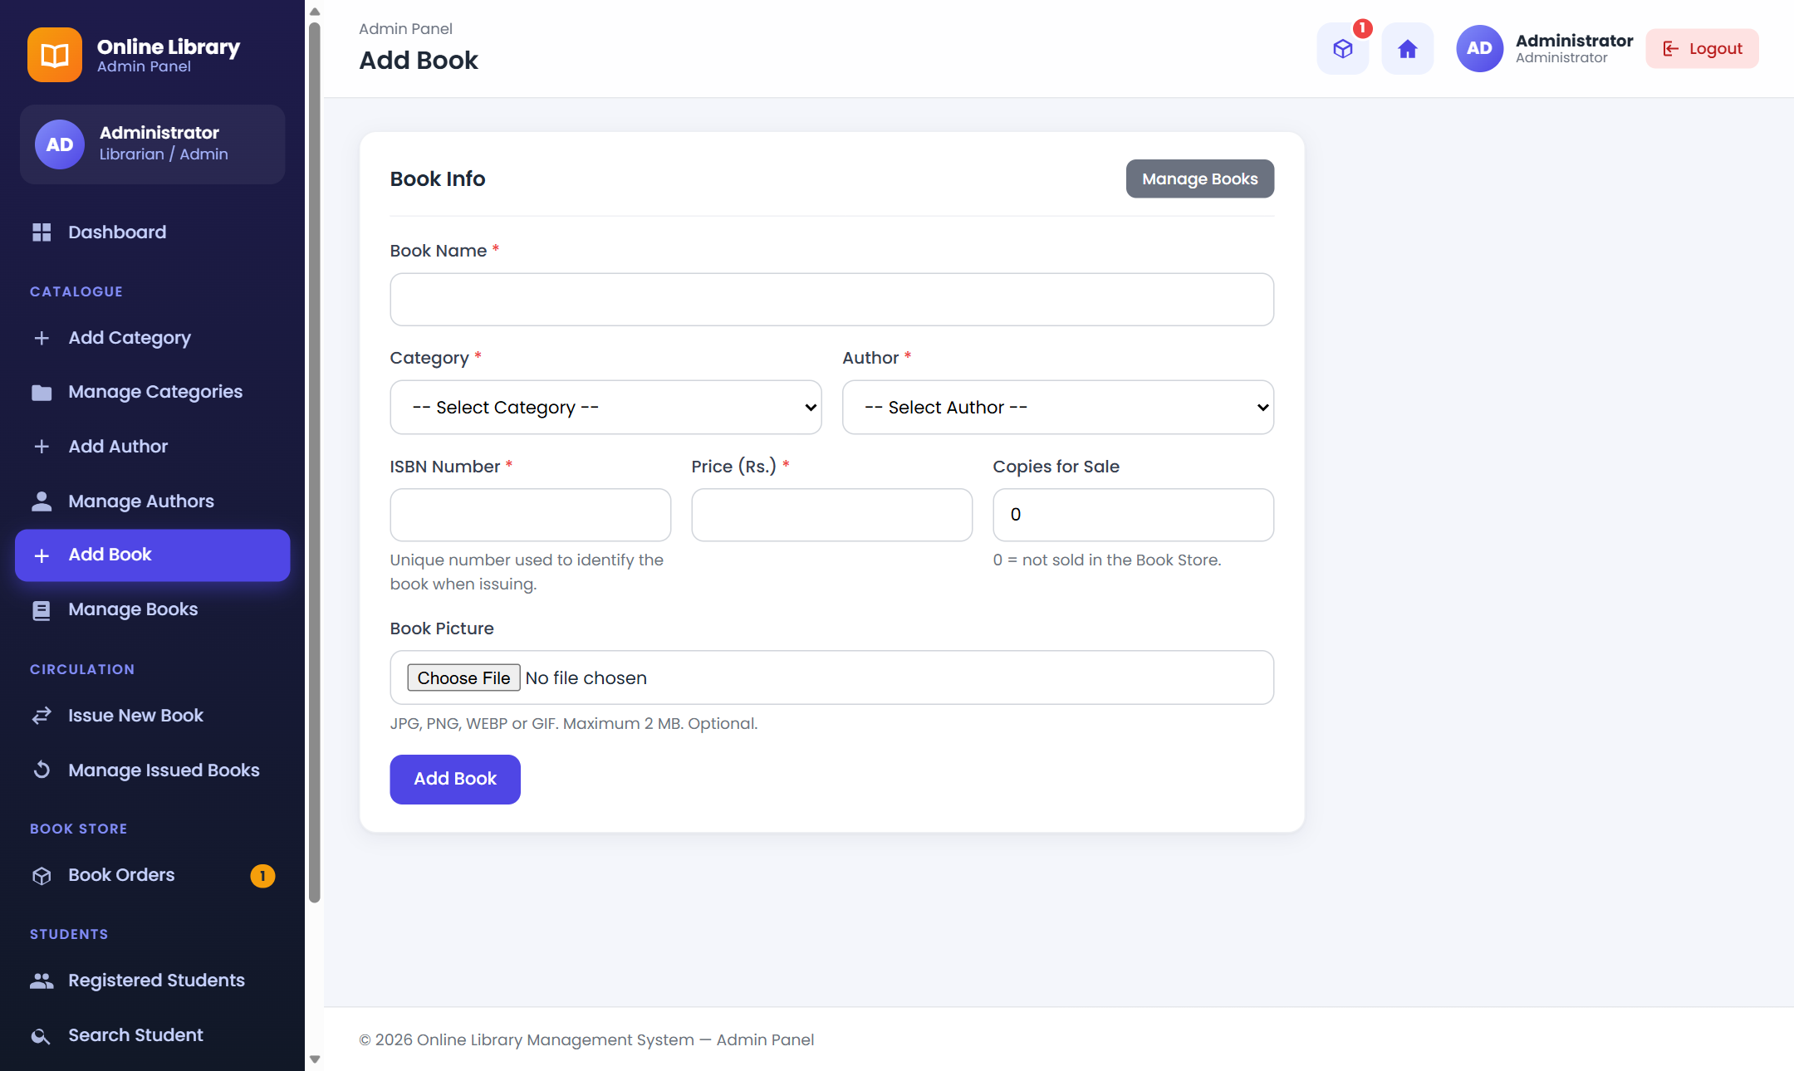
Figure 6.12: Add book with picture upload

6 System Design

6.2 User Interface – Issue and Return
On Issue New Book, the student name and book name are filled automatically with AJAX. On return, the fine is calculated automatically.
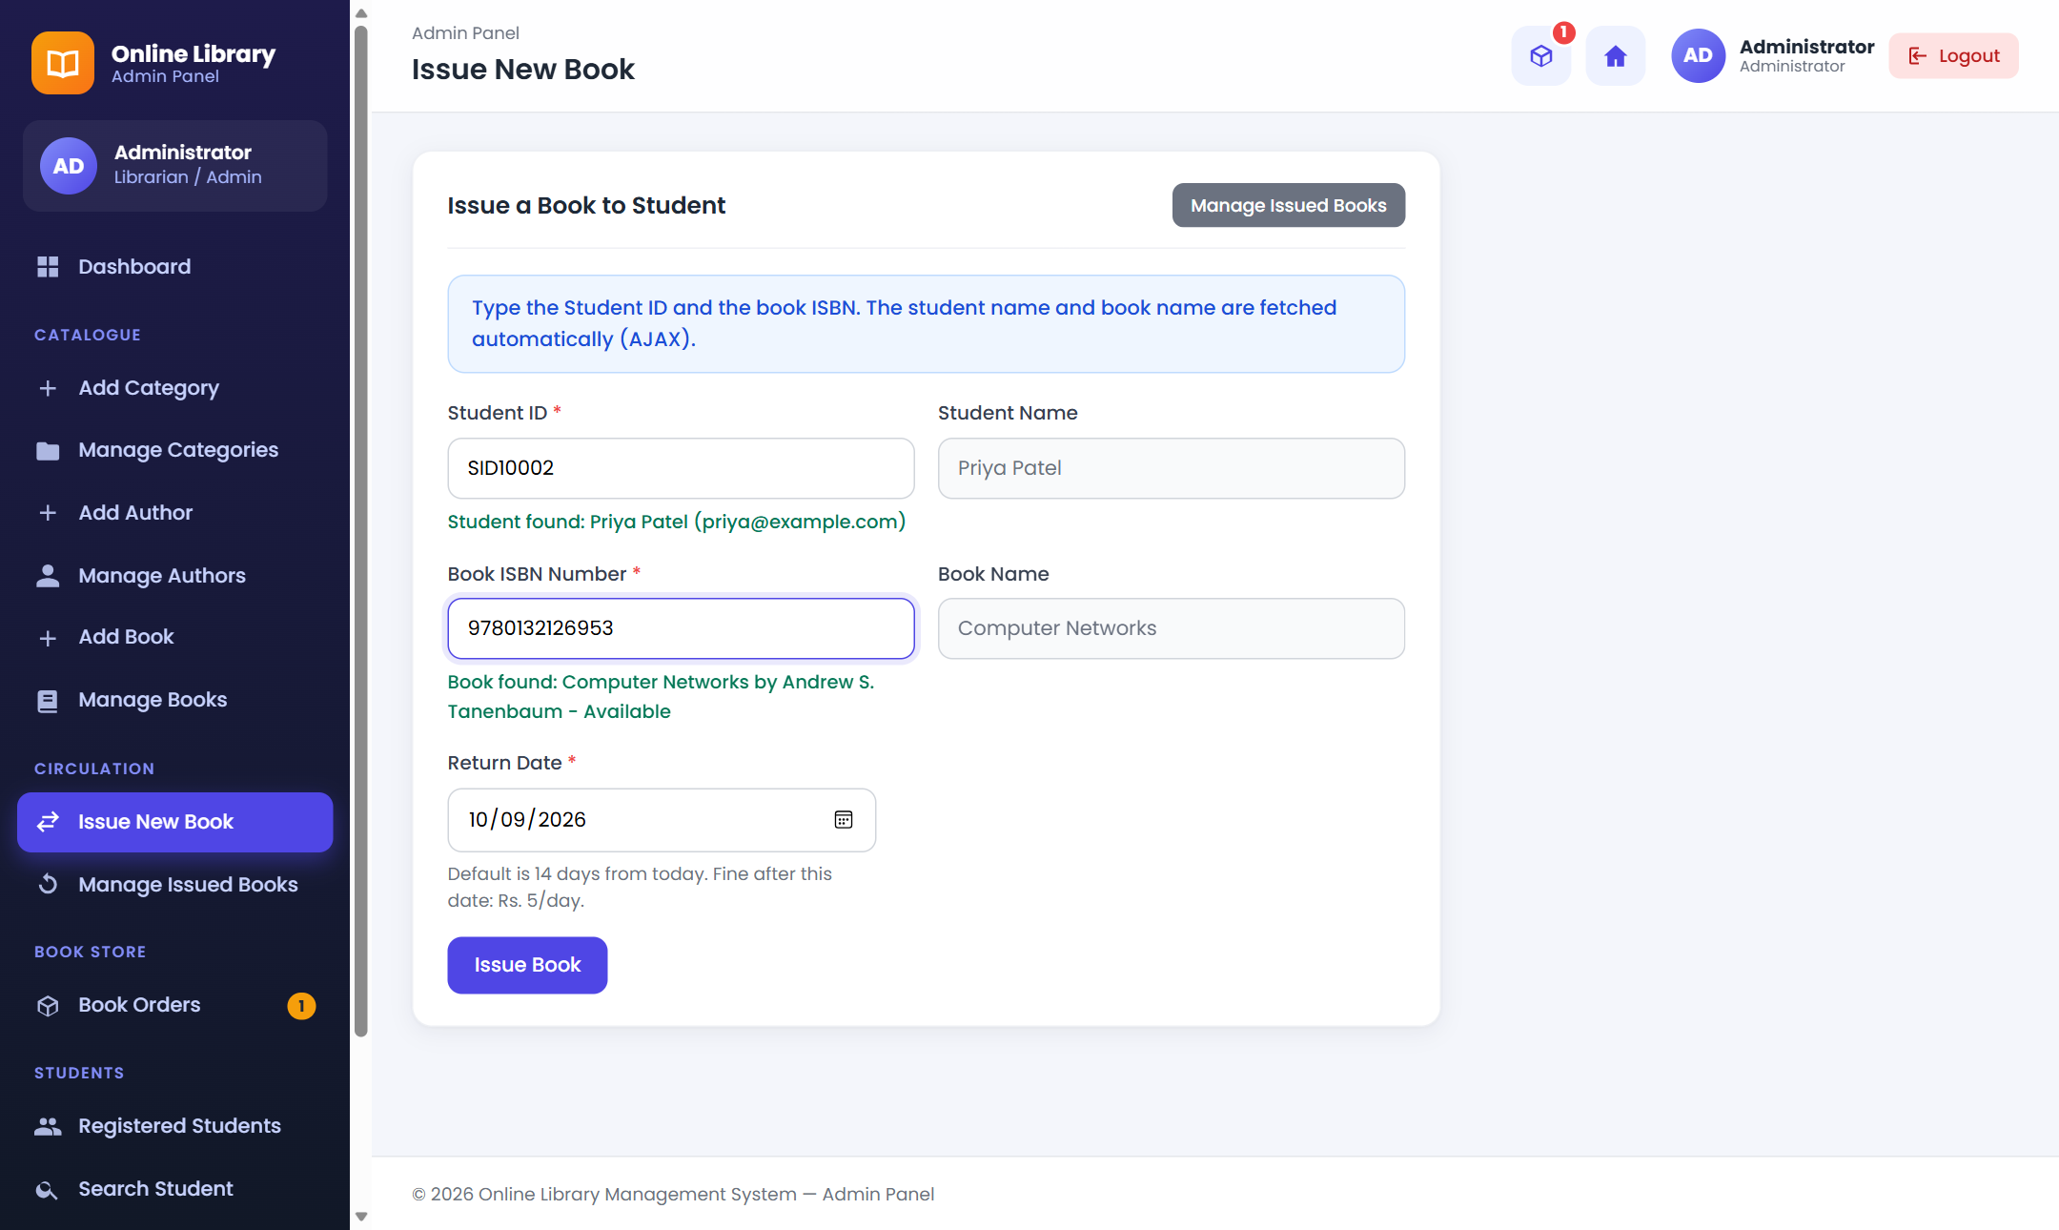
Figure 6.13: Issue new book with AJAX lookup
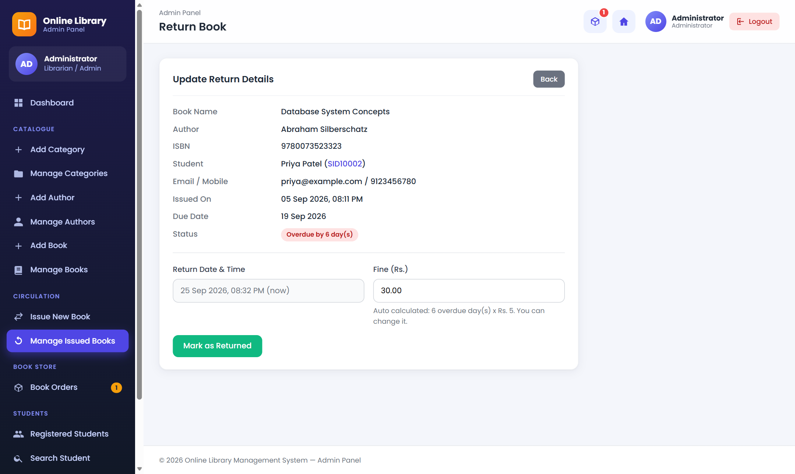
Figure 6.14: Return book with fine

6 System Design

6.2 User Interface – Book Orders and Students
Book Orders lists all orders with filters by status. The admin can also search a student by Student ID and view the full profile and issue history.
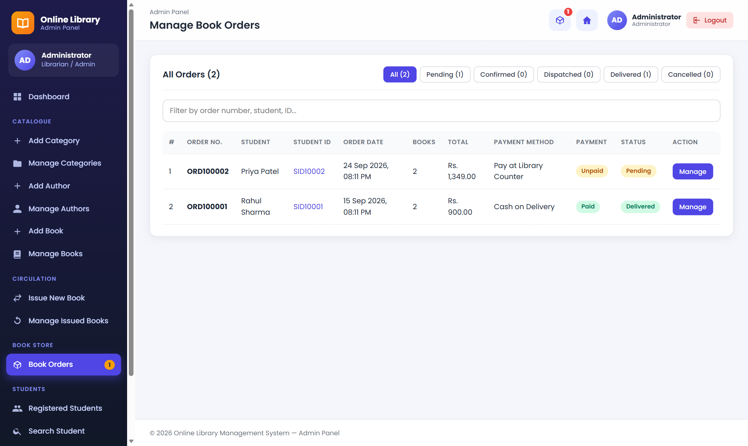
Figure 6.15: Book orders (admin)
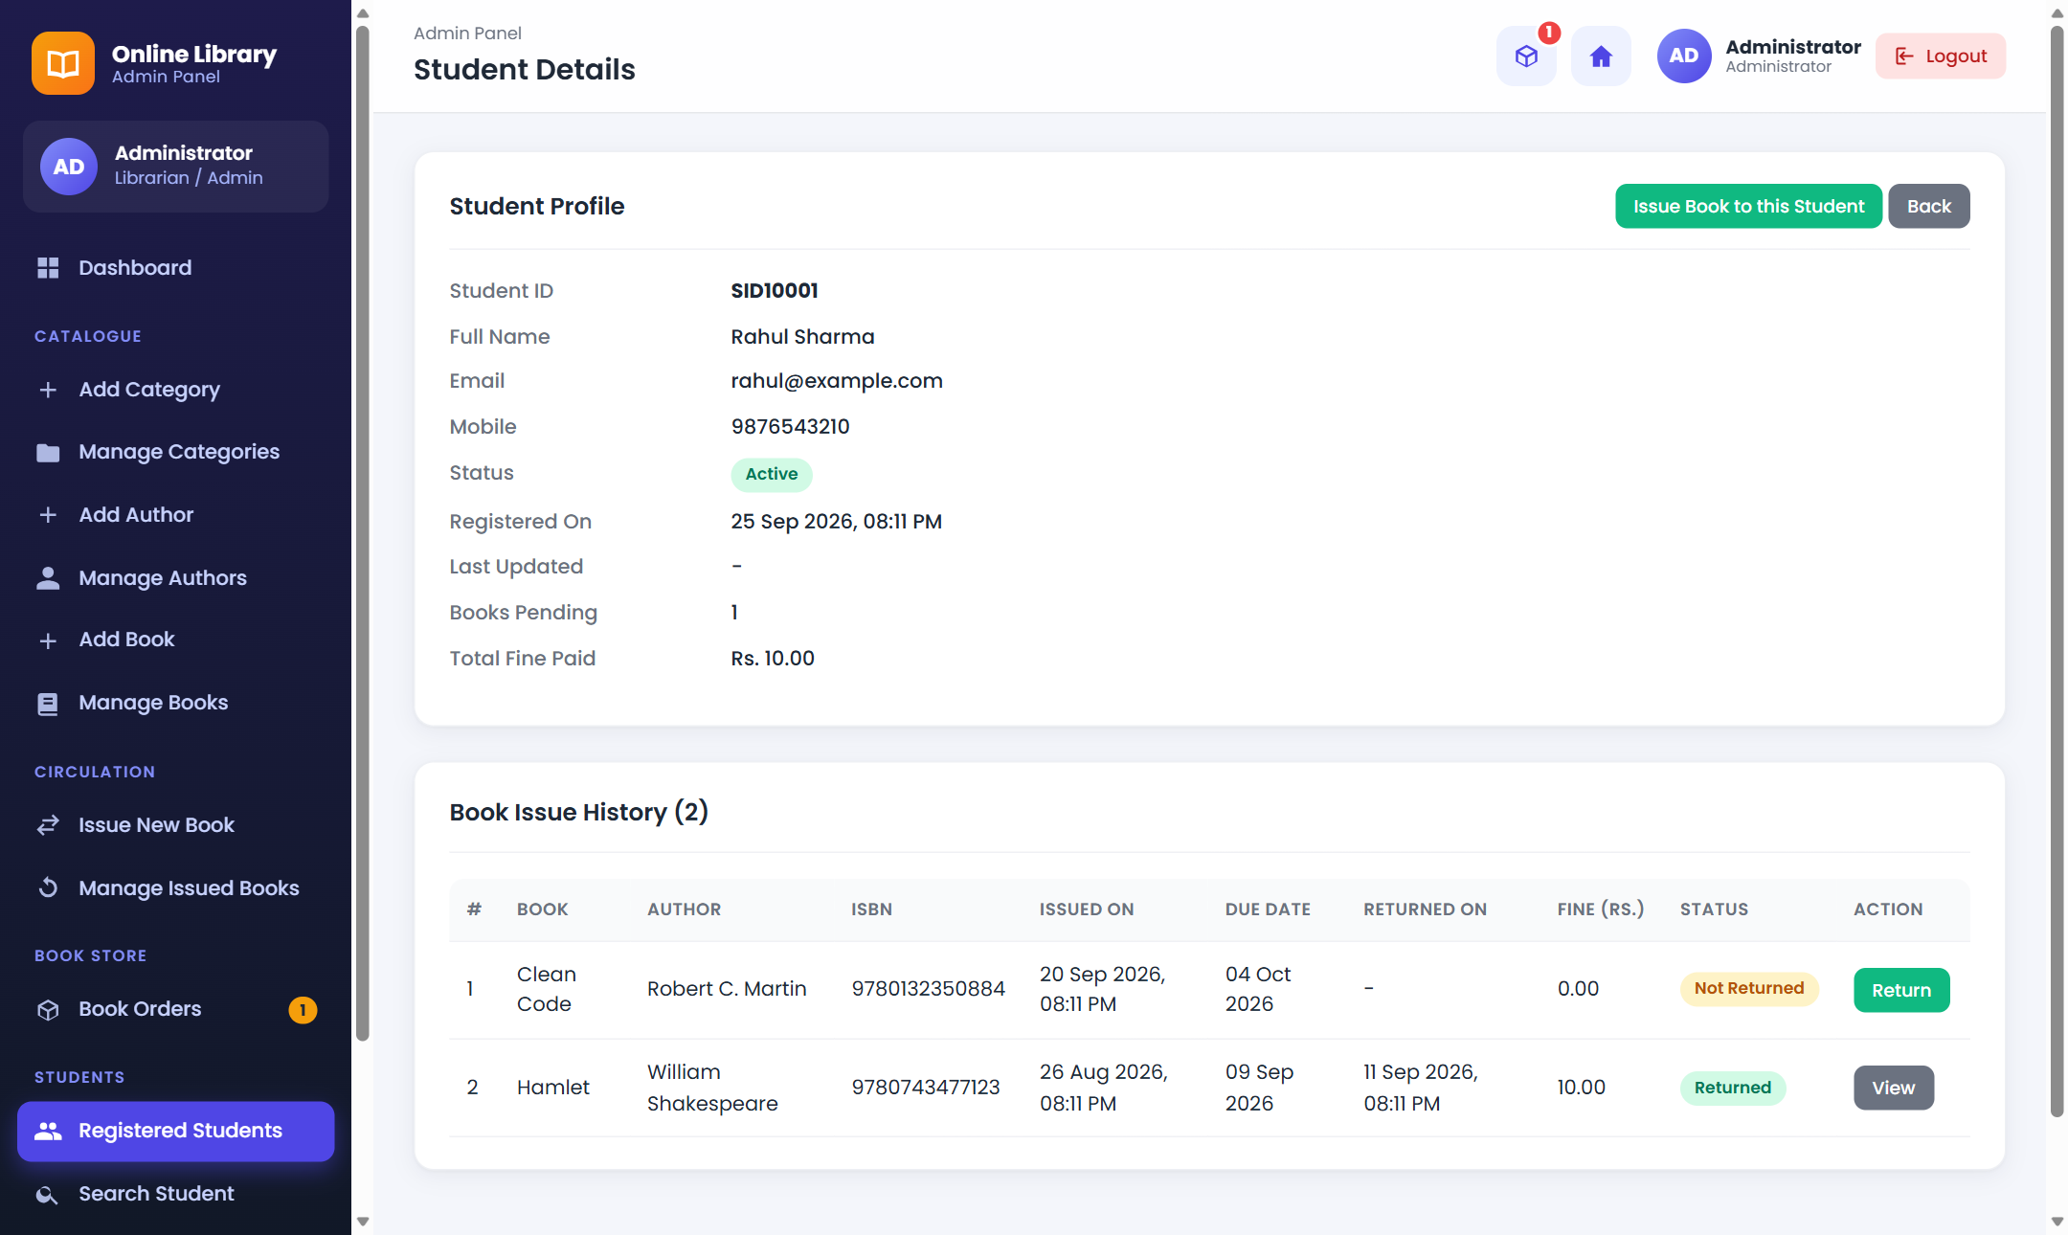
Figure 6.16: Student details (admin)

7 Software Testing & Test Cases

7.1 Testing Strategy
Testing checks the main user journeys with valid inputs, invalid inputs and boundary conditions.
- Unit testing: single functions such as fine calculation, Student ID generation and image checks.
- Integration testing: modules working together, for example issue book and the student's issued books page.
- System testing: the complete flow from registration to issue, return, cart, checkout and order delivery.
All test cases in this chapter were run on the XAMPP setup. 94 automated checks covering every page and AJAX endpoint passed with no PHP errors.

7 Software Testing & Test Cases

7.2 Authentication Test Cases
Verify registration, login, password recovery, logout and access control.
TC ID | Test | Expected Result | Status
TC-01 | Register with valid details | Account created, Student ID shown | Pass
TC-02 | Register with an existing email | Error: email already registered | Pass
TC-03 | Login with wrong password | Error: invalid ID or password | Pass
TC-04 | Login as blocked student | Error: account blocked | Pass
TC-05 | Forgot password with wrong mobile | Error: no account found | Pass
TC-06 | Open admin page without login | Redirect to admin login | Pass

7 Software Testing & Test Cases

7.3 Book and Cart Test Cases
Verify book listing, live search and cart rules.
TC ID | Test | Expected Result | Status
TC-07 | Search 'hamlet' in Listed Books | Only Hamlet card shown | Pass
TC-08 | Add 3 copies when only 2 in stock | Error: only 2 copies available | Pass
TC-09 | Add an out-of-stock book | Error: out of stock | Pass
TC-10 | Change cart quantity to 3 | Line and grand total updated | Pass
TC-11 | Set quantity above 5 | Error: choose 1 to 5 | Pass
TC-12 | Remove a book from cart | Book removed, total updated | Pass

7 Software Testing & Test Cases

7.4 Checkout and Order Test Cases
Verify checkout, stock update and order cancellation.
TC ID | Test | Expected Result | Status
TC-13 | Cash on Delivery without address | Error: enter delivery address | Pass
TC-14 | Place order with valid data | Order number shown, cart emptied | Pass
TC-15 | Check stock after order | Stock reduced by ordered quantity | Pass
TC-16 | Student cancels pending order | Order cancelled, stock restored | Pass
TC-17 | Cancel the same order again | Error: cannot be cancelled | Pass
TC-18 | Open another student's order | Error: order not found | Pass

7 Software Testing & Test Cases

7.5 Admin and Issue Test Cases
Verify catalogue management, issue/return and order processing.
TC ID | Test | Expected Result | Status
TC-19 | Add duplicate category / ISBN | Error: already exists | Pass
TC-20 | Delete category that has books | Error: cannot delete | Pass
TC-21 | Upload a non-image file as cover | Error: upload a valid image | Pass
TC-22 | Issue a book that is already issued | Error: already issued | Pass
TC-23 | Return overdue book (6 days late) | Fine Rs. 30.00 calculated | Pass
TC-24 | Set order status to Delivered | Payment marked Paid, order locked | Pass

7 Software Testing & Test Cases

7.6 Test Case Table
The following sample cases can be used during project demonstration.
TC ID | Module | Test | Expected Result
TC-01 | Register | Valid student details | Account and Student ID created
TC-02 | Login | Valid credentials | Session created, dashboard opens
TC-03 | Books | Live search | Matching books shown
TC-04 | Issue | Valid Student ID + ISBN | Book issued with return date
TC-05 | Return | Return late book | Fine calculated and saved
TC-06 | Cart | Change quantity | Total updated
TC-07 | Checkout | Valid order data | Order created, stock reduced
TC-08 | Admin | Update order status | Status saved
TC-09 | Book | Add book with picture | Cover shown in all lists
TC-10 | Security | Unauthorised admin access | Access restricted

8 Future Scope of Enhancements

8.1 Enhancement Opportunities
Future versions can add online payment (UPI / card), email and SMS reminders before the due date, barcode or QR code scanning for books, book reservation, e-books, reports in PDF/Excel, multiple copies per book with copy numbers, and a mobile app for students.

8 Future Scope of Enhancements

8.2 Security and Scalability
Before public use, the system should use HTTPS, CSRF protection, stronger password rules, login attempt limits, regular database backups and activity logs. For more users, it can use better indexing, caching and cloud hosting.

9 References
1. Online Library Management System source code and database (library_db.sql).
2. VNSGU BCA Sem V A.Y. 2026-27 project report format.
3. PHP Manual – https://www.php.net/manual/
4. MySQL Documentation – https://dev.mysql.com/doc/
5. jQuery API Documentation – https://api.jquery.com/
6. MDN Web Docs (HTML, CSS, JavaScript) – https://developer.mozilla.org/
7. Apache Friends (XAMPP) – https://www.apachefriends.org/
8. PHPGurukul, Online Library Management System (feature reference) – https://phpgurukul.com/online-library-management-system/

10 Appendix

A. Project Setup and Demonstration Steps
1. Install XAMPP (the installer is in the “xampp setup” folder of the project).
2. Start Apache and MySQL in the XAMPP Control Panel.
3. Copy the “library” folder to C:\xampp\htdocs\.
4. Open http://localhost/phpmyadmin and import library/database/library_db.sql.
5. Check database settings in library/includes/config.php (default: root, no password).
6. Open http://localhost/library/ (student) or http://localhost/library/admin/ (admin).
7. Use the demo accounts only for academic testing and change them before any public use.

B. Demo Accounts
Role | Username / Student ID | Password
Admin | admin | Password@123
Student | SID10001 | Student@123
Student | SID10002 | Student@123

