A Basic Information Retrieval System for Nepal’s Places and Websites

Prijesh
[Department name], [University name]
[Course number]: [Course name], Week 6 Assignment
[Instructor name]
October 12, 2026

A Basic Information Retrieval System for Nepal’s Places and Websites
Information retrieval (IR) is the task of finding the documents in a large collection that best match a user’s query (Manning et al., 2008). In our team project, the PGS Search Engine, we are building a search engine for Nepal’s public web that works in English and Nepali and lets people search by province, district and municipality (tekraj, 2026).
For this assignment I built a small IR system, PGS Mini Search, that follows the same design as the PGS search engine but is simple enough to explain step by step. It is written in Python and uses the methods covered in the lectures. The objectives were to:
- use a publicly available dataset about Nepal’s places and websites;
- design the system: preprocessing, indexing, retrieval model and query processing;
- implement and compare the Boolean, TF-IDF and BM25 models; and
- evaluate the results with standard measures (precision, MAP, MRR and nDCG).

Dataset
The dataset comes from the PGS project’s seed data (folder database/data in the project repository), which is built from public sources. It has two files. The first, nepal_geography.json, lists all 7 provinces, 77 districts and 753 local governments of Nepal with their English and Nepali names (sagautam5, n.d.). The second, domains.json, lists the 9,761 Nepali websites that PGS crawls, each with a category such as news, government, education or NGO.
From these files I created 9,842 documents, summarised in Table 1. Each document has three fields: the title (the name), the place (district and province) and the body (web address, type and category). When ranking, the title counts three times, the place twice and the body once.
Table 1
Documents in the Collection
Document type | Count | Example
Province | 7 | Gandaki Province (गण्डकी प्रदेश)
District | 77 | Kaski District (कास्की जिल्ला)
Local government | 753 | Pokhara Metropolitan City (पोखरा महानगरपालिका)
Website | 9,005 | pokharanews.com (news)
Total | 9,842

System Design
The system has three parts: indexing, which is done once; searching, which is done for every query; and evaluation. Figure 1 shows the architecture.
Figure 1
System Architecture
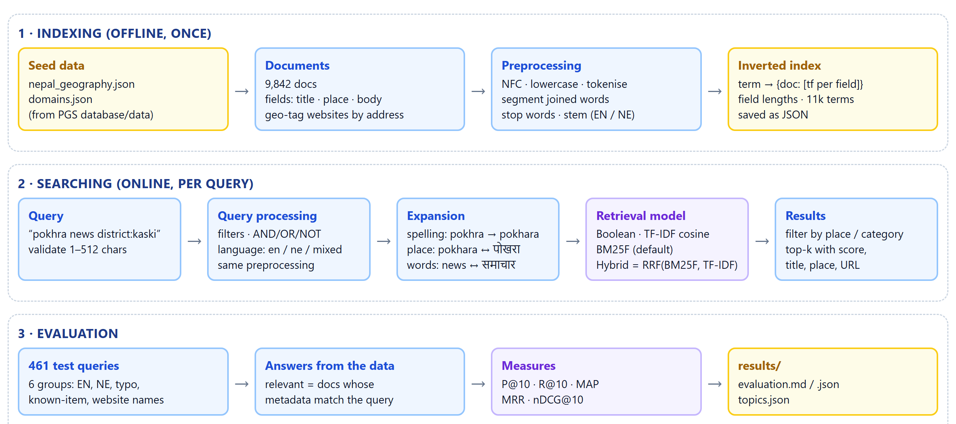

Preprocessing
The same steps are applied to the documents and to the queries, so that a word in a query becomes the same index term as in a document:
- Normalisation: convert to lowercase, normalise Unicode and remove punctuation.
- Tokenisation: split the text into words, in both the Latin and the Devanagari script.
- Word segmentation: split joined words in web addresses, for example pokharanews into pokhara and news.
- Stop-word removal: remove common words such as “the”, “of”, “को” and “मा”.
- Stemming: the Porter (1980) stemmer for English (municipalities becomes municip) and suffix removal for Nepali (काठमाडौंको becomes काठमाडौं).

Indexing
An inverted index maps every term to the documents that contain it, together with the number of times it appears in each field (Manning et al., 2008). For example, the term pokhara points to document 412, where it appears once in the title, and to document 538, where it appears once in the place field. The index has 11,352 distinct terms and 78,541 postings, takes under a second to build and is saved as a JSON file.

Retrieval Models
Four models were implemented so that they could be compared on the same index:
- Boolean model: returns the documents that contain all query words (AND), any of them (OR), or not a word (NOT). It does not rank the results.
- TF-IDF vector space model: ranks documents by the cosine similarity between the query and document vectors, where each word is weighted by its term frequency multiplied by its inverse document frequency.
- BM25, the main model: the probabilistic model used by OpenSearch and by the PGS project (Robertson & Zaragoza, 2009). It limits the effect of repeated words and adjusts for document length:
score(q, d) = Σ idf(t) · tf(t, d) · (k1 + 1) / (tf(t, d) + k1 · (1 − b + b · |d| / avgdl))
- Hybrid model: combines the BM25 and TF-IDF rankings with Reciprocal Rank Fusion (Cormack et al., 2009), the same method that PGS uses.
BM25 was chosen as the main model because it is the standard in modern search engines and works well with fields and with documents of different lengths.

Query Processing
Before searching, each query is processed in five steps:
- Validation: the query must be 1 to 512 characters long.
- Filters: the user can limit results with district:kaski, province:gandaki or category:news.
- Language detection: English, Nepali or mixed, decided from the script.
- Translation: place names and common words are translated (pokhara ↔ पोखरा, news ↔ समाचार), so an English query also finds Nepali text and the other way round.
- Spelling correction: unknown words are matched to similar words in the index (pokhra becomes pokhara).

Implementation
The system is written in Python 3 without external libraries. The code is organised into the small modules listed in Table 2.
Table 2
Project Files
File | Purpose
corpus.py | Creates the documents from the dataset
preprocess.py, porter.py | Preprocessing and the Porter stemmer
index.py | Builds, saves and loads the inverted index
models.py | Boolean, TF-IDF, BM25 and hybrid models
query.py | Query processing, translation and spelling correction
evaluate.py | Test queries and evaluation measures
__main__.py | Command-line interface

The index is built with one command, python -m pgs_ir build (Figure 2). The preprocessing function in Figure 3 is used for both documents and queries, and Figure 4 shows how the BM25 model scores each document that contains a query term.
Figure 2
Building the Index
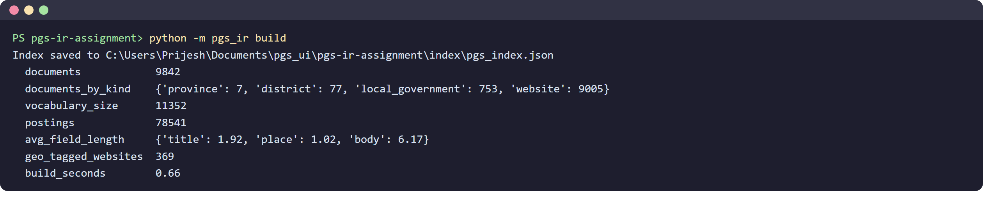
Figure 3
Preprocessing Code
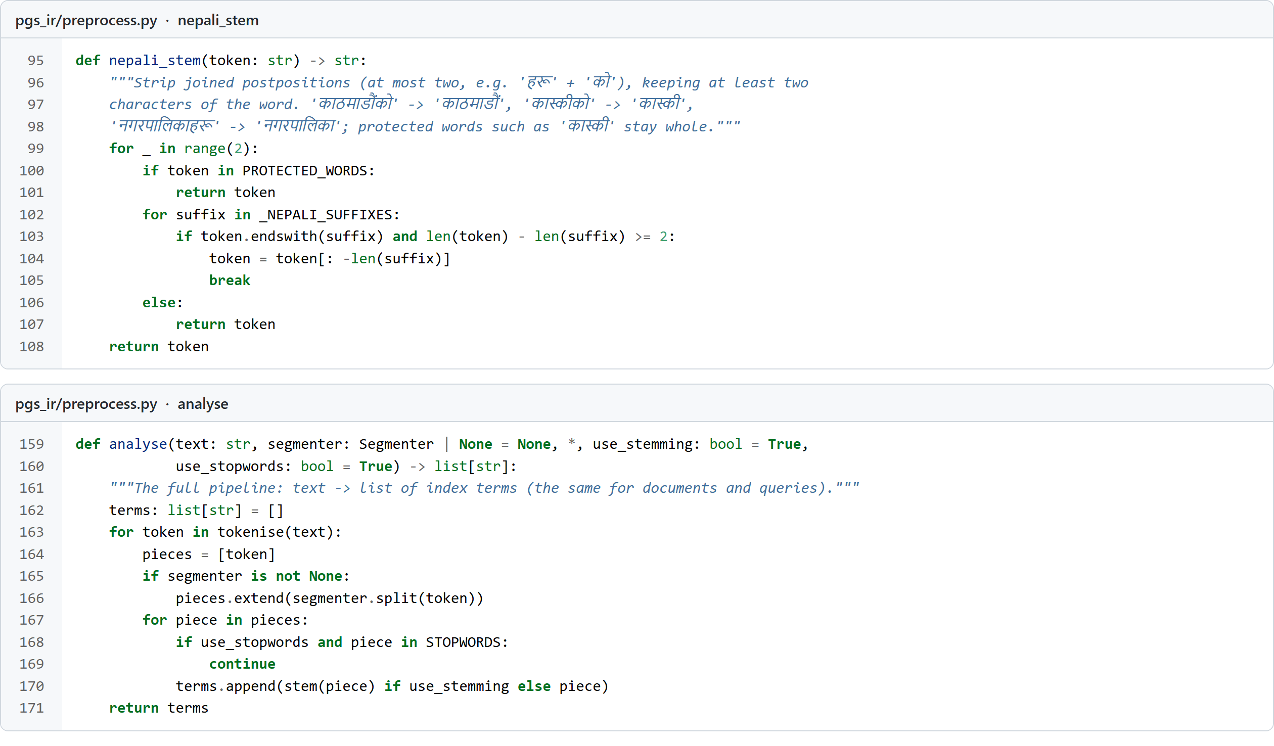
Figure 4
BM25 Ranking Code
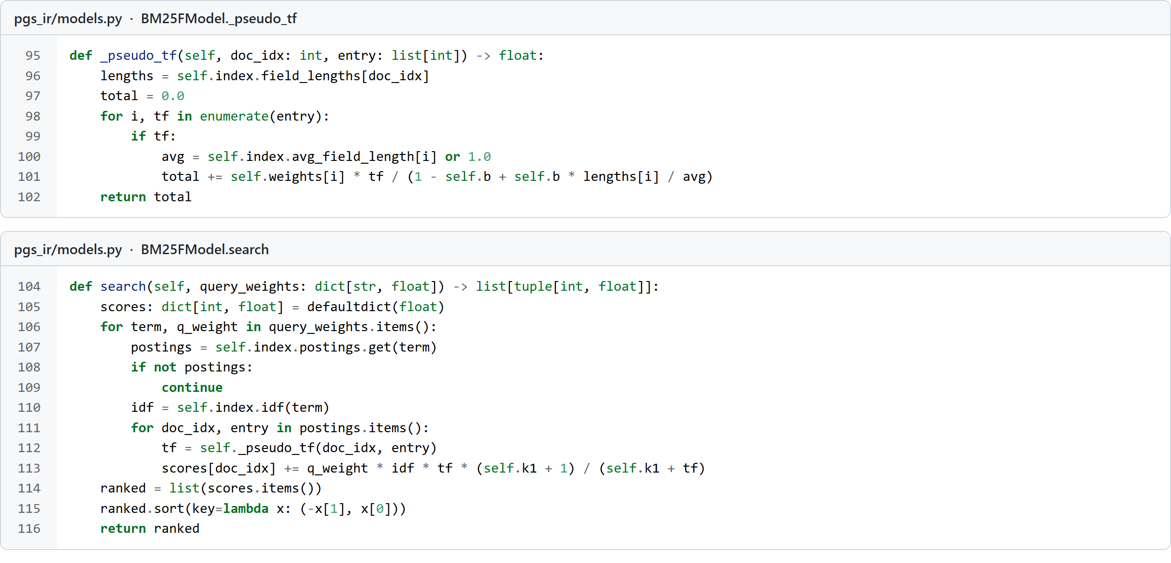

Results

Example Searches
Figure 5 shows an English query, “pokhara news”. Pokhara Metropolitan City is ranked first, followed by news websites from Pokhara. Figure 6 shows a Nepali query, “कास्कीको स्थानीय तह” (local governments of Kaski), which returns the local governments of Kaski district. Figure 7 shows that a misspelt query, “pokhra”, is corrected automatically.
Figure 5
Results for an English Query
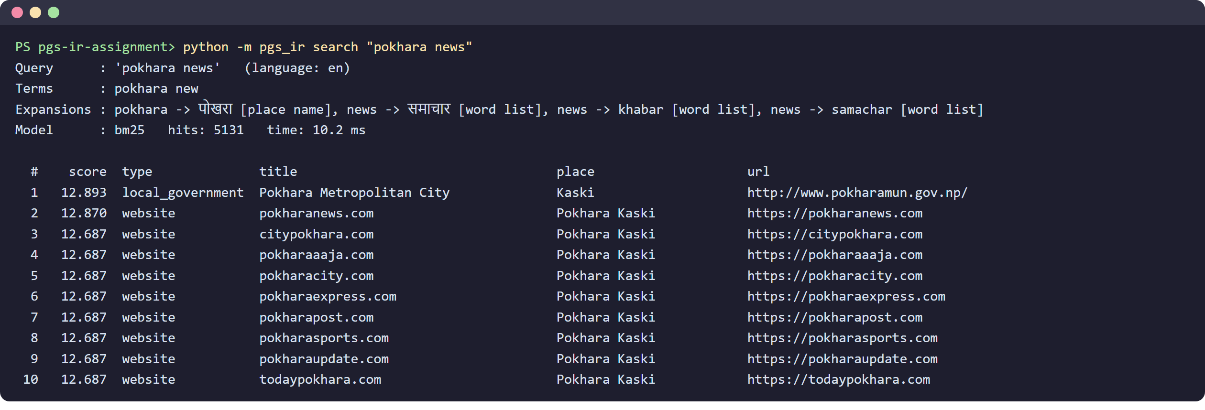
Figure 6
Results for a Nepali Query
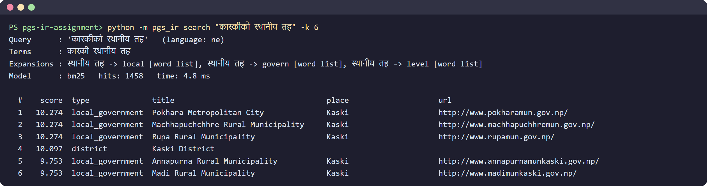
Figure 7
Automatic Spelling Correction
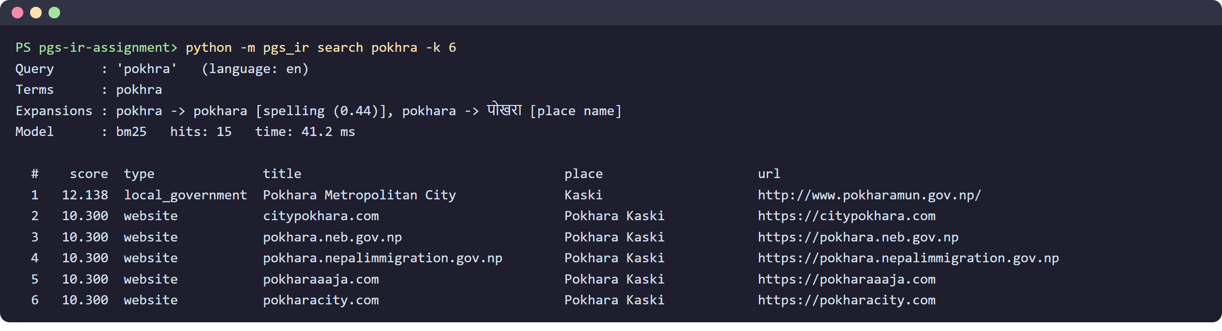

Evaluation
The models were tested on 461 test queries in English and Nepali, including place names, names with typing mistakes and website names. The correct answers were taken from the dataset itself; for example, for “local governments in Kaski district”, the correct answers are all local governments in Kaski. Results were measured with precision at 10 (P@10), mean average precision (MAP), mean reciprocal rank (MRR) and normalised discounted cumulative gain (nDCG@10; Järvelin & Kekäläinen, 2002). Table 3 and Figure 8 show the results.
Table 3
Evaluation Results
Model | P@10 | MAP | MRR | nDCG@10
Boolean (AND) | 0.341 | 0.623 | 0.616 | 0.659
TF-IDF | 0.293 | 0.652 | 0.637 | 0.669
BM25 | 0.296 | 0.643 | 0.583 | 0.657
BM25 + translation and spelling | 0.313 | 0.803 | 0.738 | 0.814
Hybrid RRF + translation and spelling | 0.296 | 0.811 | 0.816 | 0.824
Note. Higher values are better. The best value in each measure is shown in bold.

Figure 8
Comparison of the Models
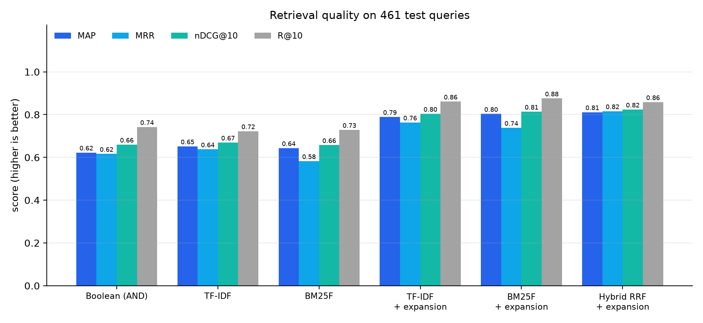

Discussion
Translation and spelling correction helped the most: they raised the MAP of BM25 from 0.643 to 0.803. The hybrid model gave the best overall results (MAP 0.811, MRR 0.816), because BM25 and TF-IDF make different mistakes and combining their rankings corrects some of them.
The Boolean model was very precise when the query words matched the documents exactly, but it found nothing when a word was misspelt and it could not rank its results. Word segmentation was essential for finding websites by name, such as “online khabar” for onlinekhabar.com.
The system has two main limitations. The documents are short (names and addresses rather than full web pages), and the test queries were generated from the data, so real user queries may give different results.

Conclusion
I designed and implemented a basic bilingual information retrieval system using a public dataset from our PGS project. It includes preprocessing, an inverted index, the Boolean, TF-IDF and BM25 retrieval models, and query processing with translation and spelling correction. The hybrid model with query expansion performed best, with a MAP of 0.811. In the future, the system could index the full text of the crawled web pages and add meaning-based (semantic) search, as the PGS project does.

Source Code
The source code is available on GitHub at https://github.com/<your-username>/pgs-ir-assignment. The index is built with python -m pgs_ir build, a search is run with python -m pgs_ir search followed by the query, and the evaluation is run with python -m pgs_ir evaluate.

References
Cormack, G. V., Clarke, C. L. A., & Büttcher, S. (2009). Reciprocal rank fusion outperforms Condorcet and individual rank learning methods. In Proceedings of the 32nd International ACM SIGIR Conference on Research and Development in Information Retrieval (pp. 758–759). ACM. https://doi.org/10.1145/1571941.1572114
Järvelin, K., & Kekäläinen, J. (2002). Cumulated gain-based evaluation of IR techniques. ACM Transactions on Information Systems, 20(4), 422–446. https://doi.org/10.1145/582415.582418
Manning, C. D., Raghavan, P., & Schütze, H. (2008). Introduction to information retrieval. Cambridge University Press.
Porter, M. F. (1980). An algorithm for suffix stripping. Program, 14(3), 130–137. https://doi.org/10.1108/eb046814
Robertson, S., & Zaragoza, H. (2009). The probabilistic relevance framework: BM25 and beyond. Foundations and Trends in Information Retrieval, 3(4), 333–389. https://doi.org/10.1561/1500000019
sagautam5. (n.d.). local-states-nepal [Data set]. GitHub. https://github.com/sagautam5/local-states-nepal
tekraj. (2026). pgs-search-engine [Computer software]. GitHub. https://github.com/tekraj/pgs-search-engine

