
MINISTRY OF EDUCATION, CULTURE AND RESEARCH
OF THE REPUBLIC OF MOLDOVA
Technical University of Moldova
Faculty of Computers, Informatics and Microelectronics
Department of Software Engineering and Automation

ANDREY UZUN FAF-242
Report
Laboratory work n.3
of Operating Systems

Checked by:
Patricia Reițman, University Assistant
DISA, FCIM, UTM

Chisinau – 2026
CONTENTS
1 INTRODUCTION 3
1.1 Purpose of the Laboratory Work 3
1.2 Environment and test data 3
2 MATERIALS AND METHODS 3
3 RESULT 4
3.1 Part 1. Move fast, find help 4
3.2 Part 2. What the shell does to your line 7
3.3 Part 3. Redirection, chaining and jobs 9
3.4 Part 4. Answer questions with one-liners 12
4 CONCLUSION 15
BIBLIOGRAPHY 16

INTRODUCTION

1.1 Purpose of the Laboratory Work
This lab is about working fast in the Linux command line. The goals are to move around bash efficiently, predict what the shell does to a command line before it runs (globbing, quoting, expansion), redirect input and output, and answer questions about data by joining small filters (grep, cut, sort, uniq, wc) with pipes.
The key idea is that the shell is only a program that rewrites the command line and starts other programs. Most of the “magic” (wildcards, variables, $(...)) happens in the shell before the program ever runs, and small tools connected by pipes can answer real questions about data.

1.2 Environment and test data
The work follows Track A of the Operating Systems course (the real OS, from the outside, Linux). All commands were run in bash on Ubuntu 26.04.1 LTS, installed in a VirtualBox virtual machine.
For the later parts, an artificial web access log of 500 lines was generated with the following commands:
mkdir -p ~/os-lab3 && cd ~/os-lab3
for i in $(seq 1 500); do
echo "2026-10-05 10:$(printf %02d $((i % 60))) user$((i % 7)) $([ $((i % 5)) -eq 0 ] && echo FAIL || echo OK) /page$((i % 4))"
done > access.log
head -3 access.log ; wc -l access.log

2026-10-05 10:01 user1 OK /page1
2026-10-05 10:02 user2 OK /page2
2026-10-05 10:03 user3 OK /page3
500 access.log

The last line prints 500 access.log, so the data set is correct. Each line of the log contains the date, the time, the user, the result (OK or FAIL) and the requested page.

2 MATERIALS AND METHODS
The lab was done entirely in the bash shell of the virtual machine, with the standard Linux tools. The main ideas used in the work are summarized below.
- Moving around and finding help: Tab completion, reverse history search (Ctrl+R), the commands type and which to see whether a command is a built-in or an external program, the PATH variable that lists the directories where the shell looks for programs, and the help sources man, --help, man -k and help.
- Expansion and quoting: before a command runs, the shell expands wildcards (*, ?, [a-b]), braces ({1..5}), variables ($HOME), command substitution ($(...)) and arithmetic ($((...))). Single quotes keep text literal, double quotes still allow $ expansions, and a backslash escapes one character.
- Redirection, chaining and jobs: each program has standard input, standard output (stdout) and standard error (stderr), which can be redirected with <, >, >>, 2> and 2>&1. Commands are chained with ;, && and || depending on the exit code, and &, jobs and kill manage background processes.
- Pipes and text filters: a pipe (|) sends the output of one program to the input of the next. The filters used are grep (select lines), cut (select fields), sort, uniq (count adjacent duplicates), wc (count lines), tail and awk.
- Verification: every answer was checked in a second way (for example, the counts per page add up to the 500 lines of the log), and all one-liners were saved in the script oneliners.sh, one per question, with the question as a comment above it.

3 RESULT

3.1 Part 1. Move fast, find help
3.1.1 Tab completion
I typed ls /usr/sh and pressed Tab twice. The first Tab completed the name to /usr/share/, and the second Tab, with several possible continuations, made bash offer to list them (Display all 253 possibilities? (y or n)). Then I typed cd /et and pressed Tab once: it completed immediately to cd /etc/, because /etc is the only match.
So Tab completes a name when it is unique, and when it is ambiguous it lists the candidates on the second press.


Figure 3.1 – Tab completion
3.1.2 Command history search (Ctrl+R)
After running pwd, whoami and date, I pressed Ctrl+R and typed pw. The prompt changed to a reverse incremental search:
(reverse-i-search)`pw': pwd

Ctrl+R searches backwards through the command history while I type, and it matched the most recent command containing those letters. Enter then ran pwd again.

Figure 3.2 – Reverse incremental history search
3.1.3 Built-in or external, and where the shell looks
type cd ; type ls ; type echo ; which ls

cd is a shell builtin
ls is aliased to `ls --color=auto'
echo is a shell builtin
/usr/bin/ls

echo $PATH | tr ':' '\n'

/usr/local/sbin
/usr/local/bin
/usr/sbin
/usr/bin
/sbin
/bin
/usr/games
/usr/local/games
/snap/bin
/snap/bin

nosuchprog ; echo "exit code: $?"

nosuchprog: command not found
exit code: 127

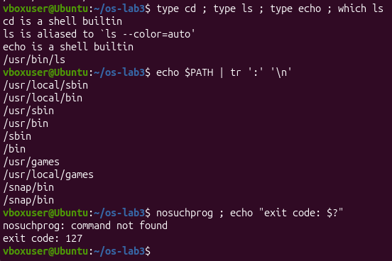
Figure 3.3 – Built-in and external commands, the PATH variable and the exit code of a missing command
3.1.4 Finding help without a browser
man ls # /sort, n for next, q to quit
ls --help | head
man -k "list directory"
help cd

man -k "list directory" found ls, dir, vdir, gnuls and others, and help cd showed the built-in's usage and options (-L, -P, -e, -@).
One difference from the handout: on this Ubuntu release ls is the Rust rewrite of coreutils (rust-ls), so ls --help is shorter than the classic GNU version, and the man page appears both as ls and gnuls. The options used in this lab behave the same.
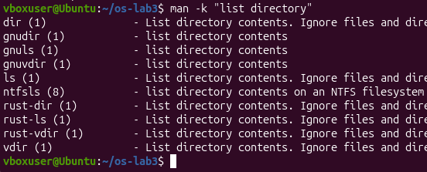
Figure 3.4 – Help from man, --help, man -k and help
3.1.5 Observations
1. Which of cd, ls, echo are built-ins, and why MUST cd be one?
cd and echo are built-ins. ls is an external program (/usr/bin/ls) that is also aliased to ls --color=auto. cd must be a built-in because the working directory belongs to the process: if cd were an external program, the shell would start it as a child process, the child would change its own directory and exit, and the shell's directory would stay unchanged.
2. How many directories are in PATH, and in which one is ls?
PATH has 10 entries, but /snap/bin appears twice, so there are 9 distinct directories. ls is in /usr/bin.
3. What exit code does a command that is not found return?
127.
4. Which option of ls sorts by modification time?
-t (newest first; -r reverses the order, so ls -ltr shows the oldest first).

3.2 Part 2. What the shell does to your line
3.2.1 Setup
A test directory was created with a few files, one of them with a space in its name:
mkdir -p ~/os-lab3/play && cd ~/os-lab3/play
touch a.c b.c file1.txt file2.txt notes.txt "alfa beta.txt"
ls

a.c 'alfa beta.txt' b.c file1.txt file2.txt notes.txt

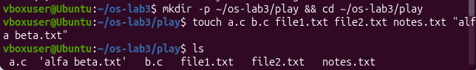Figure 3.5 – The test directory
3.2.2 Predictions and results
Before running each command, I wrote down what I expected it to print. The table compares the predictions with the real output.
Command | My prediction | Real output | Explanation (if different)
echo *.c | a.c b.c | a.c b.c
echo file?.txt | error | file1.txt file2.txt
echo [a-b]* | a.c alfa beta.txt b.c | a.c alfa beta.txt b.c
echo *.xyz | Not found | *.xyz | No file matches, so bash leaves the pattern as it is and echo prints it literally.
ls alfa beta.txt | error | ls: cannot access 'alfa': No such file or directory and the same for 'beta.txt' | Word splitting turned it into two arguments.
ls "alfa beta.txt" | 'alfa beta.txt' | 'alfa beta.txt' | Quotes keep it as one argument.
echo '$HOME' "$HOME" \$HOME | $HOME /home/vboxuser $HOME | $HOME /home/vboxuser $HOME | Only the double-quoted one is expanded.
echo {1..5} ; echo $((7 * 6)) | 1 2 3 4 5 and 42 | 1 2 3 4 5 and 42 | Brace expansion and arithmetic expansion, both done by the shell.
echo "today is $(date +%A), I am $(whoami)" | today is Sunday, I am vboxuser | today is Sunday, I am vboxuser | $(...) runs the command and substitutes its output, even inside double quotes.
touch log{1..3}.txt && ls log* | log1.txt log2.txt log3.txt | log1.txt log2.txt log3.txt | Braces create three names for touch, then log* matches them.

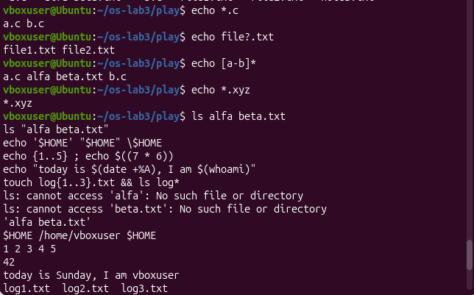Figure 3.6 – Predictions and results, part 1
Figure 3.7 – Predictions and results, part 2
Figure 3.8 – Predictions and results, part 3
3.2.3 Observations
1. Predictions vs. real output
See the table above.
2. echo knows nothing about files, yet echo *.c printed file names. Who produced them?
The shell. Before running echo, bash expands the pattern *.c against the files in the current directory and replaces it with the matching names. echo just receives a.c and b.c as two ordinary arguments and prints them. The same happens for file?.txt, [a-b]* and log*. When nothing matches (*.xyz), bash passes the pattern through unchanged.
3. Why did ls alfa beta.txt fail? Two ways to fix it.
The shell splits the line on spaces, so ls received two arguments, alfa and beta.txt, and neither file exists. Fixes:
- quote the name: ls "alfa beta.txt" (or with single quotes);
- escape the space with a backslash: ls alfa\ beta.txt.
Tab completion also works, since bash inserts the backslash automatically.
4. Difference between single and double quotes
Single quotes keep everything literal: '$HOME' prints $HOME. Double quotes protect spaces and wildcards but still allow $variable, $(command) and $((arithmetic)) to be expanded: "$HOME" prints /home/vboxuser. A backslash escapes just the next character, so \$HOME also prints $HOME.
Why ls shows 'alfa beta.txt' in quotes
ls adds quotes around names that contain special characters such as spaces when it prints to a terminal. That way the name is shown as one unit and can be copied and pasted straight into a command. The quotes are not part of the file name.

3.3 Part 3. Redirection, chaining and jobs
3.3.1 stdout and stderr into separate files
cd ~/os-lab3
ls /etc /nope > out.txt 2> err.txt
wc -l out.txt ; cat err.txt

238 out.txt
ls: cannot access '/nope': No such file or directory

The listing of /etc (238 lines, including the /etc: header) went to out.txt, and the error about /nope went to err.txt. Nothing was printed on the terminal except the output of wc and cat.
Figure 3.9 – stdout and stderr redirected into separate files
3.3.2 Both streams into one file, and the order of redirections
ls /etc /nope > all.txt 2>&1 ; tail -2 all.txt

xml
zsh_command_not_found

Both streams went to all.txt and nothing appeared on the terminal. The error line is at the top of the file (stderr is written immediately, while the listing is written afterwards), so tail shows only the end of the listing.
Now the two orders compared:
ls /etc /nope > all.txt 2>&1
ls /etc /nope 2>&1 > all.txt

The first prints nothing: the listing and the error are both in all.txt. The second prints ls: cannot access '/nope': No such file or directory on the terminal, and all.txt contains only the listing.
3.3.3 Appending, input redirection, chaining
echo first > notes.md ; echo second >> notes.md ; cat notes.md

first
second

wc -l < access.log

500

ls /nope 2> /dev/null || echo "failed with code $?"

failed with code 2

mkdir -p tmp && cd tmp && echo "I am in $(pwd)" ; cd ~/os-lab3

I am in /home/vboxuser/os-lab3/tmp

Figure 3.10 – Appending, input redirection and chaining
3.3.4 Background job
sleep 100 &
jobs ; kill %1 ; jobs

[1] 15219
[1]+ Running sleep 100 &
[1]+ Running sleep 100 &
[1]+ Terminated sleep 100

& started sleep in the background and gave job number 1 (PID 15219). kill %1 sent it a termination signal. The second jobs still said Running because the signal was only just delivered, and the shell reported Terminated right before the next prompt.
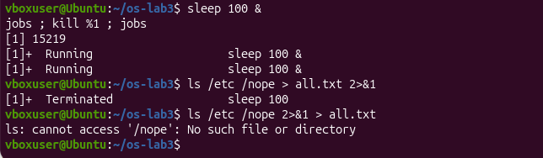Figure 3.11 – A background job started with & and stopped with kill
3.3.5 Observations
1. Which file got the error message, and which got the listing?
err.txt got the error (ls: cannot access '/nope'...), and out.txt got the listing of /etc.
2. > all.txt 2>&1 vs 2>&1 > all.txt
The shell processes redirections from left to right. In > all.txt 2>&1, stdout is first pointed at all.txt, then stderr is made a copy of stdout, so both end up in the file. In 2>&1 > all.txt, stderr is first made a copy of stdout while stdout is still the terminal, and only afterwards stdout is moved to the file. So stderr stays on the terminal and only the listing goes to all.txt. 2>&1 means “send stderr to wherever stdout points right now”, not “to stdout forever”.
3. Why does wc -l < access.log print only a number?
With <, the shell opens the file and wc reads from standard input, so it never learns the file name and has nothing to print next to the count. With wc -l access.log, the file name is an argument, so wc prints it after the count.
4. The operators
- ; runs the next command regardless of whether the previous one succeeded;
- && runs the next command only if the previous one succeeded (exit code 0);
- || runs the next command only if the previous one failed (non-zero exit code).

3.4 Part 4. Answer questions with one-liners
Each line of access.log is: date, time, user, result (OK or FAIL), page. With cut -d' ' the fields are 1 = date, 2 = time, 3 = user, 4 = result, 5 = page. All commands are saved in oneliners.sh, one per question with the question as a comment above it, and the file runs with bash oneliners.sh inside ~/os-lab3.
3.4.1 Q1. How many requests failed?
grep -c FAIL access.log

100

grep -c counts the matching lines. Every 5th request fails, so 500 / 5 = 100.
3.4.2 Q2. How many different pages were requested, and which?
cut -d' ' -f5 access.log | sort -u | wc -l ; cut -d' ' -f5 access.log | sort -u

4
/page0
/page1
/page2
/page3

cut extracts the page field, sort -u sorts and removes duplicates, and wc -l counts what is left. The ; runs the same pipeline twice: once for the count and once for the list.
3.4.3 Q3. How many requests did each page get?
cut -d' ' -f5 access.log | sort | uniq -c

125 /page0
125 /page1
125 /page2
125 /page3

uniq -c counts only adjacent duplicates, so sort has to come first. Check: 4 × 125 = 500, which matches the number of lines in the log.
3.4.4 Q4. Which user or users have the most failed requests, and how many?
grep FAIL access.log | cut -d' ' -f3 | sort | uniq -c | sort -rn | awk 'NR==1{m=$1} $1==m'

15 user5
15 user3

Two users share the top place with 15 failures each, so a plain head -1 would have hidden one of them. The awk stores the count from the first line (the maximum, since the list is sorted) in m and prints every line with that same count.
Self-check: without the final awk the pipeline lists all users. Users 5 and 3 have 15 failures each and the other five users have 14 each, so 15 + 15 + 5 × 14 = 100, which equals the answer to Q1.
grep FAIL access.log | cut -d' ' -f3 | sort | uniq -c | sort -rn

3.4.5 Q5. How many requests did user3 make, and how many of them failed?
grep -c ' user3 ' access.log ; grep ' user3 ' access.log | grep -c FAIL

72
15

The spaces around user3 make sure only that user matches. The second command filters twice: first by user, then by result. The 15 failures also agree with the Q4 list.
3.4.6 Q6. Print the last 3 failed requests, showing only time and user.
grep FAIL access.log | tail -3 | cut -d' ' -f2,3

10:10 user0
10:15 user5
10:20 user3

The order matters: first filter the failures, then keep the last three lines with tail -3, and only then cut out the fields. If cut came first, tail would have no result column to filter on.
3.4.7 Q7. Which login shells appear in /etc/passwd, and how many accounts use each?
cut -d: -f7 /etc/passwd | sort | uniq -c | sort -rn

40 /usr/sbin/nologin
6 /bin/false
2 /bin/bash
1 /bin/sync

Here the separator is : and the shell is field 7. In total there are 49 accounts. Most of them are system or service accounts with nologin or /bin/false, which cannot log in interactively; only two use /bin/bash.
3.4.8 Q8. Why do ls /etc | wc -l and ls -l /etc | wc -l differ by exactly one?
ls /etc | wc -l ; ls -l /etc | wc -l

237
238

ls -l prints an extra first line, total N, which is a summary of the disk blocks used and is not a file. wc -l counts it like any other line, so the long listing has one line more than the number of entries.
ls -l /etc | head -1

3.4.9 Bonus. Failed requests where the minute ends in 0
grep -E '10:[0-5]0 .* FAIL' access.log | wc -l

50

The pattern means: 10:, then a minute digit from 0 to 5, then 0, then anything, then FAIL. There are 50 such requests.
3.4.10 Full run
bash oneliners.sh

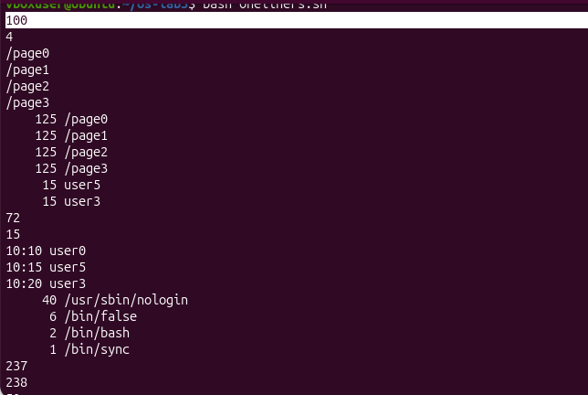Figure 3.12 – Output of oneliners.sh
- The Q3 counts add up to 500, the number of lines in the log.
- The per-user failure counts behind Q4 add up to 100, the answer to Q1.
- Q5 (user3 with 15 failures) agrees with the Q4 list.

4 CONCLUSION
In this lab I worked with Linux from the command line and saw what the shell actually does with the text I type.
- Part 1: I learned to move faster with Tab completion and Ctrl+R history search, and to find help without a browser (man, --help, man -k, help). I also saw the difference between built-in and external commands. cd has to be a built-in, because a child process cannot change the working directory of its parent shell. The shell finds external programs by searching the directories in PATH (ls is in /usr/bin), and a command that is not found returns exit code 127.
- Part 2: the shell rewrites the command line before the program runs. Wildcards (*, ?, [a-b]), braces, $(...) and $((...)) are all expanded by the shell, not by echo or ls. A pattern that matches nothing is passed through unchanged, an unquoted space splits one name into two arguments, and quoting controls what gets expanded: single quotes keep everything literal, double quotes still allow $ expansions.
- Part 3: every program has stdout and stderr, and they can be redirected independently with >, >>, 2> and <. Redirections are processed from left to right, which is why > all.txt 2>&1 and 2>&1 > all.txt give different results. The operators ;, && and || chain commands depending on the exit code, and & with jobs and kill manages background processes.
- Part 4: small tools joined by pipes can answer real questions about data. Building each pipeline one stage at a time (grep, cut, sort, uniq, wc, tail) made the answers easy to check: the page counts add up to 500 lines, and the per-user failure counts add up to the 100 failures from Q1. The “most failures” question had a tie between two users, a reminder to check the data before trusting head -1. The Q8 puzzle was explained by the total line that ls -l prints.
Overall, the main lesson is that the command line is a set of small programs connected by the shell, and understanding the order of expansion, redirection and pipes makes it possible to predict and debug any command before running it.

BIBLIOGRAPHY
- GNU Bash Reference Manual – https://www.gnu.org/software/bash/manual/bash.html
- GNU Coreutils Manual – https://www.gnu.org/software/coreutils/manual/coreutils.html
- Linux man-pages project – https://man7.org/linux/man-pages/

