JOB RECOMMENDATION SYSTEM 📑

***Wireframe Documentation***

Homepage

We have divided Job Recommender System’s Homepage into three Sections: -

1. For Job Seekers
2. Resume Analyzer
3. For Recruiters

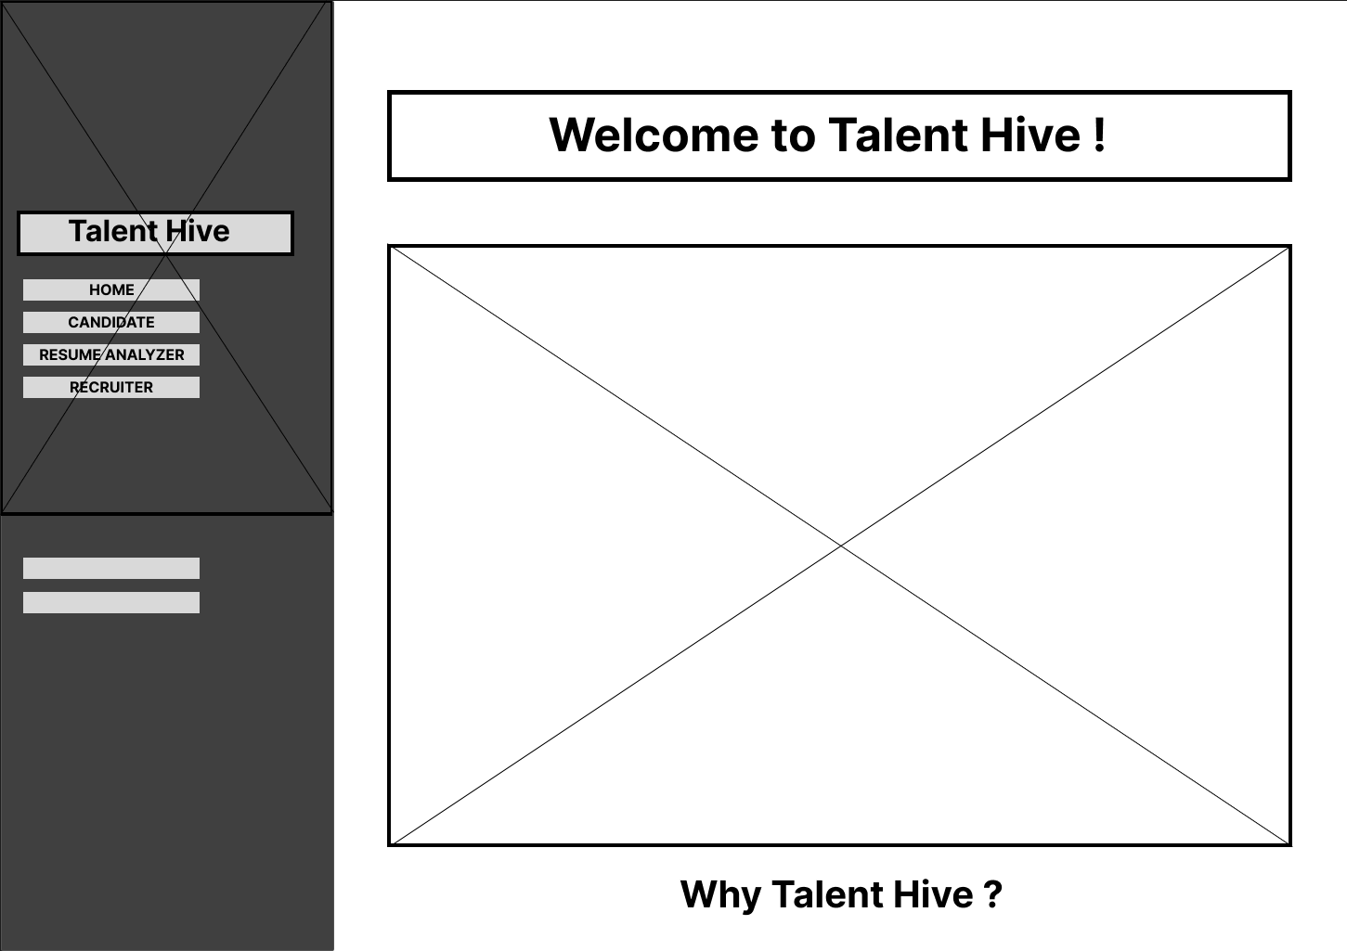



I AM A CANDIDATE PAGE

1. For Job seekers :

* First thing anyone will see when they go on “I am a Candidate” page which will ask for User Inputs which will be his/her Resume in pdf format.

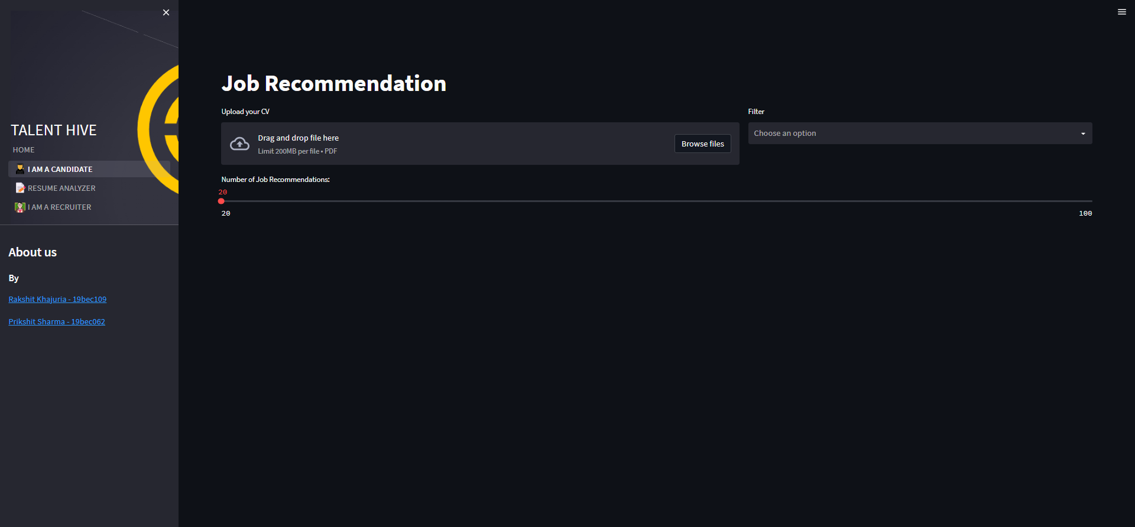

* Based on User’s input (Resume), our Job Recommendation System will recommend Jobs to User on the page itself it will include a Map which will pinpoint all the locations in which the user can get a job with the companies Ratings and Review count, also there is a filter for user to choose any desired locations.

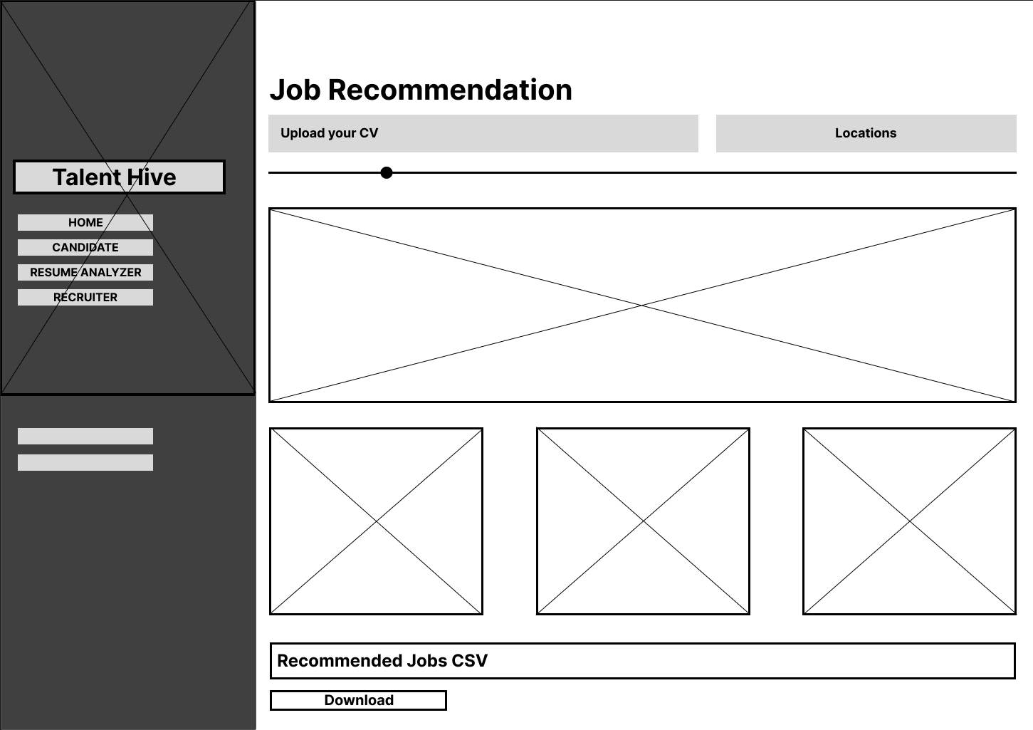

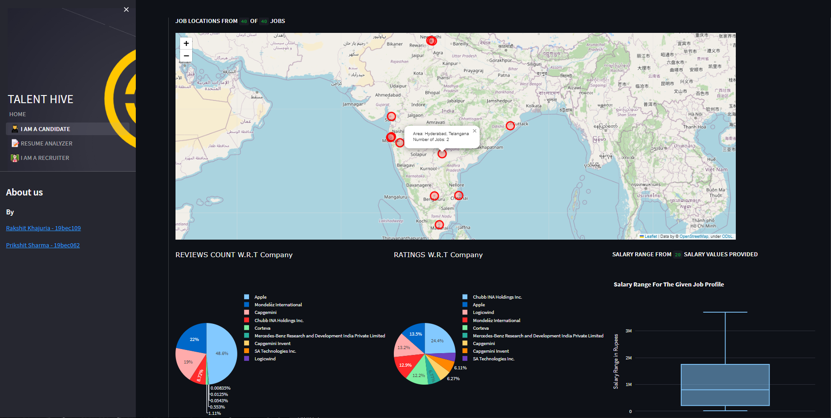

A sample view of our recommendation system showing the results

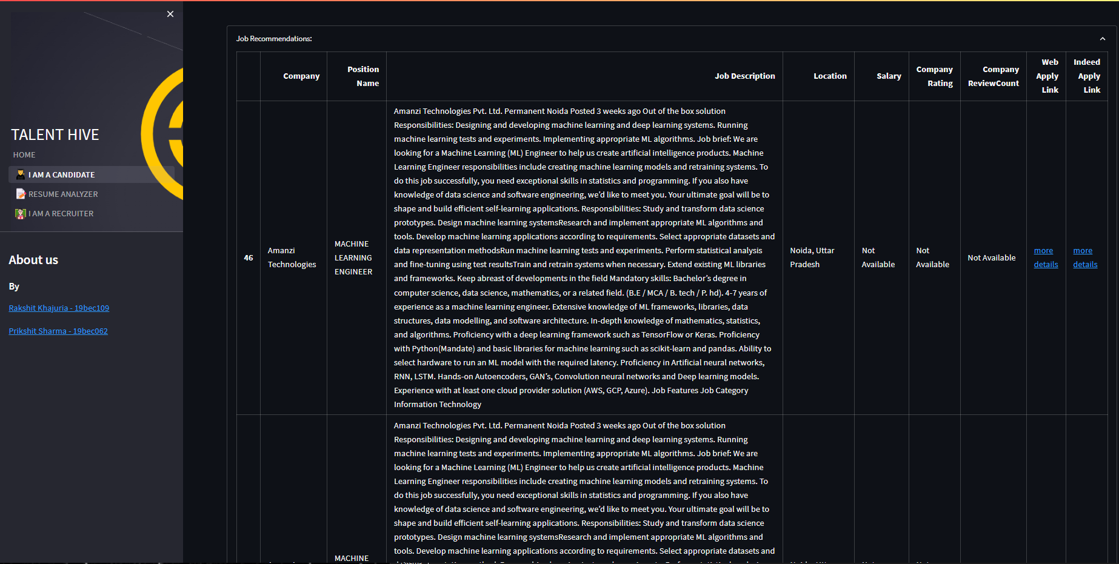

A sample view of our recommendation system showing the results

* With the help of a slider, the candidate can control the number of job posts they want to see, ranging from 0 to 100 and with the help of a filter candidate can filter the job posts based on the location .

RESUME ANALYZER

2. Resume Analysis:

* The user provides their resume in PDF format as input to our system.

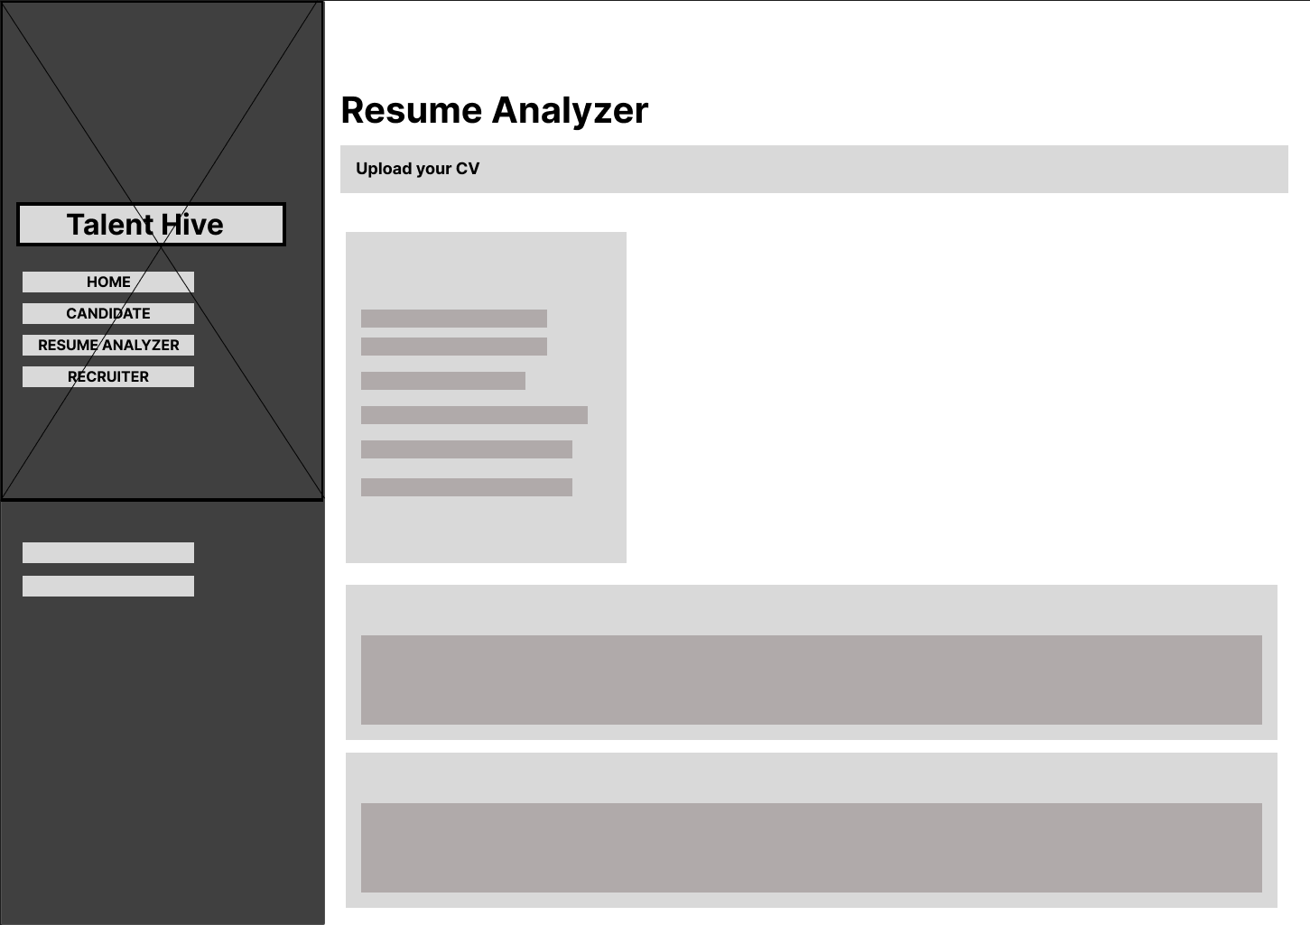

* Our advanced algorithms extract relevant information from the resume, which is then presented in an interactive and visually appealing format. The system also provides personalized recommendations for skills and courses that would be beneficial for the user's career goals. Additionally, the system evaluates the quality of the resume by generating scores based on various key metrics.

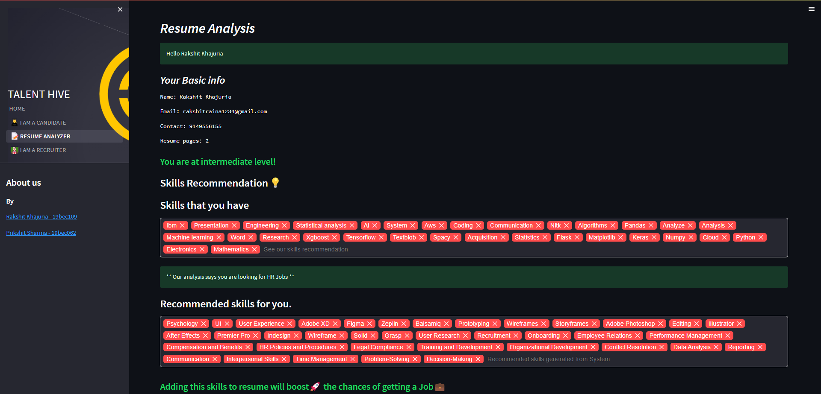

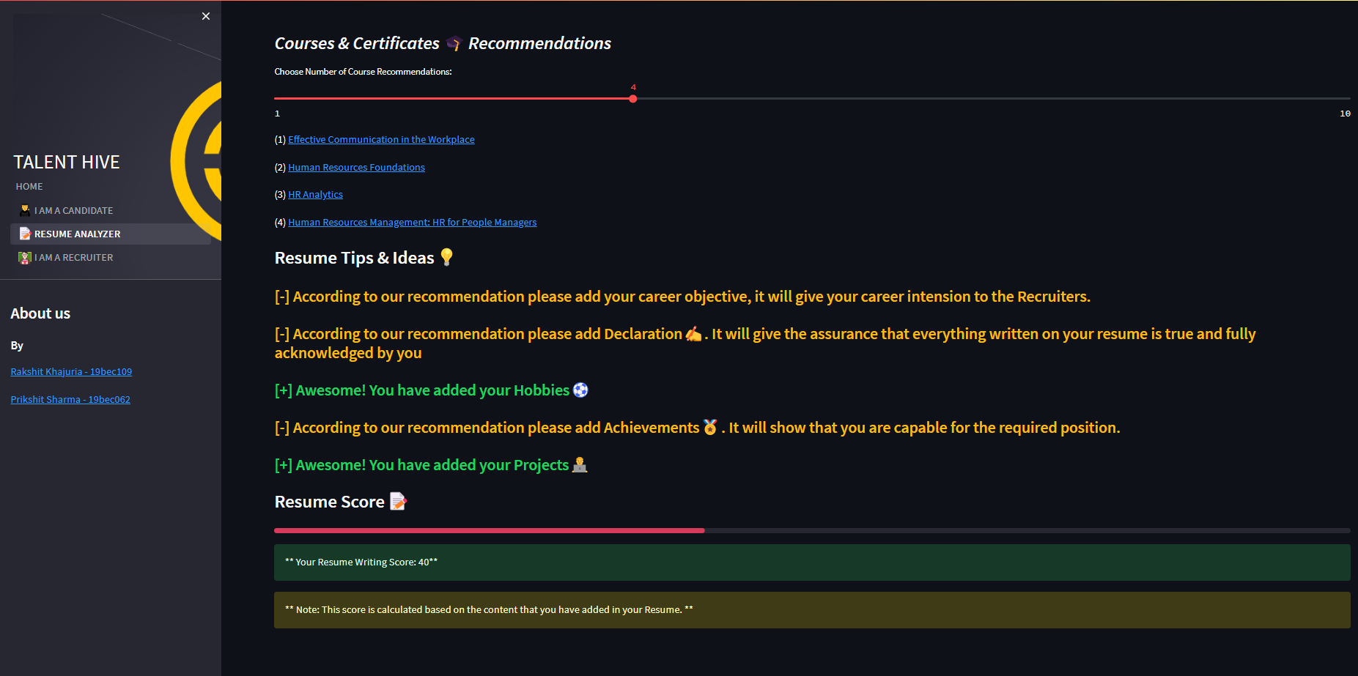

A sample view of our Resume Analyzer showing the results

I AM A RECRUITER

3. For Recruiters:

* The recruiter provides a job description or a list of job requirements as input to our system.

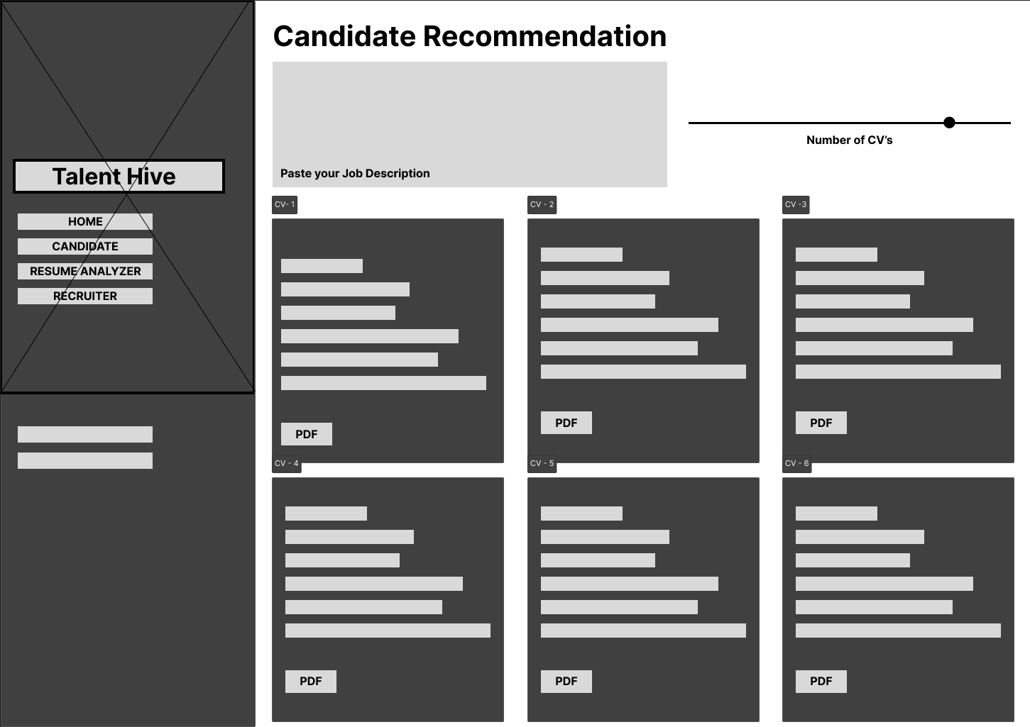

* Our advanced algorithms analyze the input and recommend resumes of candidates who match the job requirements.

A sample view of our candidate recommender showing the results

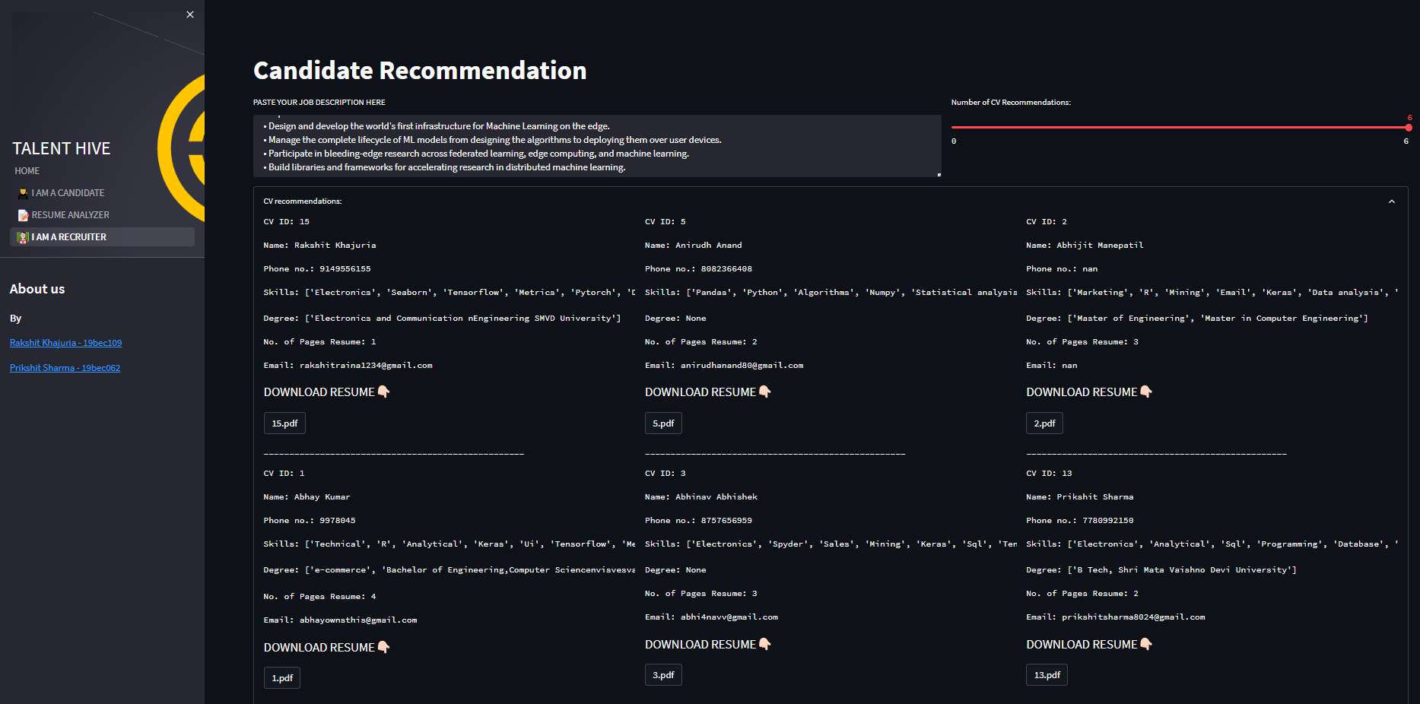

* With the help of a slider, the recruiter can control the number of recommended resumes they want to see, ranging from 0 to 6.