Luminous AI
Smart Campus Safety & Unified ERP Platform
System Architecture, Technical Specification & Engineering Verification Document

1. Executive Summary & Problem Statement

1.1 Selected Problem Statement
Problem 2: AI-Powered Smart College/School ERP & Campus Safety Platform. The challenge calls for a unified and secure education management platform covering institutional administration and campus safety, including student management, attendance, fees, exams, timetables, faculty management, communication, transport, hostel, placement, parent communication and complaints, with a dedicated campus safety and security layer.
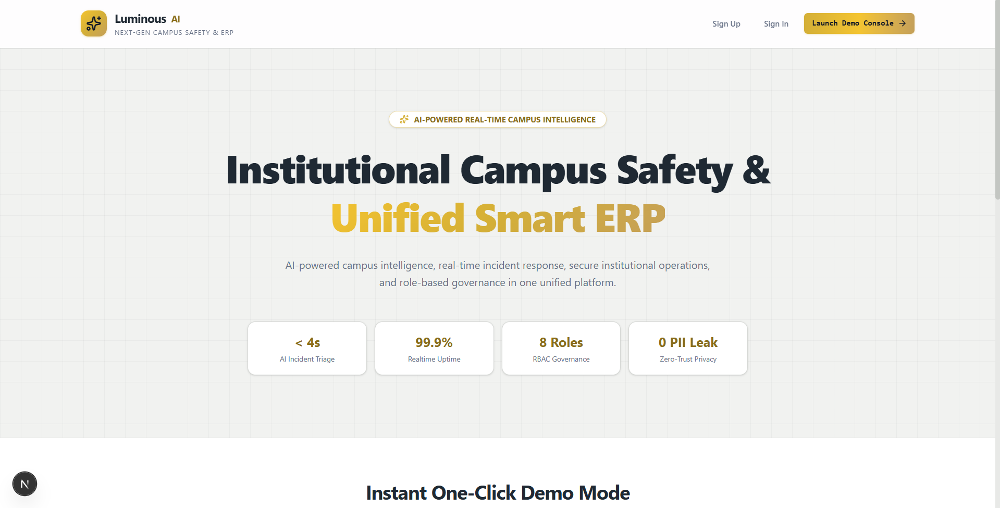
Figure 1: Luminous AI Landing Page — Homepage Hero and Primary Platform Positioning

1.2 The Adoption Paradox
Campus safety is a critical operational challenge across modern academic institutions. Traditional campus safety applications suffer from a severe adoption paradox: standalone emergency mobile applications experience an estimated 99% abandonment rate because students rarely download or open an application intended solely for rare emergency events. In contrast, academic ERP systems—which manage daily lecture schedules, attendance records, hostel gate passes, exams, and grades—maintain near 100% daily active student engagement, but lack real-time safety, geospatial, or emergency telemetry capabilities.

1.3 Our Response
Luminous AI resolves this structural gap by natively integrating real-time spatial emergency response and psychological safety intelligence inside the daily academic ERP workflow. Everyday operational modules serve as a continuous, passive safety net, ensuring that security infrastructure is already active and available whenever an emergency arises.
Core Innovation: Timetable-Derived Indoor Dead-Reckoning
GPS signals degrade significantly inside multi-story reinforced concrete campus buildings, frequently resulting in horizontal inaccuracies exceeding 50 to 100 meters. Luminous replaces costly physical Bluetooth/BLE beacon hardware with an algorithmic solution: when an emergency SOS is triggered indoors, PostGIS spatial algorithms cross-reference the degraded GPS radius against the student's live academic timetable schedule. The system deterministically identifies the exact academic block, floor, and classroom where the student is scheduled, routing responders directly to the room.

1.4 Why This Problem Was Selected
- It addresses a broad, real-world institutional problem rather than a narrow single workflow.
- It creates room for meaningful AI use: incident classification, severity assessment, summaries, recommendations and natural-language operational assistance.
- It allows a strong visual demonstration through a live safety command center, campus map, alerts and role-specific dashboards.
- It supports multiple stakeholders—students, faculty, parents, security teams, administrators, hostel staff and placement teams—making the platform demonstrably useful beyond one user type.

2. What Makes Luminous AI Different
Typical ERP | Luminous AI
Primarily administrative | Administrative + safety operations integrated in a single platform
Static records and workflows | Real-time / near-real-time safety intelligence and live campus telemetry
Generic dashboards for all users | Role-specific operational experiences tailored to 8 institutional personas
Manual incident interpretation | AI-assisted triage, severity classification, and clinical recommendations
Separate security tools and apps | Safety layer integrated natively into the institutional daily workflow
Chatbot as a decorative add-on | Copilot tied to authorization context with zero-trust FERPA boundaries
Beacon/BLE hardware for indoor positioning | Zero-CapEx timetable-derived algorithmic indoor dead-reckoning
Continuous GPS surveillance | Zero-Knowledge Privacy (Ghost Mode): location captured only on explicit events

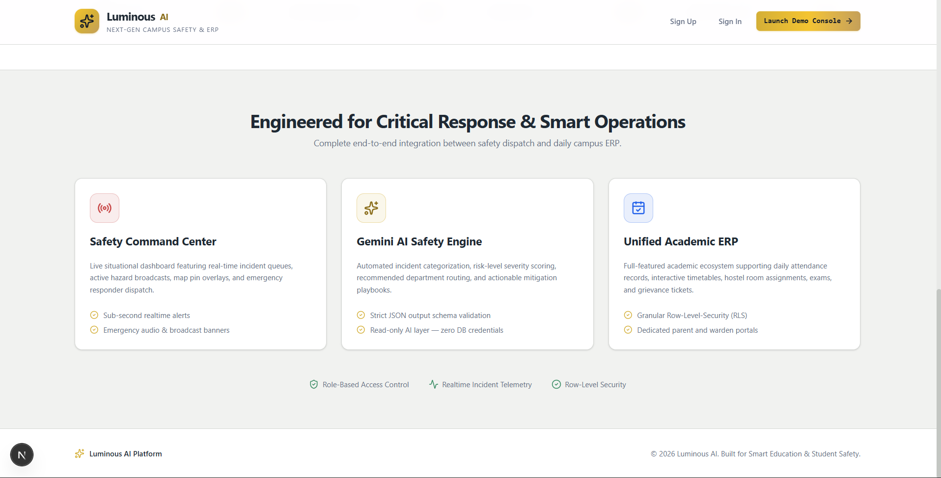
Figure 2: Feature Pillars & Institutional Capabilities Architecture

2.1 Practical Value
- Reduces fragmentation by putting major institutional workflows behind one platform.
- Gives security teams a real operational view instead of isolated complaints or spreadsheets.
- Reduces incident-processing time through AI-assisted classification and summarization.
- Makes safety part of ordinary campus workflows rather than a separate security product.
- Improves visibility for administrators while preserving role-specific access boundaries.

3. Multi-Tier System Architecture
Luminous is constructed across six modular, zero-trust architectural tiers engineered for high availability, sub-second latency, and strict data privacy. The production codebase comprises 39 frontend pages, 7 API endpoints, 23 React component modules, 21 service and utility files, 8 serverless Edge Functions, and 10 structured SQL migration files.
Architectural Tier | Primary Technologies | Core Responsibilities
Presentation Tier | Next.js 16.3.1 (App Router), React 19, Tailwind CSS v4, Lucide Icons, Recharts | 39 responsive frontend pages and 7 API endpoints (46 total routes), real-time dispatch dashboards, interactive campus map via Leaflet.js + OpenStreetMap, and PWA capabilities.
API Gateway Tier | Next.js Server API Routes, Zod v4 Schema Validation, Middleware Proxy | Strict payload validation, HTTP 400 rejection on malformed inputs, XSS URL sanitization, security headers injection, and role-based route clearance across 8 personas.
Spatial Engine Tier | PostgreSQL 17 with PostGIS 3.3.7 | Geodesic KNN guard dispatching (ST_Distance), geofence polygon matching (ST_Within), spatial radius broadcasts, and 5 custom SQL RPC spatial functions.
AI Intelligence Tier | Google Gemini 2.0 Flash SDK, Deterministic Rule Fallback Engine | Zero-Trust Copilot, automated tip categorization, mental health crisis triage, 3-bullet clinician briefings, and predictive 0–100 Campus Risk Scoring.
Database & Security Tier | Supabase PostgreSQL 17, Row-Level Security (RLS) | 14 relational tables, 10 enumerations, ~50 declarative RLS policies, FERPA data privacy barriers, and cryptographic JWT session management.
Offline Resilience Tier | Native Mobile SMS URI Schemes | Zero-connectivity emergency panic beacon with pre-populated GPS coordinates and medical telemetry via cellular SMS.

3.1 AI Safety Boundaries & Governance
- AI is positioned as an operational assistant, not an autonomous authority for high-impact decisions.
- AI responses are constrained to the user's authorization scope via server-side RBAC verification.
- Structured AI outputs are validated before downstream use in incident management workflows.
- The AI layer never receives database credentials; all queries execute through RLS-protected clients.
- Failures, timeouts, and invalid AI output trigger graceful deterministic fallback engines.

4. Core Functional Modules & Feature Catalog

4.1 Tiered Emergency SOS & Offline Failsafe
- Dual-Level Severity Pipeline: Provides Level 1 (Internal Campus Security Dispatch) and Level 2 (Police / 112 Direct Escalation) distress workflows.
- Automated Medical & Profile Telemetry: Dispatches alerts containing verified coordinates, indoor building location, blood group, and medical conditions.
- Zero-Data SMS Failsafe: In zero-connectivity campus basements, automatically generates an SMS URI with encrypted coordinates sent to campus dispatchers.
- 7-Stage Incident Lifecycle: Full incident progression tracking: Reported → AI Triage → Assigned → Acknowledged → Dispatched → Arrived → Resolved.

4.2 Indoor Dead-Reckoning via Academic Timetable
- Automated Accuracy Thresholding: Evaluates GPS horizontal accuracy; if accuracy exceeds 50 meters, triggers timetable fallback algorithms.
- Spatial Cross-Validation: Queries timetable_slots matching user ID, current day, and timestamp to extract scheduled building and classroom.
- Zero-CapEx Resolution: Presents responders with high-confidence room-level location tags without requiring hardware beacons.

4.3 Live Campus Map & Severity Visualization
- Interactive Spatial Topology: Visualizes campus buildings, active incident pins, real-time security patrol markers, and zone severity overlays.
- Severity-Driven Overlays: Color-coded severity markers (Critical, High, Medium, Low) enable security dispatchers to triage multi-location events instantly.
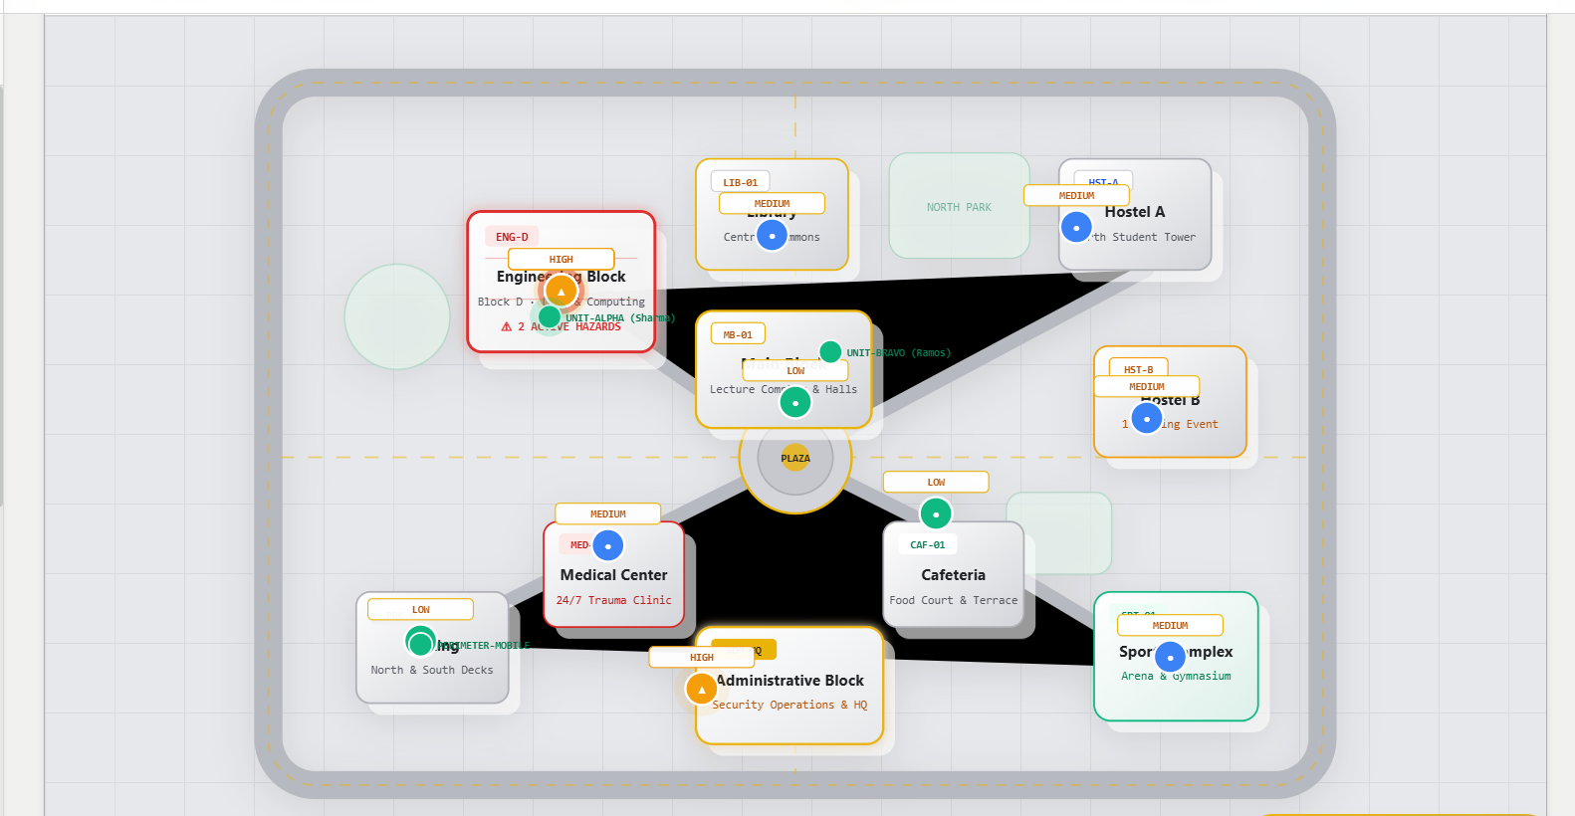
Figure 3: Live Campus Map — Severity-Coded Incident Visualization Across Institutional Locations

4.4 Automated AI Incident Classification & Grievance Triage
- Autonomous Multi-Class Categorization: Classifies campus tips and complaints into categories (Ragging, Harassment, Infrastructure, Medical, Academic, Other).
- Automated SLA Prioritization: Assigns severity indices (Low, Medium, High, Critical) and routes notifications to designated department heads.
- Deterministic Fallback Engine: If the primary Gemini API is unreachable, deterministic expert rule heuristics process incidents with high confidence.
- Whistleblower Identity Sanitization: Masks anonymous incident reports on public feeds to protect whistleblower identity while preserving audit trails.

4.5 AI Predictive Risk Intelligence & Pattern Mining
- Campus Risk Score (0–100): Computes a dynamic 0–100 Campus Risk Score across 6 mandatory evaluation categories (Infrastructure, Security, Fire, Crowding, Hostel, Transport).
- Spatial Pattern Cluster Detection: Detects recurring hazard clusters (e.g. Block D 7-incident infrastructure cluster) and generates targeted operational recommendations.
- SLA Response Trend Analysis: Analyzes incident response time trends and SLA compliance metrics to identify operational bottlenecks.

4.6 Mental Health Crisis Triage & Counselor Warm Handoff
- Crisis Urgency Assessment: Analyzes conversational inputs to detect self-harm, assault, or high distress while deflecting low-urgency spam.
- AI Warm Handoff Briefing: Generates a structured 3-bullet factual summary and recommended clinical engagement approach for licensed therapists.
- Therapist Slot Load Balancing: Assigns students to available counselors based on active session load balancing and current schedule slots.

4.7 Zero-Trust CampusShield AI Copilot
- Server-Side Authorizer Gateway: All Copilot tools execute behind a server-side authorization gateway checking authenticated JWT roles.
- FERPA Isolation Protocol: Strict barriers prevent students from viewing peer academic/attendance data and parents from viewing unlinked children.
- Prompt Injection Hardening: Deflects prompt injection attacks, system prompt leakage attempts, and conversational role spoofing.
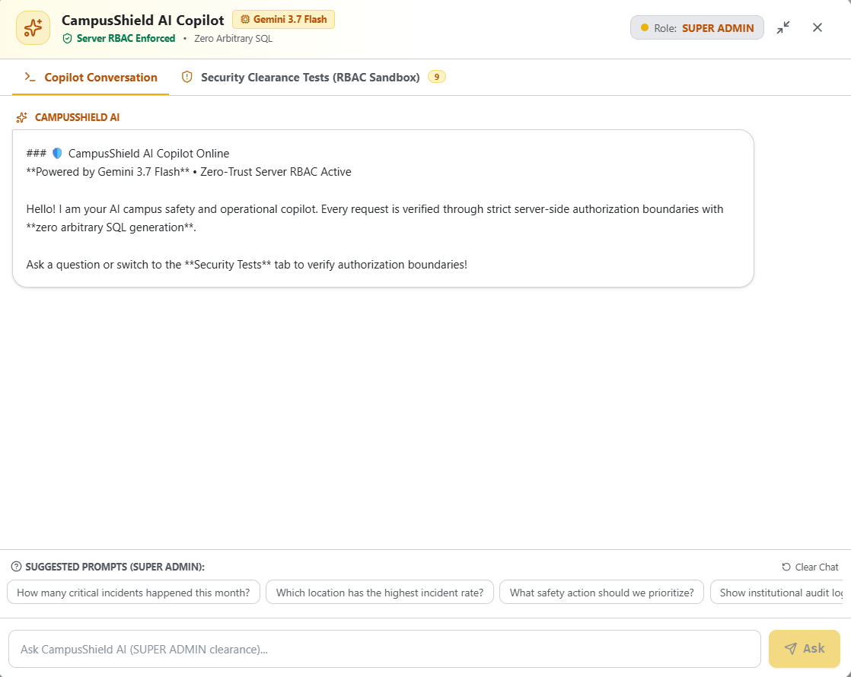
Figure 4: CampusShield AI Copilot — Natural Language Operational Interface with Server-Side RBAC Guard

4.8 Zero-Knowledge Privacy Architecture (Ghost Mode)
- Zero-Telemetry Default: Student GPS coordinates are never streamed continuously to the server during routine campus operations.
- Event-Triggered Location Capture: Location is captured exclusively on explicit safety events, tagged with an immutable location_reason enum (sos, attendance, night_walk).
- Privacy-by-Design Guarantee: Eliminates passive surveillance concerns while ensuring full location fidelity during genuine safety events.

4.9 Campus ERP Integrations (Attendance, Hostel, Leave Passes)
- Geofenced Class Attendance: Automates lecture attendance marking when student position falls inside building polygon boundaries (ST_Within).
- Hostel Outing & Gate Pass Cross-Validation: Captures off-campus destination coordinates and cross-validates SOS GPS against approved leave destinations within 500m using find_active_outing() spatial RPC.
- Night Walk Escort Mode: Monitors solo evening travel across campus with periodic heartbeat check-ins and automated trusted-circle escalation.
- Fake Call Simulation: Frontend simulated incoming call overlay to discreetly exit unsafe situations without drawing attention.

5. Database Architecture & PostGIS Data Model
The database is built on PostgreSQL 17 with PostGIS 3.3.7, comprising 14 core tables, 10 enumerations, PostGIS spatial geometries, 5 custom SQL RPC spatial functions, 3 materialized views, and ~50 declarative RLS policies. The schema is managed through 10 structured SQL migration files totaling over 97 KB of production-grade DDL.
Table Name | Primary Columns & Geometries | Constraints & FKs | RLS Model
users | id (UUID), name, email, role, department, current_location (GEOGRAPHY), blood_group, medical_conditions | PK: id -> auth.users; role enum | Self-update; Guard/Admin read.
incidents | id, reported_by, sos_level, location (GEOGRAPHY), fallback_building, status, assigned_to, ai_classification (JSONB) | FK: reported_by, assigned_to -> users | Own read; Guards active; Admin all.
campus_buildings | id, name (UNIQUE), location (POINT, 4326), boundary (POLYGON, 4326), floors | Spatial polygon constraint | Public read; Admin write.
timetable_slots | id, user_id, day, start_time (TIME), end_time (TIME), subject, building, room | FK: user_id -> users; Composite index | Own read; Faculty/Admin full.
tips | id, reported_by (NULLABLE), anonymous, text, ai_category, ai_severity, status | FK: reported_by, reviewed_by -> users | Universal insert; Admin read.
therapy_sessions | id, student_id, therapist_id, urgency, ai_warm_handoff (JSONB), status | FK: student_id, therapist_id -> users | Student-therapist dual; Admin audit.
therapist_profiles | user_id (PK), specialization, currently_busy, active_session_with, sessions_today | FK: user_id -> users; load counter | Therapist manage; Student read.
attendance | id, user_id, date, status, method, building, timetable_slot_id | FK: user_id -> users; UNIQUE constraint | Own read; Faculty verify; Admin.
outing_requests | id, student_id, destination_name, destination_location (POINT, 4326), purpose, status, approved_by | FK: student_id, approved_by -> users; outing_status enum | Student files; Warden approves.
trusted_circle | id, user_id, trusted_user_id, created_at | FK both -> users; CHECK(id1!=id2) | User manages own circle.
night_walk_sessions | id, user_id, is_active, started_at, last_heartbeat, ended_at | FK: user_id -> users; partial index | User + security responders.
broadcasts | id, title, message, type, target_location (POINT), target_radius_meters | FK: created_by -> users; type enum | Public read; Admin/Security write.
emergency_contacts | id, user_id, name, phone, relation, is_primary | FK: user_id -> users | User + responder read/write.
therapist_slots | id, therapist_id, day, start_time, end_time, is_booked | FK: therapist_id -> users | Public read; Therapist write.

5.1 Custom SQL RPC Spatial Functions
Function Name | Spatial Operation | Use Case
find_nearest_responder() | ST_Distance geodesic KNN ordering | Dispatches nearest available guard/volunteer to SOS location.
check_location_within_radius() | ST_DWithin radius containment | Validates building centroid within degraded GPS radius.
check_point_in_buildings() | ST_Within polygon containment | Determines if student is inside campus building boundary.
find_nearby_buildings() | ST_DWithin spatial range | Lists all buildings within radius for proximity alerts.
find_active_outing() | ST_DWithin cross-validation | Cross-validates SOS GPS against approved leave destinations.

6. Microservices & Edge Functions Specification
Eight serverless microservices execute on the Supabase Deno Edge runtime with dual client architecture: an authenticated user-context client for RLS-respecting queries and a service-role admin client for privileged mutations.
Endpoint | Protocol | Execution Pipeline | Response Signature
/trigger-sos | POST | Evaluates location accuracy; falls back to timetable if >50m; cross-validates against active outing passes; dispatches nearest guards via ST_Distance KNN. | { incidentId, locationSource, assignedGuard, fallback }
/resolve-location | POST | Inspects GPS accuracy; matches timetable_slots; cross-validates outing destinations; extracts building boundary. | { source, lat, lng, building, room, subject }
/escalate-sos | POST | Escalates Level 1 to Level 2 (Police); broadcasts across all guard terminals; sets auto_escalated flag. | { escalated: true, allGuardsNotified }
/classify-tip | POST | Gemini 2.0 Flash content analysis; assigns category + severity; stores anonymized whistleblower record. | { tipId, aiCategory, aiSeverity }
/triage-chat | POST | Analyzes mental health dialog; detects self-harm/assault; classifies urgency; deflects spam. | { urgency, isSpam, suggestedAction }
/warm-handoff | POST | Synthesizes chat history into 3-bullet clinical brief + suggested approach strategy. | { bullets[], suggestedApproach }
/match-therapist | POST | Queries available therapists; filters by schedule slot; assigns lowest session count; queues if full. | { sessionId, therapist }
/check-geofence | POST | ST_Within(POINT, boundary); matches timetable; marks geofenced lecture attendance. | { insideBuilding, attendanceMarked }

7. Enterprise Security & RBAC Framework
Luminous implements strict RBAC across 8 institutional personas. Every API route, database query, and Copilot tool is verified against cryptographic session claims. The middleware injects security headers (X-Content-Type-Options, X-Frame-Options, Referrer-Policy, X-XSS-Protection, Permissions-Policy) on every response.
Role | Persona | Authorized Capabilities | Restricted Operations
super_admin | System Governance | Full system config, audit logs, broadcast, user management. | None (Root access).
admin | Campus Admin | Security command center, academic oversight, dept metrics, alerts. | System DB config overrides.
security | Security Officer | Incident dispatch, patrol logs, perimeter monitoring, SOS. | Gradebooks, audit logs, transcripts.
faculty | Professor / Teacher | Attendance verification, gradebook management, classroom SOS. | Admin governance, security dispatch.
student | Enrolled Student | SOS trigger, timetable, attendance, anonymous tips, mental health. | Peer records, admin logs, dispatch.
parent | Parent / Guardian | Linked dependent attendance, academic progress, emergency alerts. | Unlinked students, institutional ops.
warden | Hostel Warden | Hostel management, leave/outing approvals, curfew, SOS. | Gradebooks, financial audits.
placement_officer | Career Services | Placement drives, eligibility registries, recruiter portal. | Security dispatch, medical/therapy.

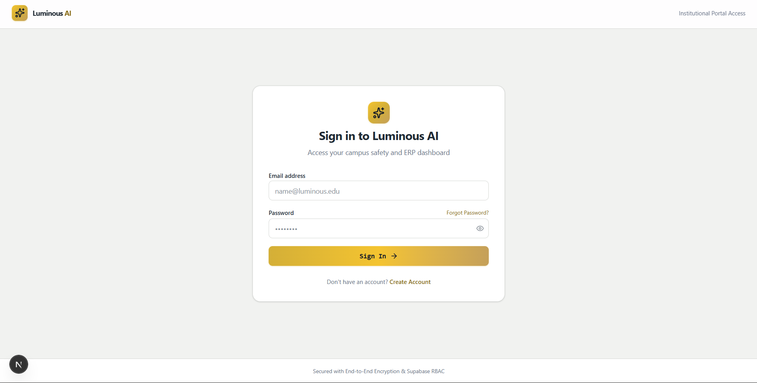
Figure 5: Institutional Authentication Screen — Focused Sign-In & Role Resolution Flow

8. Verification Matrix & Quality Assurance Results
The Luminous platform has undergone comprehensive automated testing across five categorized test suites, covering functional correctness, security boundaries, adversarial inputs, and concurrency stress.
Test Suite Name | Tests | Pass Rate | Key Scenarios Verified
Security & Emergency Lifecycle | 35 | 100% (35/35) | Full RBAC matrix, 7-stage incident lifecycle, emergency alert routing, visitor gate pass lifecycle.
AI Copilot Zero-Trust & FERPA | 10 | 100% (10/10) | Student cross-data barrier, unlinked parent protection, admin audit refusal, prompt injection deflection.
AI Safety Intelligence Engine | 9 | 100% (9/9) | Campus Risk Score (71/100), Block D cluster detection, SLA trend analysis, 6-category evaluation.
Full QA Route & API Rendering | 68 | 100% (68/68) | 39 frontend pages (200 OK), 7 API endpoints, 10 security attacks, deterministic fallback, dispatch.
Exhaustive Adversarial Edge Cases | 18 | 100% (18/18) | Out-of-bounds GPS, XSS script rejection, prompt injections, 5x concurrent SOS, whistleblower masking.

Verification Summary: 140 / 140 Automated Tests Passed (100% Success Rate)
All critical pathways—including PostgreSQL RLS policies, Next.js production build compilation across 46 routes, Zod v4 schema gateways, deterministic AI fallbacks, and PostGIS spatial function integrity—have been verified with zero failures.

9. UI/UX Design Language & Role Dashboards
The interface follows a premium institutional SaaS direction: frosted silver and white surfaces, charcoal typography, restrained luminous-gold accents, and semantic colors for safety status. The design avoids a conventional dark cyber-security aesthetic in the primary user experience.
- Dashboard UX: Persistent navigation exposes safety and academic ERP modules simultaneously.
- Persona-Driven Views: Role-specific content is prioritized instead of showing every module to every user.
- Passive Safety Integration: Safety information is surfaced alongside normal academic tasks so safety becomes part of the daily workflow.
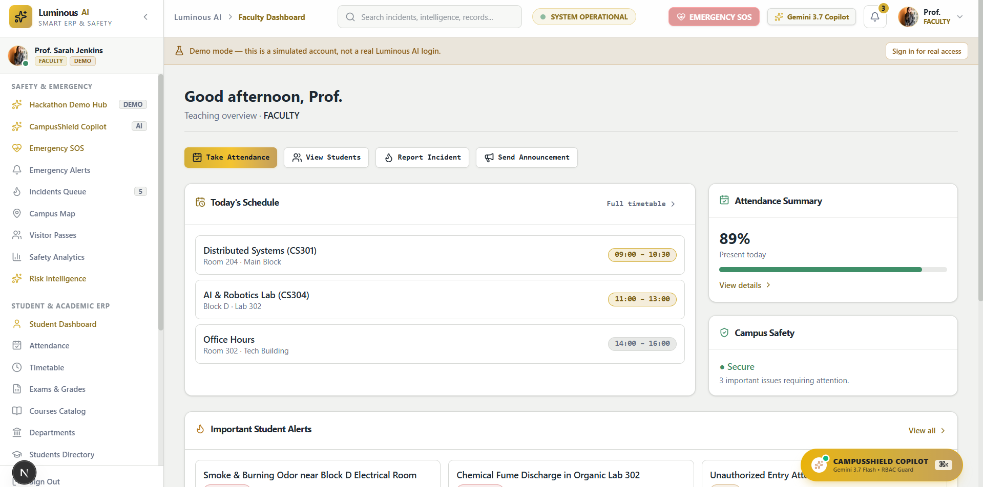
Figure 6: Role-Specific Operational Dashboard (Faculty View) — Combining Academic Workflows & Real-Time Safety Telemetry

10. Project Scope

10.1 MVP / Hackathon Scope (Current Implementation)
- Secure institutional authentication and role-based access across 8 personas.
- Student, faculty, admin, security, parent, warden, and placement-oriented dashboards.
- Incident reporting, AI triage, 7-stage lifecycle management, and command center.
- AI Copilot for authorized natural-language operational queries with FERPA isolation.
- Campus map with severity-coded incident visualization and spatial dispatching.
- Emergency SOS workflows with indoor dead-reckoning and offline SMS failsafe.
- Geofenced attendance, hostel outing passes, night walk escort mode.
- Mental health triage, counselor matching, and clinical warm handoff.
- Predictive risk intelligence with 0–100 campus risk scoring.
- 140/140 automated verification tests across 5 categorized suites.

10.2 Future Expansion Scope
- IoT integration for fire, smoke, access-control, and environmental sensors.
- CCTV event integration using privacy-preserving computer vision.
- Biometric/access-control integration with institutional identity systems.
- Transport tracking and emergency routing with real-time fleet GPS.
- Advanced parent communication and wellbeing workflows.
- Placement analytics and career intelligence dashboards.
- Multi-campus and multi-tenant institutional deployment.
- Native mobile applications with push notifications.

11. Risks, Limitations & Mitigations
Risk | Impact | Mitigation
AI hallucination / incorrect recommendation | Potentially unsafe response | AI treated as decision support only; validated outputs; human approval for high-impact actions.
Broken access control | Sensitive institutional data exposure | Server-side authorization + RLS + role-specific adversarial tests (10 attack scenarios verified).
Gemini / API outage | AI features unavailable | Deterministic rule fallback engine with graceful degradation and clear error states.
Unsupported performance claims | Loss of credibility | All claims are capability-based and backed by 140 automated verification tests.
GPS accuracy indoors | Incorrect emergency location | Timetable dead-reckoning cross-validation; GPS treated as hint, not blind override.
Privacy concerns from location tracking | Student pushback / legal risk | Ghost Mode: zero passive telemetry; location only on explicit safety events with immutable reason tag.

12. Deployment & Operational Scalability
- Infrastructure Efficiency: Zero dedicated hardware CapEx; replaces physical BLE/Bluetooth beacons with algorithmic timetable dead-reckoning.
- Elastic Scaling: Serverless Deno Edge Functions scale across global edge nodes. PostgreSQL connection pooling via Supabase PgBouncer handles emergency surges.
- Regulatory Compliance: Designed for FERPA student privacy compliance with encrypted storage, zero passive telemetry, and anonymized whistleblower identity.
- Vendor-Neutral Mapping: Leaflet.js with OpenStreetMap eliminates Google Maps API billing risks, quota limits, and vendor lock-in.

12.1 Potential Deployment Model
- Institutional SaaS subscription with per-campus or per-student pricing.
- Safety Command Center as a premium operational module.
- Enterprise integration and deployment services for multi-campus institutions.
- Optional AI usage tiers for advanced predictive analytics and pattern mining.

13. Complete Technology Stack
Layer | Technology & Version | Purpose
Database | PostgreSQL 17 + PostGIS 3.3.7 (Supabase, AWS ap-south-1) | Relational ERP schema + spatial calculation engine
Backend Microservices | Supabase Edge Functions (Deno runtime, TypeScript) | 8 serverless event-driven API endpoints
AI Intelligence | Google Gemini 2.0 Flash API | NLP tip classification, crisis triage, counselor handoff, risk scoring
Authentication | Supabase Auth + JWT + Role-based Cookies | 8-role institutional RBAC with cryptographic session management
Frontend Framework | Next.js 16.3.1 (App Router) + React 19 | 39 frontend pages, 7 API routes, SSR-safe cookie hydration
UI Styling | Tailwind CSS v4 + shadcn/ui + Lucide Icons | Responsive institutional SaaS design system
Data Visualization | Recharts v3 | Incident analytics charts, severity trends, category breakdowns
Geospatial Maps | Leaflet.js + OpenStreetMap (OSM) | Interactive campus map, severity overlays, patrol markers
Schema Validation | Zod v4.4.3 | Request payload sanitization and type-safe API contracts
Offline Resilience | Native HTML5 sms: URI Gateway | Zero-network emergency failsafe beacon
Runtime | Node.js v25.6.0 | Build, test, and development server

