* 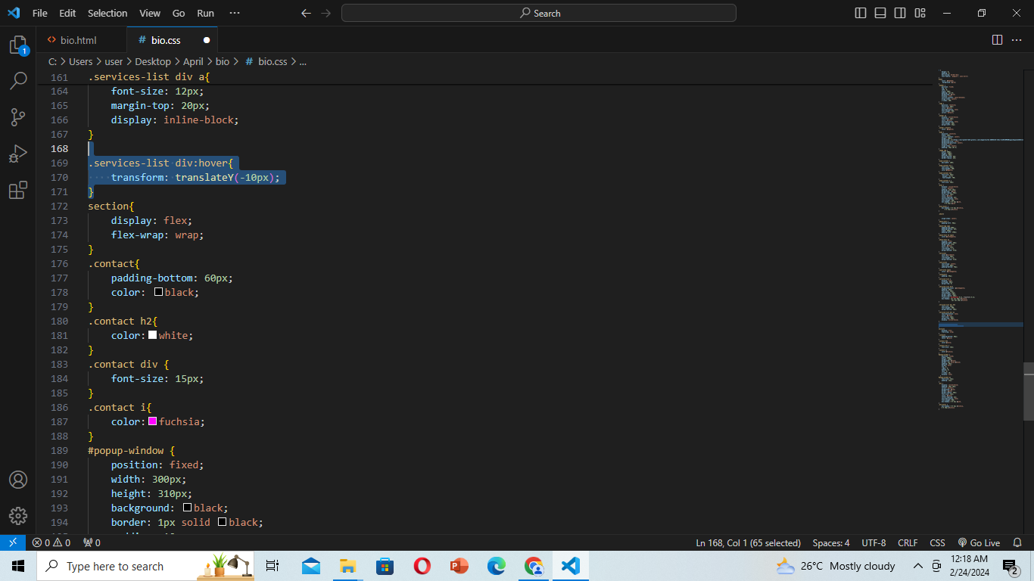Alsa-alsa ang container HAHHAH

 <ul><b>2019-2022 @OurHouse</b></ul>

                                <li>Took in 2 cats and actively cater needs</li>

                                <li>Maintain healthy relationship(s)</li>

                                <li>Heal in places I should</li><br>