ASSIGNMENT 1
Mounika Kandagadda

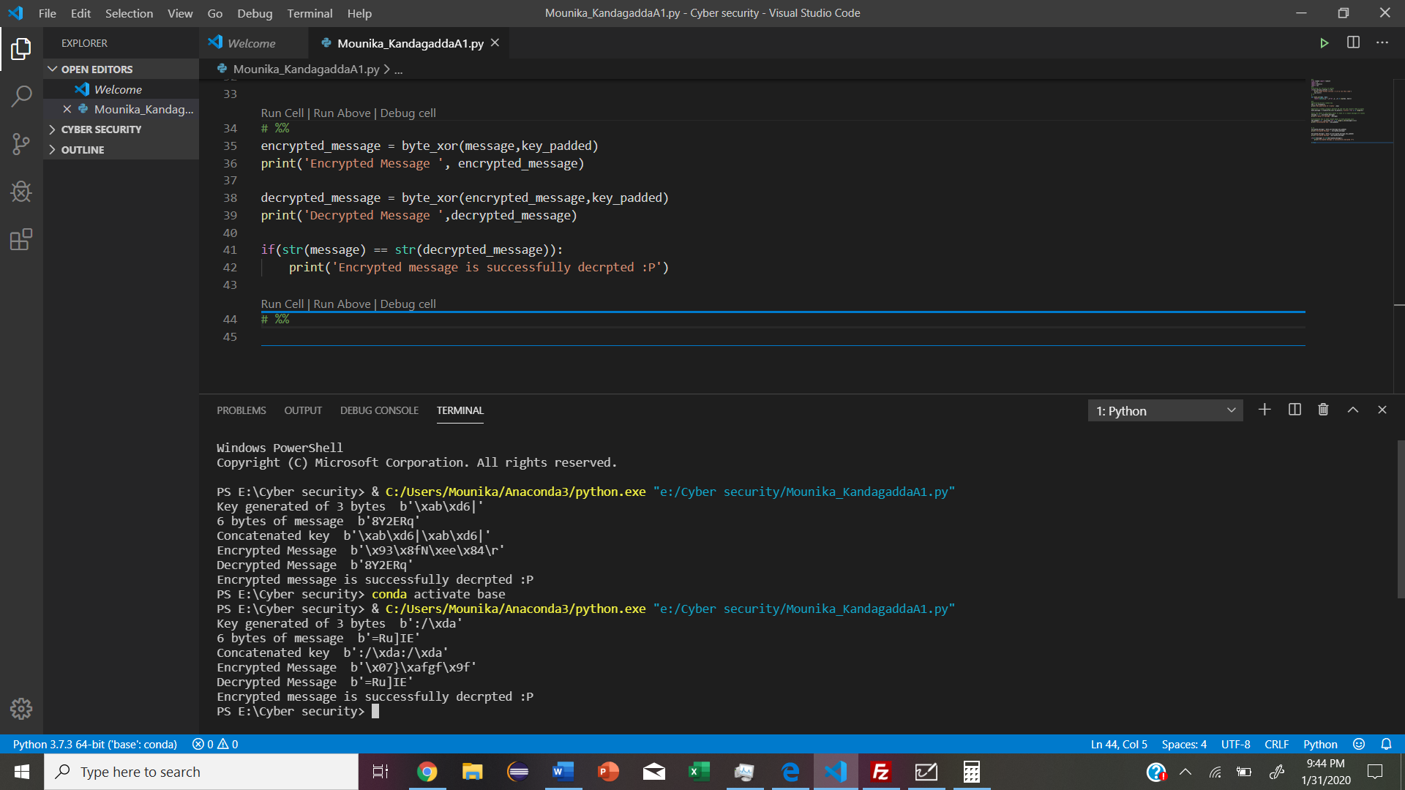

- C.I.A: confidentiality, Integrity, Availability.
A.A.A: Authenticity, Assurance, Anonymity.
- Symmetric Key Distribution: requires each pair of communication parties to share a secret key. Both the people share a secret key which is used for both encryption and decryption.
Public Key Cryptography: Separate keys are used for encryption and decryption. Only one key is needed for each recipient.
- 1679
- MAC: is message authentication code which is also know as a tag. it is a piece of message which is used to authenticate a message to check whether that message came from the stated sender and which has not been changed. This MAC values to protect both a messages data integrity as well as its authenticity by allowing the verifiers to detect and changes in the message content.

