ASSIGNMENT 4
CYBER SECURITY
IP address | 192.168.0.160
MAC address | D0-57-7B-EB-73-D2
Default gateway IP address | 192.168.0.1
DNS server | 192.168.0.1
Part 1:

2) DNS filter results in Wireshark.
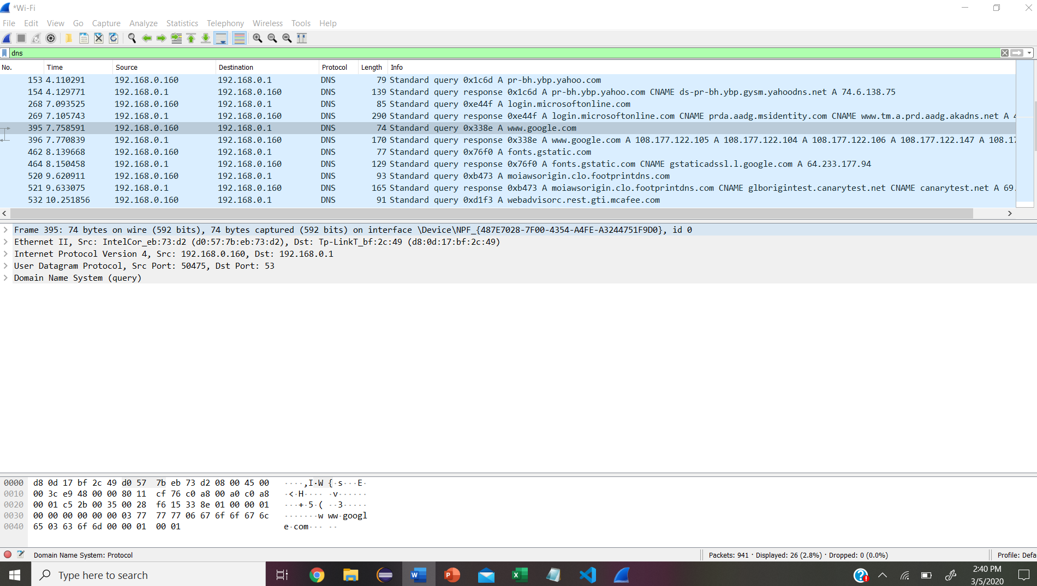

3) Part3 – step 2b
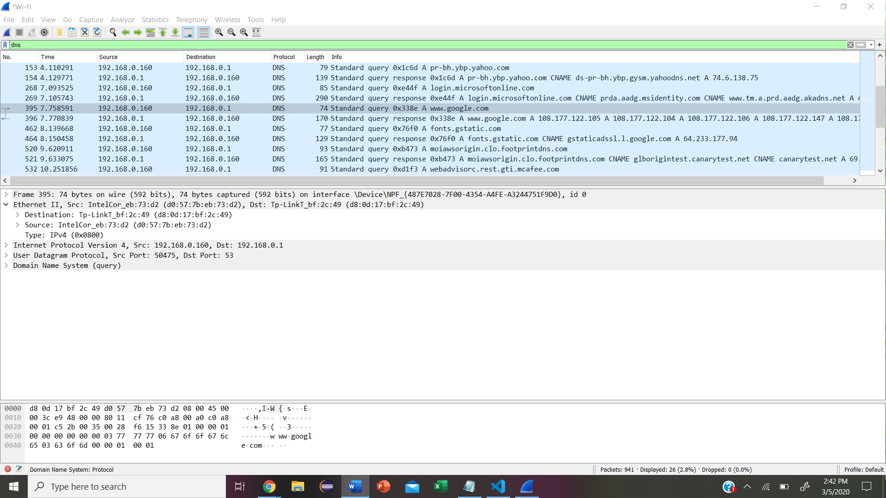
Yes, the source MAC address is the same as recorded from part 1 for the local pc.
DEVICE | IP ADDRESS | MAC ADDRESS
Local PC | 192.168.0.160 | 192.168.0.1
Default Gateway | 192.168.0.160 | 192.168.0.1

Records for WireShark results:
Frame Size | 74 bytes capture and on wire (592 bits)
Source MAC address | (d0:57:7b:eb:73:d2)
Destination MAC address | (d8:0d:17:bf:2c:49)
Source IP address | 192.168.0.160
Destination IP address | 192.168.0.1
Source Port | 50475
Destination Port | 53

Yes, the source IP address is the same as the local PC’s IP address recorded in part 1.
Yes, the destination IP address is the same as the default gateway noted in part 1.
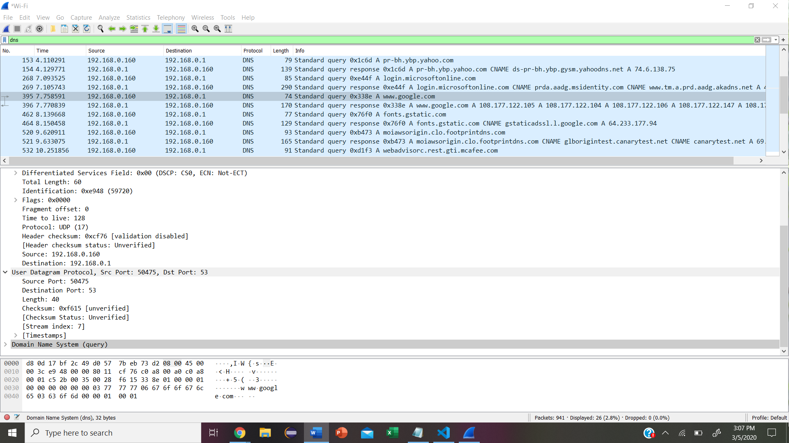

Screenshot of active DNS_spoof plugin from Ettercap in step 22
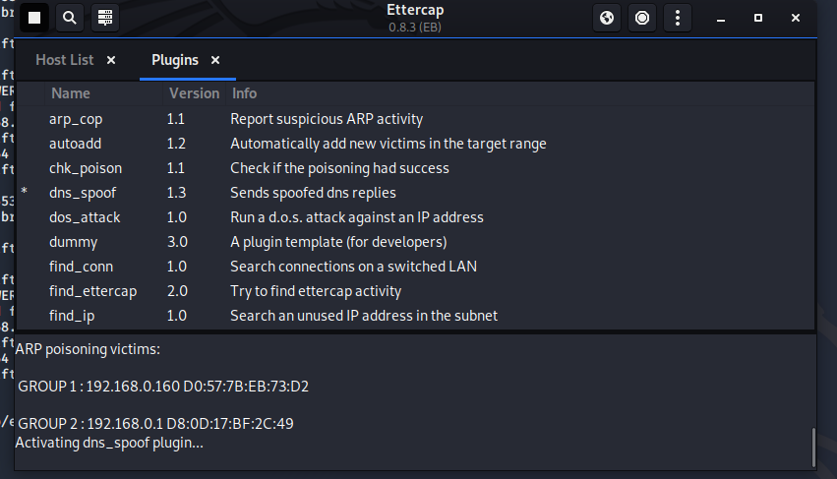
Screenshot of successful spoof from Ettercao window in step 25
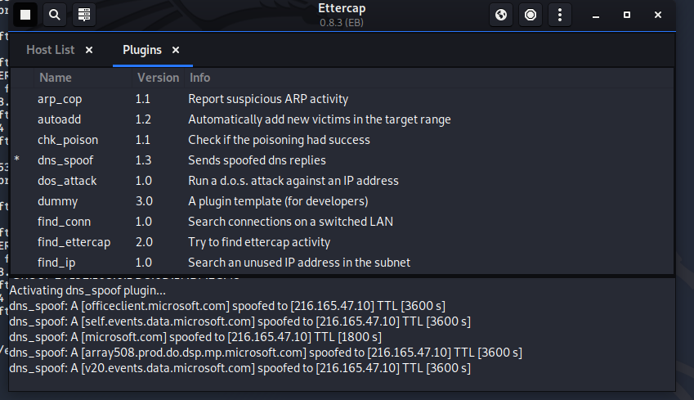

Edited etter.dns
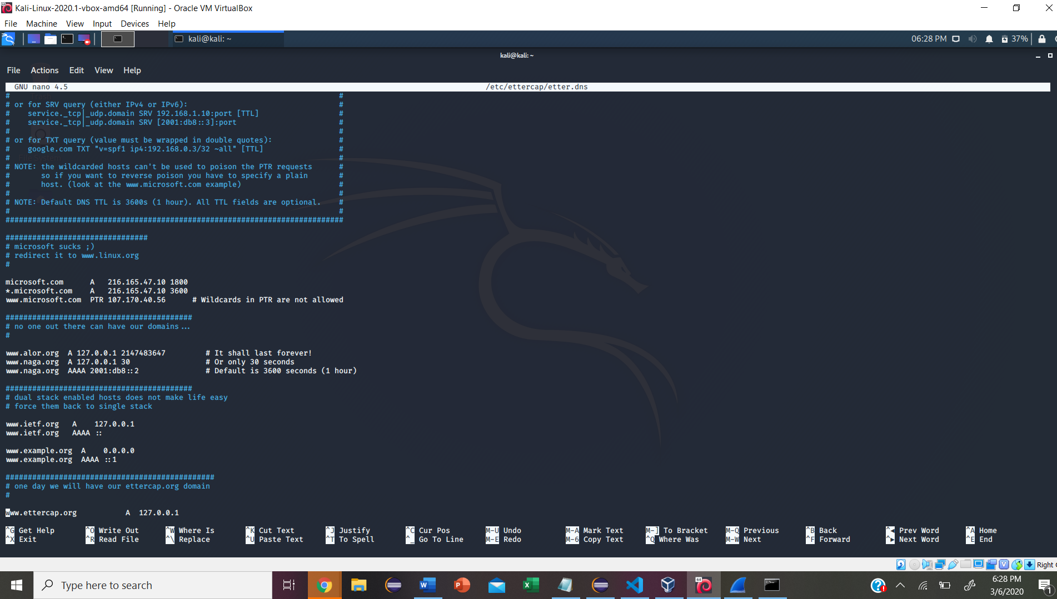
DNS poisoning and how it works.
DNS main function is to translate domain names into IP addresses which computer can understand. It also provides a list of mail servers which accept emails for each domain name. DNS poisoning is also known as DNS spoofing which is a type of attack that exploits vulnerabilities in the domain name system (DNS) to divert internet traffic away from legitimate servers and towards fake ones. One of the reasons DNS poisoning is so dangerous is because it can spread from DNS server to DNS server. DNS spoofing is done by replacing the IP addresses stored in the DNS server with the ones under the control of attacker. Once it is done, whenever users try to go to a website, they get directed to the false website placed by the attacker in the spoofed DNS server.

