Contents

Student table from course_management database 2

Admin table from course_management database 2

Instructor table from couse_management database 2

Courses table from course_management database 3

Modules table from course_management database 3

Student_activity table from course_management database 4

Instructor_activity table from course_management database 4

Workflow description of the course management system 5

## Student table from course_management database

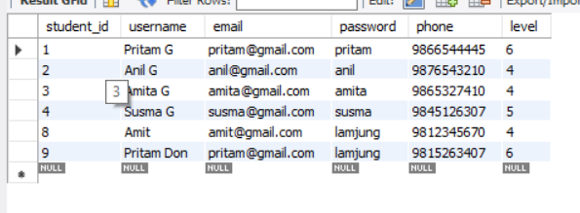

## Admin table from course_management database

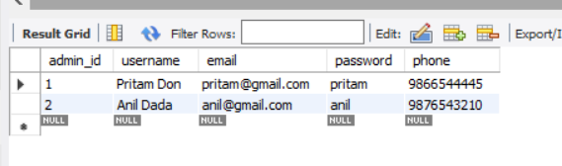

## Instructor table from couse_management database

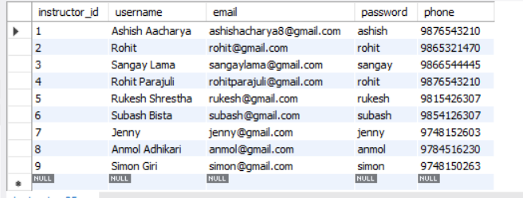

## Courses table from course_management database

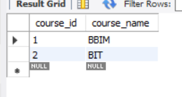

## Modules table from course_management database

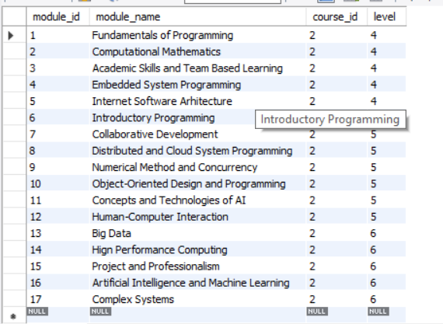

## Student_activity table from course_management database

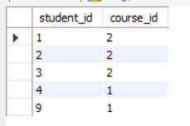

## Instructor_activity table from course_management database

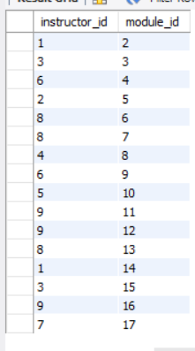

## Workflow description of the course management system

1. This system starts with sign up where we get to add users to the course management system.
2. There are 3 user modes for this program admin, instructor and student.
3. Admin can add users and courses to this system.
4. Student can enroll to certain course and view their results.
5. Instructor can update marks for student results.
6. All respective users details are saved in respective tables.
7. And courses are also saved in different tables with id passed to modules as foreign key.