The Dataset is very unbalanced, 50% with detections and 50% without detections. Read about this.

When comparing train set vs test set there is some difference between the samples but there is no variable with completly different values.

Examples:

Census_MDC2FormFactor – categorial feature, combination represent the type of the computer, based on some characteristics, contains 12 distinct values. No missing values at all.
85% of the values are from 2 categories:

Values Distribution relative to HasDetections (HasDetections has 50%:50%), log-scaleand regular.
For some values, the distribution is close to 50:50. for some values the distribution is different. Examples:

We can use one-hot encoding for this feature, however, maybe we will not take some rare values.

Values seems to be good (no garbage values) but there are some values looks similar to other values (small tablet, medium tablet, large tablet). (servers).

There is statitical significance for the observed values when HasDetections=1. Using chi-squared test:
For column Census_MDC2FormFactor, the p_value: 1.0533513301876713e-236, 12 possible values

Highly correlative for platform variables (cramer v’s) : Census_DeviceFamily, Census_OEMModelIdentifier, OEMProcessorModelIdentifier, PrimaryDiskTypeName, ChassisTypeName (very correlative!)

Census_ChassisTypeName – Very similar to Census_MDC2FormFactor and also very correlative,contains 35 values. Very few missing values (0.01%) .

Problem, a lot of gibrish variables:

Problematic values:
UNKNOWN – 3389 – 0.8% of the values, unknown. Numeric variables, other. 6.3% problematic variables. Because this column is very correlative to MC2DCColun, maybe remove it. Seems there are a lot of garbage variables
(Also, correlated to Census_PowerPlatformRoleName)
Correlations in phi

Census_DeviceFamily – mostly the same for all samples, also highly correlative to the previous columns. (Windows Desktop for Desktops and Windows Server for servers).

TODO: the distribution of the previous columns according to this column values.

OEM Columns

Census_OEMNameIdentifier
Manufacturer identifier, OEM for computers, maybe for product manufacturer, windows version restricted to a single PC, comes with the computer without CD. (name, model) probably for the maufacturer and the hardware configuration.

This is a number between 1 to 6143. It looks like a running id.

Missing – 4723 values,1.1% of the samples.
High Cardinality – 1515 values. But the first 6 values are 70% of the data.

Most frequnet values distribution (normal scale)
Will be problematic with new id, however the probability for this is very low.

Census_OEMModelIdentifier
number from 1 to 345800.
very high cardinality, 38228 distinct values in 450000 samples (12 rows in average for each value).

Maybe model identiier is running and can be correlative with time series (compare it with some time series data).

Only 1.56% of the models identifiers are associated with two or more names!

Also, high correlation in missing values.

Sadly, missing values are seem to be not in random.

In our sample:
4742 – Missing Both
491 – Missing Only Name
124 – Missing Only Model

The distribution is much more skewed where HasDetections = 1

Also, high value in the cramer coefficient for both

chi-squared test is not good for Census_OEMModelIdentifier p_value=1.0. However, becuase that the column has very high cardinality (38k distinct values for 460k rows)

TODO: look at HasDetections when Model is number (use boxplot for example)

No connection where name is number

Where model is a number there is a weak relation to HasDetections.

Very weak connection to HasDetections (pearson):

Census_ProcessorManufacturerIdentifier
2 values for most of the samples, 1 and 5. This is categorial data, there are two big processer manufacturers nowadays, Intel and AMD, probably 5 is intel and 1 is AMD. We can transform it into binary feature.
This feature is not relevant, the p_value in the chi-square test is high and the cramer coefficient between it and has detections is very low. (0.008)

For numeric features, we will use logistic regression for HasDetections.
TODO: check interactions

Census_ProcessorCoreCount:
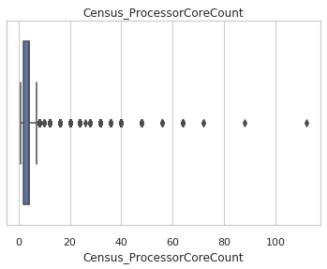

only 0.8% missing values, but the distribution is 55% for HasDetections which seems to be not at random. However, we maybe check another test.

The three most frequent values are:
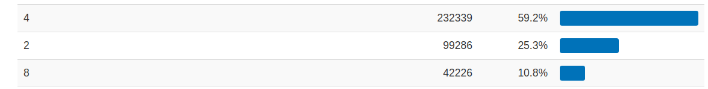
Our assumption is that Stronger computer (CPU+RAM+Storage) lead to more detections.

Missing values will be filled by KNN.

spearman score show us there is a small correlation to detection:
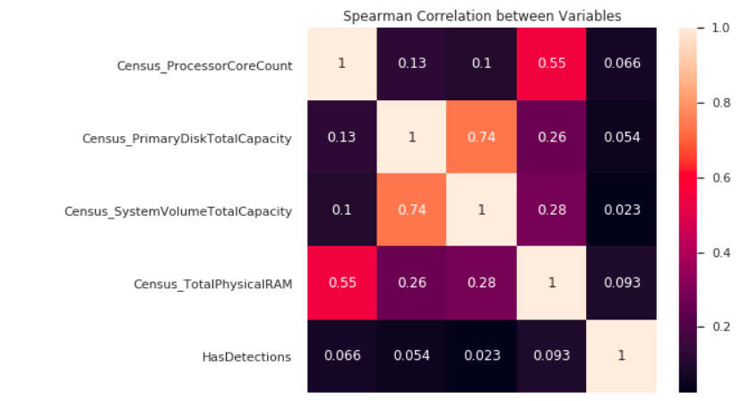
Census_ProcessorClass – Irrelevant, a lot of missing values (99.8%), drop this column.

Census_ProcessorModelId

Census_PrimaryDiskTotalCacpacity

Census_PrimaryDiskTypeName

Census_SystemVolumeTotalCapacity

Census_HasOpticalDiskDrive
Census_TotalPhysicalRAM
skewed variable.

Proposed features list:

