CS 249: Core Assignment Rules

# Programming Assignments

* ALL code files should be in the package **edu.*yourname*.assignXX**, where:
  + *yourname* is replaced with your SITNet ID *in lowercase letters*
  + XX is replaced with the zero-padded assignment number (01, 02, etc.)
* Prompts and printouts match **EXACTLY** to the specification
  + This includes capitalization, punctuation, spaces, and newlines!
* Your java files/class names/ method names MUST match the spelling/capitalization **EXACTLY**!
* ALL data in your class should be **PRIVATE** or at least **PROTECTED**!
* Unless otherwise stated, NONE of the class data in the assignments should be static! All class data is **INSTANCE** data!
* Except for replacing my SITNET ID with your own, **do NOT modify:**
  + The test programs
  + Any **complete** programs I provide

# Starting a New Assignment

For each new assignment, you must do the following procedures:

* **Switch to the "main" branch**
  + "Git" 🡪 "Branches" 🡪 click on "main" 🡪 "Checkout"
* **Fetch any changes from remotes**
  + "Git" 🡪 "Fetch"
* **Make sure any local changes are committed and pushed**
* **Merge changes from "upstream/main" (i.e., the main branch on my repository)**
  + "Git" 🡪 "Merge" 🡪 select "upstream/main"
* **Create a new branch for this assignment**
  + "Git" 🡪 "Branches" 🡪 "New Branch…"
  + Use name "assignXX", where XX is the zero-padded assignment number (01, 02, etc.)
  + Make sure "Checkout branch" is selected
* **Publish your new branch**
  + "Git" 🡪 "Push"
* **Under the appropriate subproject "assignXX":**
  + **Create package folders for main code**
    - Right-click on assignXX/src/main/java folder 🡪 "New" 🡪 "Package"
    - Name should be: **edu.*yourname*.assignXX**
  + **Create necessary Java files in this package folder**
    - Right-click on package folder 🡪 "New" 🡪 "Java Class"
  + **Modify assignXX/src/main/java/module-info.java file**
    - Replace all references to "realemj" with *yourname*
  + **Modify the test code in src/test/java**
    - Change the "realemj" part of package folder to yourname
      * Right-click on package folder 🡪 "Refactor" 🡪 "Rename…"
      * This should also change the package line in the testing files themselves
    - Do NOT change:
      * import edu.realemj.testing.*;
      * import edu.realem.testing.GeneralTesting;
  + **In build.gradle, change value of mainClass variable to refer to *yourname* instead of "realemj"**
  + **Reload all Gradle projects**
  + **Right-click on the verification:test task for the new assignment in the Gradle menu**
    - Select "Modify Run Configuration…"
    - Under "Modify Options", make sure "Run as test" is checked
    - Hit "Apply" and "OK"
* **Complete assignment code and make commits to this new branch**
  + "Git" 🡪 "Commit"
  + Feel free to push commits up to the repository as well: "Git" 🡪 "Push"

# Testing Screenshot

In addition to the code submission, you MUST submit a screenshot of the test results.

* **You MUST run the test files and send a screenshot of the test results!** 
  + Even if your program(s) do not pass all the tests, you MUST send this screenshot!
* This screenshot should show clearly what tests have passed (or not).
* **WARNING: If any code does not compile, tests will NOT run!**
* **Include the screenshot inside the subproject for the assignment!**

Here is an example of an acceptable test screenshot:

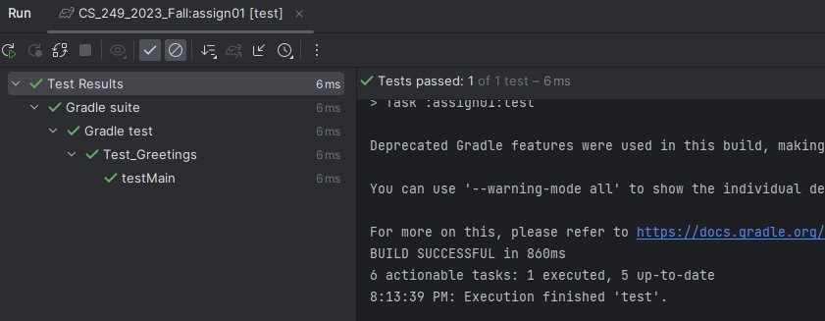

# UML Diagrams

* For the UML diagrams, use the **UMLift plugin in IntelliJ**
* To create your UML diagrams:
  + Create a new folder under your assignment project named **"uml"**
  + Create your UML Diagram(s) in that folder
    - Right-click on folder 🡪 "New" 🡪   
      "**UMLet Diagram**"
  + Your UML diagrams should be saved as **".uxf"** files
* **Make sure your methods have the EXACT names and parameters as described!**
* **You must use the UML syntax defined in the slides!**
* Unless otherwise stated, submit everything as ONE diagram.
* Unless a method is overridden, you do NOT need to repeat a parent's method in a child class' diagram.

# Completing and Submitting an Assignment

Once you have finished development on your branch, do the following:

* **Commit and push any changes to your branch**
  + "Git" 🡪 "Commit"
  + "Git" 🡪 "Push"
* **Checkout the "main" branch**
  + "Git" 🡪 "Branches" 🡪 click on "main" 🡪 "Checkout"
* **Merge your branch into the "main" branch**
  + "Git" 🡪 "Merge" 🡪 select your branch for the assignment
* **Commit as necessary and push changes to remote repository**
  + "Git" 🡪 "Push"

**Be sure to do these steps BEFORE the assignment deadline!**

# Grading

Apart from the specific grading breakdown, I reserve the right to take points off for not meeting the specifications in the assignment description.

Every assignment will have a different grading breakdown. Do NOT assume it is always the same!

For the PROGRAMMING part, these penalties will be in place unless otherwise specified:

|  |  |
| --- | --- |
| ***Issue*** | ***Penalty (in %)*** |
| **Code that does not compile** | 60 |
| Using static class data where instance data is required | 20 |
| Non-private/non-protected class data | 10 |
| Printout/prompt format incorrect **(including spaces and capitalization)** | 5 |
| Files not in correct package | 5 |
| Submission code not merged with main branch (but exists in repository) | 5 |
| New branch not created or not used for assignment code development | 5 |
| Code files/classes/methods named incorrectly | 10 |
| Other stuff submitted (class files, etc.) BUT NO CODE SUBMITTED | 100 |
| Nothing submitted at all | 100 |

In general, these are things that will be penalized:

* **Code that does not compile**
* Poor abstraction and/or encapsulation
* Sloppy or poor coding style
* Bad coding design principles
* Code that crashes, does not run, or takes a VERY long time to complete
* Using code from ANY source other than the course materials
* Collaboration on code of ANY kind; this is an INDIVIDUAL PROJECT
* Sharing code with other people in this class or using code from this or any other related class
* Output that is incorrect
* Algorithms/implementations that are incorrect
* Submitting improper files
* Failing to submit ALL required files