St10102103
[Email address]
Abstract

Cams database and boards link
XISD

1.Boards
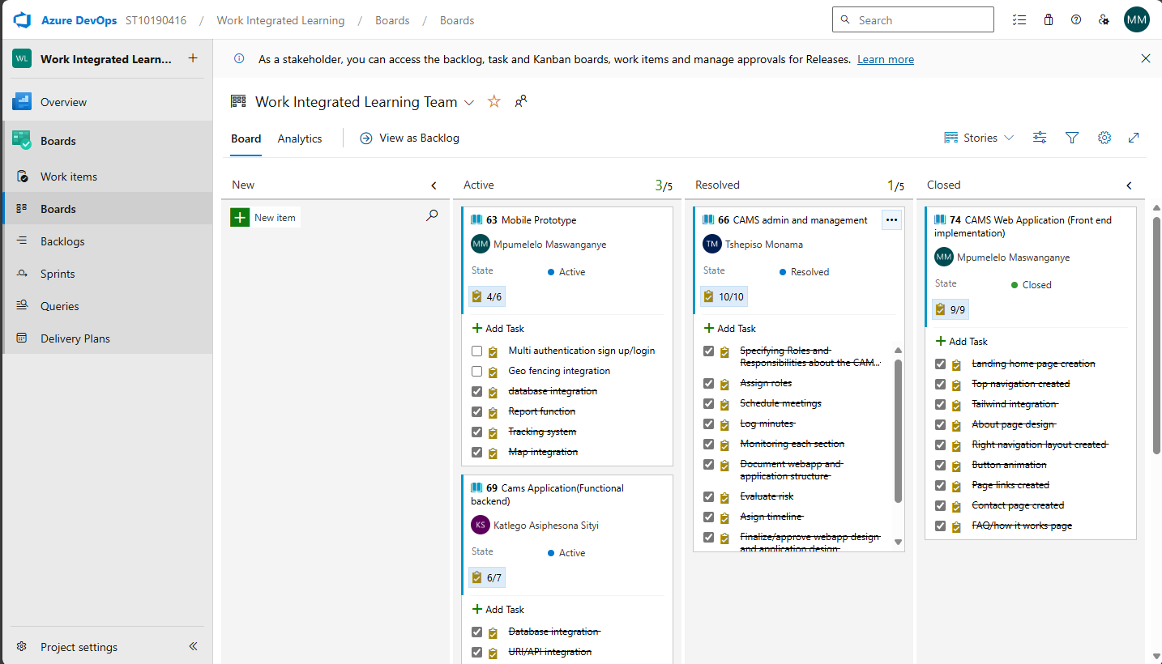
Work Integrated Learning Team Stories Board - Boards

2.Database
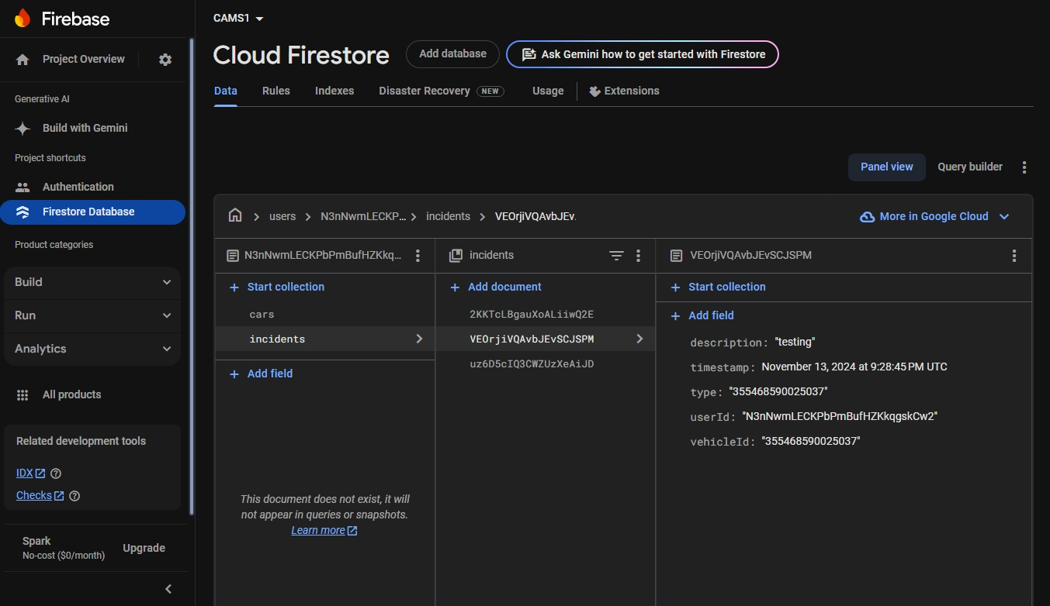
CAMS1 - Cloud Firestore - Data - Firebase console

