XISD

[Draw your reader in with an engaging abstract. It is typically a short summary of the document. When you’re ready to add your content, just click here and start typing.]
  - [Document subtitle]

Table of Contents
Introduction 2
Identifying the problem and obtain approval 4
Plan and monitor the project 6
Project Plan for CAMS App Development 6
1. Project Overview 6
2. Project Milestones & Timeline 6
3. Key Deliverables 7
4. Risk Management 7
Requirements Gathering and Analysis 8
System design 10
User Interface design 18
Development 20
Project Management 26

Introduction

In today's rapidly evolving, technology-centric landscape, the creation of effective and user-friendly applications is essential for tackling both business and societal challenges. Following our recent submission, we've revaluated and refined our understanding of what it takes to build a successful app. It’s clear that success hinges not only on having a well-structured team where roles are clearly defined but also on fostering a collaborative environment where team members actively contribute beyond their individual tasks. A truly successful application emerges from a team that embraces flexibility, encourages creative problem-solving, and works cohesively towards a shared vision, continuously adapting to the needs of users and the market.
We have defined key roles within our team, each playing a vital role in driving the project's success. The Project Manager takes charge of the overall direction, managing timelines and ensuring that objectives are achieved. The Lead Developer provides technical leadership, shaping the app’s architecture and offering guidance on development strategies. The UI/UX Designer is dedicated to crafting an intuitive, user-friendly interface that enhances the user journey. On the other hand, the Backend Developer is responsible for building and optimizing the app’s infrastructure, ensuring it performs efficiently and can handle scaling. Lastly, the Quality Assurance Tester is tasked with rigorously testing the product to ensure it meets high standards and is free from bugs before launch.
By designating these key roles, we aim to establish a structured framework that encourages teamwork, innovation and creativity. This clear division of responsibilities streamlines our workflow, allowing each member to focus on their expertise while collaborating effectively. This approach not only maximizes efficiency but also strengthens our capacity to deliver a product that aligns with user expectations. With thoughtful planning and focused effort, we are confident that our team will develop a solution that drives real value and creates a lasting impact.
Roles | Members | Responsibilities
Project Manager | Tshepiso Monama | - Oversee the project timeline and milestones.  - Coordinate between team members and stakeholders.  - Ensure the project stays on track and within scope.  - Handle risk management and resource allocation.
Lead Developer | Katlego Sityi  Oko Mwenzo | - Design the architecture of the application/system.  - Make key technical decisions and guide the development process.  - Write and review code, ensuring best practices are followed.  - ensure the code quality.
UX/UI Designer | Mpumelelo Maswanganye | - Create wireframes, mock-ups, and prototypes of the application.  - Ensure the design is user-friendly and meets user needs.  - Conduct user research and usability testing.  - Collaborate with developers to implement the design.
Backend Developer | Oko Mwenzo  Katlego Sityi | - Develop and maintain the server-side logic.  - Design and manage the database.  - Ensure the application is scalable and secure.  - Integrate third-party services and APIs as needed.
Quality Assurance Tester | Tony Mbedzi  Tshepiso Monama | - Develop test plans and test cases.  - Conduct manual and automated testing.  - Identify and report bugs and issues.  - Ensure the final product meets the required standards and specifications.
Our team has decided to adopt an iterative design approach for developing this system, breaking the project into six core processes that allow for continuous improvement and refinement throughout the development lifecycle. These processes are:
- Identifying the problem and obtaining approval:
The first step involves thoroughly understanding the problem the system is intended to solve. This means conducting research, gathering feedback, and analysing the needs of stakeholders. Once the problem is well-defined and the system’s purpose is clear, we seek approval from key stakeholders to move forward with the project, ensuring alignment with business goals and objectives.

- Planning and monitoring the project:
In this phase, we create a detailed project plan that includes timelines, deliverables, resources, and milestones. Effective planning ensures that every team member understands their responsibilities and that the project stays on track. Continuous monitoring allows us to track progress, adjust resources, and ensure the project remains within scope, budget, and deadlines.

- Discovering and understanding details:
This stage focuses on gathering detailed system requirements. We work closely with users, stakeholders, and domain experts to define functional specifications, technical requirements, and any constraints the system may face. This process helps us fully grasp the system’s needs, creating a strong foundation for the design and development phases.

- Building, testing, and integrating the system:
Here, the system is developed in small, manageable segments. Each segment or module is coded and tested independently before being integrated with other parts of the system. The iterative nature of this process allows us to identify and fix issues early, reducing the risk of major problems down the line and ensuring that all components work cohesively.

- Completing system tests:
Once all the modules are integrated, the entire system undergoes comprehensive testing. This includes functional tests to ensure that the system meets all specified requirements, as well as non-functional tests such as performance, security, and usability. Any bugs or defects discovered during this phase are resolved before the system is finalized.

By breaking the project into these iterative stages, we can continuously gather feedback, adjust to evolving requirements, and ensure the system is built with the highest quality standards. This approach increases flexibility and helps us deliver a product that effectively meets user needs.

Identifying the problem and obtain approval
In our research, we have identified a problem that may affect many users which is car security. This problem impacts those who have vehicles and concerned about the safety of the vehicles or their own safety when they are in a vehicle. For example, a new vehicle owner my have the problem of forgetting there their car is parked and would want to locate their vehicle after losing it in a parking space. Addressing this issue is crucial because there has been a lot rising crime in South Africa that is vehicle related.
To tackle this problem, we propose developing an application/system that deals with the safety of vehicles by providing tracking and notification services. Our solution aims to give users a more user friendly interface that will ensure that the user feels secure when traveling or even when their vehicles aren’t being used. Our Key features of our application will include real time tracking, Route history, alerts and notification and driver behaviour analysis.
We have approached the owner of Assertoversight and asked if we can improve or create such a system for the company if they don’t yet have one, Mr Mdaka responded “I want an app for notifications of vehicles status from the tracker and the device from the blynk site to be synced on one app.”
Add definition of the company we’re working with
Furthermore, we have asked Mr Mdaka for the approval as we believe that our solution aligns with goals, organizational values and user needs of Assert oversight. Approval for this project will enable us to proceed with detailed planning, development, and testing phases, ensuring that we deliver a high-quality product that meets the needs of our users. Below is the Approval provided by the Assertoversight company.
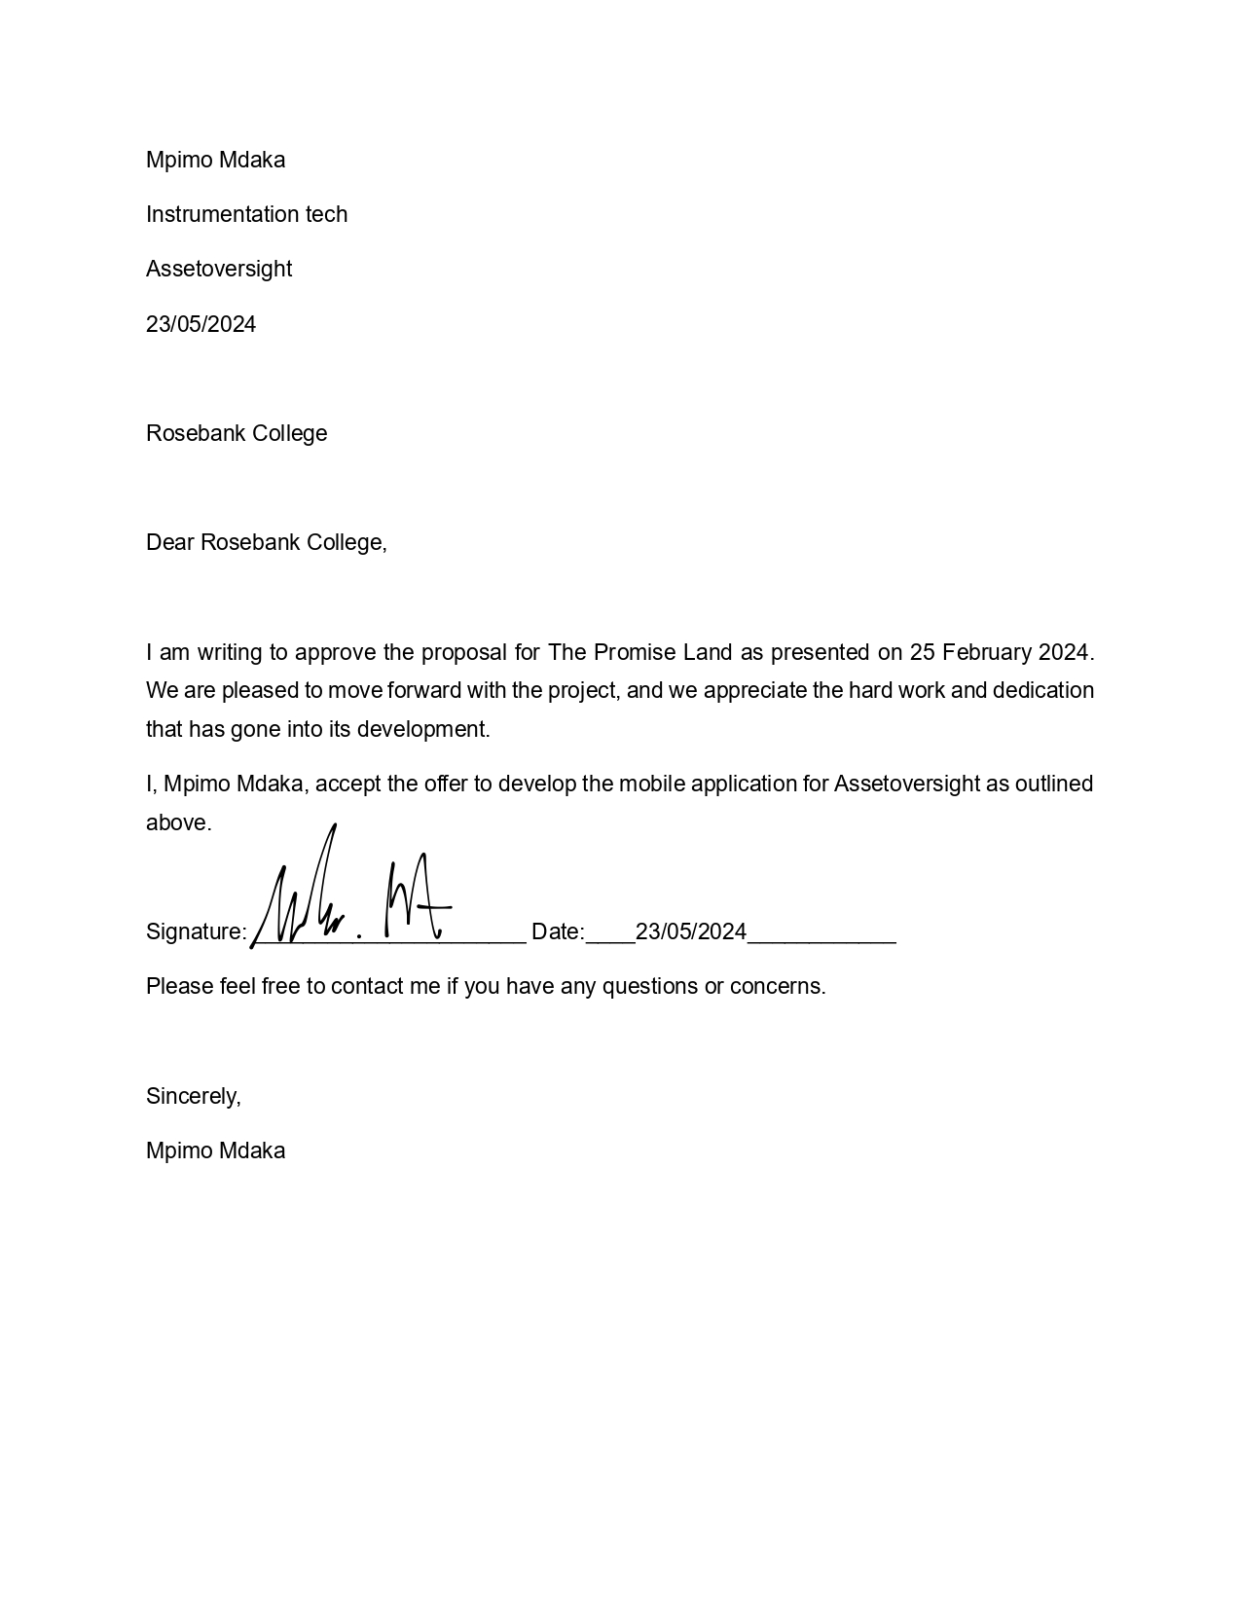

Plan and monitor the project
Before we dive into the work breakdown structure, it’s essential to have a clear understanding of what we’re working with and the status of our collaboration with AssertOversight. The company already has a physical tracking device and a functioning website. However, they aim to reinvent their website and introduce a mobile application that integrates with their existing tracking hardware. Our project, CAMS (central assert management system), is designed to seamlessly merge the new website’s functionalities with the physical tracking device, creating a unified platform that enhances the user experience.

Project Plan for CAMS App Development

Project Overview

Project Name: CAMS(central assert management system)
Client: AssertOversight
Project Type: Mobile Application Development/Website
Objective: To develop a mobile application and website that integrates a physical tracking device with a newly revamped website, providing users with real-time data tracking and a streamlined interface for management.

Project Milestones & Timeline

- Initiation and Research Review
Assert Oversight’s current website and tracking device capabilities and conduct meetings with key stakeholders to gather requirements and expectations. Identify technical requirements for integration between the app, website, and tracking device. (Week 1-2)

- Planning & Requirement Gathering
Create detailed specifications for the mobile application, including user stories, features, and functionality then draft the system architecture for integrating the physical tracking device.
Finalize technology stack and development tools (e.g., iOS/Android development frameworks, API requirements). Set up project timelines, resources, and deliverables. (Week 3-4)

- UI/UX Design Phase
Develop wireframes and mock-ups for CAMS, focusing on usability and aesthetics.
Design the key app interfaces: Dashboard, Device Tracking, Alerts, Notifications, Settings.
Conduct user feedback sessions to refine designs. (Week 5-6)

- Backend Development (Integration)
Build the backend for device integration, including APIs and data management.
Develop the logic for syncing the tracking device with the app and website.
Ensure real-time data capture and processing through the app (Week 7-9)

- Frontend Development (Mobile App)
Begin mobile application development for Android and iOS. Implement the UI/UX designs and ensure app functionality with real-time data from the tracking device. Integrate core features: user registration, device pairing, tracking history, notifications. (Week 10-12)

- Testing & Quality Assurance
Conduct functional testing to ensure all features work as expected. Perform integration testing to ensure seamless communication between the app, website, and tracking device. Carry out usability tests to validate the user experience. Test across multiple devices and operating systems to ensure compatibility (Week 13-14)

- System Tests & User Acceptance
Perform comprehensive system tests (performance, security, load). Conduct user acceptance testing (UAT) with AssertOversight’s team. Gather feedback and address any issues or bugs. (Week 15-16)

- Launch & Deployment
Prepare for launch on app stores (Google Play, Apple App Store). Implement marketing materials, user guides, and on boarding instructions. Monitor the app’s performance post-launch and resolve any post-launch issues. (Week 17-18)

Key Deliverables

- Mobile application for both iOS and Android platforms.
- Seamless integration of CAMS with AssertOversight’s tracking device and newly revamped website.
- User-friendly UI/UX design optimized for real-time tracking.
- Functional and security-tested app ready for deployment.

Risk Management
- Technical risks: Potential integration issues between the app and tracking device, which will be mitigated by early prototyping and testing.
- Timeline delays: Addressed through weekly sprints and regular progress reviews.
- User adoption risks: Mitigated by involving users in feedback sessions during the design phase and UAT.

Requirements Gathering and Analysis

Functional Requirements
As the promise land team we believe that our software application will be designed to monitor and manage the real-time location and status of vehicles within a fleet and the app could be a very critical tools for individuals who need to ensure the efficiency, safety, and proper utilization of their vehicles, this applies to businesses too. By leveraging GPS technology and other telematics data, Pro Tracker App provides a comprehensive solution for overseeing vehicle movements, improving operational efficiency, and ensuring driver safety. The following are the key functional requirements that Pro Tracker app should encompass:
- User authentication and authorization
The app should provide a secure login and signup mechanism using email, social media accounts, or phone numbers. It should include features like password recovery, two-factor authentication (2FA), and account verification to ensure user security.

- Real time vehicle tracking
The app should display the real-time location of vehicles on a dynamic map interface. It should update the vehicle's position at regular intervals for accurate tracking. The app should also ensure the GPS data is accurate and updated frequently to reflect the vehicle's current position

- Alert notification
Users should be able to set up alert for geo fencings and maintenance reminders.
Notifications should be delivered via push notifications, SMS, or email based on user preference.

- Vehicle management
The app should support the management of multiple vehicles, allowing users to add, edit, or remove trackers. Each vehicle's data should be easily accessible and distinguishable. App should provide a comprehensive view where users can see the status of all their vehicles.

- Map integration
App has to Integrate with a reliable map service (such as Google Maps or Mapbox) to provide up-to-date and interactive maps which include features like traffic information, route planning, and street views to enhance the user experience.

- UI experience
Design the app to be intuitive and easy to use, with clear navigation and responsive design that works well on various devices. Allow users to customize their interface preferences, such as themes, map views, and notification settings.

- Location sharing
App should enable users to share their live location with others through a secure link that can be sent via messaging apps, email, or social media and include privacy settings so users can control who can view their location and for how long.
Non-Functional Requirements
In addition to the functional requirements, Pro Tracker must also address non-functional requirements to ensure it performs efficiently and delivers a high-quality user experience. These requirements are crucial for the overall success and reliability of the application. The following are the key non-functional requirements for Pro Tracker are:
- Scalability
The app must estimate the expected growth in users and vehicles to ensure the system can handle increased load meaning that there must be an architecture design to scale dynamically based on demand, allowing for seamless expansion without downtime.

- Security
App will encrypt sensitive data at rest and in transit using industry-standard encryption algorithms and implement secure authentication methods such as OAuth or JWT to prevent unauthorized access.

- Usability
App will have a user-friendly interface with clear navigation and intuitive controls to enhance user experience. We will also gather user feedback through surveys or usability testing to continuously improve usability.

- Compatibility
The app will be designed to be compatible with major operating systems such as iOS and Android, as well as modern web browsers.

- Compliance
The app will adhere to relevant industry regulations and standards, such as GDPR, HIPAA, or PCI-DSS, to protect user data and privacy and it will implement data protection measures, including data encryption and secure transmission protocols, to safeguard user information.

Approval of requirements

Project name: Pro Tracker app
Version: 0.1
Date:25th February 2024
Approval Signatories:
We, the undersigned, hearty approve the requirements documentation for the pro tracker application
-Representative [Mpimo]
-Project Manager [Promise]
-Lead Developers [Oko, Katlego]
Approval Date: 12 March

System design
This part involves making high-level decisions about how the system will be organized and how its components will interact with each other and with external systems. A well-designed system architecture lays the foundation for building a scalable, reliable, and maintainable software system. Here are the key components of system architecture design:

- Components
- Modules
- Data management
- Interactions
- System architecture design
- Database design
- API design
Components
As a team, we have decided on a modular approach to the system which then allows us to separate the system as components. this will allow us to build the app or system such as Lego blocks as components do not only encapsulate specific functionality and behaviour. but it allows for reusability and easier composition when creating the system, the main components of the Pro Tracker app are:
- Map view
Since this will be a tracking app, a map view would be the main component which displays the real-time location of the vehicle on the map. This component is crucial as it allows users to visualize the position of their vehicles. this module can utilize mapping API, s such as google maps, Mapbox or openStreetMap to render interactive maps with zooming and panning capabilities. This module continuously updates the vehicle location on the map which means this module has to seamlessly integrate with GPS tracking. This feature will ensure that users receive real time data on their vehicles whereabouts.

Even more, this module has to integrate live visual tracking by representing each tracked vehicle by an icon or marker that indicates its position. The last function that this module should provide is the visualization of historic routes taken as this feature will also assist when it comes to the overall analytics

- Alert System
The alert system component is just as important as it has to continuously monitor various events and conditions associated with vehicle tracking such as a regular update on vehicles current location, low battery or maintenance reminders. Not only that but the notification system has to respond to real-time events via multiple communication channels.

A user can customise their alert setting and they should be able to see their alert history as well which will mean the alert module should also provide timestamps which will allow the user to review past alerts to track vehicle behaviour

- Vehicle management
This component should allow the user to describe and give their tacking device an identity that is directly tied to their vehicle, meaning that the user should be able to customize the name of their tracking device so that they may determine which car is being tracked. the component should also allow new vehicles to be added to the tracking system by providing details such as the vehicle name, model, year, registration etc.

This Component will allow for users to assign profiles for each vehicle, the vehicle profiles can store detailed information such as vehicle specifications, insurance details, maintenance history and ownership information

- User authentication
This component allows for users to create an account by providing necessary information such as their emails and security key (password) which they can manage as well by changing or resetting the password. This component also allows for the log in and log out function to be utilized and also separates access of different parts of the system meaning it implements Role based access control. The control also allows for the user to access their own profile on multiple devices. This is seen as a security measure in the development of systems such as the one we plan to build

- Analytics
The analytics components deal with collection of data from different parts of the app, this is also an important part of data processing as the data collected can be used and configured for analysation, meaning that the raw data can be transformed into meaningful insight. This involves data cleaning and other pre-processing steps to ensure data quality and consistency and allows for quality report generation

This component will provide dashboards and visualization that represents data in a user friendly format by using charts and graphs.

- Settings
The settings component enhances the flexibility and usability of the car tracking app by allowing users to tailor the app's functionality and behaviour to their specific needs and preferences. It ensures that the app can adapt to different user requirements, operational workflows, and security policies.

This component encompasses the modification of all other components and parts of the application such as Alert settings, report settings, map settings, user account settings and security settings.

- Support and help
the support and help component enhances user satisfaction and retention by providing accessible, comprehensive, and effective assistance. It ensures users can fully leverage the capabilities of the car tracking app, resolve issues promptly, and feel supported throughout their experience.

This component includes sub services such as user manuals and documentation, help centre/knowledge base, in app assistance, live chat support, troubleshooting tools and the platform for users to leave their feedback on their overall experience

Modules

- Tracking Module
The Tracking Module is the core module responsible for capturing, processing, and displaying real-time and historical location data from tracking devices installed in vehicles. This module ensures continuous monitoring and accurate tracking of each car's location and status.

1. Real-time Tracking:
- GPS integration for live location updates.
- Interactive live map view with status indicators.

2. Historical Data:
- Store and playback routes.
- Detailed trip history reports.

3. Vehicle Status Monitoring:
- Track operational status and maintenance needs.
- Alerts for unusual behaviour.

4. Data Visualization:
- Use mapping libraries for real-time and historical data visualization.

- Reporting Module
The Reporting Module is designed to transform tracked data into comprehensive reports for analysis and decision-making. It offers customizable templates and various data export options to meet diverse user needs.

1. Customizable Templates:
- Pre-defined and custom report templates.

2. Data Filtering:
- Advanced filters for specific data analysis.

3. Export Options:
- Export reports in PDF, Excel, CSV formats.

4. Scheduled Reports:
- Automated regular report generation.

5. Data Integrity:
- Ensure accuracy and maintain audit trails.

- Notification Module
The Notification Module is responsible for keeping users informed about important events, alerts, and updates related to their vehicles. This module supports multiple communication channels and allows users to customize their notification preferences.

1. Push Notifications:
- Real-time alerts for critical events.

2. Email Alerts:
- Detailed email notifications with periodic summaries.

3. SMS Notifications:
- Quick alerts via SMS.

4. In-App Notifications:
- Centralized alert management within the app.

5. Customization:
- User-defined notification settings and 'do not disturb' mode.

- Data Visualization Module
The Data Visualization Module is designed to present tracking data in an engaging and interactive manner. It helps users interpret complex data through various visual formats like maps, charts and graphs.

1. Interactive Maps:
- Live and historical routes.

2. Charts and Graphs:
- Display performance metrics and trends.

By combining these modules, app can offer a comprehensive solution for tracking, analysing, and managing vehicle data, providing users with the tools needed to make informed decisions and optimize their fleet operations.
Data management
The data management section outlines the strategies and processes for collecting, storing, processing, and securing data within the app. Effective data management ensures that the vast amounts of data generated by tracked vehicles are handled efficiently, enabling real-time monitoring, accurate analytics, and actionable insights. This section will cover data architecture, database management, data security, and compliance with relevant regulations, ensuring the integrity and accessibility of data throughout the app's lifecycle.

- Types of Data Collected:
- Location Data: Real-time GPS coordinates of the vehicle.
- User Data: Driver identity, trip history, preferences, and contact information.

- Data Sources:
- GPS Module: Integrated within the vehicle or the user's smartphone.
- Vehicle Sensors: OBD-II interface or CAN bus data.
- User Input: Data entered manually by the user in the app.

- Data Storage
- Database Management System (DBMS)
- Relational Databases: Firebase for structured data.
- Cloud Storage: Firebase.
- Local Storage: Device storage for temporary caching of data.

- Data Backup:
- Automated Backups: Regular backups to prevent data loss.
- Disaster Recovery Plan: Strategies for data recovery in case of system failures.

- Data Processing:
- Real-Time Processing
- Stream Processing: Using tools like Apache to process data in real-time.
- Event-Driven Architecture: Reacting to data changes and triggers for timely updates.

- Data Analytics:
- Descriptive Analytics: Dashboards and reports showing historical data and trends.

- Data Security
(Effective data management includes implementing strong security measures to protect sensitive data from breaches and unauthorized access. This is especially important in a car tracking app where personal and location data are handled.)

-Encryption: using password hashing on user login details
-Data Encryption in Transit: Using SSL/TLS for data transmitted over networks.
-User Authentication: Implementing secure login methods such as OAuth or multi-factor authentication (MFA).
- Authorization: Role-based access control (RBAC) to restrict data access based on user roles.
- Logging and Monitoring: Keeping track of data access and modifications for security audits.
- Compliance: Ensuring adherence to regulations such as GDPR or CCPA.

- Data Privacy
  - Informed Consent: Clearly explaining data collection practices and obtaining user consent.
  - Opt-out Options: Allowing users to opt-out of certain data collection practices.

Software interactions
Software interaction refers to the communication and collaboration between different software components or modules within a system. It involves the exchange of data, commands, and signals to perform specific functions and achieve the system's objectives. Understanding software interactions is essential for designing, developing, and maintaining complex software systems effectively.
The UI will interact with the backend server through API requests, sending user input and receiving data updates in response and the backend server communicates with the database management system to store and retrieve application data, ensuring data consistency and integrity. External services, such as map APIs for real-time location tracking and notification services for alert notifications, will be integrated with the backend server via API calls and components within the backend server will collaborate to execute business logic, process data and generate responses to client requests. Below are all the software interactions listed:
- User Interface (UI) to Backend Server:
- Backend Server to Database Management System (DBMS):
- Backend Server to External Services (e.g., Map API, Notification Service)
- Backend Server Components Interaction
- Error Handling and Exception Propagation:
- Backend Server to Messaging Service for Alert Notifications
- Backend Server to Logging and Monitoring System

System Architecture Design

The system architectural design of this tracking application serves as the blueprint for its structure and functionality. It outlines how various software and hardware components interact to fulfil the application's objectives, ensuring efficiency, scalability, and reliability. This section provides an overview of the system's architecture and highlights its importance in ensuring the success of the application.
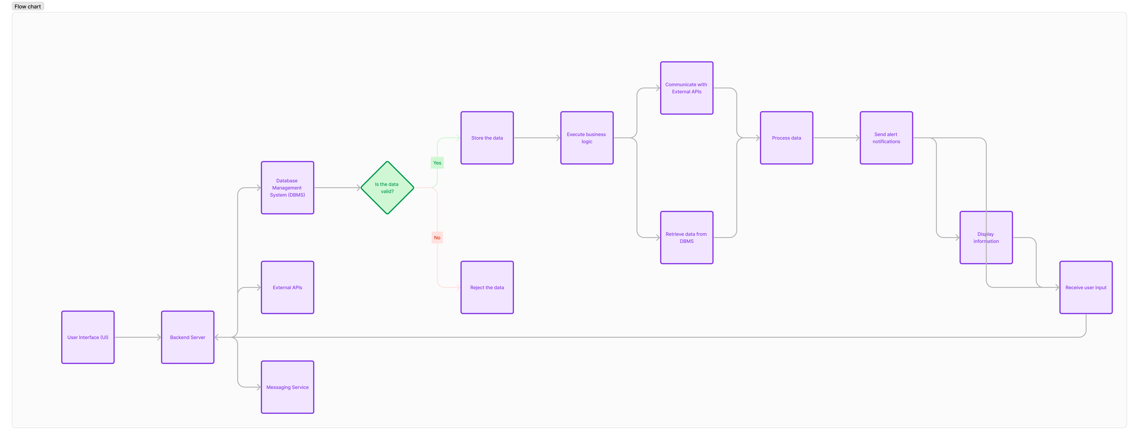
- User Interface (UI): This component serves as the front-end interface for users to interact with the application. It displays information and receives user input.
- Backend Server: This component acts as the central processing unit of the system. It handles incoming requests from the UI, executes business logic, and communicates with other components.
- Database Management System (DBMS): This component stores and manages the application's data, including user profiles, vehicle information, route history, and system configurations.
- External APIs: These represent third-party services or APIs integrated into the application to provide additional functionalities. For example, a Map Service API may be used for real-time vehicle tracking.
- Messaging Service: This component is responsible for sending alert notifications to users. It may use SMS, email, or other messaging channels to notify users about specific events or conditions

Database Design
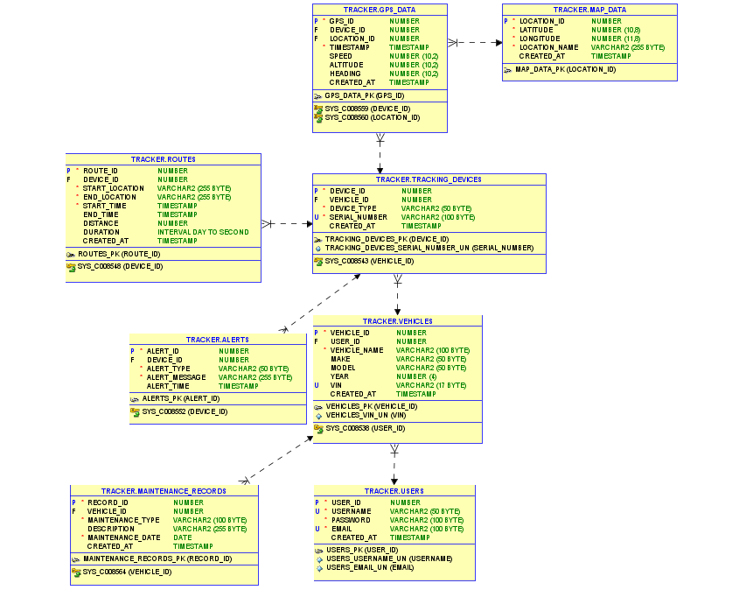

- users: Stores information about users, including their username, password, email, and creation timestamp.

- vehicles: Stores information about vehicles, including their owner (user_id), name, make, model, year, VIN (Vehicle Identification Number), and creation timestamp.

- tracking devices: Represents the tracking devices installed in vehicles, including their type, serial number, and creation timestamp.

- routes: Stores information about routes taken by vehicles, including the start and end locations, times, distance travelled, and duration.
- alerts: Stores alert notifications generated by the tracking devices, including the alert type, message, and timestamp.

- map data: Stores geographical location data for mapping purposes, including latitude, longitude, location name, and creation timestamp.

- GPS data: Stores GPS data collected by the tracking devices, including location, speed, altitude, heading, and timestamp.

- maintenance records: Records maintenance activities performed on vehicles, including the type of maintenance, description, maintenance date, and creation timestamp

User Interface design

Wireframes
Wireframes are essential for visualizing the structure and layout of the car tracking app that we are creating. They serve as a blueprint for the design and development phases, ensuring that the app meets user needs and business objectives. The main screens to be wireframe include the login screen, registration screen, and tracking map,. Each screen will be designed with a focus on usability and functionality.
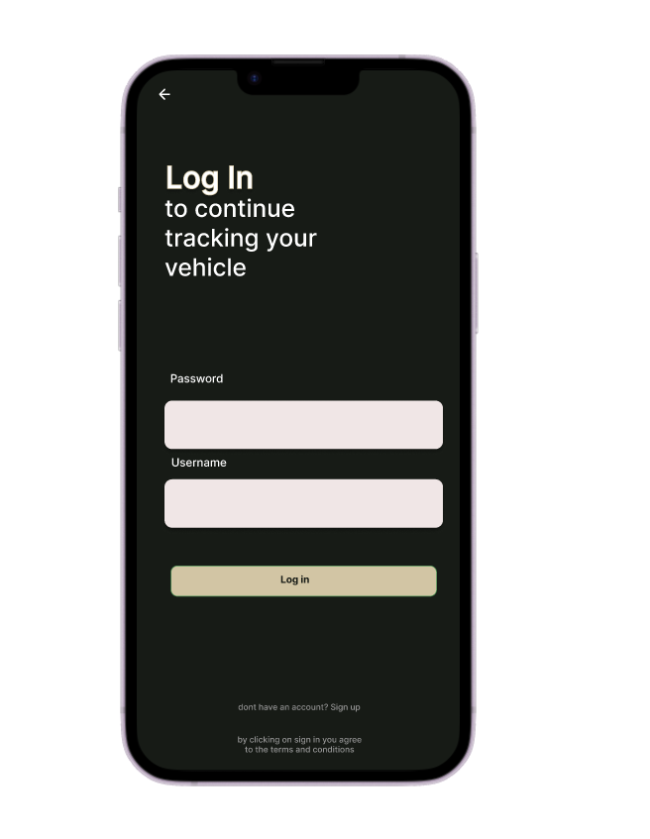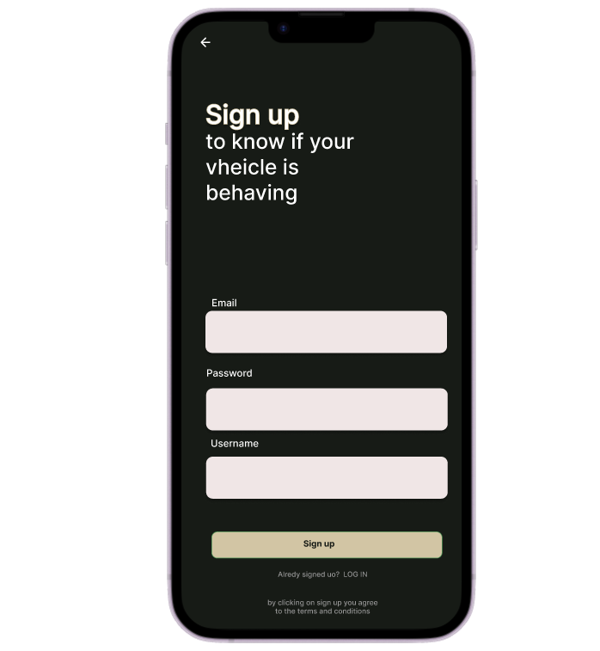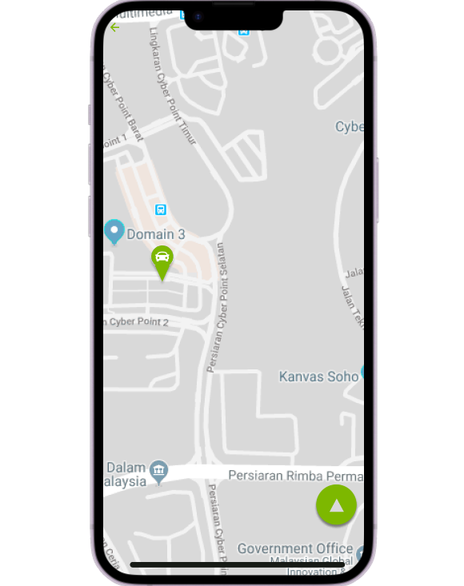
We used Figma for creating and collaborating on wireframes. Figma's cloud-based platform allows for real-time feedback and iteration, ensuring that all stakeholders can participate in the design process.
- Login Screen:
Elements: Username field, password field, login button, and sign-up link.
Description: Users will enter their credentials to access the app. The design will be simple and focused on ease of use.

- Registration Screen:
Elements: Fields for username, email, password, register button.
Description: New users can create an account. Validation messages will guide users to enter correct information.

- Tracking Map Screen:
Elements: Interactive map, real-time vehicle markers, float button, menu arrow
Description: This screen shows the real-time location of vehicles on a map click the float button which will give the option to search or locate exact position of vehicle

Mock-ups
In this section, we will present a mock-up of the Pro Tracker car tracking app, showcasing its user interface and user experience. The mock-up will provide a visual representation of the systems layout, navigation, and key features, giving stakeholders a clear understanding of how the app will look and feel.

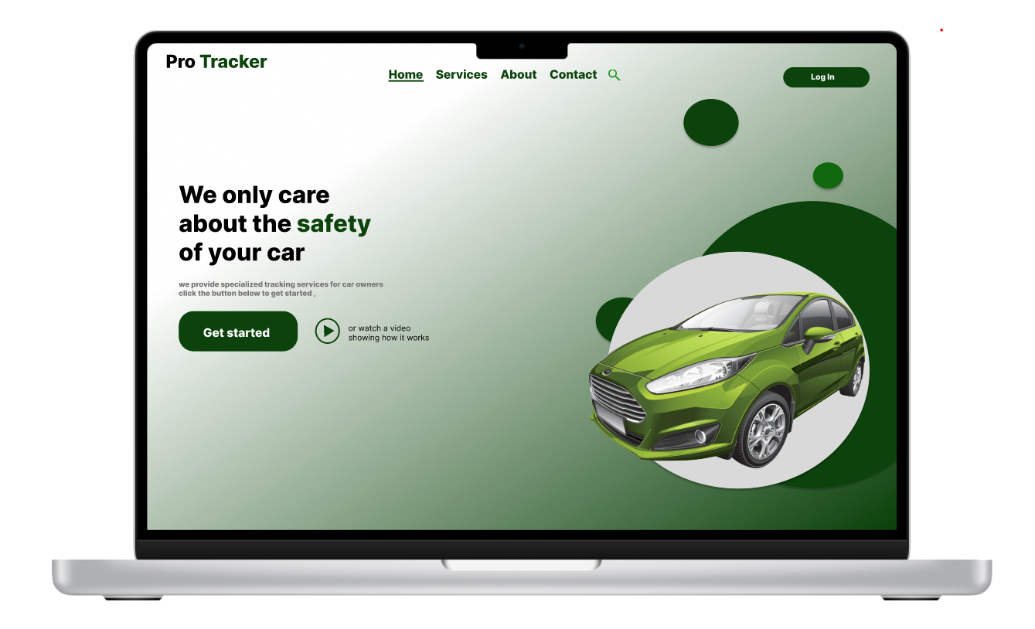
We have decided to make use of the colour green as the main theme colour and also to incorporate a sort of serious feel to our interface to give the users a much more professional experience
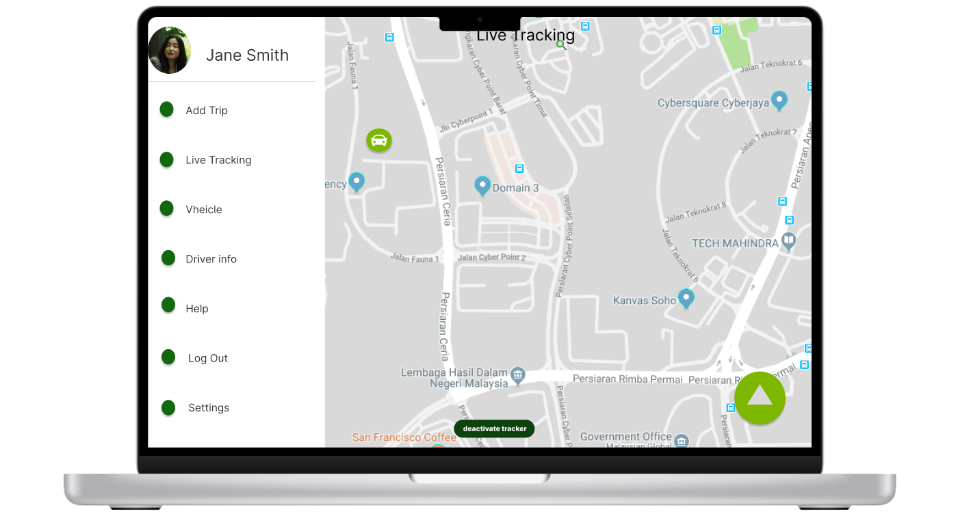
Just like the application, users will be able to locate their vehicles and have a map view, users should be able to add a trip which alert the system of any trips and also help with data capturing, user will be able to view vehicle and the driver’s information will be viewable ass well by the menu.

Development

Front end development:
For the Pro Tracker website, we will utilize HTML5, the latest version of the HTML standard, as the primary front-end development language. HTML5 offers improved semantic meaning, enhanced multimedia support, and better error handling our reasons for using html for the website build are:
- Universality: HTML is supported by all modern web browsers, ensuring cross-platform compatibility.
- Flexibility: HTML allows for easy integration with other technologies like CSS, JavaScript, and server-side languages.
- Accessibility: HTML provides a clear structure for content, making it accessible for users with disabilities.
- Search Engine Optimization (SEO): HTML's semantic elements improve search engine ranking and visibility.
The HTML features and widgets that will be used are:
- Semantic elements (e.g., header, navigation bar, main page, footer) for improved structure and SEO.
- Multimedia support (API integration(Map), images) for engaging content.
- Canvas and SVG for dynamic graphics and animations.
- Responsive design using CSS media queries for a mobile-friendly interface.
- Integration with CSS for styling and JavaScript for dynamic functionality.
HTML Development Tools:
- Visual Studio Code (VS Code) for coding and debugging.
- Sublime Text for coding and text editing.
- Atom for coding and customization.
HTML Assistance and Resources:
- W3Schools (https://www.w3schools.com/) for HTML documentation, tutorials, and examples.
- Mozilla Developer Network (https://developer.mozilla.org/en-US/) for comprehensive HTML reference.
- Stack Overflow (https://stackoverflow.com/) for community support and troubleshooting.
- HTML5 Rocks (https://www.html5rocks.com/en/index) for tutorials, examples, and best practices.

For the Pro Tracker Android app, we will use Kotlin 1.8, the latest version of the language, as the primary programming language. Kotlin is a modern, expressive language that is fully interoperable with Java and optimized for Android development. The reason why we chose to use the kotlin language is because:

- Concise syntax and reduced boilerplate code.
- Null safety features and runtime checks for improved app stability.
- Extension functions for easy integration with Android SDK and libraries.
Kotlin Features:
- Data classes for simple and efficient data modelling.
- Enum classes for type-safe and expressive enumerations.
- Coroutines for asynchronous API calls and background processing.
- Anko library for concise and expressive coding.
Kotlin Development Tools:
- Android Studio for coding, debugging, and testing.
- IntelliJ IDEA for coding, debugging, and project management.
- Visual Studio Code (VS Code) for coding and debugging.
Kotlin Assistance and Resources:
- Official Kotlin documentation for language reference and tutorials.
- Android Developer Academy for Android development guides and resources.
- Kotlin Slack community for community support and feedback.
- Kotlin Weekly for news, tutorials, and best practices.

Additional Resources:
Online Courses:
- Udemy for HTML and Kotlin courses.
- Coursera for web development and Android development courses.
- edX for web development and Android development courses.
Books:
- "HTML and CSS: Design and Build Websites" by Jon Duckett.
- "Kotlin Programming Language" by Venkat Subramaniam.
- "Android Development with Kotlin" by Marcin Moskala and Igor Wojda.

Back end Development

For the Pro Tracker project, we will utilize Java as the primary back-end development language, leveraging its platform independence, strong security features, and large community support. Java's seamless compatibility with Kotlin, used for the Android app, enables efficient data exchange and integration between the back-end and mobile app the advantages of java are:

- Platform Independence: Java's virtual machine (JVM) allows for cross-platform compatibility.
- Strong Security: Java's sandboxing and memory management ensure robust security features.
- Large Community: Java's vast and active community provides extensive libraries, frameworks, and support.
- Multithreading: Java's built-in multithreading support enables efficient concurrent programming.
- Easy Integration: Java's compatibility with Kotlin enables effortless data exchange and integration with the Android app.

Java Frameworks and Tools:

- Spring Boot: A popular framework for building scalable and robust back-end applications.
- Hibernate: An ORM (Object-Relational Mapping) tool for efficient database management.
- Kotlin: a popular framework that allows integration between java and kotlin code
- Java Servlet: A web framework for building scalable web applications.
- Apache Tomcat: A popular web server and servlet container.
- IntelliJ IDEA: A comprehensive IDE for coding, debugging, and testing.

Java and Kotlin Interoperability:

- Kotlin's compatibility with Java enables seamless data exchange and integration.
- Java's extensive libraries and frameworks complement Kotlin's Android app development.
- Shared data models and APIs facilitate efficient communication between the back-end and mobile app.

Java Development Process:

- Design and plan the back-end architecture and API structure.
- Set up the development environment with IntelliJ IDEA and necessary libraries.
- Implement API endpoints and data models using Spring Boot or Java Servlet.
- Integrate with Kotlin code for data exchange and mobile app functionality.
- Test and debug the back-end using IntelliJ IDEA and Java's built-in tools.

Java Assistance and Resources:

- Official Java Documentation for language reference and tutorials.
- Java Tutorials for comprehensive tutorials and guides.
- Stack Overflow for community support and troubleshooting.
- Java Weekly for news, tutorials, and best practices.

Kotlin and Java Interoperability Resources:

- Official Kotlin for language reference and tutorials.
- Kotlin and Java Interoperability Guide for integration and data exchange.
- Kotlin Slack community for community support and feedback.

Additional Resources:

- Udemy for Java and Kotlin courses.
- Coursera for web development and Android development courses.
- edX for web development and Android development courses.
Books:
- "Head First Java" by Kathy Sierra and Bert Bates.
- "Kotlin Programming Language" by Venkat Subramaniam.
- "Android Development with Kotlin" by Marcin Moskala and Igor Wojda.

Integration of tracking device

The Pro Tracker app and website will seamlessly integrate with a tracking device provided by a reputable company, enabling real-time location tracking and updates. This device will be installed in the vehicles, allowing us to leverage its advanced features and capabilities. The tracking device features go as follows:

- GPS Technology: The tracking device utilizes GPS technology to provide precise location data, enabling us to track the vehicle's movement in real-time.

- Cellular Connectivity: The device uses cellular connectivity to transmit location data to our servers, ensuring constant communication and updates.

- Speed and Direction: The device provides real-time speed and direction data, enabling us to monitor driving habits and optimize routes.

- Ignition and Motion Detection: The tracking device detects when the vehicle is started or moved, providing insights into usage patterns and potential theft.

- Battery Life: The device features a long-lasting battery, ensuring continuous tracking and updates without interruptions.

Integration Benefits:

- Real-time Tracking: The integration enables real-time location tracking, allowing us to monitor vehicle movement and update the app and website accordingly.

- Improved Security: The tracking device provides an additional layer of security, enabling us to detect potential theft or unauthorized use.

- Optimized Routes: By analysing speed and direction data, we can optimize routes and reduce fuel consumption.

- Enhanced User Experience: The integration provides a seamless user experience, allowing users to access real-time location data and updates within the app and website.

- Increased Efficiency: The tracking device enables us to streamline our operations, reducing manual tracking and improving overall efficiency.

Down below are the images of the physical tracking device:

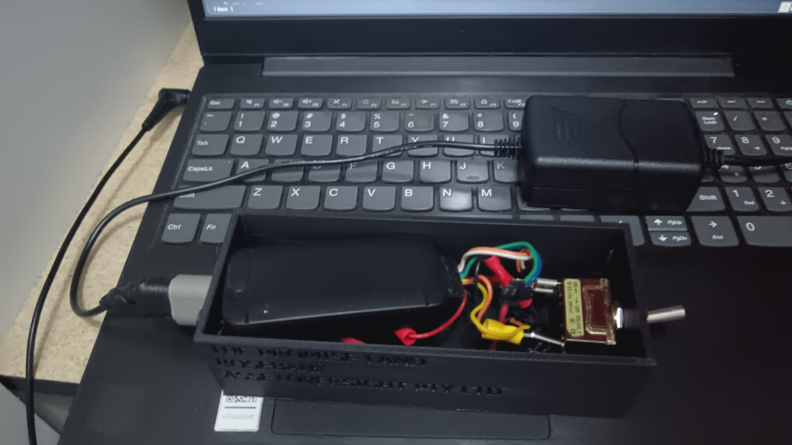

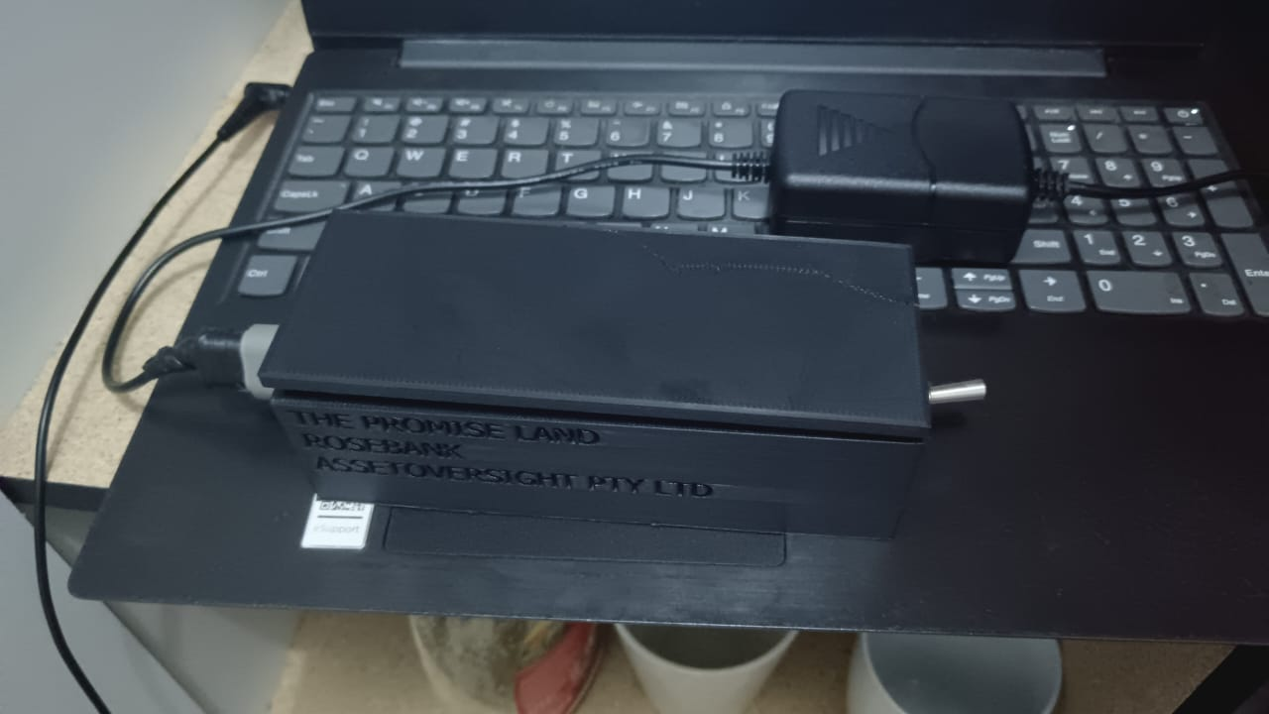

Project Management

Project Timeline
Week 1 | Project Planning and Requirements Gathering  - Define project scope and objectives.  - Identify key stakeholders and set up communication channels.  - Gather and document detailed requirements for the car tracker system.  - Conduct feasibility study and risk analysis.  - Create an initial project plan and timeline
Week 2 | Research and Design  - Research existing car tracker solutions and technologies.  - Select the hardware components (GPS module, GSM module, microcontroller, etc.).  - Design the system architecture (hardware and software).  - Develop wireframes and flowcharts for the software interface.  - Review design with stakeholders and gather feedback.
Week 3 | Hardware Setup and Configuration  - Procure hardware components and tools.  - Assemble the hardware components (connect GPS and GSM modules to the microcontroller).  - Configure the hardware modules for initial testing.  - Write and upload basic firmware to test hardware functionality.  - Document hardware setup process.
Week 4 | Software Development  - Set up development environment for software coding.  - Develop the backend software for data collection and processing.  - Implement GPS data reading and parsing functionality.  - Develop GSM communication protocol for data transmission.  - Conduct unit testing of individual software modules.
Week 5 | Software Development  - Develop the front-end user interface (web or mobile app).  - Implement real-time tracking and data visualization features.  - Integrate backend with the front-end interface.  - Conduct integration testing to ensure seamless communication between hardware and software.  - Debug and fix any issues found during testing.
Week 6 | Testing and Refinement  - Conduct comprehensive system testing (hardware and software integration).  - Perform field tests to validate real-world performance.  - Gather user feedback and identify areas for improvement.  - Optimize system performance based on test results.  - Finalize user documentation and training materials.
Week 7 | Deployment and Evaluation  - Deploy the car tracker system in the real-world environment.  - Monitor system performance and collect user feedback.  - Make final adjustments and refinements based on deployment feedback.  - Conduct a project review meeting with stakeholders.  - Prepare and submit the final project report.

Risk management

1. Introduction
Risk management plays a pivotal role in supporting our mission. By proactively identifying, assessing, and mitigating risks, we ensure that our solutions remain reliable and secure, while also maintaining our leadership position in a rapidly evolving market. Our objectives are clear: to protect the organization from unforeseen disruptions, safeguard customer and stakeholder interests, and enable sustainable growth through sound risk management practices.
This Risk Management Plan serves as a comprehensive framework for identifying, analysing, and managing risks that could impact the success of our operations and long-term strategic goals. It outlines our approach to risk management, providing guidance on how to anticipate potential threats and respond effectively to minimize their impact.

2. Risk Management Policy

Statement of Commitment to Risk Management

We are committed to maintaining a proactive and systematic approach to managing risks across all aspects of our business operations. Our risk management policy reflects our dedication to safeguarding the organization’s assets, reputation, and interests of stakeholders, while also supporting our long-term growth and operational excellence.

Risk management is not only about preventing negative outcomes but also about enabling informed decision-making, enhancing resilience, and seizing opportunities with calculated precision. We pledge to continuously identify, assess, mitigate, and monitor risks that may impact our business activities, ensuring that we remain agile in the face of uncertainty.

This policy is integral to maintaining a robust internal control environment, ensuring compliance with legal and regulatory requirements, and embedding a culture of risk awareness at every level of the organization.

3. Risk Identification
- Systematic process for identifying potential risks associated with the company's operations, including:
- Equipment failure
- Data breaches
- Regulatory compliance issues
- Physical security risks
- Environmental factors (e.g., weather conditions)
- Techniques for gathering input from stakeholders and experts to ensure comprehensive risk identification.

4. Risk Assessment
- Methodology for assessing the likelihood and potential impact of identified risks.
- Criteria for prioritizing risks based on severity and likelihood of occurrence.
- Tools and techniques for quantitative and qualitative risk analysis.

5. Risk Mitigation Strategies
- Development of strategies to mitigate identified risks, including:
- Equipment maintenance schedules
- Cybersecurity measures (e.g., encryption, access controls)
- Regulatory compliance measures (e.g., training programs, audits)
- Physical security measures (e.g., surveillance, access controls)
- Implementation of risk controls to reduce the likelihood or impact of risks.

6. Risk Monitoring and Control
- Procedures for ongoing monitoring of risks and their mitigation strategies.
- Regular review and update of risk registers and mitigation plans.
- Mechanisms for tracking key risk indicators and triggering corrective actions when necessary.

7. Contingency Planning
- Development of contingency plans for managing risks that cannot be completely eliminated, including:
- Backup systems and redundancy measures
- Incident response plans for data breaches or security incidents
- Emergency response plans for unexpected events (e.g., natural disasters, accidents)
- Testing and rehearsal of contingency plans to ensure effectiveness.

8. Training and Communication
- Training programs to educate employees on risk management procedures and protocols.
- Establishment of clear communication channels for reporting and addressing potential risks or incidents.
- Integration of risk management into regular company communications and meetings.

9. Review and Reporting
- Process for regular review and reporting on the effectiveness of the risk management plan.
- Conduct of periodic risk assessments to identify new risks or changes in existing risks.
- Review of incidents or near-misses to identify opportunities for improvement in risk management practices.

10. Documentation and Record Keeping
- Maintenance of comprehensive documentation related to risk management activities, including:
- Risk registers
- Mitigation plans
- Incident reports
- Training records
- Secure storage and retention of records in compliance with applicable regulations.

11. Continuous Improvement
- Commitment to continuous improvement of the risk management process through:
- Regular review and updating of policies and procedures.
- Feedback mechanisms for soliciting input from employees and stakeholders.
- Participation in industry forums and best practice sharing initiatives.

