**CS-2042 – Operating Systems**

**Name: A. P. P. S. Pathirana**

**Index No: 170425X**

**Date: 03.06.2019**

**Shortest-job-first (SJF) scheduling algorithms simulation**

**SJF Algorithm**

Shortest Job First scheduling works on the process with the shortest **burst time** or **duration** first. SJF is a non-preemptive algorithm. Furthermore, SJF is the optimal algorithm for CPU scheduling. Major concerns of SJF algorithm are listed below,

* SJF is a greedy algorithm.
* SJF is the optimal CPU scheduling algorithm.
* The length of the next CPU burst should be known.
* May cause starvation if shorter processes keep coming, this problem can be solved using the concept of aging.

The Gantt chart for SJF scheduling algorithm is shown below.

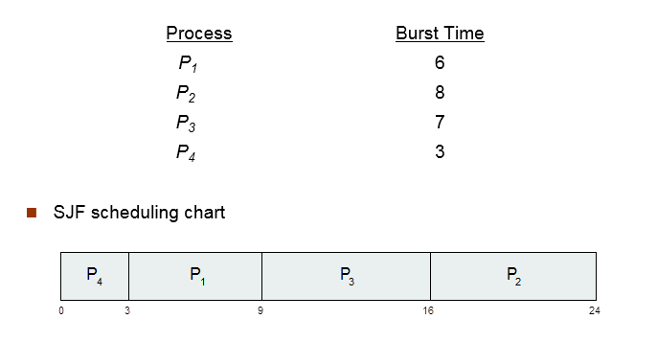

**Implementation**

I intend to implement the solution using a simple java algorithm. If necessary a simple user interface can be created using simple tools like javafx, java swing.

**What is included in the solution?**

* Five processes as inputs.
* Average waiting time of each process.
* Average turnaround time of each process.