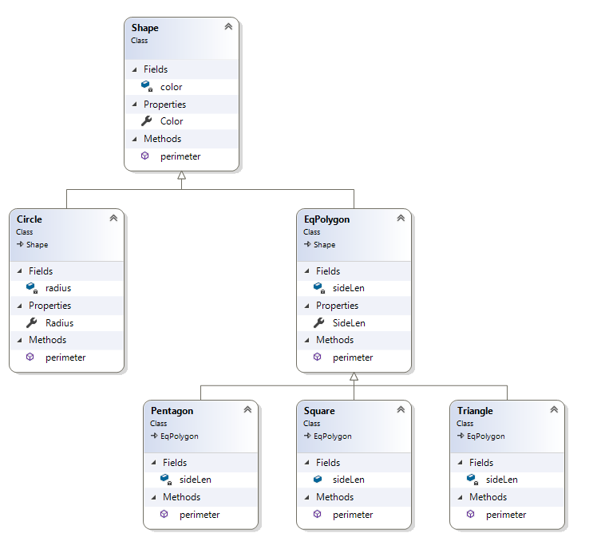

My design starts with the Shape class being the super class above all others it is linked throughout the project by inheritance. But the child classes below shape are the circle and EqPolygon shape classes as a circle is more or less a one of a kind shape and not considered a polygon. EqPolygon has child classes that inherit from it as well and they are Triangle, Square, and Pentagon because they are all polygons but they are the bottom rung classes.