CIL Code: seems to contain what my code is doing in very abstract ways such as using “Call” when I am using a method call and shows whitespace and what variables I am using for different parts of my code such as strings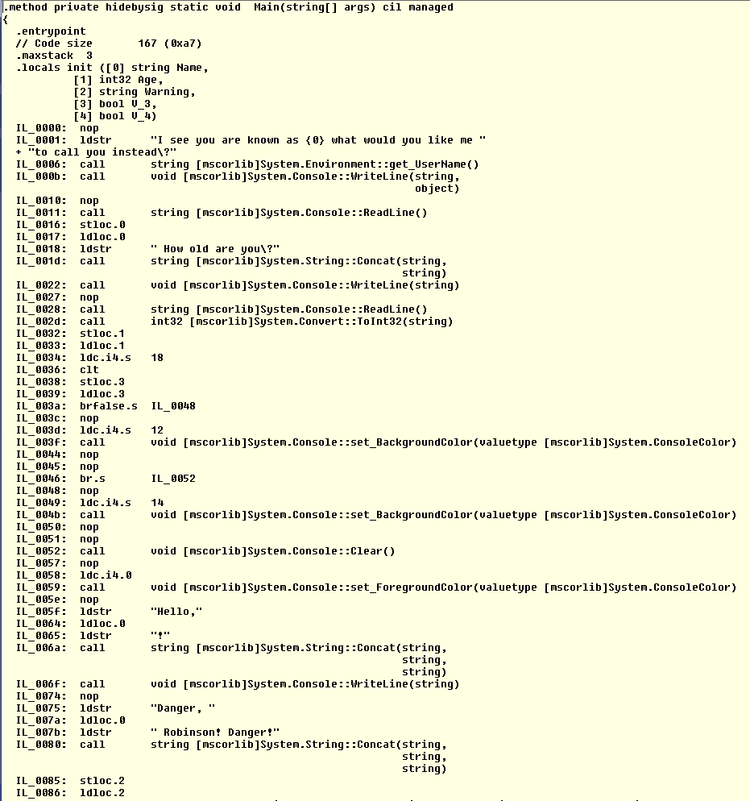

Type Metadata: seems to show fields of global variables and local variables as well as my functions and references to any members if I had any but since this project is basic there isn't much to see beside Type references 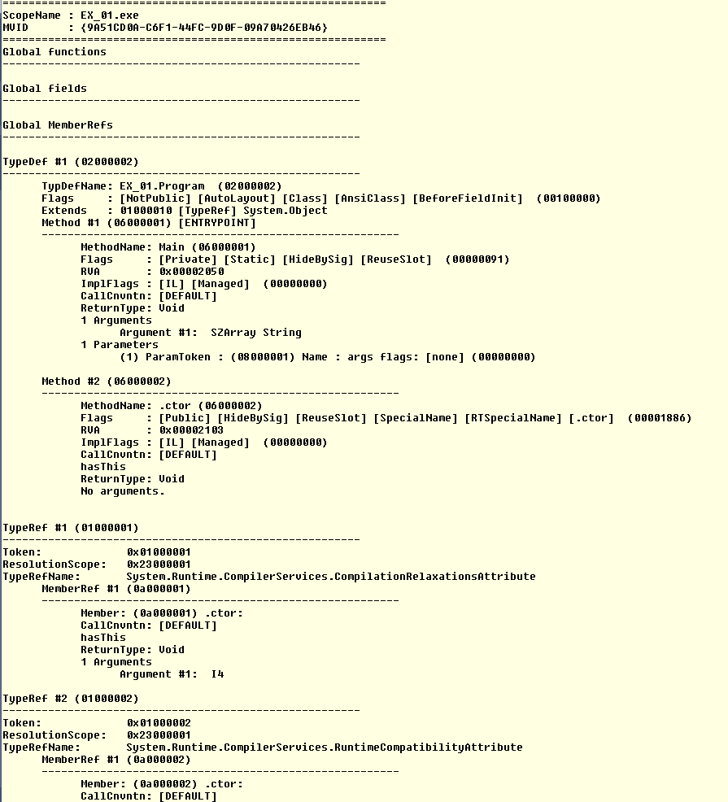

Assembly Metadata: seems to contain my variable types in most cases and displays where to see the allocations in hex I think from all the numbers and letters put together