Process Manual
For the process: Refurbed

Version x.x
Validity of document: xxx
Responsible for this document is: Kalarickal Dominic, Ivanic Marcel
This document was created in collaboration with: FH Technikum Wien
Released on xxx by xxx

Table of Content
Versioning and list of changes 4
1. Process Overview 5
1.1. Process Name 5
1.2. Process Content / Process description 5
1.3. Process Trigger 5
1.4. First Process Step 5
1.5. Last Process Step 5
1.6. Preceding Process 5
1.7. Following Process 5
1.8. Quantity structure (runs per time unit) 5
1.9. Average cycle time of the Process 5
1.10. Worthiness of the process 5
1.11. Goals of the process 5
2. Process Life Cycle 6
2.1. Process Identification Methods 6
2.1.1. IGOE 6
2.1.2. PCDM 6
2.2. Process Analysis 7
2.2.1. Qualitative Process Analysis 7
2.2.1.1. Value-Added Analysis 7
2.2.1.2. Waste Analysis 7
2.2.1.3. Stakeholder Analysis 7
2.2.1.4. Issue Documentation 7
2.2.2. Quantitative Process Analysis 7
3. Process Model 8
4. Process Redesign (To-Be Process) 9
4.1. Appliction of redesign heuristic 9
4.2. To-Be model in BPMN 9
4.3. Devil’s Quadrangle 9
4.4. Implementation in company 9

Versioning and list of changes

Version | Status | Date | Responsible | Changes | Reason for change
0.1 | R | 23.11.2023 | Ivanic Marcel, Kalarickal Dominic | 1.1 – 1.10 | Process Name, Content, Trigger, Quantity Structure, Average Cycle Time
0.2 | R | 24.11.2023 | Ivanic Marcel, Kalarickal Dominic | 1.11 – 2.1.1, 4.2 | Goals and Worthiness of the Process, IGOE, PCDM, BPMN
0.3 | R | 13.12.2023 | Ivanic Marcel, Dominic Kalarickal | 2.2.1.1-2.2.1.4 | Value Added Analysis, Stakeholder Analysis, Waste Analysis, Issue Register

Notes on status and version management
Versioning | 0.1, 0.2, … | unreleased versions, with the status 'in progress' or 'in review‘
Versioning | 1.0 | first released version with the status 'released‘
Versioning | 1.1, 1.2, … | Versions that complement the original product in version 1.0 and are 'in progress' or 'under review'.
Versioning | 2.0 | second released version with the status 'released‘

Process Overview
The process overview is used to collect (usually summarized on one page) the most important facts about a process.

Process Name
Refurbishment

Process Content / Process description
The refurbishment process at Refurbed involves assessing, repairing, and quality-checking used electronics to prepare them for resale. This process aligns with the company's business objectives by promoting environmental sustainability through reducing electronic waste and supporting a circular economy. Additionally, it upholds high quality and reliability standards, fostering customer trust and satisfaction in the refurbished electronics market.

Process Trigger
The trigger for the refurbishment process is the arrival of used electronic devices that have been sourced from customers or suppliers. This can be a scheduled shipment or an ad hoc collection of devices that have been sold back to the company.

First Process Step
The first process step after the trigger would be the "Inspection & Assessment" where each device is checked to identify any damage, functionality issues, or missing parts.

Last Process Step
The last step in the refurbishment process is "Distribution" which involves the shipping of the refurbished device to the customer or to a retail outlet for sale.

Preceding Process
The preceding process to refurbishment is the "Acquisition & Collection" process, which involves sourcing, collecting, and logging the used devices into inventory upon arrival.

Following Process
The process that follows refurbishment is the "Sales and Customer Support" process. This includes listing the refurbished devices on sales channels, processing customer purchases, and providing after-sale support.

Quantity structure (runs per time unit)
Refurbed likely executes its refurbishment process approximately 7,000 times per year, considering a consistent volume of device trade-ins and purchases.

Average cycle time of the Process
The estimated cycle time for the refurbishment process, from initial inspection to final distribution, is about 3 to 5 days, reflecting efficient refurbishing and quality control practices.

Worthiness of the process
Criterion | 1-2 points | 3-4 points | 5-6 points | points achieved
Numbers of different departments involved | <3 | 3-4 | >4 | 4
Roles involved | <3 | 3-4 | >4 | 5
Strategic relevance | low | medium | high | 6
Number of runs per year | <3 | 4-100 | >100 | 6
Risk - probability | low | medium | high | 3
Risk - damage | low | medium | high | 3

Goals of the process
Generic Goals/ Category | Objectives | input/output/process
Cost | increase profit | input, output, process
Quality | Ensure high standard of refurbished devices | output
Efficiency | Minimize the time from device intake to ready-for-sale | process
Environmental Impact | Maximize the environmental benefit by reducing waste | output
Employee Satisfaction | Maintain high levels of staff engagement and expertise | input

Process Life Cycle

Process Identification Methods

IGOE
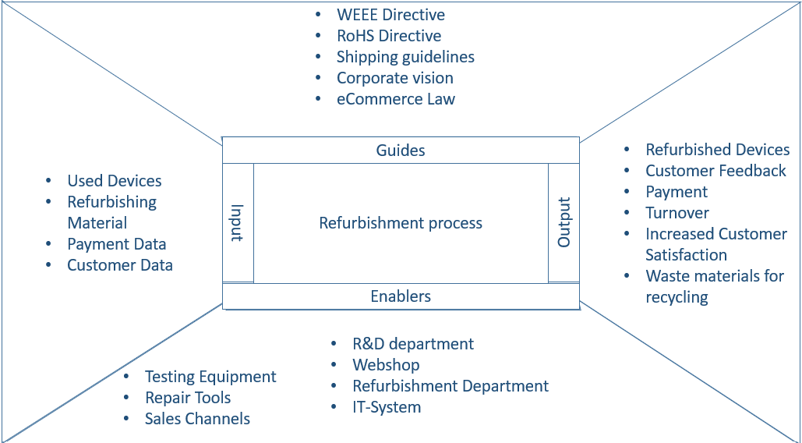

PCDM
Input | Activity | Output | Role | Tools/Method
Used electronic devices | Acquisition & Collection | Devices ready for refurbishment | Logistics Coordinator | Webshop
 | Inspection & Assessment | Refurbished electronic devices | Quality Inspector | Testing Equipment
 | Repair | Devices with enhanced functionality | Technician | Repair tools
Product Data | Quality-checking | Quality assurance reports | Engineer | Quality Control Checklists
Delivery product data | Packaging | Packaged and labelled products | Packaging Specialist | Packaging materials, Labels
 | Inventory logging | Inventory records updated | Inventory Manager | Inventory Management Software
 | Distribution | Product ready for resale | Logistic Coordinator | Sales Channels

Process Analysis
Complexity Handling: The ability to handle the complexity of the refurbishment process, which involves multiple departments and steps.
Stakeholder Involvement: Involving various stakeholders such as technicians, quality inspectors, and sales personnel in the process discovery.
Resource Efficiency: Efficient use of time and resources in the process discovery, given that Refurbed may have limited resources to devote to extensive process mapping.
Technology Integration: Capability to integrate with existing technology used in the refurbishment process, such as inventory management systems or quality control software.
Scalability: The method should accommodate growth as Refurbed expands into new markets or adds new processes.
Detail Level: The level of detail the method provides, which is important for understanding the intricacies of the refurbishment operations.

Interviews:
Complexity Handling: Medium. Can capture detailed information but may miss interactions between different roles.
Stakeholder Involvement: High. Directly involves stakeholders in sharing their part of the process.
Resource Efficiency: Low. Time-consuming and requires the availability of employees for interviews.
Technology Integration: Low. Relies on stakeholder knowledge rather than direct system data.
Scalability: Low. Becomes increasingly complex with more stakeholders.
Detail Level: High. Can uncover nuanced details of each process step.
Workshops:
Complexity Handling: High. Can map out complex processes with multiple stakeholders.
Stakeholder Involvement: High. Brings together diverse groups to collaborate.
Resource Efficiency: Medium. Requires scheduling and coordinating group meetings.
Technology Integration: Medium. Can be used to discuss existing technologies and how processes integrate with them.
Scalability: Medium. Can handle larger groups but may become unwieldy.
Detail Level: High. Encourages the cross-pollination of ideas and details.
Document Analysis:
Complexity Handling: Low. Documents may not fully capture the complexity of actual processes.
Stakeholder Involvement: Low. Passive analysis of existing documentation.
Resource Efficiency: High. Can be done asynchronously without tying up multiple employees.
Technology Integration: Medium. Can review documents related to technology use.
Scalability: High. Documents can be analyzed at scale.
Detail Level: Medium. Dependent on the quality and thoroughness of the documentation.
Automated Process Discovery Tools:
Complexity Handling: High. Can analyze complex interactions by mining system logs.
Stakeholder Involvement: Low to Medium. Does not require active stakeholder involvement but may need their input for context.
Resource Efficiency: High. Automated tools can quickly process large amounts of data.
Technology Integration: High. Directly integrates with IT systems to analyze actual usage and process flows.
Scalability: High. Can handle large datasets and multiple processes.
Detail Level: High. Can reveal detailed process maps based on real user actions.

Qualitative Process Analysis

Value-Added Analysis

Step | Performer | Classification
Receive and log devices | Inventory Manager | BVA
Initial device assessment | Quality Inspector | VA
Data wiping | Technician | VA
Repair and replace components | Technician | VA
Software updates | Technician | VA
Quality control check | Quality Control Officer | VA
Packaging | Logistics Operator | BVA
Update inventory system | Inventory Manager | BVA
Device storage | Warehouse staff | NVA
Shipment preparation | Logistics Operator | BVA

Waste Analysis
Step | Performer | Classification | Waste Identified | Waste Type
Receive and log devices | Inventory Manager | BVA | Walking distance to storage | Move
Initial device assessment | Quality Inspector | VA | Waiting for devices | Hold
Data wiping | Technician | VA | Multiple system handoffs | Move
Repair and replace components | Technician | VA | Excess inventory of parts | Hold
Software updates | Technician | VA | Update installation times | Overdo
Quality control check | Quality Control Officer | VA | Re- inspection due to errors | Overdo
Packaging | Logistics Operator | BVA | Excessive packaging materials | Overdo
Update inventory system | Inventory Manager | BVA | Delays in inventory update | Hold
Device storage | Warehouse staff | NVA | Extended storage time | Hold
Shipment preparation | Logistics Operator | BVA | Inefficient packaging process | Move

Stakeholder Analysis
Stakeholder | Interest/Needs
Consumers buying refurbished electronics | High-quality, reliable products; environmental sustainability; good value for money
Technicians,  Quality Inspectors,  Logistics Operators | Clear procedures; safe working conditions; job satisfaction; adequate resources and training
Suppliers of spare parts,  Recycling partners | Timely transactions; clear specifications; long-term business relationships
Refurbishment Process Manager,  Inventory Manager,  Quality Assurance Manager | Process efficiency; quality compliance; cost control; team performance
CEO,  CFO,  Chief Sustainability Officer | Process effectiveness and ROI; alignment with company goals; sustainability impact; brand reputation

Issue Documentation
Name | Explanation | Assumptions | Qualitative Impact | Quantitative Impact
Inconsistent Product Quality | Refurbished products do not meet expected quality standards | 10,000 products refurbished p.a;  5% fall below quality standards  €50 (lost profit per product) | Reduced customer satisfaction;  Negative brand reputation | 10,000* 0.05* €50= €25,000 potential lost revenue per unsatisfied customer
Insufficient Training | Technicians lack adequate training for refurbishment tasks | Training improves efficiency by 20%; 100 technicians require training  50 technicians need training | Lower morale and productivity; increased error rates | 50 * €1.000 = €50,000 p.a. (cost of training per technician)
Supply Chain Disruptions | Delays in receiving spare parts from suppliers | 20,000 parts ordered p.a; 10% experience supply delays  €5 (cost per delayed part) | Strained supplier relationship;  Operational delays | 20,000*0,10* €5= €50,000 cost p.a
Ressource Allocation Inefficiencies | Resources are not allocated effectively in the refurbishment process | Efficient allocation can reduce costs by 10%;  $300,000 annual budget | Frustration among managers;  Decreased efficiency | $300,000* 0,10= €30,000 savings p.a
Misalignment with Sustainability Goals | Process not fully aligned with sustainability objectives. | Company’s sustainability targets are set to reduce waste by 10% p.a. | Impact on reputation;  Stakeholder dissatisfaction | If 10% waste reduction equals $20,000 in savings, then non- alignment cost= $20,000 p.a.

Quantitative Process Analysis
Flow Analysis, Queuing Analysis, Simulation

Process Model
Here the more detailed process model happens. Possible methods: EPK, flow chart, value added diagram, …

Process Redesign (To-Be Process)

Application of redesign heuristics

To-Be model in BPMN
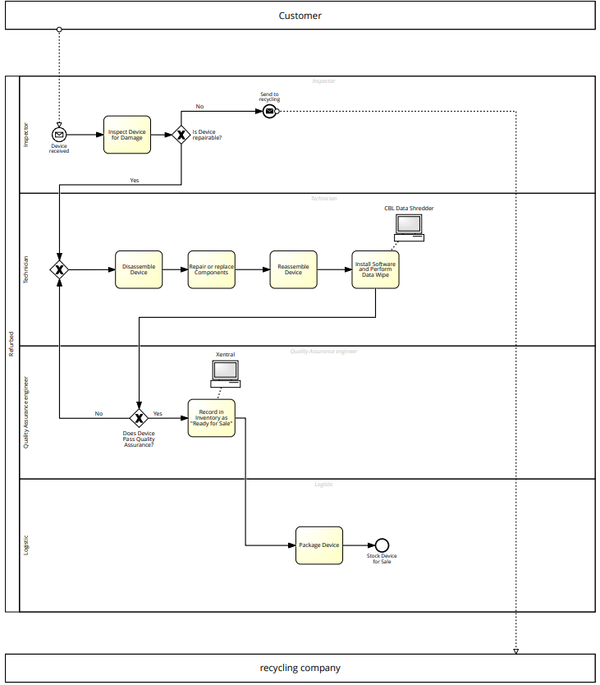

Devil’s Quadrangle

Implementation strategy in company

