Business Process Management Manual
For the company: Refurbed

Version x.x
Validity of document: xxx
Responsible for this document is: Kalarickal Dominic, Ivanic Marcel
This document was created in collaboration with: FH Technikum Wien
Released on xxx by xxx

Table of Content
Versioning and list of changes 5
Contact people in the process 6
1. Introduction of the Company 7
1.1. Company Description 7
1.2. Mission 7
1.3. Vision 7
2. Strategic Company Goals 8
2.1. Overview of Strategic Company Goals 8
2.2. Analysis of Conflicting Goals 8
3. Balanced Scorecard 9
3.1. Strategy Map 9
3.2. Cascading 9
4. Process Management 10
4.1. Introduction to the Process Management 10
4.2. What is a process – process worthiness criteria 10
4.3. Process Categories 10
4.4. Process Standards 10
4.5. Process Architecture 10
4.5.1. Process Landscape 10
4.5.2. Business Processes 10
4.5.3. Sub Processes & Tasks 10
4.6. Roles & Responsibilities in the Process Management 10
4.6.1. Process Manager 10
4.6.2. Process Owner 10
4.6.3. Process Team 10
5. Process Life Cycle 11
5.1. Process Identification 11
5.1.1. Methods 11
5.1.1.1. IGOE 11
5.1.1.2. PCDM 11
5.1.1.3. Frameworks 11
5.2. Process Discovery (As-Is Process) 11
5.2.1. Modeling Standards & Quality Assurance 11
5.2.2. Methods 11
5.2.2.1. Evidence Based 11
5.2.2.2. Interview Based 11
5.2.2.3. Workshop Based 11
5.3. Process Analysis 11
5.3.1. Methods 11
5.3.1.1. Qualitative Process Analysis 11
5.3.1.2. Quantitative Process Analysis 11
5.4. Process Redesign (To-Be Process) 12
5.4.1. Methods 12
5.4.1.1. The Redesign Orbit 12
5.5. Process Implementation 12
5.5.1. Process Training & Communication Plan 12
5.6. Process Monitoring and Controlling 12
5.6.1. Standards and Methods 12
6. Business Process Modeling Tool 13
6.1. Requirements 13
6.1.1. Functional Requirements 13
6.1.2. Non Functional Requirements 13
6.2. Selection 13
6.2.1. Criteria 13
6.2.2. Alternatives 13
6.2.3. Analytic Hierarchy Process 13
7. Templates / Documents 14
8. Definitions and Abbreviations 15

Versioning and list of changes

Version |  | Status |  | Date |  | Responsible |  | Changes |  | Reason for change
0.1 | R |  | 18.11.2023 |  | Kalarickal Dominic |  | 1.1, 1.2, 1.3 |  | Description of the company, it’s mission and vision
0.2 | R |  | 19.11.2023 |  | Ivanic Marcel |  | 2.1, 2.2 |  | Strategic Company Goals
0.3 | R |  | 20.11.2023 |  | Kalarickal Dominic, Ivanic Marcel |  | 2.3, 2.4 |  | Strategy Map, Cascading
0.4 | R |  | 24.11.2023 |  | Kalarickal Dominic, Ivanic Marcel |  | 3.1.1, 3.1.2, 4.1 |  | Process Landscape, BPMN, Quality Assurance

Notes on status and version management
Status | A | in progress = when creating and editing a document
Status | R | in Review = when soliciting review comments
Status | F | Released = as completion of the editing and review phase
Versioning | 0.1, 0.2, … | unreleased versions, with the status 'in progress' or 'in review‘
Versioning | 1.0 | first released version with the status 'released‘
Versioning | 1.1, 1.2, … | Versions that complement the original product in version 1.0 and are 'in progress' or 'under review'.
Versioning | 2.0 | second released version with the status 'released‘

Authorized for change | Kalarickal Dominic, Ivanic Marcel
Target group | Refurbed
Responsible for review | Kalarickal Dominic, Ivanic Marcel
Quality assurance | Kalarickal Dominic, Ivanic Marcel
Responsible for Release | Kalarickal Dominic, Ivanic Marcel

Contact people in the process
Name | Role in project | E-mail
Kalarickal Dominic | project member | wi22b096@technikum-wien.at
Ivanic Marcel | project member | wi22b018@technikum-wien.at
Loeffler Ursula | project manager | loeffleu@technikum-wien.at

Introduction of the Company

Company Description
Refurbed, a second-hand electronics company, specializes in acquiring used electronic products such as mobile phones and laptops, refurbishing them, and subsequently reintroducing these renewed items to the market. Focused on mitigating the environmental impact of the surge in new mobile phone releases, Refurbed is dedicated to extending the service life of electronic devices by several years through its reconditioning efforts.
The company has successfully implemented this concept across various countries, with employees engaged in diverse roles, including marketing, repair, and sales. Each niche typically comprises 10-15 employees, and the company benefits from support from wholesalers and international firms, providing both individual parts and second-hand equipment.
Despite successful ventures in multiple countries, the company is currently facing challenges in Austria, where the reception of their new concept has proven more challenging than anticipated. Although individuals express willingness to sell their old equipment, there is reluctance when it comes to purchasing refurbished items. This hesitancy has resulted in sluggish sales for several months, leading to a rise in employee resignations or dismissals.
Encountering challenges in every country so far, the company recognizes the need to adapt its processes to find a more sustainable solution for the growing electronics market. The aim is to overcome the current obstacles and establish a stronger foothold in Austria, aligning with the company's overarching goal of promoting sustainability in the electronics industry.

Mission
At Refurbed, we are on a mission to reshape the electronics landscape by championing sustainability through the procurement and refurbishment of premium second-hand devices. Our goal is to provide accessible, eco-friendly alternatives that not only extend the life of electronics but also pave the way for a more conscientious and environmentally responsible future.

Vision
Refurbed envisions a global shift where our brand is synonymous with trusted, sustainable electronics. We aspire to lead a community that embraces refurbished technology, fostering a world where environmental responsibility is inherent in every technological choice.

Strategic Company Goals

Overview of Strategic Company Goals
Generic Goals/Category | Objectives (composite measures) | Measures | Target
Cost | Increase profitability | Percentage increase in profit margin | >5% annually
Quality Assurance | Improve product reliability | Return rate due to defects | <5% annually
Customer Satisfaction | Enhance customer trust in refurbished products | Net Promoter Score (NPS) | >40
Market Expansion | Establish market presence in Austria | Market share in Austria | >10% annually
Cost Efficiency | Reduce refurbishing costs | Average cost per refurbished unit | <50€ per unit
Employee Engagement | Increase employee retention and satisfaction | Employee turnover rate | <10% annually
Innovation | Develop new refurbishing techniques | Number of new methods implemented | >2 annually
Environmental Impact | Reduce carbon footprint | CO2 emissions saved per product | >50 kg CO2 per item

Analysis of Conflicting Goals
 | Goal A | Goal B | Goal C | Goal D | Goal E | Goal F | Goal G | Goal H | sum
Goal A |  | +2 | +2 | +2 | +2 | 0 | +1 | +1 | 10
Goal B | -1 |  | +1 | +1 | +2 | +1 | 0 | +2 | 6
Goal C | +2 | +1 |  | +2 | +1 | +2 | +1 | +2 | 11
Goal D | +1 | +1 | +2 |  | +1 | +1 | +2 | +2 | 10
Goal E | +1 | +2 | +1 | -1 |  | 0 | -2 | +2 | 3
Goal F | 0 | +1 | +2 | +1 | 0 |  | +1 | 0 | 5
Goal G | +2 | 0 | +1 | +2 | -2 | +1 |  | -1 | 3
Goal H | 0 | +1 | +2 | +1 | +1 | 0 | +1 |  | 6
sum | 5 | 8 | 11 | 8 | 5 | 5 | 4 | 8

Goal A: Increase profitability
strongly positive +2
weakly positive +1
Neutral 0
weakly negative -1
strongly negative -2
Goal B: Improve product reliability
Goal C: Enhance customer trust in refurbished products
Goal D: Establish market presence in Austria
Goal E: Reduce refurbishing costs
Goal F: Increase employee retention and satisfaction
Goal G: Develop new refurbishing techniques
Goal H: Reduce carbon footprint

Goal A - Increase Profitability: Increasing profitability aligns well with enhancing customer trust, establishing a market presence, and reducing the carbon footprint.
Goal B - Improve Product Reliability: While improving product reliability aligns with profitability, it may conflict with goals related to reducing refurbishing costs and developing new refurbishing techniques.
Goal C - Enhance Customer Trust in Refurbished Products: Enhancing customer trust aligns well with profitability, product reliability, market presence, and reducing the carbon footprint.
Goal D - Establish Market Presence in Austria: Establishing market presence in Austria aligns well with profitability, product reliability, and customer trust.
Goal E - Reduce Refurbishing Costs: Reducing refurbishing costs conflicts with improving product reliability and developing new refurbishing techniques but aligns with establishing market presence and employee satisfaction.
Goal F - Increase Employee Retention and Satisfaction: Increasing employee retention and satisfaction aligns well with profitability and enhancing customer trust.
Goal G - Develop New Refurbishing Techniques: Developing new refurbishing techniques conflicts with improving product reliability and reducing refurbishing costs but aligns with reducing costs.
Goal H - Reduce Carbon Footprint: Reducing the carbon footprint aligns well with profitability, enhancing customer trust, and increasing employee satisfaction, but conflicts with reducing refurbishing costs.

Balanced Scorecard

Strategy Map

Financial perspective | Increase profitability
Customer perspective | Establish market presence in Austria  Enhance customer trust in refurbished products
Internal/Process perspective | Improve product reliability  Reduce carbon footprint  Reduce refurbishing costs  Develop new refurbishing techniques
Innovation/Learning & Growth perspective | Increase employee retention and satisfaction

Financial perspective | Increase profitability
Customer perspective | Establish market presence in Austria  Enhance customer trust in refurbished products
Internal/Process perspective | Improve product reliability  Reduce carbon footprint  Reduce refurbishing costs  Develop new refurbishing techniques
Innovation/Learning & Growth perspective | Increase employee retention and satisfaction

Cascading
Strategy Map |  | Measurement |  | Key action programs
Perspectives | Objectives | Measures | Target | Initiatives | Responsibility(who)
Financial | Increase profitability | Percentage increase in profit margin | >5% | Cost management | Employee of Controlling
Customer | Establish market presence in Austria | Market share in Austria | >10% | Expand local marketing efforts in Austria. | Country Manager for Austria
Customer | Enhance customer trust in refurbished products | Net Promoter Score (NPS) | >40 | Launch a customer education campaign on refurbished quality. | Marketing Director
Internal / Process | Improve product reliability | Return rate due to defects | <5% | Standardize quality control procedures. | Quality Assurance Manager
Internal / Process | Develop new refurbishing techniques | Number of new methods implemented | >2 annually | Invest in R&D for advanced refurbishing technology. | Chief Innovation Officer
Internal / Process | Reduce carbon footprint | CO2 emissions saved per product | >50 kg CO2 per item | Partner with eco-friendly suppliers for parts. | Supply Chain Manager
Internal / Process | Reduce refurbishing costs | Average cost per refurbished unit | <50€ per unit | Introduce lean management techniques in refurbishing. | Production Manager
Innovation/ Learning & Growth | Increase employee retention and satisfaction | Employee turnover rate | <10% annually | Develop an employee recognition and reward program. | HR Director

Process Management

Introduction to the Process Management
What does the company in the area of BPM

What is a process – process worthiness criteria
What is a process and when is a process „worth“ tob e a managed process?

Process Categories
e.g. KeyPz, CorePz, SupportingPz, ManagementPz, …

Process Standards
e.g. BPMN 2.0 + short description

Process Architecture

Process Landscape
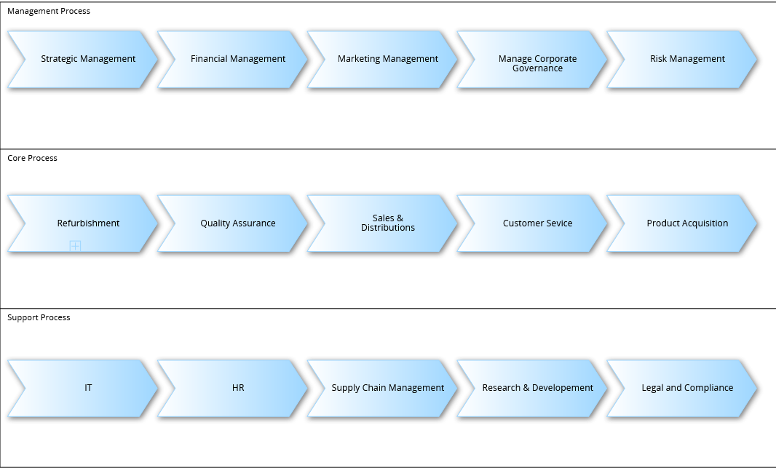

Business Processes
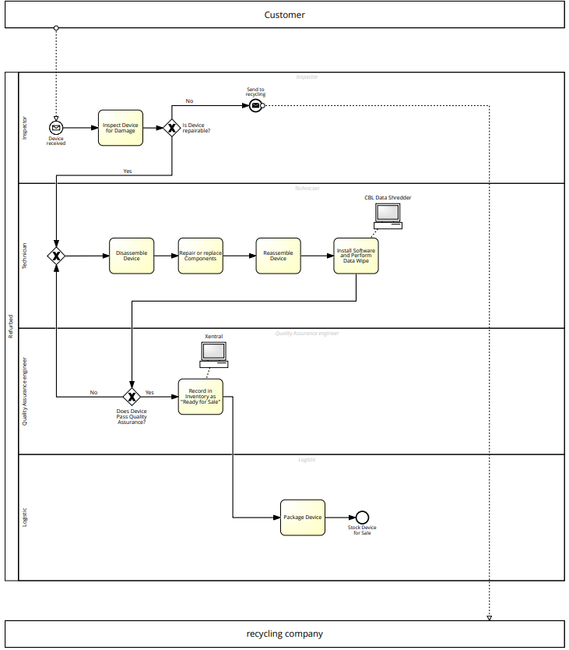

Sub Processes & Tasks

Roles & Responsibilities in the Process Management

Process Manager

Process Owner

Process Team

Process Life Cycle

Process Identification

Methods
Complexity Handling: The ability to handle the complexity of the refurbishment process, which involves multiple departments and steps.
Stakeholder Involvement: Involving various stakeholders such as technicians, quality inspectors, and sales personnel in the process discovery.
Resource Efficiency: Efficient use of time and resources in the process discovery, given that Refurbed may have limited resources to devote to extensive process mapping.
Technology Integration: Capability to integrate with existing technology used in the refurbishment process, such as inventory management systems or quality control software.
Scalability: The method should accommodate growth as Refurbed expands into new markets or adds new processes.
Detail Level: The level of detail the method provides, which is important for understanding the intricacies of the refurbishment operations.

Interviews:
Complexity Handling: Medium. Can capture detailed information but may miss interactions between different roles.
Stakeholder Involvement: High. Directly involves stakeholders in sharing their part of the process.
Resource Efficiency: Low. Time-consuming and requires the availability of employees for interviews.
Technology Integration: Low. Relies on stakeholder knowledge rather than direct system data.
Scalability: Low. Becomes increasingly complex with more stakeholders.
Detail Level: High. Can uncover nuanced details of each process step.
Workshops:
Complexity Handling: High. Can map out complex processes with multiple stakeholders.
Stakeholder Involvement: High. Brings together diverse groups to collaborate.
Resource Efficiency: Medium. Requires scheduling and coordinating group meetings.
Technology Integration: Medium. Can be used to discuss existing technologies and how processes integrate with them.
Scalability: Medium. Can handle larger groups but may become unwieldy.
Detail Level: High. Encourages the cross-pollination of ideas and details.
Document Analysis:
Complexity Handling: Low. Documents may not fully capture the complexity of actual processes.
Stakeholder Involvement: Low. Passive analysis of existing documentation.
Resource Efficiency: High. Can be done asynchronously without tying up multiple employees.
Technology Integration: Medium. Can review documents related to technology use.
Scalability: High. Documents can be analyzed at scale.
Detail Level: Medium. Dependent on the quality and thoroughness of the documentation.
Automated Process Discovery Tools:
Complexity Handling: High. Can analyze complex interactions by mining system logs.
Stakeholder Involvement: Low to Medium. Does not require active stakeholder involvement but may need their input for context.
Resource Efficiency: High. Automated tools can quickly process large amounts of data.
Technology Integration: High. Directly integrates with IT systems to analyze actual usage and process flows.
Scalability: High. Can handle large datasets and multiple processes.
Detail Level: High. Can reveal detailed process maps based on real user actions.

Frameworks

Process Discovery (As-Is Process)

Modeling Standards & Quality Assurance

Pros:
- Accuracy: Quality assurance methods ensure that the documented processes accurately represent the real-world operations, reducing the risk of misinterpretation.
- Consistency: Syntactic verification helps maintain consistency in language and notation, enhancing clarity and reducing confusion among stakeholders.
- Usability: Pragmatic quality assessment ensures that the documented processes are practical and usable, contributing to smoother implementation.
- Alignment with Objectives: Validation methods help align documented processes with organizational objectives, ensuring that they support strategic goals.
Cons:
- Resource Intensive: Quality assurance processes, especially involving validation with domain experts, can be resource-intensive and time-consuming.
- Subjectivity: Some aspects of quality, especially semantic accuracy, may be subjective and depend on the interpretation of domain experts.
- Inflexibility: Strict adherence to syntactic rules may limit the flexibility needed for creative process design, potentially stifling innovation.
- Scope Limitations: Quality assurance may focus more on individual steps rather than the overall efficiency and effectiveness of the end-to-end process.

Methods
- Syntactic Quality and Verification
The use of a standardized notation system (e.g., BPMN) promotes syntactic consistency. Verification confirms that process steps and notations align with established conventions.
- Semantic Quality and Validation
Validation involves cross-checking with domain experts to confirm that the documented steps align with actual operations. Semantic accuracy is crucial for effective process understanding.
- Pragmatic Quality and Certification
Pragmatic quality is confirmed through user feedback and testing. Certification involves evaluating how well the documented process supports operational goals and objectives.

Evidence Based
Document analysis, Observation, Automated process discovery

Interview Based

Workshop Based

Process Analysis

Methods

Qualitative Process Analysis
Value-Added Analysis, Waste Analysis, Stakeholder Analysis & Issue Documentation, Root-Cause Analysis

Quantitative Process Analysis
Flow Analysis, Queuing Analysis, Simulation

Process Redesign (To-Be Process)

Methods

The Redesign Orbit
Transactional Methods, Transformational Methods, Analytical Methods, Creative Methods, Inward-looking Methods, Outward-looking Methods

Process Implementation

Process Training & Communication Plan

Process Monitoring and Controlling

Standards and Methods

Business Process Modeling Tool
Criteria catalogue for the selection of the BPMS, Market research, Selected search engines, Chosen keywords, Matrix with the results of the searches, Long list with at minimum 20 results of BPMS, Comparison, Defined K.O. (knock-out) criteria, Evaluation of the K.O. criteria for the BPMS of the long list, by white papers of the vendors, 3 Recommended BPMS for the respective company

Requirements

Functional Requirements

Non Functional Requirements

Selection

Criteria

Alternatives

Analytic Hierarchy Process

Templates / Documents

Definitions and Abbreviations

