Notes on Erste’s Calypso Implementation of ISDA SIMM

The Role of Calypso in the daily Calculation of Initial Margin

- Representation of all IM relevant trade information
  - for the whole banking group
  - includes counterparty information
  - with IM CSA information per trade daily updated from Colline
- Daily availability of quality-assured market data
- Calculation of NPVs and raw sensitivities of all derivatives
- Conversion of raw sensitivities to standardized CRIF
- Calculation of SIMM based on the generated CRIF files using the parameters of the current ISDA SIMM calibration
- Calculation of IM Schedule
- Delivery of IM figures to Colline for monitoring / reconciliation

Position keeping of trades relevant for bilateral initial margin

All trades relevant for the calculation of bilateral initial margin figures are taken from Calypso. The Calypso representation is either
- the primary representation of the trades for FO, RM, BO and accounting (IRDs, CRDs, FXOs, EQDs) or
- imported from Kondor (used for FO position keeping) having RM, BO, accounting done from the Calypso representation (FX-Swaps, FX-Forwards, FX-NDs, ...) or
- imported from the local Kondors of the subsidiaries for Risk Management (VaR, FRTB) purposes

In the first two cases we have a full real-time representation of the trades in Calypso, especially the counterparty information. They are in trade status VERIFIED.
The trades imported from local Kondors for risk management purposes have their counterparty information only as a trade attribute (Kondor_RicosCode) and follow their own RM workflow. No settlement or accounting is done based on them. These trades are in the risk-management workflow in trade status RM_VERIFIED.
As a special case Ceska has also FX Range Accrual trades booked in Calypso in status VERIFIED. These are also included in the set of IM relevant trades

Assignment of IM-CSA information to all Calypso trades

As for the case of the variation margin, the terms of all initial-margin CSAs are captured and maintained in the Collateral Management System Colline. Since the trade representation is in Calypso and all calculations are also done there, we established a mechanism of assigning the id of the initial margin CSA to each relevant Calypso trade.

For this purpose, all un-cleared derivatives (excluding physically settled FX-Swaps, FX-Forwards) are exported from Calypso to Colline in a daily schedule after COB. This is done by an SQL Report scheduled task (id 144911, report template name 218_Colline_trade_feed_for_SIMM) which runs daily at 8 pm in the evening. Colline then imports the trade data, determines which trades fall under which IM-CSA and returns this information back to Calypso. In Calypso, the IM-CSA information is saved per trade in the trade attribute called Colline_IM_AgreementID.

The import of this attribute is done by the scheduled task COLLINE_TK_IMPORT, task id 160172. For trades that do not fall under any IM-CSA, the attribute Colline_IM_AgreementID is not set, for matured and terminated trades the attribute is deleted after maturity.

The IM-CSA information is also stored in the Calypso custom database table ERSTE_COLLINE_IM_TRADE_AGRMNT for documentation and back-testing purposes.
This is done daily by ST id 7310 (IMPORT_COLLINE_IM_AGREEMENT).
From this table the historic sets of trades that were considered under the various IM-CSAs at various dates is available.

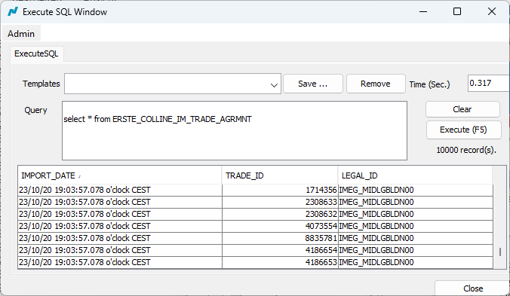

Assignment of SIMM product classes to all Calypso trades

The four available SIMM product classes (RatesFX, Credit, Equity and Commodity) are assigned to each trade based on the product type of the Calypso trade. The mapping of Calypso product
types to SIMM product classes is maintained in the erste_mapping db table under the map_reference SIMM_PRODUCT_CLASS, map_name being the Calypso product type and
map_value the SIMM product class. The settings are as follows:

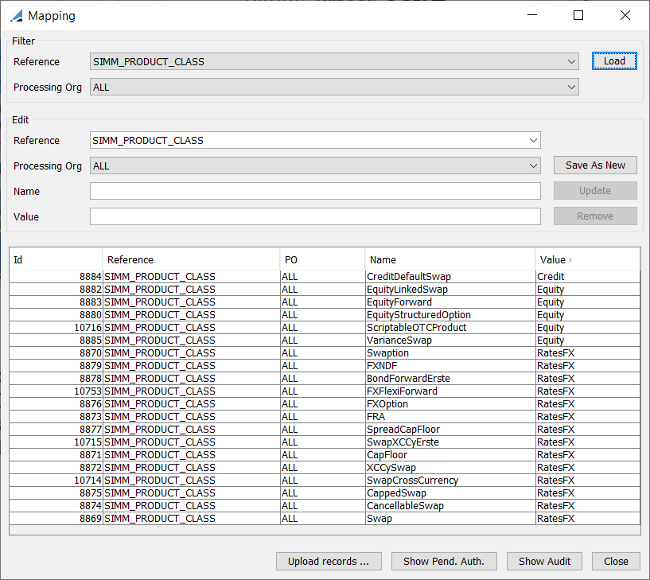

Currently no Commodity derivatives are traded within Erste Group and therefore no commodity mapping is specified.

Check of completeness of IM-CSA assignment

A Report ST (id 242761) checks daily whether all IM relevant trades of EBVI and LINZ_SPK have been assigned a Colline_IM_AgreementID. This is done using the SQL Query report (template 218_Colline_IM_AgreementIDs_monitoring). The query result (missing IM-CSA assignments) is sent to Collateral Management via email for potential setup of new IM-CSA.

The completeness checks for the portfolios of the subsidiaries lies in the responsibility of the local RMs.

Calculation of Sensitivities in Calypso

The calculation of the sensitivities required for SIMM is done by the Risk Analysis Scheduled Tasks 112050, 112051 running each morning from 3:30am for the previous day.

The names of the configured risk analysis set are 371_SIMM_sensi with the following sensitivity analyses for equity delta and equity vega risk of equity derivatives

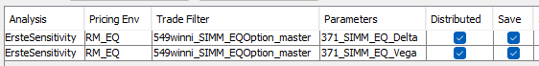
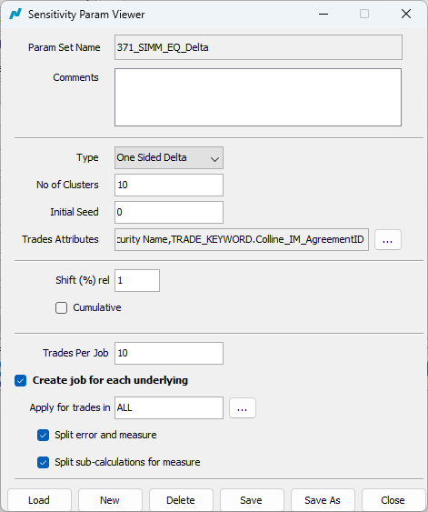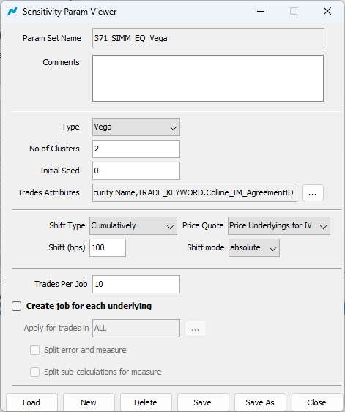

and 371_SIMM_master providing interest-rate (delta and vega) / FX / inflation and CDS risks figures
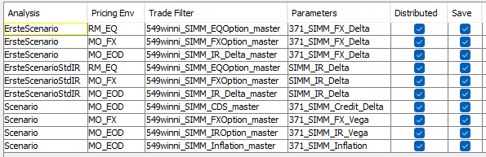

The trade filters are all derived from the master trade filter 549winni_SIMM_master containing all trades flagged as falling under an IM-CSA by the attribute 'Colline_IM_AgreementID' plus a portfolio of test trades for reference.

The interest-rate risk is calculated directly on the particular tenor grid specified in the SIMM documentation. For this purpose, a new custom ScenarioRule called ErsteScenarioStdIR was implemented in Calypso that
- virtually creates a new interest curve setup according to SIMM on the fly
- maps the official EOD curve setup to the curve and tenor structure required by SIMM
- calculates the quote values (MM deposits & IRS) of the new curves from the EOD curves
- applies the shifts of the market data required by SIMM on the new curves

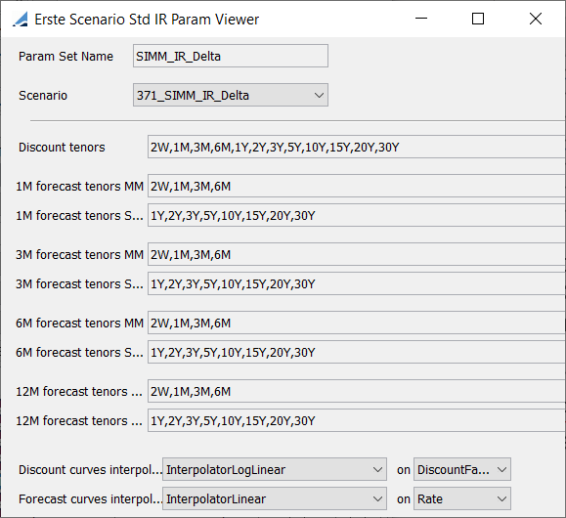

This approach provides for a direct calculation of the sensitivities used in SIMM irrespective of the underlying original curve structure and without further need to attribute risk data from the original curves to the grid used by SIMM.

Here is an example of the interest-rate risk of a 12y receiver IRS over 3m Euro calculated with this method:

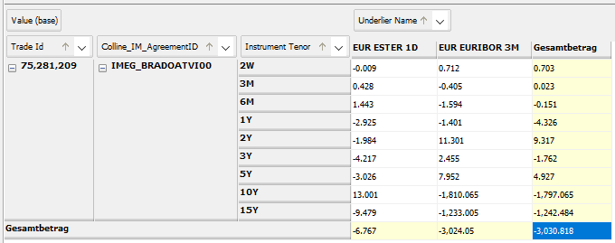

All scenario output files are exported by ST 112051 with a date stamp in the format 'yyyyMMdd' to the folder fromCalypso/Colline/ISDA_SIMM/SCENARIO
The output formatter used is 'scenario-util-csv' and comma is used as the field separator.
The location of this folder is \\s0196cerf02.f000.d0196.sd.spardat.at\calypso\PROD\. Each line of the output files should have the following entries

Trade Id
Risk Measure Full Name
Risk Measure Name
Type
Underlier Market Data Name
Value
Value (base)
TRADE_KEYWORD.EG_product
Processing Org.Short Name
CounterParty.Short Name
Product Type
Processing Org.Attribute.RICOS_CODE
CounterParty.Attribute.RICOS_CODE
TRADE_KEYWORD.Kondor_RicosCode
Trade Date
TRADE_KEYWORD.TransferDate
TRADE_KEYWORD.Colline_IM_AgreementID
Risk Currency

Conversion of Scenario output to CRIF

The conversion of the calculated scenarios to the standardised CRIF format is done by the scheduled tasks of type CONVERT_TO_CRIF which are run for each scenario output file.
The resulting CRIF files are stored in the folder fromCalypso/Colline/ISDA_SIMM/CRIF with a time stamp in the format 'yyyyMMdd'. The PortfolioID in the CRIF files corresponds to the Colline_IM_AgreementID in Calypso.

The lines of the CRIF files contain the following fields in exactly that order:

TradeID
ProductClass
RiskType
Qualifier
Bucket
Label1
Label2
Amount
AmountCurrency
AmountEUR
AmountUSD
TradeType
CounterpartyName
EntityName
InceptionDate
PortfolioID
ValuationDate

Below is the CIRF file for the above example IRS. The PortfolioID (IMEG_BRADOATVI00 in this example) comes from Colline and stored in Calypso as trade_keyword Colline_IM_AgreementID.

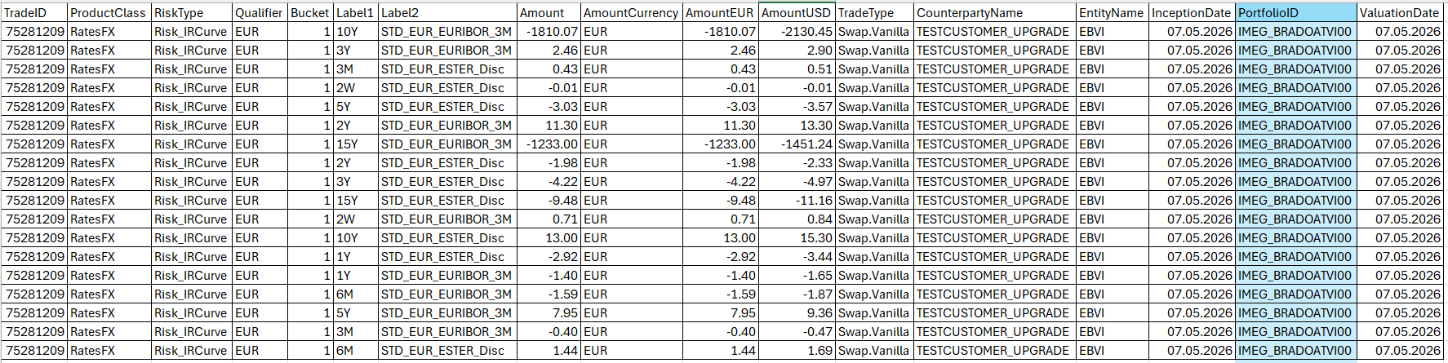

Aggregation of various CRIF files to Initial Margin figures

For the aggregation of the generated CRIF files to the initial margin figures, we have two independent tools

- a custom Calypso ST named CREATE_EXT_IA (id 229099) based on the java package https://github.com/AcadiaSoft/simm-lib by AcadiaSoft. The SIMM calculation is done in the AcadiaSoft classes. Only the interfacing & provision of CRIF data is done by Calypso. The results of this ST are exported to Colline each morning around 7am and therefore constitute the official IM figures. Unfortunately AcadiaSoft ended their support of version updates of SIMM so this tool can only be used for legacy comparisons.
- a custom Calypso report named CalcSIMMfromCRIF based on our own implementation of SIMM in Calypso. Here all implementation was done in house and uses the parameter file provided by ISDA for each version of SIMM.
The report is used for the analysis (drilldown) of the calculated SIMM for the various derivatives portfolios. Furthermore what-if calculations to estimate the impact of new trades / terminations / portfolio transfers on the IM can also be performed.
The functionality “Exclude Trade Ids” is also used to implement
  - the exemptions of single-stock & equity-index options granted by ESAs (trade filter 549winni_SIMM_excl_non_basket_EQDs) as well as
  - the regulatory intragroup exemptions granted by the local supervisors (trade filter 549winni_SIMM_excl_intragroup).
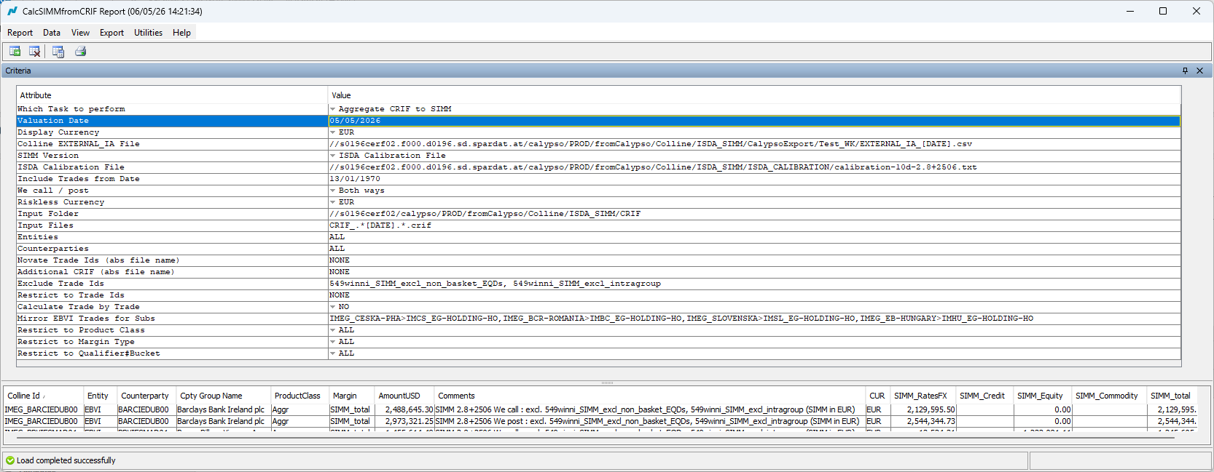

Chain of Calypso STs executed daily in the morning

This is the chain of scheduled tasks that is executed every morning in Calypso:
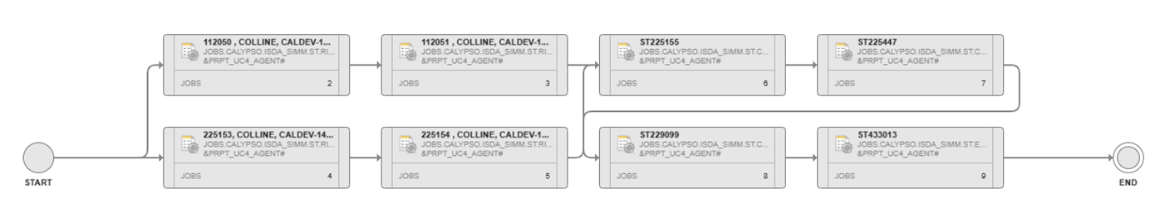

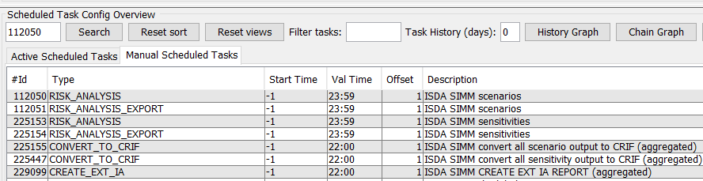

The end result is a file with SIMM figures to be imported in Colline (Colline EXTERNAL_IA file). This file can be created by a dedicated ST (CREATE_EXT_IA) or directly from the CalcSIMMfromCRIF Report (file name specified in line Colline EXTERNAL_IA File).

Calculation of Initial Margin according to Schedule

There are two Report scheduled tasks in Calypso, ids 157398 and 157399, one for EBVI / EBOE / SPKs and the other for the subsidiaries, that extract trade data relevant for IM Schedule from the Calypso data base. Scheduled task 7311, IM_STD_CALC, ISDA SIMM IM STANDARD APPROACH CALCULATION, uses the AcadiaSoft Classes to perform the Schedule calculation. The CSA information is again taken from Colline via the trade attribute Colline_IM_AgreementID. The flat output text files are saved to \\s0196cerf02\calypso\PROD\fromCalypso\ in the folder

Colline\ISDA_SIMM\IM Standard Approach\IM_STD_CALC Output

see ESA_2023_33_-_Amending_RTS_-_Equity_option_bilateral_margining.pdf

