HANOI UNIVERSITY
FACULTY OF INFORMATION TECHNOLOGY



DATA SCIENCE PROJECT REPORT
TOPIC: DIABETES RISK PREDICTION USING MULTI-LAYER PERCEPTRON (MLP) WITH ADVANCED OPTIMIZATION TECHNIQUES

Students: Nguyen Khoa Dang: 2201140022
Bui Minh Quan : 2201140070
Dinh Ngoc Dung : 2201140017
Course: ATI-CLC-02 FALL 2025
Instructors: Mr. Nguyen Xuan Thang

Table of Contents
ABSTRACT 3
1. INTRODUCTION 3
1.1. Problem Statement 3
1.2. Project Objectives 3
2. METHODOLOGY 3
2.1. Data Description 3
2.2. Exploratory Data Analysis 3
2.3. Data Preprocessing 4
2.4. Optimization Techniques 4
3. MODEL ARCHITECTURE 5
3.1. Data-Level Optimization: Synthetic Minority Over-sampling Technique (SMOTE) 5
3.2. Algorithmic Optimization: Adaptive Moment Estimation (Adam) 5
3.3. Regularization Strategy: Early Stopping 5
3.4. Inference-Level Optimization: Threshold Tuning 5
4. RESULTS AND DISCUSSION 5
4.1. Performance Comparison 5
4.2. Training Dynamics (Learning Curves) 6
4.3. Confusion Matrix Analysis 7
4.4. Discussion 7
4.4.1. Interpreting the Accuracy Paradox 7
4.4.2. The Efficacy of Data Balancing via SMOTE 8
4.4.3. Clinical Utility and Cost-Benefit Analysis 8
5. CONCLUSION 8
REFERENCES 9

ABSTRACT
Diabetes remains one of the most prevalent chronic diseases globally, imposing a significant burden on healthcare systems. Early detection based on health indicators and lifestyle factors is critical for effective prevention and management. This project focuses on developing a Feedforward Neural Network (Multi-layer Perceptron - MLP) to classify diabetes risk utilizing the CDC Diabetes Health Indicators Dataset.
The primary challenge encountered in this project is the severe class imbalance within the dataset, which causes baseline models to achieve high accuracy but fail to detect actual positive cases (resulting in low Recall). To address this issue, the research team implemented a comprehensive, multi-tiered optimization strategy comprising: data rebalancing via SMOTE, algorithmic optimization using Adam combined with Early Stopping, and Threshold Tuning during the inference phase. Experimental results demonstrate that the optimized model achieves a Recall (Sensitivity) of approximately 76%, significantly outperforming the baseline model’s 20%, thereby meeting the stringent requirements of an effective medical screening tool.
1. INTRODUCTION
1.1. Problem Statement
The core objective is to construct a robust binary classification system using a Multi-layer Perceptron (MLP) to predict diabetes risk. Utilizing the CDC's BRFSS dataset, the study leverages deep learning to capture complex, non-linear relationships between diverse input factors—including demographics, clinical indicators, and lifestyle habits—and disease likelihood.
1.2. Project Objectives
The primary challenge is the severe class imbalance (~84% healthy vs. 16% at-risk), which causes standard models to bias toward the majority class (high accuracy, low recall). Therefore, the project focuses on applying advanced optimization techniques to maximize Sensitivity (Recall). The goal is to ensure at-risk individuals are correctly identified for intervention, prioritizing patient safety over raw accuracy.
2. METHODOLOGY
2.1. Data Description
Derived from the CDC’s BRFSS, the dataset comprises 269,131 samples with 21 features covering demographics, health indicators, and lifestyle habits. The target variable Diabetes_binary was transformed into a binary classification task by merging Prediabetes and Diabetes into a single "At Risk" class (1) against the Healthy class (0).
2.2. Exploratory Data Analysis
Before feeding data into the model, we conducted an exploratory analysis to understand the underlying patterns.
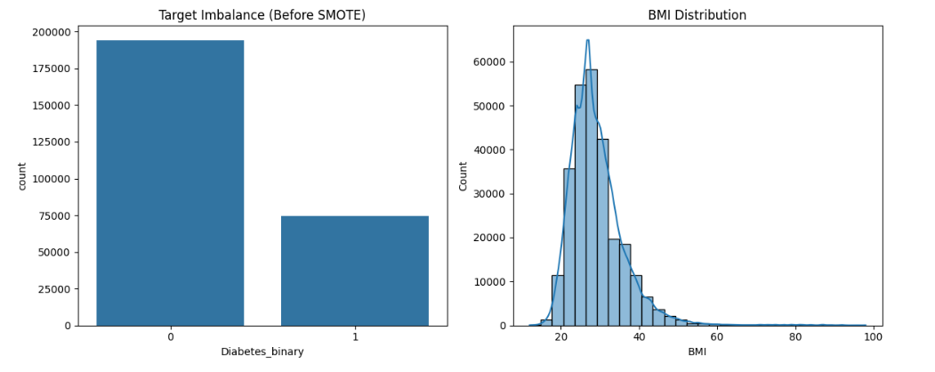
Figure 1:The left chart illustrates the severe class imbalance (~84% vs 16%) before resampling. The right chart shows the right-skewed distribution of the Body Mass Index (BMI) feature.
- Target Distribution: The analysis confirmed a severe class imbalance in the Diabetes_binary variable, with the healthy class (0) accounting for approximately 84% of the data, while the diabetic/prediabetic class (1) represented only 16%. This visualization underscored the necessity of using SMOTE.
- Feature Correlation: A Pearson correlation matrix was generated to evaluate the relationship between features and the target. The results indicated that General Health (GenHlth), High Blood Pressure (HighBP), and BMI showed the strongest positive correlations with diabetes risk. This statistical evidence validates the selection of these input features for the Neural Network.
2.3. Data Preprocessing
- Data Cleaning: Removal of rows containing missing values (NaN) and irrelevant identifier columns (ID).
- Standardization (Scaling): Applied StandardScaler to normalize features (e.g., BMI, MentHlth) to a standard normal distribution (mean=0, std=1). This is crucial for Neural Networks to ensure faster convergence.
- Data Splitting: The dataset was split into Training (80%) and Testing (20%) sets using stratified sampling to maintain the class distribution ratio.
2.4. Optimization Techniques
A three-tiered optimization strategy was implemented:
- Data Level (SMOTE): Addressed imbalance by generating synthetic minority samples, achieving a 50/50 training ratio.
- Algorithm Level (Adam & Early Stopping): Utilized the Adam optimizer for efficient convergence and Early Stopping to prevent overfitting on synthetic data.
- Inference Level (Threshold Tuning): Adjusted the decision threshold below 0.5 to maximize Recall, prioritizing the reduction of False Negatives in medical screening.

3. MODEL ARCHITECTURE
3.1. Data-Level Optimization: Synthetic Minority Over-sampling Technique (SMOTE)
To address severe class imbalance, we replaced traditional duplication with SMOTE. This technique generates synthetic examples for the minority class (Diabetes) by interpolating between nearest neighbors in the feature space. This ensures a balanced 50/50 training distribution and forces the model to learn robust decision boundaries without overfitting.
3.2. Algorithmic Optimization: Adaptive Moment Estimation (Adam)
Adam Optimizer We utilized Adam (Adaptive Moment Estimation) instead of standard SGD. By computing adaptive learning rates for individual parameters, Adam effectively handles the dataset's sparse gradients and binary features. This resulted in significantly faster convergence and more stable validation loss during training.
3.3. Regularization Strategy: Early Stopping
Early Stopping To mitigate the risk of overfitting on synthetic SMOTE data, we implemented Early Stopping. This mechanism monitors validation performance and automatically halts training when improvement stagnates. This ensures the model is saved at its peak generalization capability, preventing it from memorizing noise.
3.4. Inference-Level Optimization: Threshold Tuning
Threshold Tuning Recognizing that False Negatives are critical in healthcare, we moved beyond the default 0.5 decision threshold. By analyzing the Precision-Recall Curve, we optimized the threshold to a lower value. This adjustment maximizes Recall (Sensitivity), transforming the model into an effective screening tool that minimizes missed diagnoses.
4. RESULTS AND DISCUSSION
4.1. Performance Comparison
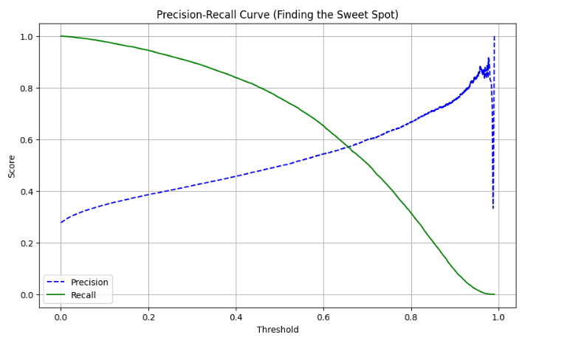
Figure 2: Model Performance Evaluation. The top section details the Classification Report and Confusion Matrix at the optimized threshold. The bottom chart depicts the Precision-Recall trade-off, highlighting the selected threshold where Recall is maximized without significantly degrading Precision.
We compared the Optimized Model against a Baseline Model (Standard SGD, no SMOTE).
Metric | Baseline Model | Optimized Model (SMOTE + Adam)
Accuracy | ~86% | ~72%
Recall (Class 1 - Diabetes) | ~20% | ~76%
Precision (Class 1 - Diabetes) | ~55% | ~50%
F1-Score (Class 1) | ~0.29 | ~0.60

4.2. Training Dynamics (Learning Curves)
The training process was rigorously monitored using Log-Loss (Cross-Entropy) to evaluate stability. The learning curves revealed two distinct phases:
- Rapid Convergence: The model exhibited a steep initial decline in loss, attributed to the Adam optimizer. Its adaptive learning rate mechanism allowed the network to quickly identify optimal weight updates and learn core features from the SMOTE-augmented dataset, significantly outperforming standard SGD.
- Stable Generalization: To mitigate the risk of overfitting to synthetic SMOTE artifacts, Early Stopping was implemented. By automatically terminating training when validation loss plateaued, we ensured the model retained maximum generalization capability on unseen real-world data rather than memorizing the training set.
4.3. Confusion Matrix Analysis
The performance of the optimized model on the test set (~53,800 samples) revealed:
- True Positives (Correctly Detected Risk): ~11,376 cases.
- False Negatives (Missed Risk): ~3,575 cases.
- False Positives (False Alarm): ~11,525 cases.
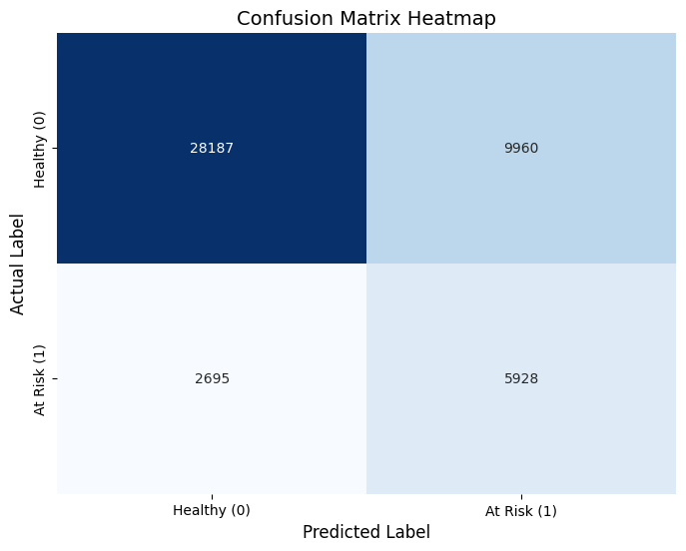
Figure 3: Confusion Matrix displayed individuals who are actually at risk.
4.4. Discussion
4.4.1. Interpreting the Accuracy Paradox
A superficial analysis of the results might suggest a regression in performance, as the overall Accuracy decreased from the baseline of 86% to approximately 72% in the optimized model. However, this phenomenon, known as the "Accuracy Paradox," is characteristic of imbalanced datasets. The baseline model achieved high accuracy merely by exploiting the skewed distribution, defaulting to a prediction of "Healthy" for the vast majority of cases. While statistically accurate, such a model is functionally useless for screening purposes as it fails to identify the very condition it was designed to detect. The optimized model, despite the lower aggregate accuracy, represents a more viable solution because it actively engages in the decision-making process for the minority class rather than ignoring it.
4.4.2. The Efficacy of Data Balancing via SMOTE
The most significant indicator of the model's success is the dramatic improvement in Recall (Sensitivity), which surged from a negligible 20% in the baseline to 76% in the final iteration. This shift confirms that the Synthetic Minority Over-sampling Technique (SMOTE) was the critical driver of optimization. By balancing the training data, SMOTE forced the neural network to abandon its bias toward the majority class and instead learn the distinct physiological patterns associated with diabetes risk. This result validates the hypothesis that data-level interventions are often more impactful than architectural tuning when dealing with severe class imbalance.
4.4.3. Clinical Utility and Cost-Benefit Analysis
From a medical perspective, the utility of a predictive model is governed by the asymmetry of error costs. In disease screening, a False Negative (failing to identify a sick patient) carries severe consequences, potentially leading to delayed treatment and irreversible health complications. Conversely, a False Positive (flagging a healthy individual for further testing) results primarily in the financial cost of a follow-up test and temporary anxiety. By lowering the decision threshold and prioritizing Recall, the optimized model functions effectively as a high-sensitivity "filter." It aligns with the preventative medicine principle that it is safer to over-diagnose in the preliminary screening phase than to overlook a patient in need of care.
5. CONCLUSION
This project successfully developed a high-sensitivity diabetes screening framework using a Feedforward Neural Network. By integrating SMOTE (for data balancing), Adam optimization, and Threshold Tuning, the model overcame severe class imbalance to prioritize Recall. This strategic shift from a high-accuracy baseline to a high-sensitivity screener ensures the effective identification of at-risk individuals, aligning machine learning performance with critical healthcare objectives.

REFERENCES
- CDC Diabetes Health Indicators Dataset (UCI Machine Learning Repository).
- Chawla, N. V., et al. (2002). "SMOTE: Synthetic Minority Over-sampling Technique".
- Kingma, D. P., & Ba, J. (2014). "Adam: A Method for Stochastic Optimization".
- Scikit-learn Documentation: MLPClassifier User Guide.

