**Assignment 1**

**Design**

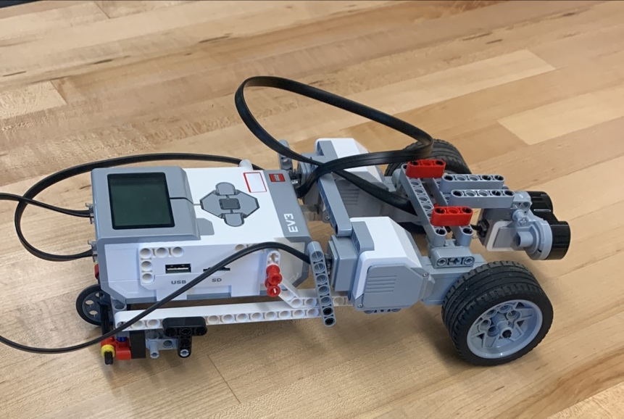

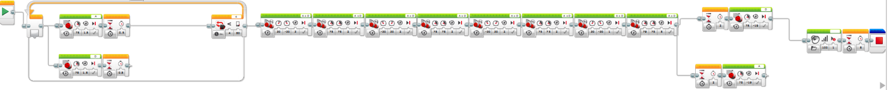

For our robot, we chose to utilize the 3 wheeled robot design, because this format makes navigation easiest without having to balance. For the driving mechanism, we used 2 large motors, with the third wheel being a simple non-pivoting wheel. Initially we had a pivoting wheel, then the ball bearing, but those two systems lead to inconsistencies with simple forward and backward motion, and a greater inconsistency when turning. This simple fixed wheel design does introduce some slippage of the wheels when turning, but was found to be much more consistent than the other two alternatives listed above. For sensing, we went with the common option of the ultrasonic sensor.

**Implementation**

The two large electric motors were attached essentially to the front of the mind storm controller unit. The third tire was attached to the other end of the mindstorm controller unit, by way of using a cross axle through round holes, with retaining clips. One issue encountered when testing this robot was excessive compliance leading to unplanned movement. The two drive motors were not secured well enough just by simply connecting them together, and then to the controller, so braces were implemented that connected the motors to the other end of the controller, where the third tire mount is located. These braces on either side brought the flex down to a reasonable amount and allowed straight driving.

**Operation**

**TASK 1**

For task 1 the robot operates through dead reckoning. When the program starts it moves forward the calculated 19 rotations, waits 3 seconds, and then moves back 19 rotations.

**PSUEDO CODE**

Move forward 19 rotations

Wait 3 seconds

Move backwards 19 rotations

**TASK 2**

The robot operates primarily through an ultra-sonic sensor. If the sensor does not detect any objects in front of it the robot will move forward two rotations and then scan again. This process will continue until the sensor detects object in range, in which case it will do a series of motor operations to turn clear of the object. Then it will continue the rest of the distance to the end of the course, stop and wait three seconds, then reverse the entire distance back.

**PSEUDO CODE**

While “sensor detects nothing within 50cm“

Move forward two rotations

(Once object is detected within 50cm loop breaks)

Preform motor operations to turn around object

Move forward 9.5 rotations

Wait 3 seconds

Move back 19 rotations

End Program

**Questions**

QUESTION 1

If we had time to redesign from scratch, there are two options that would have been beneficial to do, the first being to make a 2 wheeled self-balancing robot that could avoid obstacles, and if that wasn’t possible, it would have been beneficial to have the third tire be able to steer, using the smaller electric motor.

QUESTION 2

We noticed that the robot's detection was substantially better when it paused every now and then, because of this in the loop we had the robot only move forward a small amount stop and scan. We also noticed that the ultrasonic sensor actually had a fairly decent range, being accurate for us all the way up to 200 centimeters. Meaning that we were able to detect the obstacle quickly and have plenty of time to avoid it.

QUESTION 3

One beneficial part to the Mindstorm-G development environment is the ease of use. The block programming system is very simple and comprehensive to use, and easy to modify. The EV3 robot is also easy to manipulate because it uses Lego and Lego connectors, which is much easier than other systems of building robots. Though, this could also be considered a downside if the Mindstorm-G and the EV3 robot as well. It is so simple that it makes more difficult programs require a very large amount of programming blocks, and a more complex robot requires unnecessary linkages.

QUESTION 4

There are basically unlimited used of the EV3 robot because of its modular design, but one of the coolest uses I have seen is a robot that is capable of solving a Rubik’s cube. This robot uses many different parts, and multiple of them, but is controlled using Lego NXT. <https://www.youtube.com/watch?v=staapsj3eRQ>

There is also a robot that plays a guitar that runs on the Lego EV3 system specifically.

<https://youtu.be/cXgB3lIvPHI>