

**Secure Programming**

**Credit Card Verifier**

**Primrose Nyagwaya (B0099882)**

***School of Informatics***

***Department of Informatics and Engineering***

***Institute of Technology, Blanchardstown***

***Dublin 15.***

**Actual Word Count: 501**

**Bachelor of Science**

**Computing in Information Technology**

**19/04/2019**

Contents

Table of figures 2

Introduction 3

Credit Card Verifier 3

Classes 3

BankCard 3

Authentication 4

Checksum Function 4

Verify 5

Vendor 6

Checksum 7

Conclusion 7

References 8

References 9

References 9

# Table of figures

Figure 1 BankCard class 4

Figure 2Authetication Class 5

Figure 3 Checksum 5

Figure 4 Verify the card 6

Figure 5Vendor 7

Figure 6 Checksum 8

# Introduction

Luhn makes it possible to check numbers (credit card, SIRET, etc.) via a control key (called checksum, it is a number of the number which makes it possible to check the others). If a character is misread or badly written, then Luhn's algorithm will detect this error.

In this lab we asked to do the following

* Verify: Take a credit card number as input and output if it is a valid or invalid credit card number.
* Vendor: Again, take a credit card number as input and output the issuing vendor 3
* Checksum: Given just the first portion of a credit card calculate the checksum
* Generate: Select the issuing vendor, then generate a random valid credit card

# Credit Card Verifier

For this lab I started by creating classes and functions.

# Classes

## BankCard

BankCard is the first class I created. Working with classes makes programming easier, it helps not write very long code. According to (MicroPyramid, 2017 ) using using the "self" keyword we can access the attributes and methods of the class in python and __init__initialize the values of instance members for the new object.

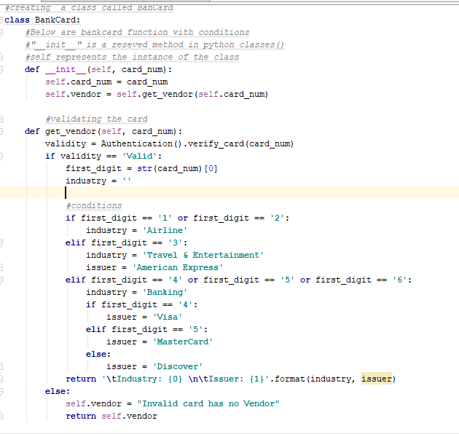

Figure 1 BankCard class

### Authentication

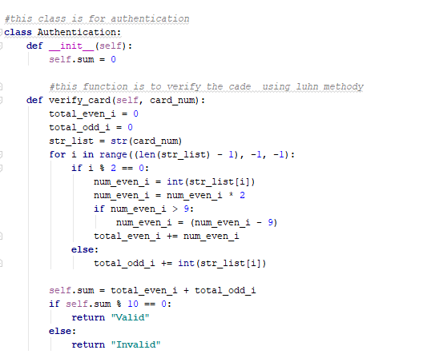

Figure 2Authetication Class

### Checksum Function

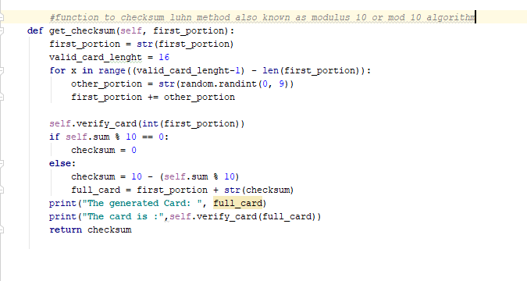Figure 3 Checksum

# Verify

Verifying is to check if the credit card is valid or not valid. Because we are asking for the user input so when the user enters the 16 digits long number the program will verify if the bank card is valid or not valid.

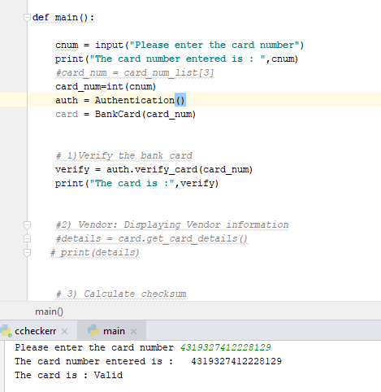

Figure 4 Verify the card

# Vendor

Vendor shows us who the issuer of the credit card is.

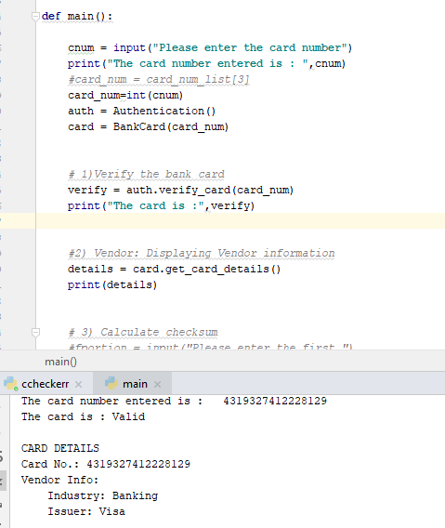

Figure 5Vendor

# Checksum

The checksum can help identify credit card numbers that have been entered incorrectly -- or phony credit card numbers created by counterfeiters. When I was running this code it came to light that the last number of every credit card is the check number.

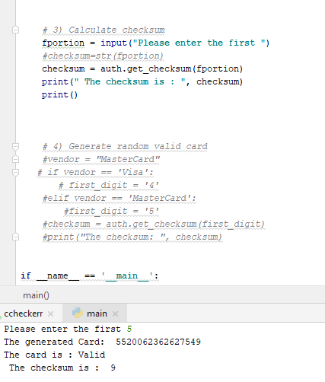

Figure 6 Checksum

# Conclusion

In a world where there is an increase of crime it is good to be able to validate a card before making use of it. The credit card validate allows us to authenticate ,validate the card and also to know the issuer of the card.

# References

*checksum-credit-card*. (n.d.). Retrieved from www.sapling.com: https://www.sapling.com/7966257/checksum-credit-card

*https://www.youtube.com/watch?v=wsphC8V36i0* (n.d.). [Motion Picture].

MicroPyramid. (2017 , May 05 ). *understand-self-and-__init__-method-in-python-class*. Retrieved from micropyramid.com: https://micropyramid.com/blog/understand-self-and-__init__-method-in-python-class/

*Payment_card_number*. (n.d.). Retrieved from en.wikipedia.org: https://en.wikipedia.org/wiki/Payment_card_number

# References

*checksum-credit-card*. (n.d.). Retrieved from www.sapling.com: https://www.sapling.com/7966257/checksum-credit-card

*https://www.youtube.com/watch?v=wsphC8V36i0* (n.d.). [Motion Picture].

MicroPyramid. (2017 , May 05 ). *understand-self-and-__init__-method-in-python-class*. Retrieved from micropyramid.com: https://micropyramid.com/blog/understand-self-and-__init__-method-in-python-class/

*Payment_card_number*. (n.d.). Retrieved from en.wikipedia.org: https://en.wikipedia.org/wiki/Payment_card_number

(https://www.youtube.com/watch?v=wsphC8V36i0)