

**Secure Programming**

**Brute Force**

**Primrose Nyagwaya (B0099882)**

***School of Informatics***

***Department of Informatics and Engineering***

***Institute of Technology, Blanchardstown***

***Dublin 15.***

**Actual Word Count: 284**

**Bachelor of Science**

**Computing in Information Technology**

**19/04/2019**

Contents

Introduction 2

The Program 2

User Input 3

Plain text entered 3

Cyphertext 4

Brute Force 4

Conclusion 5

References 5

# Introduction

This program is a cypher brute forcing tool Encoding and decoding has been made easier with the use of code. For this program I declared a function called rot13 and a for-loop to iterate over the string characters. I also made use of the built in function ord.

# The Program

The screenshot below is a copy of the code. This program will take in user input in plain text and we use rot13 to ciphertext .

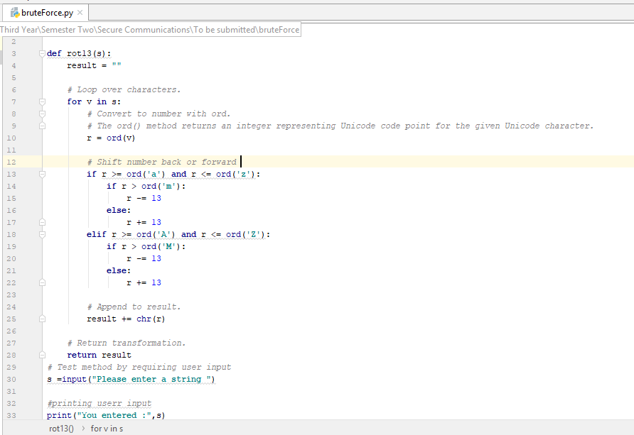Figure The code

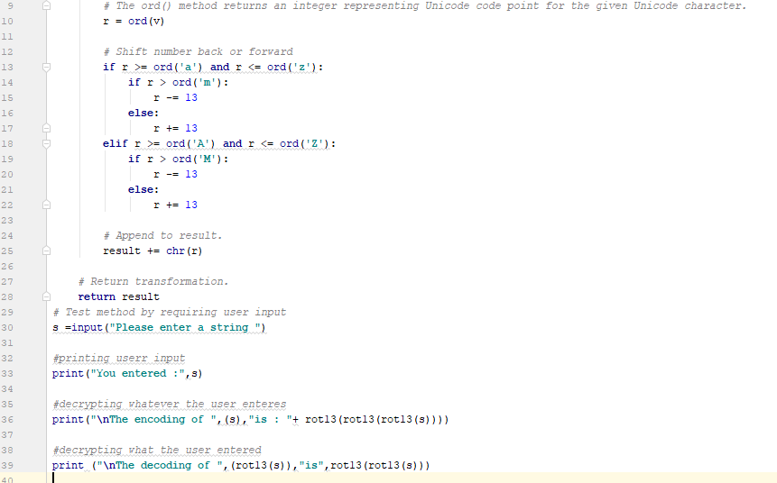Figure Part 2

## User Input

Below is a screenshot of asking for user input. The user is requested to put a plain text.

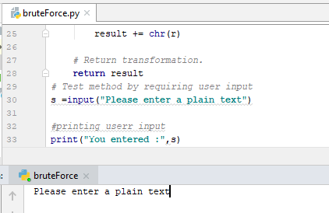

Figure user input

## Plain text entered

Below is a screenshot of the plain text that the user entered. The user entered

Plain text = rose

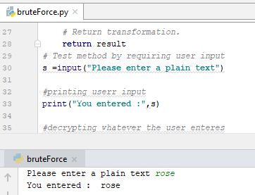

Figure User inputs rose

## Cyphertext

Figure 5 shows a screenshot of encrypted text.

Plaintext = rose

Cyphertext = ebfr

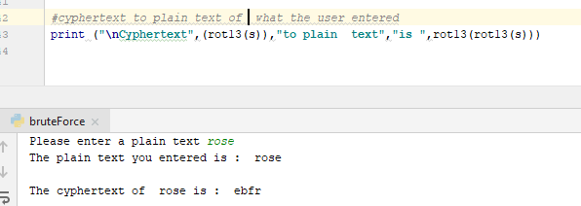

Figure Encryption

## Brute Force

Below screenshot shows the plain text being decoded

Plaintext = rose

Encrypted text = ebfr

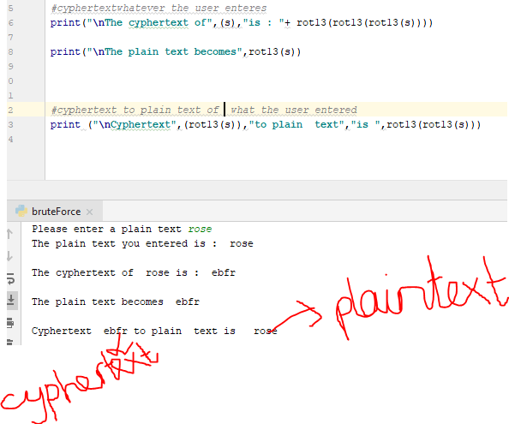

Figure Decoded

# Conclusion

Working from text to cyphertext to plain text was exiting it opened my mind to trying many things. I enjoyed doing this lab.

# References

*built-in/ord*. (n.d.). Retrieved from www.programiz.com: https://www.programiz.com/python-programming/methods/built-in/ord

*ciphers/caesar-cipher/*. (n.d.). Retrieved from www.practicalcryptography.com: http://www.practicalcryptography.com/ciphers/caesar-cipher/

*https://www.youtube.com/watch?v=e_ykbF9hbH8&t=345s* (n.d.). [Motion Picture].

*https://www.youtube.com/watch?v=n0yi-NsLUWs* (n.d.). [Motion Picture].

*ord-function-python*. (n.d.). Retrieved from /www.geeksforgeeks.org: https://www.geeksforgeeks.org/ord-function-python/

(ciphers/caesar-cipher/, n.d.) (ord-function-python, n.d.)