AUCA Student Portal - Project Report
Student Name: RUKESHA Prince
Student ID: 26474
Course: [Your Course Name]
Date: [Insert Date]

1. Introduction
The AUCA Student Portal is a web application designed to allow students to log in, view available courses, select courses, and manage their selected courses. The portal is built with a frontend served via Live Server and a backend powered by Node.js.

2. Objectives
- Enable student authentication (login/logout)
- Display available courses
- Allow students to select and remove courses
- Display selected courses on the dashboard
- Provide a simple, intuitive user interface

3. System Architecture
- Frontend: HTML, CSS, JavaScript (Live Server)
- Backend: Node.js, Express.js, CORS enabled for frontend communication
- Data Storage: Currently stored in-memory (students array), can be replaced with a database later

4. Functional Requirements
- Login with valid credentials
- Redirect to dashboard upon successful login
- Display a list of available courses
- Allow students to select or remove courses
- Logout option

5. Non-Functional Requirements
- User-friendly interface
- Fast response from backend
- Security for login credentials
- Responsive design for different screen sizes

6. Classes and UML Diagram
Classes:
1. Student – handles login, course selection, and logout
2. Course – stores course details
3. Dashboard – displays selected and available courses
4. LoginForm – handles login form submission
UML Diagram:
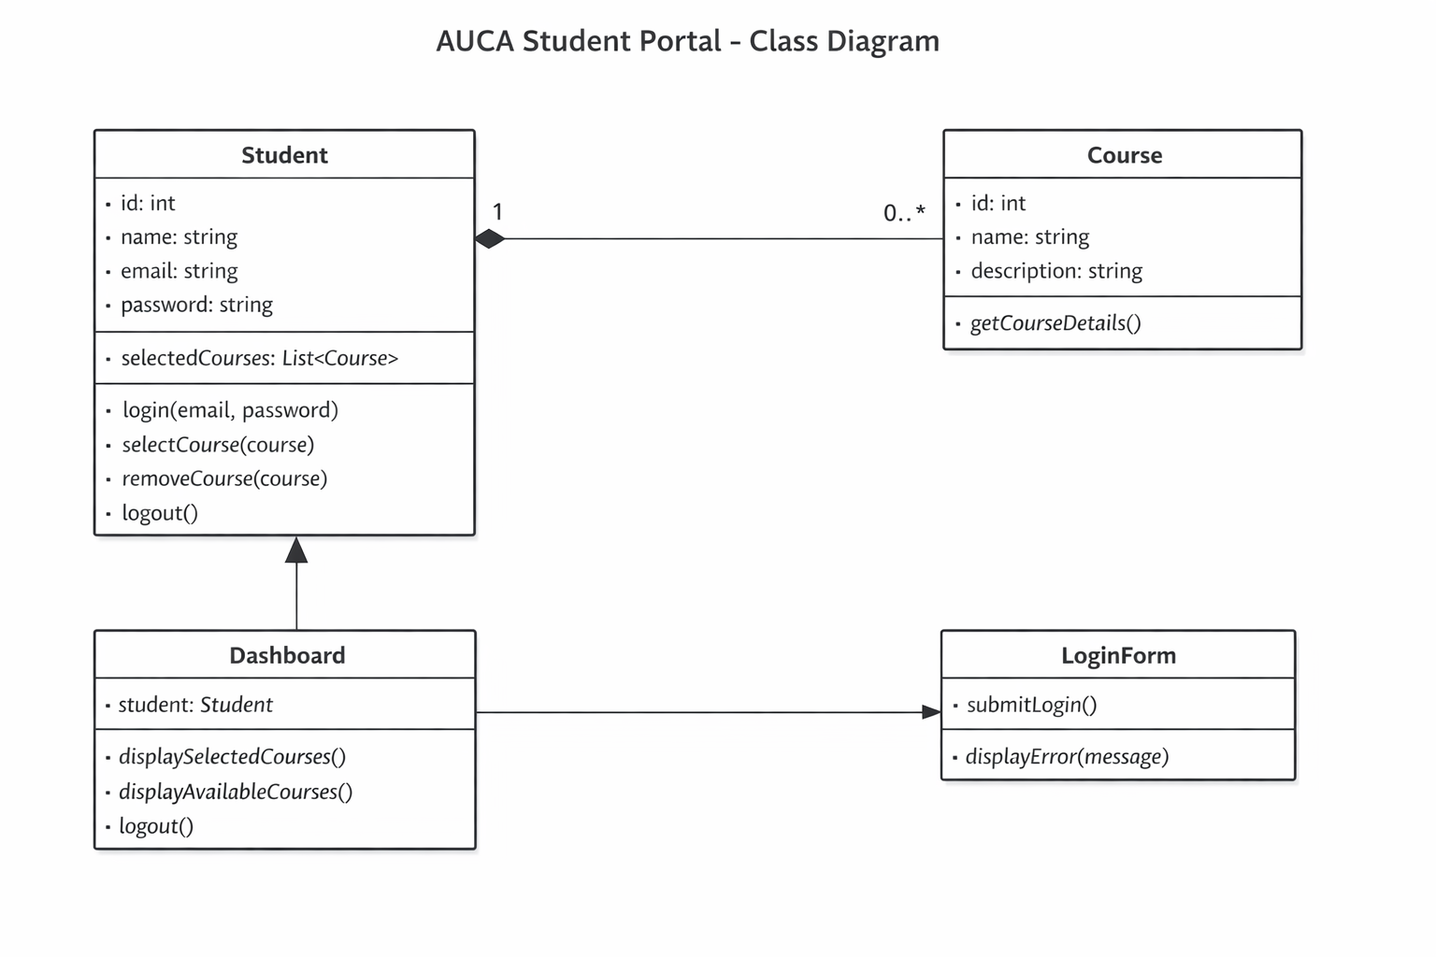

7. Implementation Details
- Backend login route (/login) uses Node.js and Express
- Frontend login page uses fetch API to call backend
- Live Server serves HTML files for login and dashboard
- Courses are stored in an array and linked to students via selectedCourses
- Dashboard dynamically displays selected courses

8. Screenshots
- Login page (Insert screenshot here)
- Dashboard page (Insert screenshot here)
- Course selection (Insert screenshot here)

9. Conclusion
The AUCA Student Portal project demonstrates a simple yet functional web application for student course management. It successfully integrates frontend and backend components, user authentication, and course selection features.

