Week-05_Assignment – 05
Q1: What are the key limitations of traditional MapReduce that make Spark a preferred choice for modern big data processing?
A1: Traditional MapReduce relies heavily on physical disk I/O. Between the Map and Reduce phases, intermediate data must be written to and read from the hard drive (HDFS). This creates a severe disk I/O bottleneck. Spark resolves this by processing data in-memory (in RAM), making it up to 100x faster for multi-stage applications.
Q2: Explain how Spark uses In-Memory Computing to speed up iterative machine learning algorithms compared to disk-based systems.
A2: Iterative Machine Learning algorithms (like K-Means or Logistic Regression) pass over the same dataset multiple times. Disk-based systems must reload the data from disk on every single iteration. Spark uses Resilient Distributed Datasets (RDDs) and DataFrames to cache or persist intermediate results directly in RAM across the cluster, allowing subsequent iterations to read the data instantly from memory.
Q3: Write a code snippet to remove all duplicate rows from a DataFrame based on a specific set of columns: user_id and transaction_date.
A3: 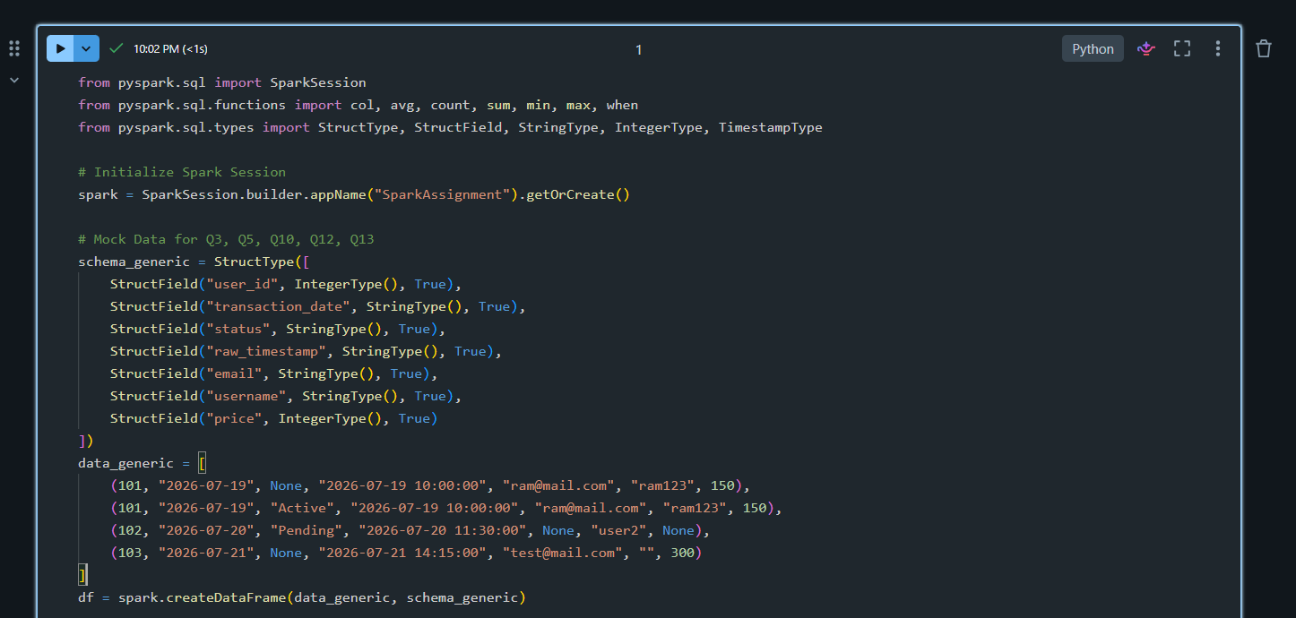
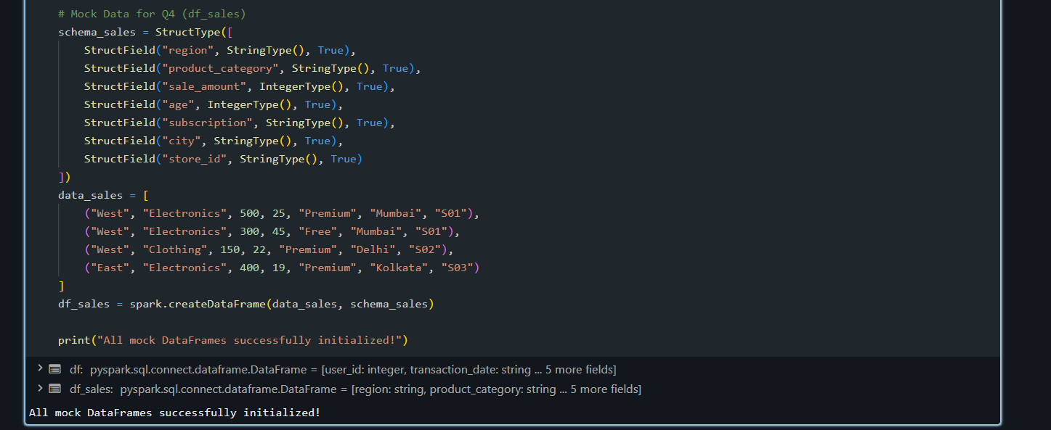
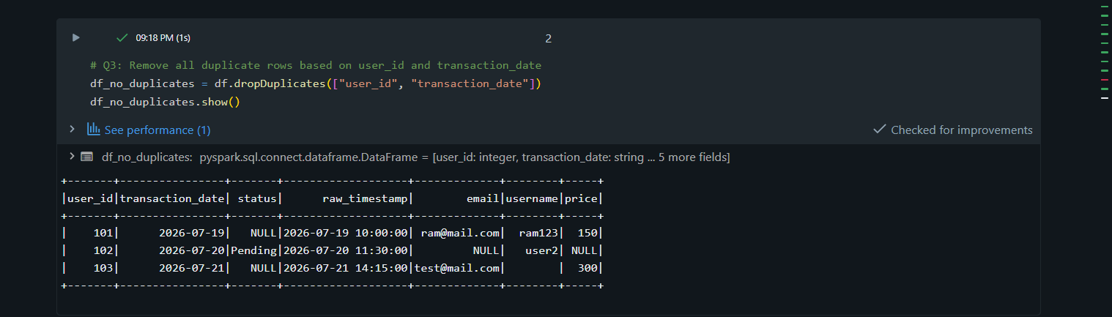
Q4: Given a DataFrame df_sales, write a query to filter for rows where the region is 'West' and then group by product_category to find the average sale_amount.
A4: 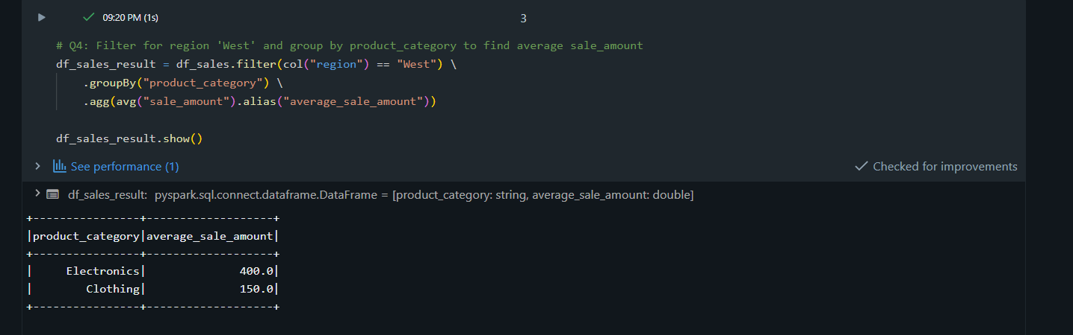
Q5: What is the difference between .na.drop() and .na.fill()? Provide a code example of filling null values in a status column with the string 'Unknown'.
A5: 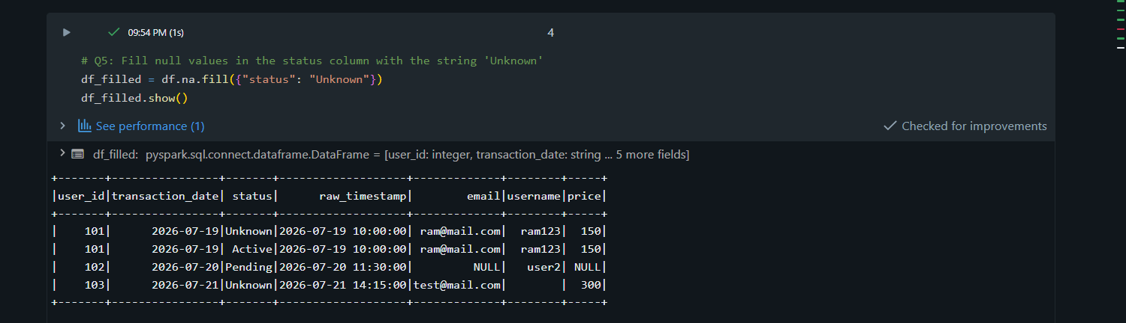
Q6: Write a query to find the total count of records for each city in a DataFrame, but only for cities where the count is greater than 100.
A6: 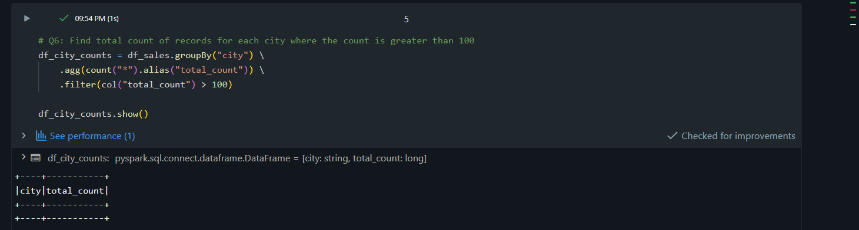
Q7: How does the immutability of Spark DataFrames affect how you perform "data cleaning" steps like dropping columns or renaming them?
A7: Because Spark DataFrames are immutable, they cannot be modified in place. When you perform cleaning steps like dropping or renaming columns, Spark doesn't change the original DataFrame. Instead, it creates a brand-new DataFrame that points to a new node in the logical execution plan. This preserves the original data structure and allows Spark to optimize the entire processing pipeline before executing it.
Q8: Write a Spark command to filter a dataset for rows where the age is between 18 and 30 (inclusive) and the subscription is 'Premium'.
A8: 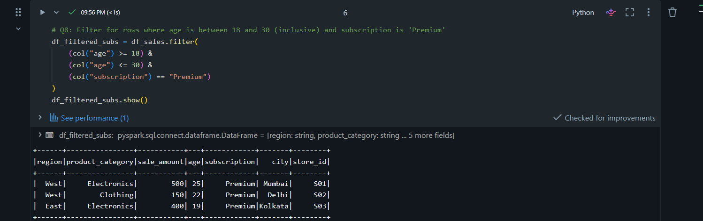
Q9: When cleaning a dataset, why is it often better to handle null values before performing mathematical aggregations like sum() or avg()?
A9: Handling null values before mathematical operations ensures accuracy and consistency. Built-in aggregation functions like avg() or sum() inherently ignore null values, which can skew structural metrics or lead to unexpected results if your business logic requires empty values to be treated as 0 or a baseline average. Handling them first guarantees your downstream calculations align with your data strategy.
Q10: Write the code to revise a column named raw_timestamp by casting it to a TimestampType and renaming it to event_time.
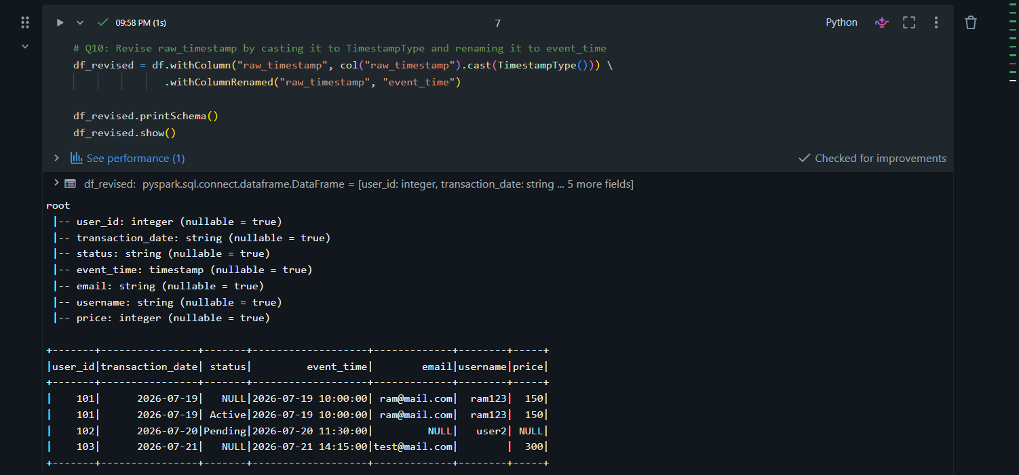
Q11: Explain the "Shuffle" process that occurs during a grouping operation. Why is it considered a wide transformation?
A11: A Shuffle is the physical redistribution of data across different cluster nodes over the network. It occurs during grouping operations because records sharing the same key (e.g., the same city or category) might live on different partitions. It is considered a wide transformation because each input partition contributes to creating multiple output partitions, requiring an expensive network communication phase.
Q12: Write a code snippet that identifies and removes rows where the email column contains null values OR the username is an empty string.
A12: 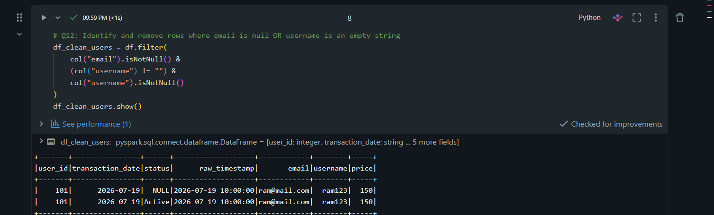
Q13: How do you use the .agg() function to calculate multiple statistics at once, such as the min, max, and mean of the price column?
A13: 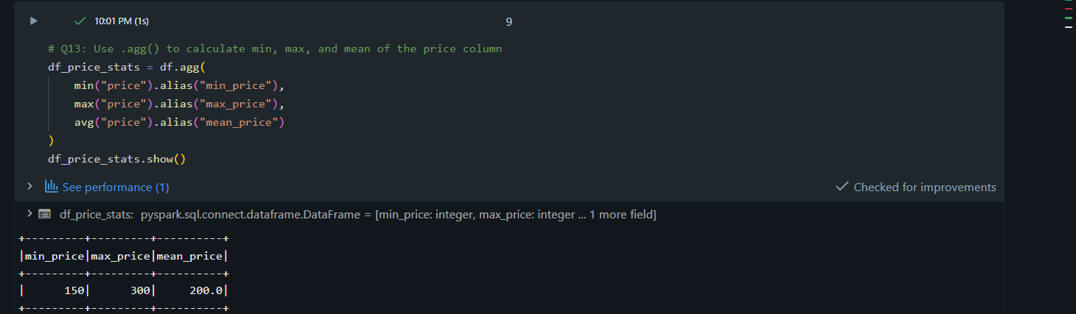
Q14: In the context of cleaning a dataset, what is the risk of using inferSchema=true when your source data contains messy or inconsistent date formats?
A14: When inferSchema=true encounters messy or inconsistent date formats (e.g., mixed MM/dd/yyyy and dd-MM-yyyy strings), Spark will fail to parse them into a uniform timestamp type. It will instead default the entire column to a generic StringType. This hides format errors and forces you to perform manual casting and manual string parsing later.
Q15: Write a final processing pipeline that:
- Filters out duplicates.
- Fills null prices with 0.
- Groups by store_id to calculate total revenue.
A15: 