**Challenge Identification**

1. Manual Customer Registration for Loans

**Root Cause Analysis (5 Whys)**:

* Why are errors occurring? → Because the registration process is done manually.
* Why is the process manual? → There is no automated system to handle customer registration.
* Why isn’t there an online system? → The company hasn't adopted technology for this function yet.
* Why hasn’t technology been adopted? → There is a lack of awareness or resources dedicated to digital transformation.
* Why is there a lack of resources or awareness? → The company has been prioritizing other areas, and digital transformation is perceived as costly.

2. Inconsistent Loan Recovery Process

The loan recovery team frequently calls back to the office for confirmation of customer details (GPS, collateral, loan information) when in the field.

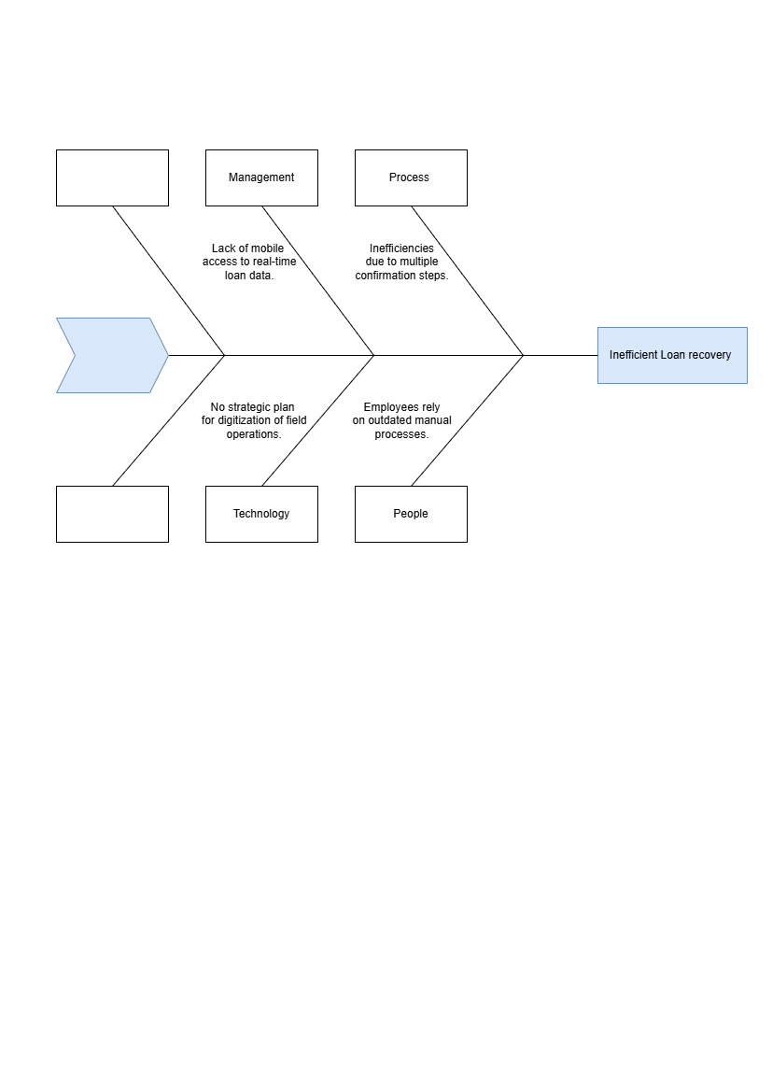

**3. Geographical Restrictions for Loan Approval**

The company does not permit giving loans to people who live far from a central point due to the difficulty of recovering loans in distant locations.

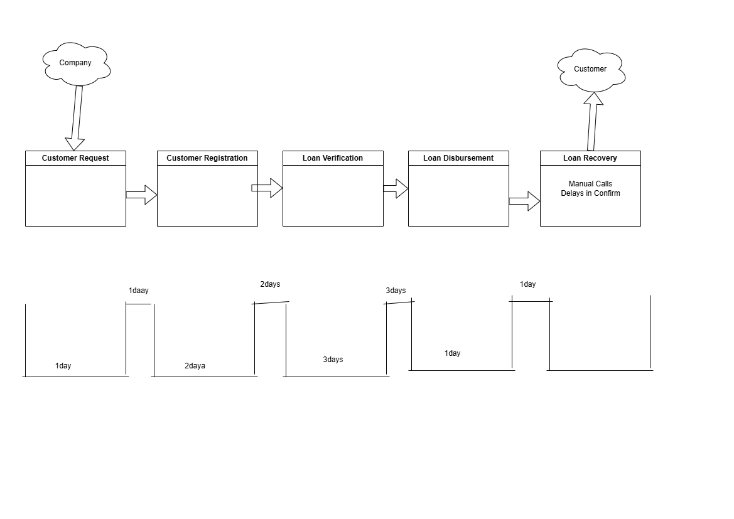

Impact Analysis

**Impact of Manual Registration Process**:

* **Operational Efficiency**: The manual process consumes significant employee time, reducing productivity. Errors caused by manual entry can delay loan approval and reduce staff efficiency.
* **Cost**: Errors in registration can lead to financial losses for the company, either from processing incorrect loan applications or from delayed services requiring corrections.
* **Customer Satisfaction**: Customers experience delays due to manual data entry, potentially leading to dissatisfaction and loss of trust.
* **Quantified Data**: According to industry reports, manual processes can lead to a 20-30% increase in data entry errors, with correction efforts costing companies between $100-$300 per error (source: *Financial Services Study on Process Automation*).

**Impact of Inconsistent Loan Recovery Process**:

* **Operational Efficiency**: Field teams are slowed down by having to call the office to confirm customer details. This results in delays in loan recovery, affecting daily productivity.
* **Cost**: The delays reduce the number of recoveries that can be completed in a day, potentially leading to higher outstanding balances and slower cash flow for the business.
* **Customer Satisfaction**: Customers experience inconsistent service when recovery teams cannot provide immediate information, reducing confidence in the company’s process.
* **Quantified Data**: A survey of microcredit companies shows that companies implementing mobile technology for field agents reduce field confirmation times by up to 40% and recover loans 15-20% faster (source: *Field Automation in Microfinance*).

**Impact of Geographical constraints**:

* **Operational Efficiency**: Limiting loans to customers near the central point reduces the potential market size and customer base. This prevents the company from expanding and growing beyond a specific geographical area, limiting revenue opportunities.
* **Cost**: By excluding distant customers, the company misses out on potential revenue streams. Additionally, the high costs of manual recovery from distant customers, if attempted, would lead to inefficiencies and increased operational expenses.
* **Customer Satisfaction**: Potential customers who live in distant locations may feel excluded and dissatisfied, leading to negative word of mouth and reputational risk.
* **Quantified Data**: A study in the microfinance sector shows that implementing technology for remote loan management (e.g., mobile platforms, GPS tracking) increases loan recovery efficiency by 20-30% and allows companies to expand their reach by 50% (source: *Microfinance Digital Transformation Study*).
* Financial Services Study on Process Automation. (2022). *Reducing Manual Errors in Financial Product Management*.
* Field Automation in Microfinance. (2023). *Mobile Solutions for Loan Recovery Efficiency*.
* (source: *Microfinance Digital Transformation Study*).