**FB Note on "Code Fellaz” organized by Parivartan Technical committee CGC on 3 Nov, 2022**

Event Objective: On 3 Nov, 2022 Parivartan Technical committee, CGC conducted “**Code Fellaz**" with an objective to test the technical knowledge of participants.

**About the event**: Sometimes, a healthy competition is must for one to know about his/her skills and to encourage them to learn about new things. On 3 rd Nov, 2022 Parivartan Technical Committee hosted a Coding Competition “**Code Fellaz**”. It was a 2 round competition with eliminations happening in each round. Total Participation of around 54 students was observed. The competition proved to be very beneficial for the students as they not only got to test their knowledge but also enhance it. The participants were giving certificates. The prize pool was worth Rs 6000. Along with cash prizes the first three winners were awarded. Event Outcome: This “**Code Fellaz**” aided the students in enhancing their technical , Coding skills and enabled them to enhance their knowledge

**ROUND 1** 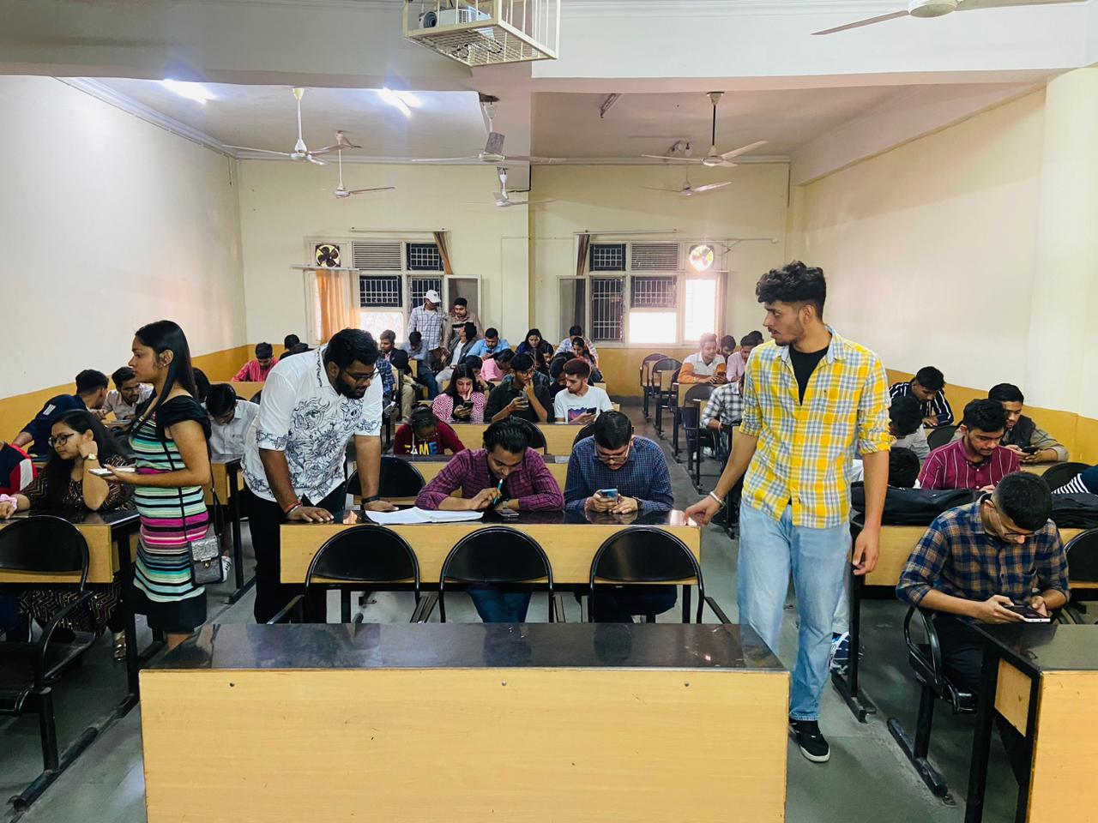

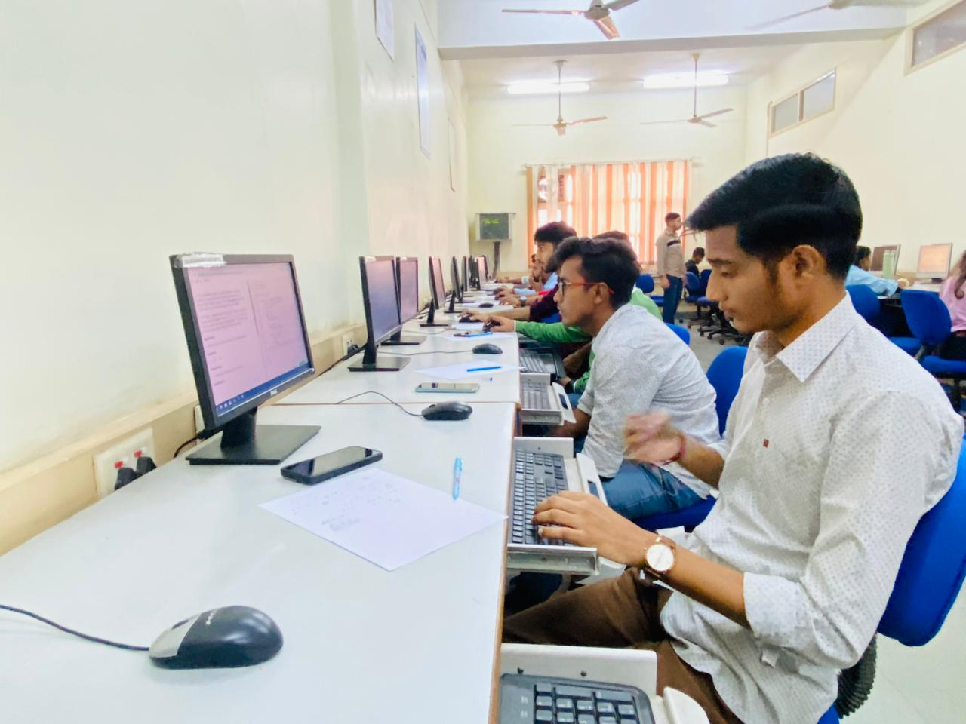**ROUND 2**