**Question 1. Analyse the time complexity of the following Java code and suggest a way to improve it:**

**int sum = 0;**

**for(int i = 1; i <= n; i++) {**

**for(int j = 1; j <= i; j++) {**

**sum++;**

**}**

**}**

**Ans:**

Time complexity of this program to find the sum of n numbers is : BigO(n).

We can make it BigO(1) is by using the mathematical formula to find the sum of n natural number.

Code:

public class Main

{

public static void main(String[] args) {

int n=10;

int sum = 0;

sum=n*(n+1)/2;

System.out.print(sum);

}

}

**Question 2: Find the value of T(2) for the recurrence relation T(n) = 3T(n-1) + 12n, given that T(0) = 5.**

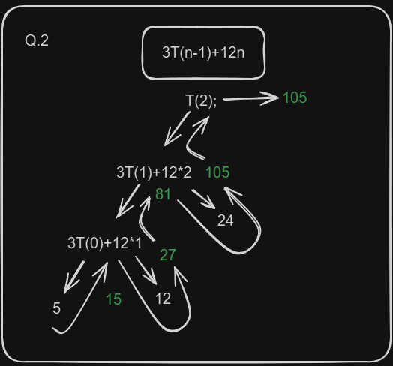Ans: