Society Management System

1.Project Title

Project Type: Console-Based Application
Programming Language: C++
Storage Mechanism: Text File Handling
Programming Paradigm: Object-Oriented Programming (OOP)
User Roles: Admin and Resident

2. Introduction

The Society Management System is a C++ - based application designed to manage and organize the daily activities of a residential society. It helps maintain society member details, flat information, and other records efficiently through a menu-driven interface.

The main objective of this project is to reduce manual paperwork, minimize errors, and simplify society management. It demonstrates the practical use of C++ programming concepts and provides a foundation for developing more advanced society management applications.

3. Problem Statement

Managing a residential society manually can be time-consuming and may lead to errors in maintaining member details, flat information, and other society records. Retrieving and updating information through traditional methods can also be difficult.

The Society Management System aims to provide a simple C++ - based solution to organize and manage society records efficiently, reduce manual work, and improve the accuracy and accessibility of information.

4. Objectives

The main objectives of the project are:
- To develop a reliable and user-friendly Society Management System using C++.
- To maintain society member and flat details in an organized manner.
- To simplify the management and retrieval of society records.
- To reduce manual paperwork and minimize data entry errors.
- To improve the efficiency and accuracy of society record management.
- To provide a menu-driven interface for easy operation.
- To demonstrate the practical application of C++ programming concepts in society management.

5. Scope of the Project

The Society Management System focuses on managing the essential administrative activities of a residential society through a console-based application. It provides basic facilities for maintaining records, managing resident information, tracking maintenance payments, handling complaints, and sharing important notices.

The scope of the project includes the following operations:

- Flat Management: Adding, viewing, updating, and managing flat details within the society.
- Resident Management: Maintaining resident information, including personal details, flat allocation, and login credentials.
- Maintenance Management: Recording maintenance charges, payment details, and payment status.
- Complaint Management: Allowing residents to submit complaints and enabling the Admin to manage their status.
- Role-Based Access: Providing separate functionalities for Admin and Residents.
- File-Based Data Storage: Storing and retrieving records using C++ text file handling.
- Personal Data Access: Restricting residents to viewing their own private records while allowing access to common society notices.
The project is limited to basic society management operations and is intended for academic purposes. It does not include a graphical user interface, online payment integration, or database connectivity.

6. Proposed System

The proposed Society Management System is a C++ based application developed to simplify the management of residential society activities. It provides a structured platform where the Admin and Residents can perform their respective operations through a menu-driven interface.
The system maintains society records digitally using text files, reducing the need for manual registers and making information easier to store, update, and retrieve.

The application provides the following facilities:

- Admin Access: Manage flats, residents, maintenance records, and complaints.
- Resident Access: View personal details, flat information, maintenance records, and payment history.
- Complaint Handling: Allow residents to submit complaints and enable the Admin to manage their status.
- Data Management: Store and retrieve records using C++ file handling.
- Access Control: Provide separate menus and permissions for Admin and Residents.
The system uses Object-Oriented Programming concepts to organize its functionality into classes and member functions. Its file-based approach makes it suitable for demonstrating practical C++ programming concepts in a real-world management scenario.

7. System Features

The Society Management System provides separate features for the Admin and Residents to manage and access society-related information. Each user is provided with a dedicated menu based on their role.

7.1 Admin Features

The Admin is responsible for managing the overall operations of the society. The following features are available to the Admin:

- Flat Management: Add new flats, view available flats, update flat details, and manage flat records.
- Resident Management: Add new residents, view resident information, update records, and manage resident details.
- Maintenance Management: Create maintenance records, update payment status, and maintain payment information.
- Complaint Management: View complaints submitted by residents, update complaint status, and manage complaint records.
- Record Management: Store and retrieve society information using text files.
- Admin Logout: Securely exit the Admin session and return to the main menu.

7.2 Resident Features

Residents can access their personal information and society-related services through their dedicated menu.

- View My Profile: Display personal details and resident information.
- View Flat Details: Access information about the resident's allocated flat.
- View Maintenance Details: Check maintenance charges and payment status.
- View Payment History: Review previous maintenance payments.
- Submit Complaint: Register a complaint related to society facilities or services.
- View My Complaints: Check previously submitted complaints and their current status.
- Resident Logout: End the current session and return to the main menu.

8. OOP Concepts Used

The Society Management System uses the following OOP concepts in C++ to organize code and manage society operations.

- Classes and Objects: The Resident, Admin, Maintenance, and Complaint classes manage resident, administrative, maintenance, and complaint-related data.

- Inheritance: Resident inherits from Maintenance and Complaint, while Admin inherits from Resident.

- Encapsulation: Classes combine data members and functions, while access specifiers control access to members.

- Abstraction: Functions such as CreateAccount(), ViewProfile(), and AddResident() perform specific operations.

- Polymorphism: Function overloading and overriding are not explicitly implemented in this project.

- Friend Functions: LoadData() and CheckLogin() are declared as friend functions of the Resident class.

- Static Data Members: ResidentID and CountResident are declared static. ResidentID is used to generate resident IDs, while CountResident is not actively used.

- File Handling: ifstream and ofstream are used to read and write records in text files such as Resident.txt, Maintence.txt, and Complaint.txt.

- Error Handling: Input validation and conditional checks handle invalid inputs and file-related errors. The program does not explicitly use try, catch, or throw.

These concepts make the system organized, reusable, and easier to maintain.

9. Class Design

The Society Management System follows a class-based structure in C++ to organize its data and operations. Each class represents a specific entity or functional component of the society.

The class design separates responsibilities, improves code organization, and makes the application easier to understand and maintain.

9.1 Classes and Their Responsibilities

Class Name | Responsibility
Admin | Manages resident records, including adding, viewing, searching, updating, and deleting residents. It also manages maintenance records and complaint statuses.
Resident | Manages resident registration, login-related data, profile viewing and updating, maintenance details, complaint submission, and complaint status viewing.
Maintenance | Stores maintenance details such as month, year, amount, and payment status.
Complaint | Stores complaint-related information, including complaint title, description, and complaint ID.

9.2 Class Descriptions

Admin Class
- Authenticates administrator credentials.
- Adds, views, and updates flat records.
- Manages resident information.
- Creates and updates maintenance records.
- Views and manages resident complaints.
Resident Class
- Stores resident details and login credentials.
- Displays personal profile information.
- Provides access to allocated flat details.
- Displays maintenance and payment records.
- Allows residents to submit complaints.
- Displays previously submitted complaints.
Maintenance Class
- Stores maintenance charges and payment information.
- Maintains payment status.
- Displays maintenance records.
- Supports payment history retrieval.
Complaint Class
- Stores complaint details and resident identification.
- Maintains complaint status.
- Displays submitted complaints.
- Supports complaint status updates.

10. Project Flow

The Society Management System follows a menu-driven approach in which users select their role and perform operations according to their access permissions.

The application starts with the Main Menu, where users can choose Admin Login, Resident Login, or Exit. After successful login, the system displays the respective menu and allows users to perform the available operations.

All records are stored and retrieved using text files. After completing their operations, users can log out and return to the Main Menu.

10.1 Project Flow Diagram

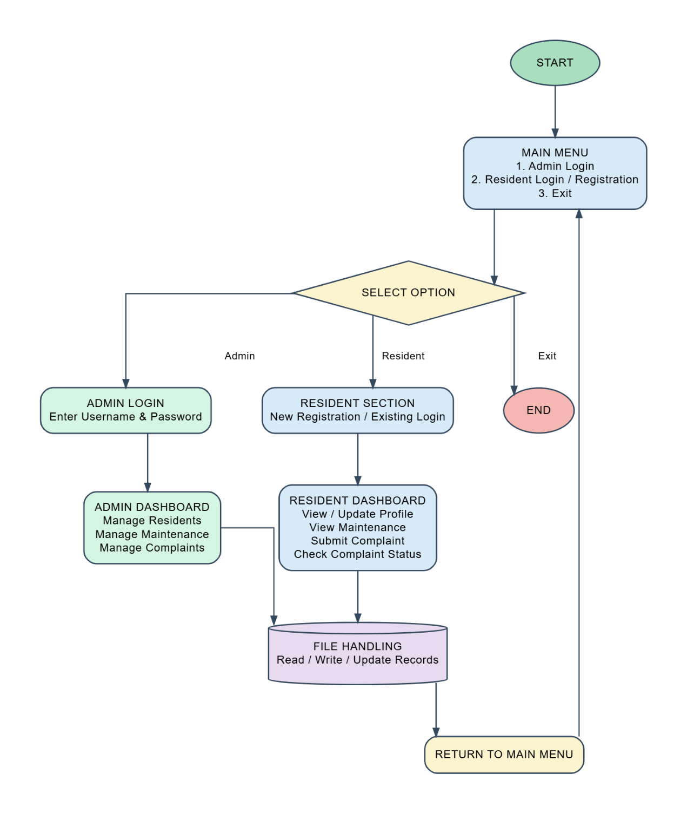

10.2 Working Process

The Society Management System follows a menu-driven approach to manage residents, maintenance records, and complaints.

- Main Menu: The program displays the available options to the user.

- Admin Login: The administrator logs in to access resident management, maintenance management, and complaint management features.

- Resident Registration and Login: New residents can create accounts, while existing residents log in using their mobile number and password.

- Resident Management: The admin can add, search, view, update, and delete resident records. Residents can view and update their profile information.

- Maintenance Management: The system stores maintenance records and allows the admin to manage payment status. Residents can view their maintenance details.

- Complaint Management: Residents can submit complaints and check their status. The admin can view complaints and update their status.

- File Handling: The system reads and writes records using text files to preserve resident, maintenance, and complaint information.

- Exit: After completing the required operations, the user can return to the main menu or exit the program.

11. Working Process

Step 1: Start the Program
The program starts and displays the main menu, where the user can select the available options.

Step 2: Admin Login
The administrator logs in using the predefined username and password. After successful login, the admin dashboard provides options to manage residents, maintenance records, and complaints.

Step 3: Resident Registration and Login
A new resident can create an account by entering the required details. Existing residents can log in using their registered mobile number and password.

Step 4: Resident Profile Management
Residents can view their profile, update personal information, and change their mobile number or password.

Step 5: Maintenance Management
The system maintains monthly maintenance records. The admin can add and view maintenance records and update payment status. Residents can check their maintenance details and payment status.

Step 6: Complaint Management
Residents can submit complaints and check their status. The admin can view complaints, check pending complaints, and update complaint status to Pending, In Progress, or Resolved.

Step 7: File Handling
The system uses text files to store and retrieve resident, maintenance, and complaint records. Temporary files are used during certain update and deletion operations.

Step 8: Exit the Program
After completing the required operations, the user can return to the main menu and select the exit option to terminate the program.

12. Data/File Management

The Society Management System uses file handling in C++ to store, retrieve, and manage records permanently. The system uses text files to maintain resident information, maintenance details, complaint records, and deleted resident records.

The program uses ifstream to read data from files and ofstream to write data to files. Temporary files are used during certain update and deletion operations to modify records safely.

12.1 Files Used in the Project

File Name | Purpose
Resident.txt | Stores resident information and account details.
TempResident.txt | Temporarily stores resident records during update or deletion operations.
Maintence.txt | Stores maintenance records, including amounts and payment status.
TempMaintence.txt | Temporarily stores maintenance records during modifications.
Complaint.txt | Stores complaint details and their status.
TempComplaint.txt | Temporarily stores complaint records during modifications.
DeletedResident.txt | Stores records of deleted residents.

12.2 File Handling Operations

1. Reading Data: The system reads existing records from text files to display resident information, maintenance details, and complaint records.

2. Writing Data: New resident, maintenance, and complaint information is written to the corresponding files.

3. Updating Records: When records need to be modified, temporary files are used to store the updated data. The original file is then replaced using file operations.

4. Deleting Records: During resident deletion, temporary-file handling is used to retain the records that should remain, while the deleted resident's record can be stored separately.

5. Data Persistence: Text files preserve records after the program closes, allowing the system to retrieve saved information when it runs again.

12.3 Advantages of File Management

- Provides permanent storage of records.
- Allows information to be retrieved whenever required.
- Helps manage resident, maintenance, and complaint data.
- Supports record modification and deletion.
- Reduces the need to enter the same information every time the program starts.

13. Output Screenshots

This section contains screenshots of the Society Management System during program execution. It demonstrates the main menu, resident and admin operations, and the changes made to data files during different operations.

13.1 Login Dashboard:

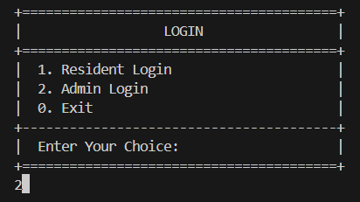

13.2 Admin Login & Admin Dashboard:

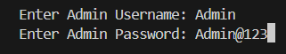
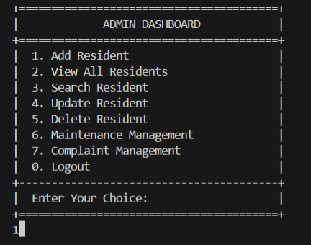

13.2.1 Add Resident:
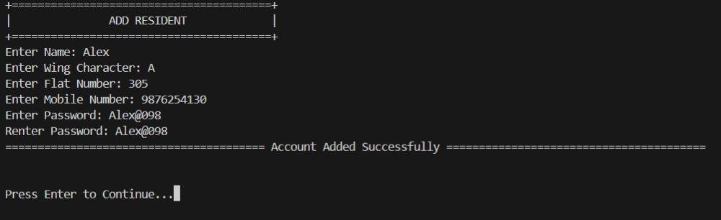

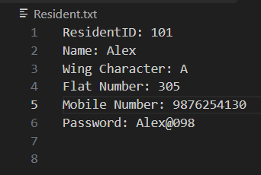

13.2.2 View All Resident:
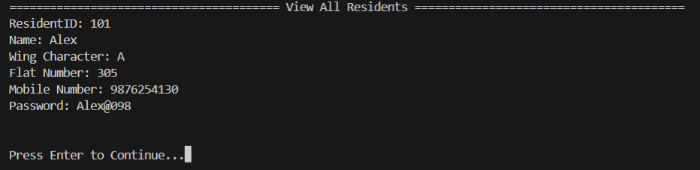

13.2.3 Search Resident Dashboard:

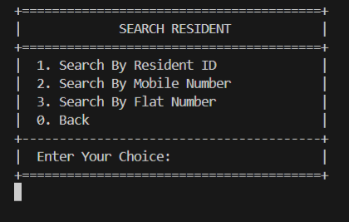

13.2.3.1 Search By Resident ID:

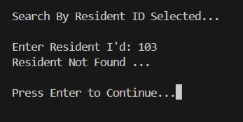

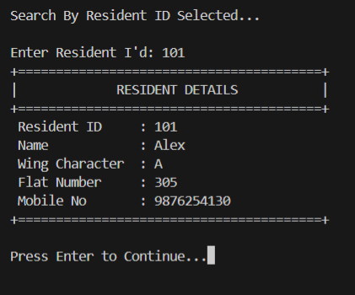

13.2.4 update Resident Dashboard:

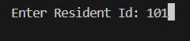

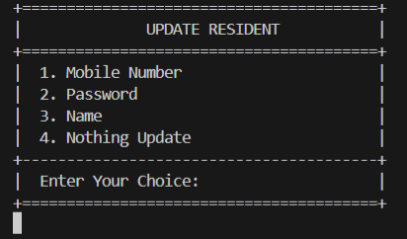

13.2.4.1 Mobile Number Update :

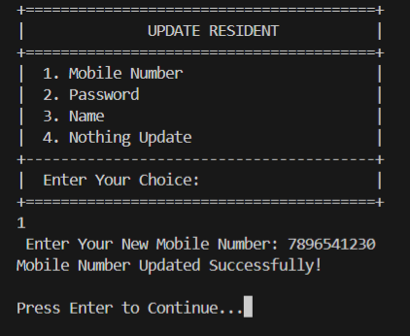

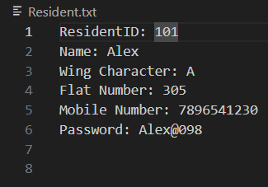

13.2.5 Maintenance Management Dashboard:

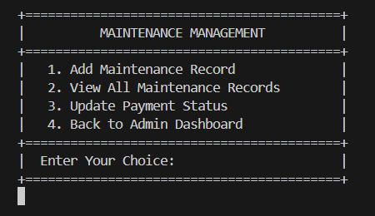

13.2.5.1 Add Maintenance Record:

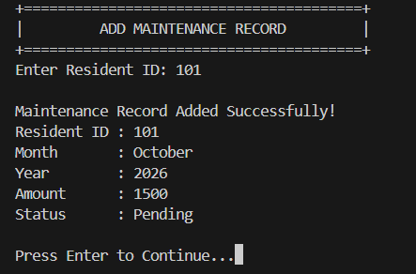

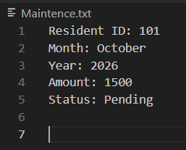

13.2.6 Complaint Management Dashboard:

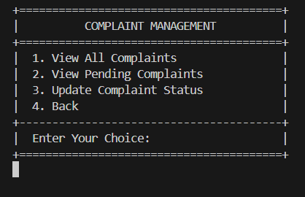

13.2.6.1 View All Complaints:

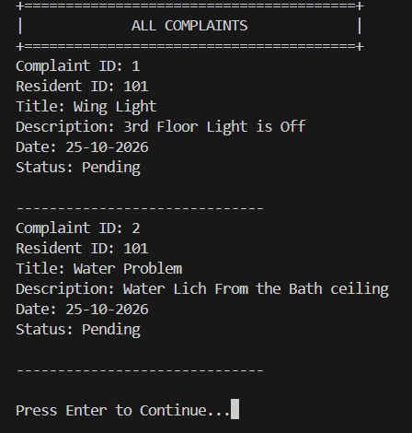

13.3 Resident Login:

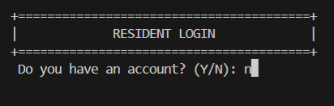

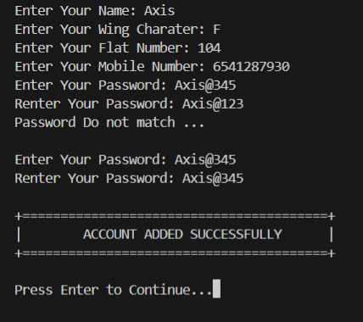

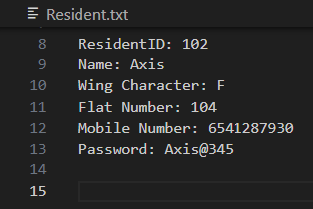

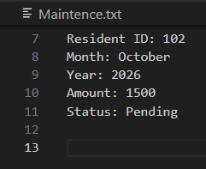

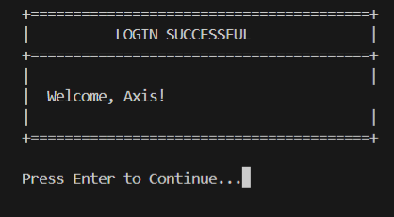

13.3.1 Resident Dashboard:
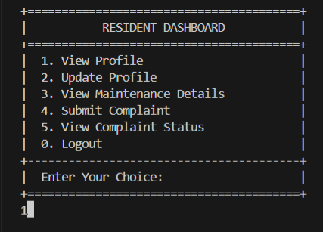

13.3.1.1 View Profile:
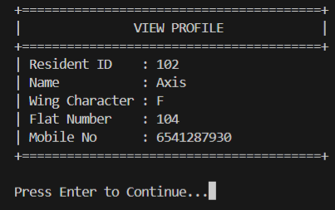

13.3.1.2 Update Profile Dashboard:
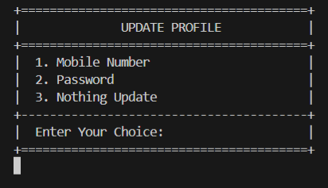

13.3.1.2.1 Password Update:
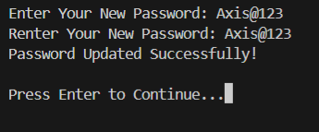

13.3.1.3 View Maintenance:
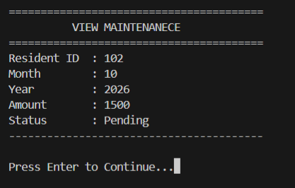

13.3.1.4 Submit Complaint: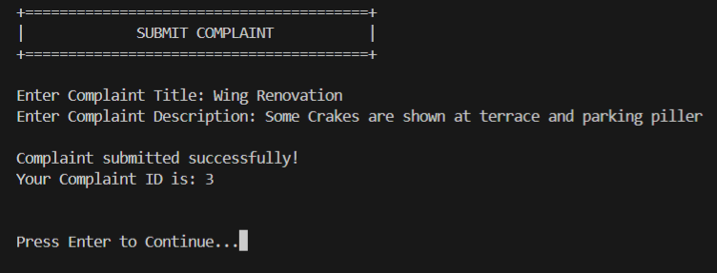

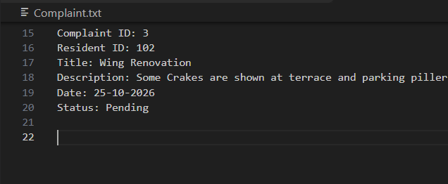

13.3.1.5 View Complaint Status:
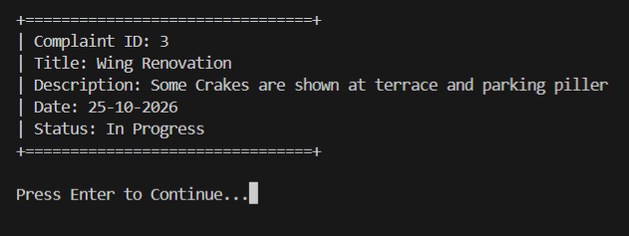

13.3.1.6 Logout:
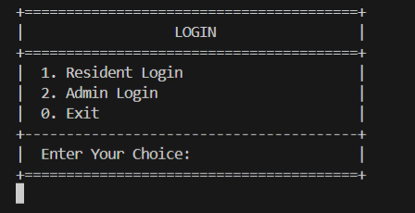

14. Advantages of the System
- Easy to Use: Provides a simple menu-driven interface.
- Resident Management: Allows admins to manage resident records.
- Maintenance Management: Tracks maintenance records and payment status.
- Complaint Management: Helps residents submit complaints and check their status.
- File Storage: Stores records permanently in text files.

15. Limitations of the System
- Text File Storage: The system uses text files instead of a database.
- Console Interface: It does not have a graphical user interface (GUI).
- Limited Security: Advanced security features are not implemented.
- No Online Access: The system does not support remote access through the internet.
- Limited Reporting: Advanced reports and analytics are not available.

16. Future Scope
- Database Integration: Use MySQL for better data management.
- GUI Development: Add a graphical user interface.
- Online Payments: Enable digital maintenance payments.
- Mobile Application: Allow access through smartphones.
- Enhanced Security: Improve password protection and user authentication.

17. Conclusion
The Society Management System is a C++ - based project developed to manage the daily activities of a residential society. It provides separate facilities for administrators and residents to perform different operations.

The administrator can add, search, view, update, and delete resident records, manage maintenance payments, and handle complaints. Residents can create accounts, log in, update their profiles, view maintenance details, submit complaints, and check complaint status.

The project uses Object-Oriented Programming concepts such as classes, objects, inheritance, encapsulation, and file handling. Text files are used to store and retrieve resident, maintenance, and complaint records. Input validation helps maintain the accuracy of important information.

Overall, this project provides a simple and organized way to manage society records, reduces manual paperwork, and demonstrates the practical use of C++ programming concepts in a real-world application.

18. Bibliography

The following resources were used as references during the development of the Society Management System:
- C++ Programming Language – For understanding programming concepts and syntax.
- Object-Oriented Programming in C++ – For classes, objects, inheritance, and encapsulation.
- File Handling in C++ – For reading and writing data using text files.

