📘 AI-Based Smart Classroom Monitoring & Optimization System

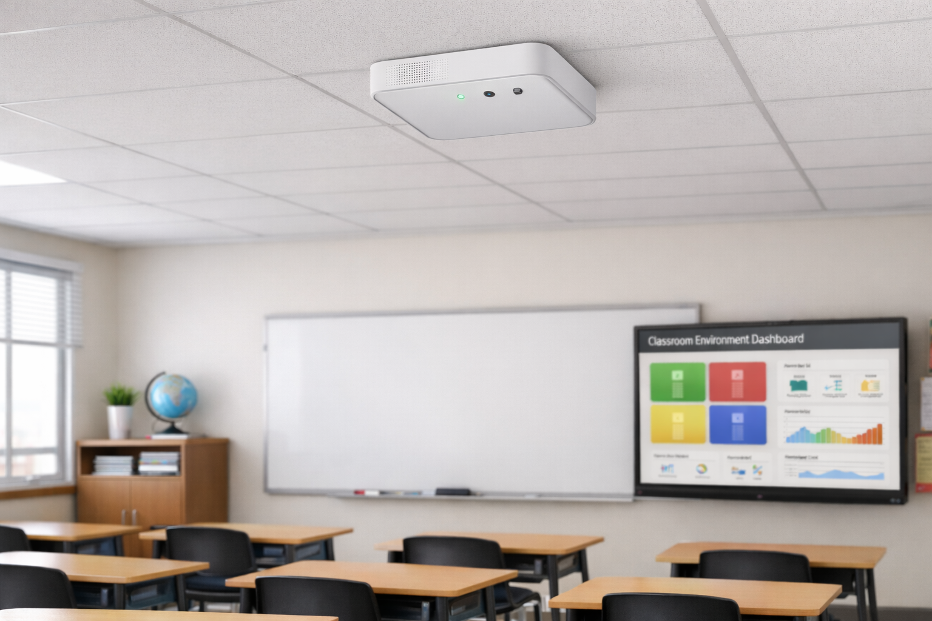
# | Feature Name | Description | Type | Difficulty | Why It Matters
1 | Real-Time Monitoring | Live temperature, humidity, noise & occupancy data | Core | Easy | Basic environmental awareness
2 | Smart Noise Classification (AI) | Classifies noise (talking, shouting, clap, normal) | AI | Medium–Hard | Prevents false alerts & adds intelligence
3 | Automatic Voice Warning | Plays message if noise exceeds threshold for duration | Automation | Medium | Maintains discipline automatically
4 | mmWave Radar Sensor | Accurate human presence detection | Hardware Upgrade | Medium | Eliminates false motion detection
5 | Mesh Network (ESP-MESH) | Classroom nodes communicate via mesh | Network | Medium | Scalable for campus-wide deployment
6 | Campus Heatmap Dashboard | Visual map showing room status by color | UI/Analytics | Medium | Instant visual decision making
7 | Energy Optimization Mode | Detects unused room & suggests turning off AC/lights | Smart Logic | Medium | Reduces electricity waste
8 | Comfort Score Index | Calculates classroom comfort score (0–100) | Analytics | Medium | Single KPI for environment quality
9 | Predictive Alert | Detects recurring noisy time patterns | AI/Analytics | Hard | Moves from reactive to predictive system
10 | Teacher Mode | Teacher disables auto-warning temporarily | Control Feature | Easy | Avoids embarrassment during activities
11 | Silent Exam Mode | Strict low-noise threshold during exams | Smart Mode | Easy | Customizable environment control
12 | Data-Based Room Efficiency Ranking | Ranks rooms by discipline & energy efficiency | Analytics | Medium | Gamification & admin insights
13 | Historical Data Graphs | 24h / weekly environmental trends | Dashboard | Easy | Pattern visibility
14 | Admin Announcement Broadcast | Admin sends manual voice message to classroom | Communication | Medium | Centralized control

📌 Project Overview
The AI-Based Smart Classroom Monitoring System is an IoT-enabled intelligent solution designed to monitor environmental and behavioral conditions inside classrooms. The system uses ESP32-based sensor nodes integrated with temperature, humidity, noise, and human presence sensors to collect real-time data.
Using TinyML-based sound classification and intelligent decision logic, the system differentiates between acceptable classroom behavior (e.g., teacher lecture) and disruptive crowd noise. The collected data is transmitted via an ESP-MESH network and visualized on a centralized web dashboard.
The platform provides:
- Real-time monitoring
- AI-powered noise classification
- Automated announcements
- Energy optimization insights
- Predictive analytics
- Campus-wide heatmap visualization
This solution enhances discipline, comfort, and energy efficiency within academic institutions.
📖 Detailed Feature Explanation

1️⃣ Real-Time Monitoring
Each classroom node continuously monitors:
- Temperature
- Humidity
- Noise levels
- Human presence
Data is transmitted to the dashboard in real time. This forms the foundation of the system.

2️⃣ Smart Noise Classification (AI)
Using TinyML on ESP32, the system classifies sound into categories such as:
- Single voice (teacher lecture)
- Multiple voices (crowd chatter)
- Shouting
- Sudden impulse sound (clap/bang)
- Silence
Instead of triggering alerts purely on decibel levels, the system makes context-aware decisions.

3️⃣ Automatic Voice Warning
If:
- AI detects crowd noise
- Noise persists beyond a defined duration
- Human presence is confirmed
The system automatically plays a warning message:
“Please maintain silence.”
A cooldown period prevents repeated announcements.

4️⃣ mmWave Radar Sensor
Traditional PIR sensors may trigger false detections due to fan movement or environmental factors.
mmWave radar sensors detect:
- Micro-movements
- Stationary human presence
- Breathing-level motion
This ensures accurate occupancy detection.

5️⃣ Mesh Network (ESP-MESH)
Instead of connecting every classroom directly to WiFi, nodes communicate via a mesh network.
Advantages:
- Extended range
- Fault tolerance
- Easy scalability
- Reduced router dependency

6️⃣ Campus Heatmap Dashboard
The dashboard visually represents classroom status using color coding:
- 🟢 Green → Optimal
- 🟡 Yellow → Moderate
- 🔴 Red → High Noise
- 🔵 Blue → Too Cold
This enables instant campus-level monitoring.

7️⃣ Energy Optimization Mode
If:
- No human detected
- Low noise
- Sustained inactivity
The system sends an alert recommending turning off electrical appliances.
This reduces electricity wastage.

8️⃣ Comfort Score Index
A weighted formula calculates classroom comfort:
Example:
- 40% Temperature
- 20% Humidity
- 30% Noise
- 10% Occupancy
Output is displayed as a score from 0–100.
This simplifies environmental evaluation into one KPI.

9️⃣ Predictive Alert
Using historical data patterns, the system detects recurring behavior trends such as:
“Room 3 consistently becomes noisy at 2 PM.”
This transforms the system from reactive monitoring to predictive management.

🔟 Teacher Mode
Teachers can temporarily disable automatic warnings during:
- Group activities
- Discussions
- Interactive sessions
Prevents unnecessary announcements.

1️⃣1️⃣ Silent Exam Mode
During exams:
- Noise threshold is lowered
- Alerts are triggered faster
- Strict monitoring enabled
Ensures discipline during critical sessions.

1️⃣2️⃣ Data-Based Room Efficiency Ranking
Monthly ranking based on:
- Average noise level
- Energy efficiency
- Comfort score
Gamifies discipline and promotes accountability.

1️⃣3️⃣ Historical Data Graphs
Provides:
- 24-hour graphs
- Weekly trends
- Monthly analysis
Helps administrators track performance and anomalies.

1️⃣4️⃣ Admin Announcement Broadcast
Admin can send live announcements directly from dashboard to selected classrooms.
Provides centralized control and emergency communication capability.

