SMART: Simulated Multigame App Integrated Robo Eyes And Time Display Dice
Prince  Affiliation  princetagadiya11@email.com | Jenil  Affiliation  khushibelani11@gmail.com | Khushi  Affiliation  2021002345.gcet@cvmu.edu.in | Geetali  Affiliation  author@email.com
Corresponding Author: geetalisaha@gcet.ac.in

Prince Tagadiya¹, Jenil Belani², Khushi Patel³, Geetali Saha⁴

¹ Department of Information Communication & Technology, GCET, Gujarat, India. princetagadiya11@email.com
² Department of Information Communication & Technology, GCET, Gujarat, India. khushibelani11@gmail.com
³ Department of Electronics & Communication, GCET, Gujarat, India. 2021002345.gcet@cvmu.edu.in
⁴Faculty, Department of Electronics & Communication, GCET, Gujarat, India. Corresponding Author: geetalisaha@gcet.ac.in

Abstract— This paper presents the design and implementation of SMART Dice, an interactive and intelligent electronic dice system developed using embedded systems and IoT technologies. The device is powered by a NodeMCU (ESP8266) microcontroller and integrates multiple components, including an MPU6050 motion sensor, TTP223 capacitive touch sensor, SSD1306 OLED display, vibration motor, piezoelectric buzzer, and a light-dependent resistor (LDR). The system supports multiple user interactions such as shake-to-roll, touch-based control, and remote operation via a mobile application using the Blynk platform.

SMART Dice includes advanced features such as real-time clock synchronization via NTP, adaptive brightness control based on ambient light, night mode animations, and multisensory feedback through haptic and auditory cues. The device is enclosed in a custom-designed acrylic casing and is powered by a rechargeable lithium-ion battery with onboard charging support.

Performance evaluation confirms the system's low response latency, stable sensor integration, and user-friendly functionality. The proposed solution offers an accessible and engaging gaming experience and demonstrates how embedded smart objects can be effectively applied for both recreational and assistive applications.

Index Terms— assistive technology, embedded systems, smart dice, IoT, human-computer interaction, visual impairment.

- Introduction
Vision is the sense that enables the perception of objects in the environment through the eyes [1]. It plays a crucial role in how we interact with and understand the world around us. There are four types of blindness in the world, they are Total blindness, Low vision, Legal blindness and Visual impairments [2]. For those with normal vision, it is easy to overlook just how essential this sense is. This research paper focuses on supporting individuals with low vision or complete blindness by exploring assistive technologies designed to enhance their quality of life. According to a World Health Organization (WHO) report of 10 August 2023, Globally, at least 2.2 billion people have a near or distance vision impairment. In at least 1 billion of
NowNav is a navigation and orientation aid for the blind and visually impaired. It provides turn-by-turn directions and information about your surroundings. NowNav was developed by the blind, for the blind [6]. Another supporPS to monitor the traveller's location and bus arrivals, providing real-time updates on bus stops and routes, as well as notifying the user when a bus transfer is necessary. Conversely, ViaOpta Nav [8] guides visually impaired individuals along their route by providing helpful, turn-by-turn directions from their current location to their obstacles. These gaps led to the development of ENVISION, a system that supports speech recognition, real-time obstacle detection, and intelligent route adjustments to ensure safe navigation [9].

- LITERATURE REVIEW

Assistive technologies are important in enhancing the quality of life for people with visual impairment. The technologies are aimed at overcoming obstacles in daily activities like navigation, reading, and communication. Various systems have been developed to assist accessibility and independence over the years.

Some mobile apps and wearable tech have been suggested to aid visually impaired people. For instance, Envision is an artificial intelligence-based mobile app that is capable of real-time object recognition, text scanning, and scene description in more than 90 languages [1]. Likewise, NowNav is a turn-by-turn navigation service specifically created by and for the blind, offering contextual awareness regarding the environment [2].

Another application, ViaOpta Nav, employs GPS and voice feedback to navigate users along pre-programmed routes, providing voice assistance and alerting them to obstacles [3]. These solutions combine technologies like speech synthesis, optical character recognition (OCR), and machine learning to level the playing field.

Recent studies also investigate hardware-based systems with embedded platforms. Sensors such as accelerometers, gyroscopes, and capacitive touch modules are integrated into devices to form interactive and tactile interfaces for the visually impaired. The integration of haptic feedback, audio cues, and visual output has proven efficient in enhancing user interaction and comprehension.

In spite of all these advancements, most solutions are only concerned with navigation or reading, and visually impaired users lack access to interactive and entertainment experiences. This gap is filled with this paper by presenting SMART Dice, a sensor-based, mobile-controlled electronic dice system that provides multi-modal interaction and accessibility capabilities.
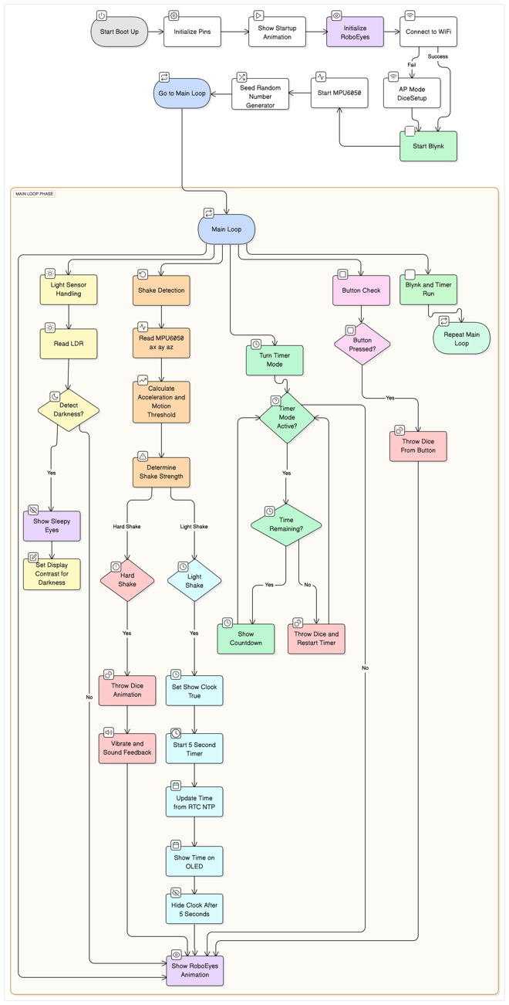
Fig. 1. Flowchart of the various features executed in the SMART Dice

Fig. 2. Circuit diagram of the circuit implementation

III. SYSTEM OVERVIEW
The SMART Dice system is an intelligent, multi-interaction electronic dice designed to simulate real dice behavior through various input methods such as motion, touch, and mobile control. The system is centered around the NodeMCU (ESP8266) microcontroller, which integrates and processes data from several components to deliver a responsive and user-friendly experience.
The core concept behind SMART Dice is to make a conventional dice roll accessible and interactive using embedded hardware. The device supports both single and double dice modes, and offers a rich feedback mechanism through vibration, sound, and visual display.
Key hardware modules include:
- MPU6050: Detects strong shake gestures to initiate a dice roll.
- TTP223 Touch Sensor: Enables tap-based control for mode switching or triggering rolls.
- SSD1306 OLED Display: Visually shows dice face animations, current time, and idle screens.
- GL5528 LDR: Monitors ambient light to adjust OLED brightness and activate night mode.
- Vibration Motor and Buzzer: Deliver haptic and auditory feedback to simulate physical rolling effects.
- TP4056 Charging Module: Supports safe charging of a Li-ion battery, enabling portable operation.
The system is enhanced by software-controlled interactions, including:
- A screensaver mode that activates RoboEyes animations during idle periods.
- An auto-brightness feature that adapts to the lighting environment.
- A Blynk mobile app that allows remote control of game mode, brightness, and timer.
Overall, the SMART Dice merges embedded control, Internet of Things (IoT) capabilities, and assistive features into a compact, portable design, offering an inclusive solution for both entertainment and accessibility.

IV. METHODOLOGY
The Smart Dice is a smart, interactive electronic dice system powered by the NodeMCU (ESP8266) microcontroller. It is designed to simulate a real dice roll based on user interaction, namely motion, touch, and remote commands via a mobile application. The results are displayed through an OLED screen and are supported by haptic and auditory feedback. Enhanced features such as game modes, screen animations, brightness control, and night mode further enrich the user experience, making it a truly “SMART” object.

A. System Design

The Smart Dice system is programmed using the Arduino IDE and integrates several libraries to manage various hardware modules and functionality. The OLED screen is managed using the Adafruit_SSD1306 library, while motion detection is handled by the MPU6050 library. The device supports Wi-Fi-based configuration and mobile based App control via the WiFiManager and BlynkSimpleEsp8266 libraries respectively. In idle states, animated eyes are rendered on the OLED using the FluxGarage_RoboEyes library.

B. How the User Interacts
- Shake to Roll
The MPU6050 sensor detects a strong shake to simulate a dice roll.
- Touch to Roll or Change Mode
The TTP223 capacitive touch sensor enables dice rolling with a simple tap. Depending on the current state, the same touch input may be used to switch between game modes or to display the current time.
- Wi-Fi Reset via Mobile App
Wi-Fi credentials can be reset using the integrated Blynk mobile application. When triggered, the following functions are executed internally:
-WiFiManager.resetSettings()
-ESP.restart()
The device can re-enter configuration mode and connect to a new network.
- Mobile App Integration (Blynk)
The Blynk app connects to the device via Wi-Fi, allowing full control of dice mode, screen brightness, timer, and view of all logged data.

C. Feedback System

The Smart Dice system delivers multisensory feedback to enhance user interaction and responsiveness. The following components are employed:
- OLED Display:
The 0.96" SSD1306 OLED screen provides visual output, displaying the rolled dice number, current time, and idle animations using the RoboEyes library.
- Vibration Motor:
A coin-type vibration motor delivers haptic feedback during dice rolls, simulating a physical dice shake.
- Buzzer:
An integrated piezoelectric buzzer emits a short audio tone to indicate a successful dice roll.
- Ambient Light Sensor (LDR):
A light-dependent resistor (LDR) detects ambient brightness levels. The sensor data is used to dynamically adjust the OLED screen brightness, enhancing visibility in varying lighting conditions.
V. MODEL PROCESSING

The Smart Dice system operates on an event-driven architecture and is developed using the Arduino IDE. It continuously monitors sensor inputs, timers, and mobile application commands to determine and execute appropriate actions. The core processing modules are described below.
A. Sensor Input Handling
- Motion Detection (MPU6050):
The MPU6050 sensor provides three-axis acceleration data. It calculates the total acceleration magnitude using equation 1
 | $$A=\sqrt{x^{2}+y^{2}+z^{2}}$$ | (1)
If the computed value exceeds a predefined threshold, a dice roll event is triggered.
- Ambient Light Sensing (LDR):
An LDR (Light Dependent Resistor) sensor is employed to measure ambient brightness levels. The measured analog value is mapped to adjust the OLED screen contrast in real-time over a range of 0 to 255 brightness level.

- Touch Input (TTP223):
The TTP223 capacitive touch sensor is connected to a digital input pin on the NodeMCU and is configured with interrupt handling. A touch input serves as a trigger to roll the dice or perform mode-related switching functions.
- Wi-Fi Reset via Mobile Application:

Instead of pressing a physical button, the Smart Dice system lets you reset the Wi-Fi settings through the Blynk mobile app. When you press and hold the reset button in the app for 5 seconds, the device automatically resets the Wi-Fi credentials using the necessary code.

B. Dice Rolling Logic

A dice roll can be started in four ways: by shaking the device, touching it, using the Blynk mobile app, or through a countdown timer. A random number is generated to simulate the dice result. In single-dice mode, the number ranges from 1 to 6. In double-dice mode, two separate numbers between 1 and 6 are generated and shown as dice faces on the OLED display. Both modes provide vibration and buzzer sounds to indicate the dice roll.

C. Power Saving and Display Behavior

Various power saving modes, triggered by events that are physical and code controlled, are introduced in this smart object ensuring variable display-based behavior.
- Idle Mode:
If the system is inactive for a while (5 Seconds) it enters screensaver mode, displaying animated RoboEyes.
- Night Mode:
In dark environments, the device’s LDR senses low light levels and triggers the OLED to display “sleepy eyes”, indicating a rest mode.
- Auto Brightness:
OLED brightness dynamically adjusts based on ambient light, enhancing visibility and conserving power.

D. Time Management
Time is synchronized over Wi-Fi using the NTPClient library, configured for Indian Standard Time (GMT+5:30) and is displayed on the OLED.

E. Mobile App Synchronization
- The Blynk mobile app is used to control the Smart Dice remotely via Wi-Fi.
- The app allows the user to:
  - Switch single/double mode of dice
  - Set screen brightness (manual/auto)
  - Enable/disable the Turn timer Mode
  - Configure turn Timer durations
  - View dice roll logs
  - Reset the System via Blynk App (Wi-Fi Control)
- All changes made in the Mobile based Blynk app are instantly processed by the NodeMCU and reflected on the OLED display. The delay times are limited to few milliseconds.

VI. Hardware Design Overview
The Smart Dice device is housed in a custom-built acrylic enclosure that highlights all contributors.

A. Microcontroller Unit
- NodeMCU (ESP8266)
This compact, Wi-Fi-enabled microcontroller, based on the ESP8266 chip, has 10 GPIO pins, I²C/SPI/UART support, and 3.3V logic. Common variants employ CP2102/CH340 USB-to-serial converters. Programs are uploaded via the Arduino IDE using micro-USB.

B. Sensors and Input Modules
- MPU6050 (Gyroscope + Accelerometer)
This 6-axis motion sensor, connected via I²C to the NodeMCU (SCL: D1, SDA: D2), detects shake gestures and provides acceleration data to simulate dice rolls.
- TTP223 (Capacitive Touch Sensor)
The device detects finger touch and provides a digital HIGH output to pin D7. It can be used for various applications such as rolling dice, switching modes, or displaying time. It operates at 3.3V.
- GL5528 LDR (Light Dependent Resistor)
Senses ambient light to control the OLED brightness and night mode. Connected to analog pin A0, it works in a voltage divider configuration with a 4.6 KΩ resistor to Output (read) via the NodeMCU.

C. Display and Output Components
- OLED Display (0.96" SSD1306, I²C)
The device features a 128x64 monochrome display via an I²C interface, connected to SDA pin D2 & SCL pin D3. It can display many images - a dice face, a RoboEyes screensaver, a clock, and mode information. It uses Adafruit_SSD1306 and Adafruit_GFX libraries for the same.
- Piezoelectric Buzzer (Passive Type)
The device connected to pin D7 provides audio feedback during dice rolls. It is driven using PWM signals via the playGamblingTone() routine to generate random frequencies between 1–2 KHz in short bursts to simulate rolling sound effects.
- Vibration Motor (1.5-5V)

The device is a 10mm vibration motor connected to pin D6, providing haptic feedback during dice rolls. It operates at 3.7V, draws 0.195A, and runs at 19,000 RPM. Controlled via a transistor circuit, it uses an unbalanced shaft to generate vibrations.

D. Vibration Motor Control Circuit
- 2N2222 (NPN Transistor)
The device acts as a switch to control the vibration motor and is driven by digital pin D8 through a 1 kΩ, ¼ W base resistor.
- 1N4001 Diode and 0.01µF ceramic Capacitor
The diode protects the transistor from back EMF generated by the motor. And the capacitor suppresses electrical noise and voltage spikes from motor leads.

E. Power Supply Components
- Li-ion Battery (3.7V, e.g., 18650)
This powers the NodeMCU and all modules. It provides portable operation without the need for a wired connection.
- TP4056 Charging Module with Micro-USB
Safely charges the Li-ion battery and includes protection features such as overcharge/discharge shutdown. It also provides power to the NodeMCU.

F. Physical Design
- 4mm Acrylic Sheet Outer Shell:
Shows a square shape, 9.8 cm on each side, with three straight edges and a front edge that is slightly angled. The front part forms a small triangle shape, making it stand out and showing clearly which side is meant to face forward for display.
- 2mm Acrylic Sheet Inner Track and Mounts:
Cut from 2mm acrylic sheets to hold the ESP8266, Sensors Soldered Circuit.

G. The Smart Dice Layout

The entire circuity is housed inside the outer shell. The Figure 3 shows the orthographic projections of the final faces and location of various components with the features executed and the Mobile App Integration.
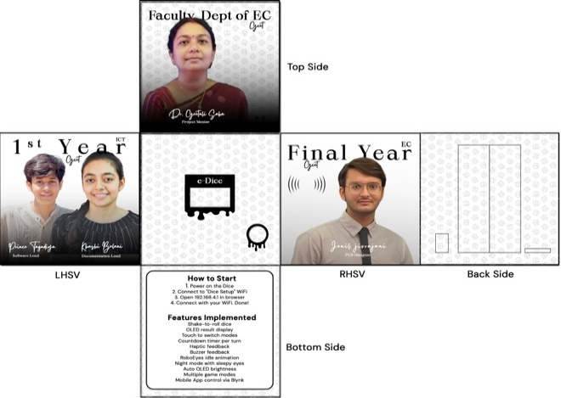
Fig. 3. Orthographic projection of the module
- Result and discussion

All SMART Dice features are explored and tabulated in Table 1 highlighting the various

components in use and the time taken for execution. Additionally, figure 4 shows the inner connections of the SMART Dice. Figure 5 indicates an image of the connections and the components while under the testing phase. Figure 6 shows the completed module with all features executed.

TABLE I. FEATURE-TO-HARDWARE MAPPING

 | FEATURE | FUNCTIONALITY | NODEMCU  +  COMPONENTS | RESPONSE TIME  (MS) | AVG  TIME (MS)
1 | Shake-to-Roll | Detects shake to roll | MPU6050 | 212.43  209.87  215.22 | 212.51
2 | OLED Display | Displays result, animations, time | SSD1306 OLED | 83.57  85.31  82.99 | 83.96
3 | Touch Input | Tap to switch mode or show time | TTP223 | 13.75  14.02  12.91 | 13.56
4 | Countdown Timer | Auto roll after timeout | Code based | 0.00  0.00  0.00 | 0.00
5 | Haptic Feedback | Vibration motor pulses | Coin motor, Diode 2N2222, 1KΩ Resistor | 52.83  54.11  53.36 | 53.43
6 | Sound Feedback | Short beep on dice roll | Piezo Buzzer | 41.77  40.21  42.53 | 41.50
7 | Screensaver | Idle animation (Robo Eyes) | OLED | 124.88  122.64  126.01 | 124.51
8 | Sleepy Eyes | Eyes react to dark (Night Mode) | LDR, OLED | 287.34  291.87  289.76 | 289.66
9 | Auto Brightness | OLED brightness adjusts via light | LDR, 4.6KΩ | 244.12  246.89  242.57 | 244.53
10 | Game Modes | Single/Double dice modes | Code based | 148.12  152.45  150.89 | 150.49
11 | Mobile  Application Integration | Control mode,  Brightness, Timer,  Logs, Reset WiFi | Blynk App, Wi-Fi | 408.11  411.59 405.72 | 408.47
12 | Power Supply | Rechargeable via micro-USB | Li-ion, TP4056 | N/A | N/A
13 | Physical layout | Laser-cut cube housing, 9.8 cm³ | Acrylic sheets - 4mm & 2mm with Images | N/A | N/A

All response times listed above are in milliseconds (ms) and are too fast to be noticed by the human eye.

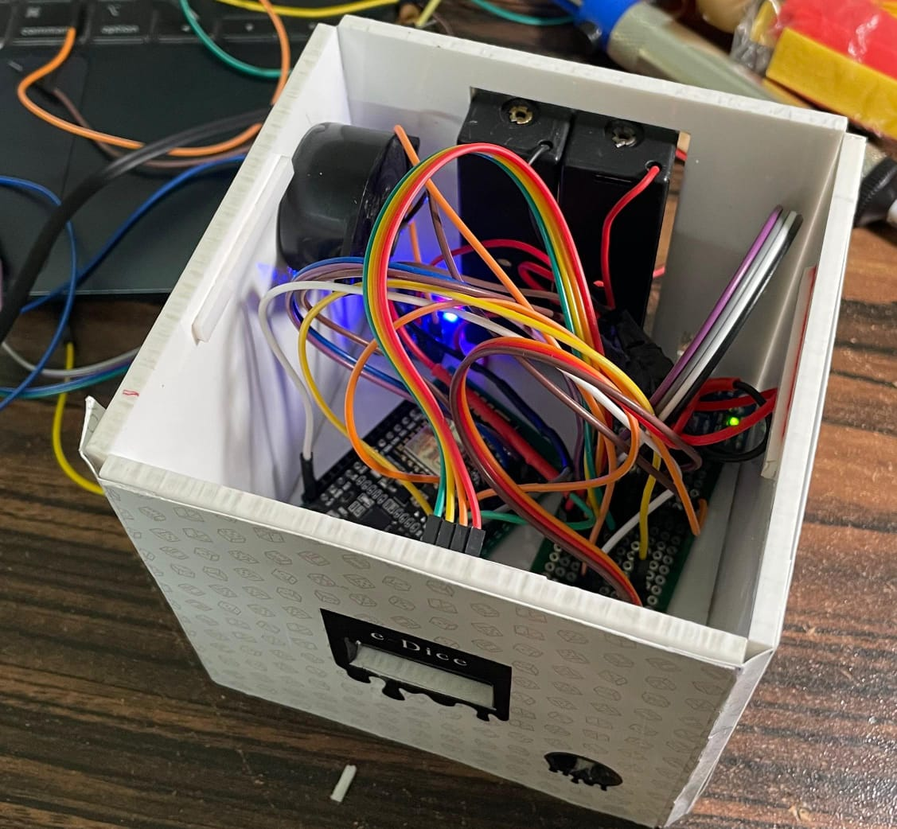
Fig. 4. The inner connections of the SMART Dice.

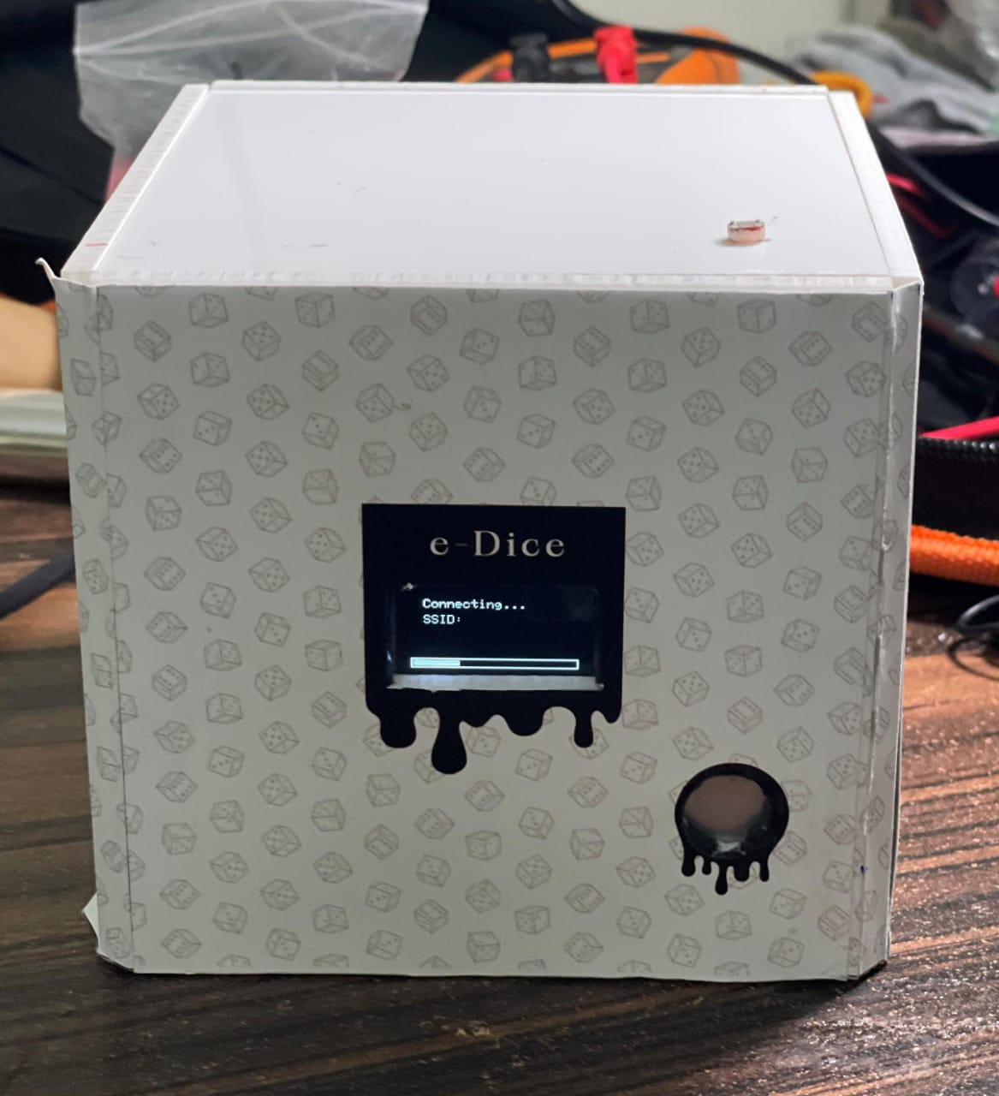
Fig. 5. Image under the testing

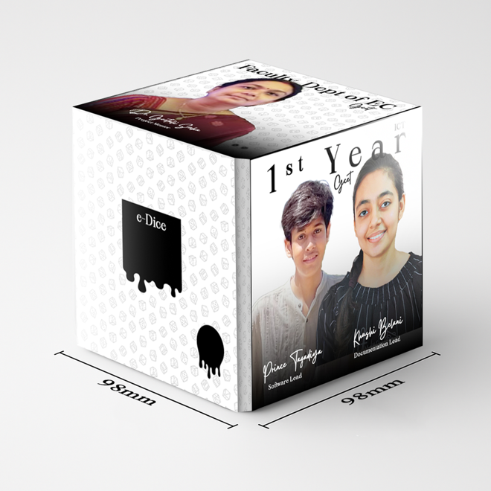
Fig. 6. The final completed product(3D Rendered)

- Conclusion and Future Work
This project introduced SMART Dice, a multi-functional electronic dice that supports shake, touch, and mobile-based interactions. It includes features like time display, brightness control, night mode, and animated screens, with feedback through sound and vibration. The system is powered by a NodeMCU microcontroller and supports wireless control via the Blynk mobile application.
All features were successfully implemented and tested, and the device responded quickly to user input. The SMART Dice system demonstrates how low-cost components can be combined to create an interactive tool that is not only fun but also potentially helpful for users with visual impairments.
In the future, we plan to add voice output to announce dice results, enable multiplayer support through Wi-Fi, and introduce AI-based smart gaming modes. Another possible extension is to adapt the SMART Dice for car dashboards, where it could display simple navigation directions, show the distance from the car in front using ultrasonic sensors, and act as a compact safety and alert device. These ideas could open new use cases in both gaming and real-world assistive technologies.

REFERENCES
[1] Envision Technologies, "Envision AI App," [Online]. Available: https://www.letsenvision.com/app. [Accessed: May 30, 2025].
[2] NowNav, "NowNav Navigation App for the Visually Impaired," [Online]. Available: https://www.nownav.com. [Accessed: May 30, 2025].
[3] Novartis, "ViaOpta Nav App," [Online]. Available: https://www.viaopta-apps.com. [Accessed: May 30, 2025].
[4] World Health Organization, "World Report on Vision," August 2023. [Online]. Available: https://www.who.int/publications/i/item/world-report-on-vision. [Accessed: May 30, 2025].
[5] Adafruit, "Adafruit SSD1306 OLED Display Library," [Online]. Available: https://github.com/adafruit/Adafruit_SSD1306. [Accessed: May 30, 2025].
[6] Blynk Inc., "Blynk IoT Platform," [Online]. Available: https://blynk.io. [Accessed: May 30, 2025].
[7] RoboEyes by FluxGarage, "Animated OLED Eyes Library," [Online]. Available: https://github.com/FluxGarage/RoboEyes. [Accessed: May 30, 2025].
[8] InvenSense, "MPU6050 - MEMS MotionTracking Devices," [Online]. Available: https://www.invensense.com/products/motion-tracking/6-axis/mpu-6050/. [Accessed: May 30, 2025].
[9] TTP223 Touch Sensor Datasheet, "Touch Pad Detector IC," [Online]. Available: https://www.electrodragon.com/product/ttp223b-touch-sensor/. [Accessed: May 30, 2025].
[10] NTPClient Library for Arduino, "Network Time Protocol Client," [Online]. Available: https://github.com/arduino-libraries/NTPClient. [Accessed: May 30, 2025].
[11] TP4056 Charging Module Datasheet, [Online]. Available: https://datasheet.lcsc.com. [Accessed: May 30, 2025].

