📄 Smart Universal Remote System
By Prince Tagadiya

📌 Introduction
In our living room -- there are too many remotes lying around:
- TV remote
- Soundbar remote
- Set-top box remote
- AC remote
- fan remote
- Streaming device remote (Fire TV)
In my room, I have:
- AC remote
- fan remote
In my father’s room, there is:
- AC remote
- fan remote
We faced a common problem: Too many remotes and too much confusion.
So I decided to make one smart remote that can control both rooms and remove all the remote headaches.

💡 Why We Made This
- To combine multiple remotes (AC, Fan, TV) into one smart remote.
- To work with both smart and normal appliances.
- To eliminate the problem of losing remotes.

🔧 How It Works
This remote uses:
- ESP32 for wireless communication (ESP-NOW).
- IR Blaster to control old devices.
- IR Receiver to learn and calibrate other remotes.
- Temperature & Mode Buttons for control.
- OLED Display for easy interface.
- The docking station is equipped with an OLED display and features a built-in button that allows users to locate the remote using ESP-NOW technology. When the button is pressed, the system communicates with the remote and displays its approximate distance based on RSSI (Received Signal Strength Indicator) values. The OLED screen also continuously shows the remote’s charging status, providing a clear and user-friendly interface for both tracking and monitoring the device.

⚙️ Features

📱 Remote Unit
Universal Smart Remote with IR Blaster and ESP-NOW Communication
- IR Blaster with Learning Mode
Supports learning mode through an onboard IR receiver, allowing users to record and replicate signals from any IR-based device like TVs, ACs, Fans, and Projectors.
- OLED UI with Button Interface
Features a compact OLED display paired with intuitive physical buttons, offering a clear and responsive user interface for navigating functions and selecting devices.
- Multi-Device Control
Seamlessly controls a variety of household electronics, including Air Conditioners, Fans, Televisions, and Projectors.
- ESP-NOW Wireless Communication
Uses ESP-NOW protocol for low-latency and power-efficient wireless communication with the docking station or other ESP-based systems.
- Rechargeable Battery-Powered
Powered by an internal rechargeable battery, offering portability and ease of use without the need for frequent replacements.
- "Find Remote" Feature via RSSI
In case the remote is misplaced, the docking station can trigger a signal via ESP-NOW. The remote responds, and the docking station estimates the remote’s proximity using RSSI values, displaying distance info on its OLED screen.
- Battery-Saving Sleep Mode
Automatically enters sleep mode during periods of inactivity to conserve battery life, significantly improving efficiency.
- Auto-Rotate & Motion Wake-Up
Equipped with a gyroscope sensor, the screen auto-rotates based on orientation. It also wakes up the remote instantly upon detecting motion, enhancing user interaction while saving power during idle times.

🧲 Docking Station
- Charges the remote via USB/Type-C
- Shows charging status on OLED
- Displays distance from remote using RSSI signal
- Makes beep sound or triggers buzzer if remote is lost
- Can be mounted or placed near wall

⚙️ Ideal Use
- Keep the dock in one fixed place (like bedroom wall).
- Remote is always charged and ready.
- If you lose the remote, press a Find Button on the dock.
- Dock shows how far the remote is (using signal strength).
- Remote buzzes if nearby.

💡 How It’s Made
- 🧠 Brain: ESP32
- 🧲 IR LED + IR Receiver for universal control
- 💡 Touch Screen Display for UI
- 🔋 Battery with charging circuit
- 📶 ESP-NOW for low power communication
- ⚡️ Dock with OLED & Buzzer
- 🧪 Simple calibration method using existing remotes
- 🎨 3D-printed body

🔒 Future Scope
- patent the complete system
- Add mobile app control
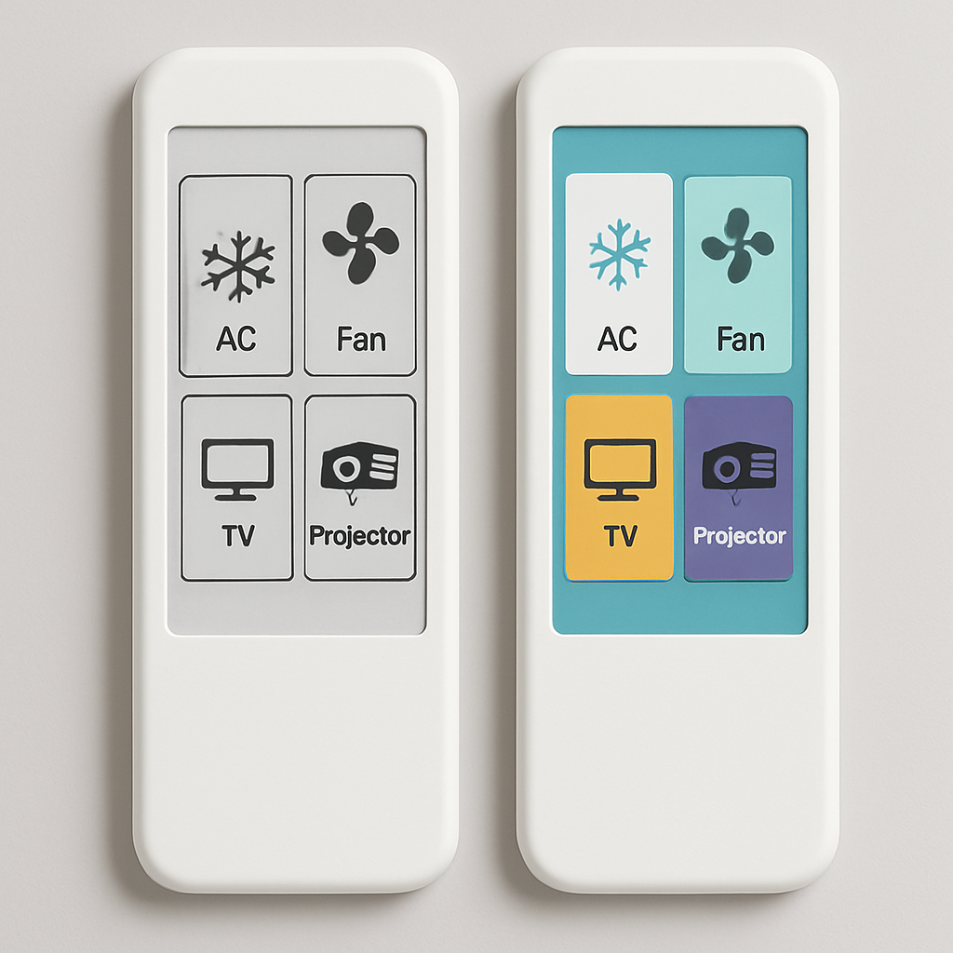
E-Paper Display vs. Normal Display

✅ Conclusion
With one smart IoT remote:
- We can control all devices in both rooms
- Find lost remote easily
- Simple UI and great user experience
One remote. All control. No headaches.

