UIDAI DATA & ENROLMENT ANALYTICS DASHBOARD

Integrated Analytics Report – Data Hackathon 2026

EXECUTIVE SUMMARY
Unique Identification Authority of India oversees a nationwide digital identity ecosystem that continuously generates large volumes of enrolment, update, and authentication data. While raw dashboards provide operational visibility, administrators require interpreted analytics, trend explanations, and action-oriented insights to guide policy and infrastructure decisions.
This project delivers an integrated analytics platform that combines:
- Cross-dataset UIDAI performance analytics, and
- Focused enrolment & update behavior analytics
The system transforms raw CSV data into interpretable metrics, trend narratives, anomaly alerts, and governance insights, enabling administrators to move from monitoring data to acting on evidence.
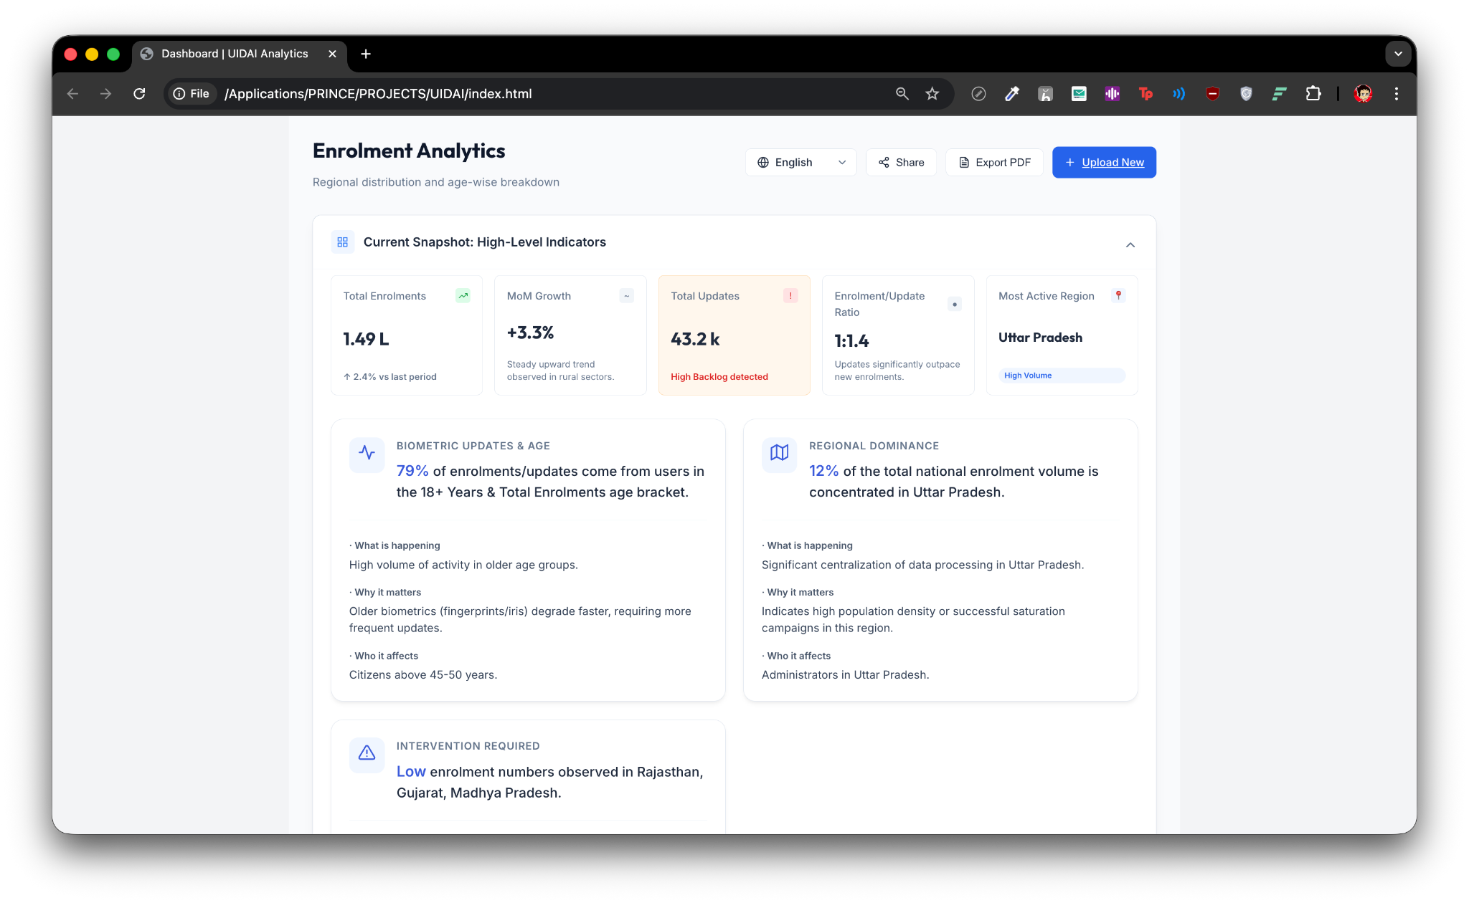

1. PROJECT SCOPE
The platform covers two tightly integrated analytical domains:

1.1 UIDAI Core Data Analytics
- Biometric authentication analysis
- Demographic authentication analysis
- Enrolment coverage evaluation
- District-level service readiness scoring

1.2 Enrolment & Update Analytics
- Regional enrolment distribution analysis
- Age-wise enrolment and update patterns
- Update vs enrolment imbalance detection
- Temporal trend analysis
- Automated spike and consistency detection
Together, these modules provide a holistic view of Aadhaar service performance and citizen interaction behavior.

2. SYSTEM OVERVIEW
The system is designed as a privacy-first, client-side analytics platform capable of handling heterogeneous datasets without predefined schemas.

End-to-End Flow:
Data Upload
→ Column Auto-Detection
→ Validation & Normalization
→ Aggregation (Region / District / Age)
→ Metric Computation
→ Trend & Imbalance Detection
→ Insight Generation
→ Analytics Output
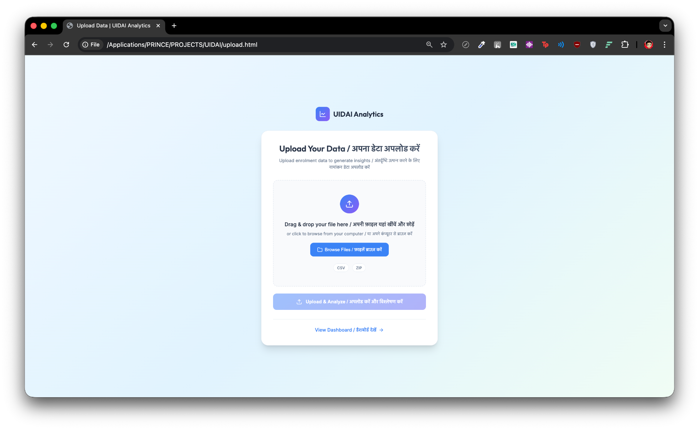

3. ENROLMENT ANALYTICS MODULE
The Enrolment Analytics module focuses on how citizens interact with the Aadhaar ecosystem over time, rather than raw counts.

Key Analytical Dimensions:
- Regional concentration of enrolment and update activity
- Age-group driven update behavior
- Balance between new enrolments and profile updates
- Temporal seasonality and trend patterns
This module answers what is happening, why it matters, and who is affected — a critical requirement for governance dashboards.
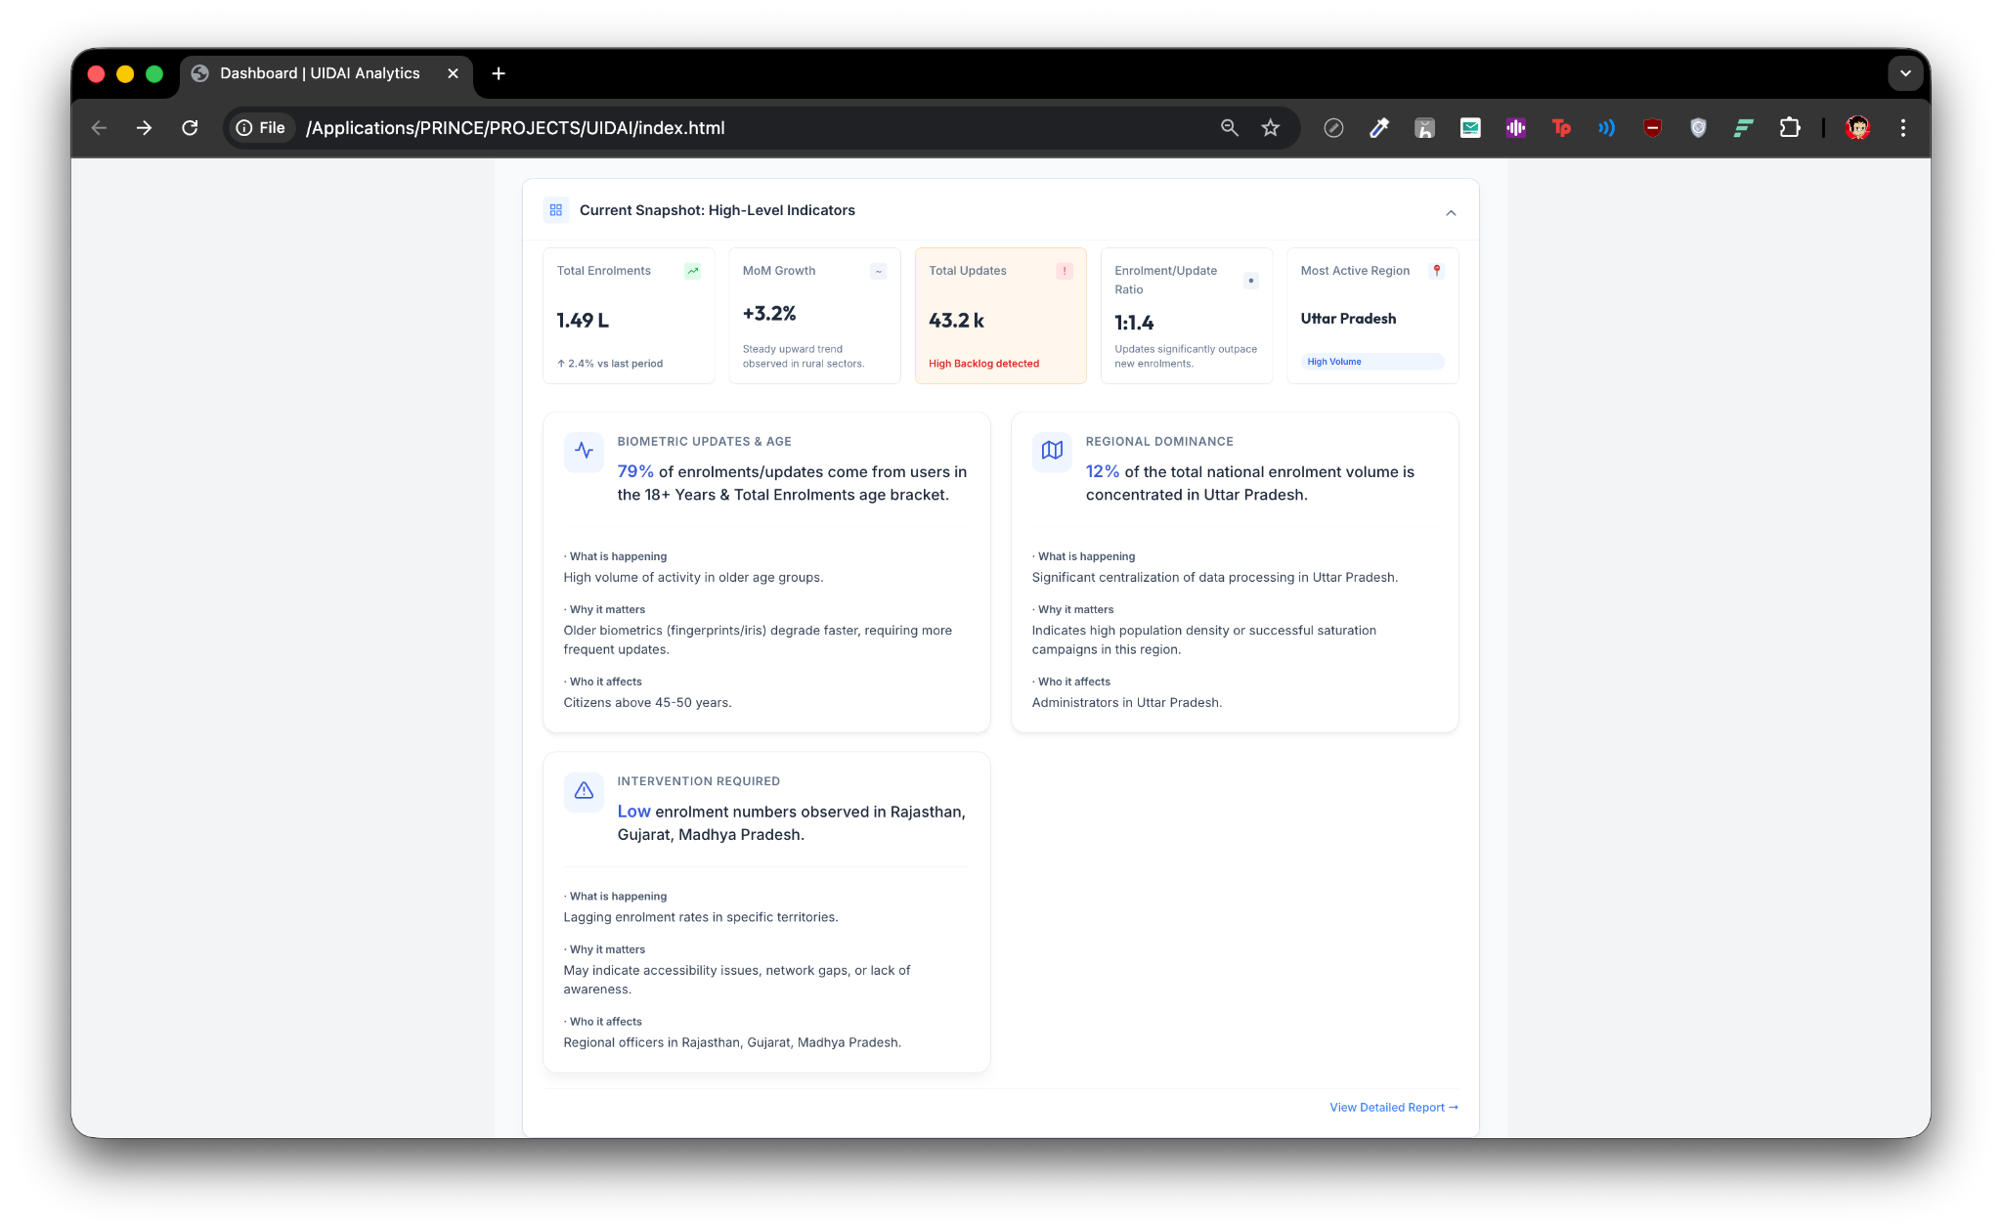

4. REGIONAL DISTRIBUTION ANALYSIS

Image Section Heading (for future use):
Figure: Region-wise Enrolment & Update Distribution
The system identifies:
- Regions with consistently high activity
- Regions showing stagnation or decline
- Geographic concentration of administrative load
Analytical Purpose:
- Detect operational centralization
- Identify regions requiring outreach or infrastructure expansion
- Support region-specific administrative planning
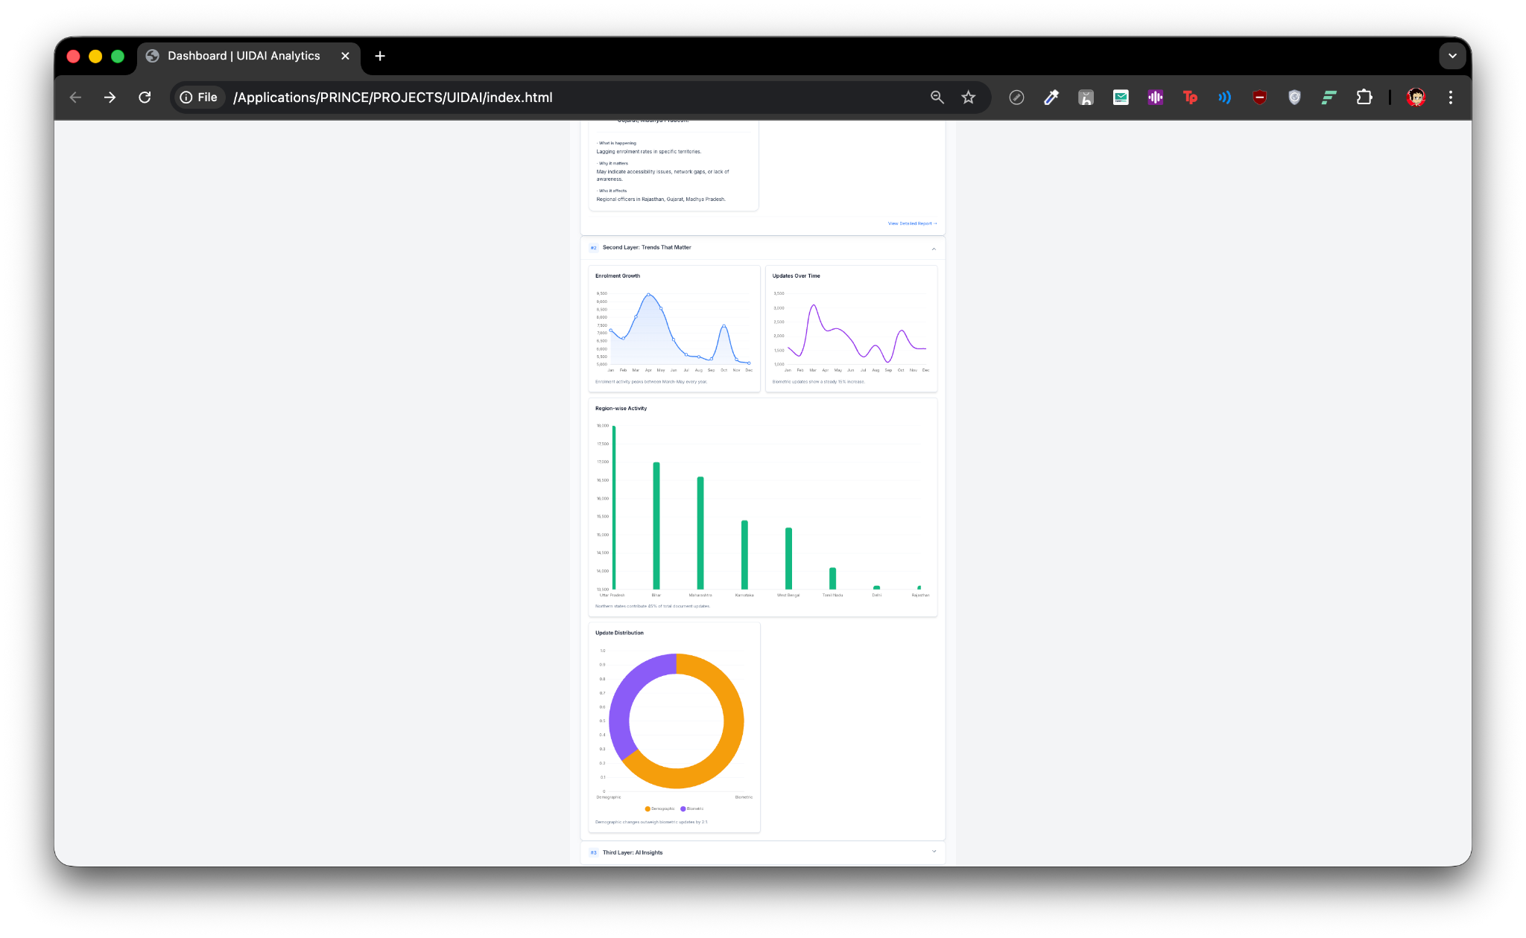

5. AGE-WISE ENROLMENT & UPDATE ANALYTICS

Image Section Heading (for future use):
Figure: Age-Group Based Enrolment & Update Distribution
The platform analyzes enrolment and update activity across age cohorts to detect structural patterns.
Key Observations (Abstracted):
- Higher update frequency in older age groups
- Repeated updates linked to biometric aging
- Stable enrolment dominance by a single age cohort across regions
Why This Matters:
- Aging biometrics require proactive infrastructure planning
- Update-heavy cohorts increase system load
- Helps forecast future update demand

6. UPDATE VS ENROLMENT IMBALANCE ANALYSIS

Image Section Heading (for future use):
Figure: Enrolment-to-Update Ratio Analysis
The system evaluates the balance between:
- New Aadhaar enrolments
- Profile and biometric updates
Analytical Insights:
- Update-heavy systems may indicate saturation
- Persistent imbalance suggests policy or awareness gaps
- High update ratios signal operational stress on update centers
This insight helps administrators reallocate resources and adjust enrolment strategies.
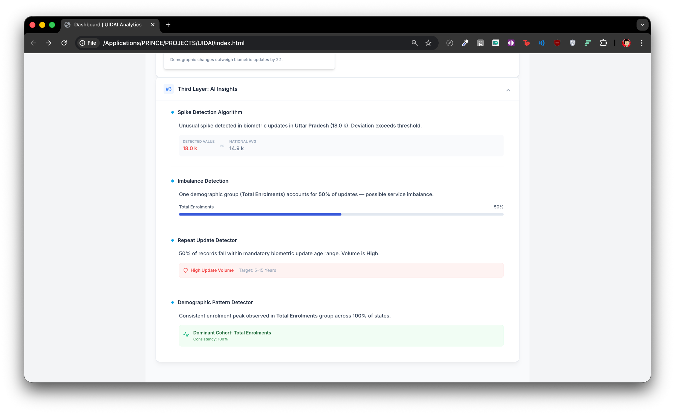

7. TEMPORAL TREND & SEASONALITY ANALYSIS

Image Section Heading (for future use):
Figure: Enrolment & Update Trends Over Time
The analytics engine detects:
- Periodic enrolment peaks
- Long-term growth or stagnation patterns
- Consistent behavioral cycles across years
Policy Value:
- Enables workforce and infrastructure planning
- Supports seasonal campaign alignment
- Improves preparedness for peak activity periods

8. AUTOMATED SPIKE & CONSISTENCY DETECTION

Image Section Heading (for future use):
Figure: Spike & Anomaly Detection Output
The system automatically flags:
- Sudden surges beyond expected thresholds
- Region-specific abnormal activity
- Dominance of a single demographic group
Detection Logic Includes:
- Statistical deviation from national baselines
- Cross-region consistency checks
- Repeat-update density analysis
These alerts help identify data quality issues, infrastructure strain, or unexpected citizen behavior.

9. INTEGRATION WITH SERVICE READINESS ANALYTICS
The enrolment analytics module feeds directly into the Service Readiness Score by influencing:
- Enrolment coverage calculations
- Anomaly penalties
- Stability assessments
This ensures enrolment behavior is not viewed in isolation but as a core contributor to service performance.

10. TECHNOLOGY & DESIGN PRINCIPLES
Area | Approach
Processing | Client-side, schema-independent
Privacy | No server-side data transfer
Analytics | Rule-based + statistical
Explainability | Metric-driven, no black-box AI
Usability | Designed for non-technical administrators

11. GOVERNANCE VALUE
This integrated dashboard enables administrators to:
- Understand where enrolment is concentrated
- Identify who is driving update demand
- Detect imbalances and anomalies early
- Plan region-specific interventions
- Support data-backed policy decisions

12. CONCLUSION
By combining UIDAI core data analytics with deep enrolment and update behavior analysis, this platform transforms operational dashboards into decision intelligence systems.
The solution moves beyond displaying numbers and instead explains:
- What is happening
- Why it matters
- Who is impacted
- Where intervention is required
This makes the system suitable not only for hackathon evaluation but also for real-world administrative deployment.

FOR:
UIDAI Data Hackathon 2026

