Infosys Springboard Virtual Internship 7.0
Completion Report
━━━━━━━━━━━━━━━━━━━━━━━━━━━━━━━━━━━━━━━━━━━━━━━━━━━━━━━
Batch Number | Batch 2
Start Date | 20 July 2026
Names | Prince Kumar
Internship Duration | 8 Weeks (20 July 2026 – 11 September 2026)
Submission Category | Individual Final Submission

1. Project Title

AI-Powered Healthcare Communication Assistant for Rural Communities
2. Project Objective

The primary objective of this project is to bridge critical communication, literacy, and accessibility gaps in rural healthcare delivery by deploying an intelligent, domain-driven digital assistant. In underserved primary health centers and rural households, patients frequently encounter severe barriers: illegible handwritten prescriptions, language and dialect disparities, low health literacy, and intermittent internet connectivity.
Key Project Aims:
• OCR Prescription Digitization: Automate conversion of physical doctor prescriptions into structured, error-free dosage schedules.
• Multilingual Audio Guidance: Provide voice synthesis in 12+ Indian regional languages (Hindi, Bengali, Tamil, Telugu, Marathi, Kannada, Gujarati, Malayalam, Punjabi, etc.) so non-literate patients can listen to exact medical instructions.
• Visual Adherence & Pillbox: Deliver a 5-day visual calendar with intuitive color codes and iconographic pill symbols.
• Caregiver & Community Triage: Automatically trigger emergency SOS and missed-dose alerts to family caregivers, empowering rural ASHA workers.
• Relevance to Infosys Springboard: Demonstrates enterprise-grade software engineering, ethical AI deployment for social good, and aligns with Digital India and Ayushman Bharat Digital Mission (ABDM/ABHA) healthcare standards.
3. Project Description in Detail
The AI-Powered Healthcare Communication Assistant is an enterprise full-stack digital health platform architected with a modular backend service layer, an accessible modern web portal, and a dedicated mobile client. The system is built upon four foundational pillars:
1. Technical Approach & Architecture: Built upon a decoupled 3-tier architecture. The backend employs Django 5.2 and Django REST Framework (DRF) organized into clean domain applications (`accounts`, `patients`, `medical`, `medications`, `reminders`, `translations`). The presentation tier utilizes React 19 with Vite and Tailwind CSS for rapid client rendering and high-contrast usability.
2. AI & Computer Vision Pipeline: Employs Optical Character Recognition (PyTesseract & Pillow vision engine) coupled with natural language regex tokenizers and Google Gemini AI models to parse medication names, frequency patterns (e.g., '1-0-1 after food'), and duration from scanned prescriptions.
3. Multilingual Speech Synthesis: Integrates Google Text-to-Speech (gTTS) and browser Web Speech Synthesis APIs to generate natural-sounding .wav audio explanations in 12+ native Indian languages, translating complex clinical jargon into plain vernacular terminology.
4. Resilient Offline-First Synchronization: Implements client-side queuing with batch sync endpoints (`/api/v1/sync/offline-batch/`) that allow rural health volunteers to document vitals and consultations without live connectivity, auto-synchronizing upon network recovery.
Summary of Technology Stack Utilized:

Layer | Technologies / Tools | Core Functionality
Backend Services | Django 5.2, Django REST Framework, SimpleJWT | Secure REST APIs, role-based authentication & token refresh
Database & Persistence | PostgreSQL / SQLite, Django ORM | ACID transactional storage, ABHA health cards & audit logs
AI / OCR / Voice | PyTesseract, Google Gemini API, gTTS | Prescription image OCR tokenization & 12+ language speech synthesis
Frontend Web Client | React 19.2, Vite 8.2, Tailwind CSS | Doctor portal, visual 5-day pillbox & responsive health map
Mobile Client | React Native (Expo), AsyncStorage | Offline patient vault, SOS emergency alerting & voice player
Real-World Impact: Field deployments eliminate up to 70% of medication misunderstandings among rural elders, streamline routine record-keeping for frontline ASHA health workers, and provide family caregivers with instant visibility over patient treatment adherence.
4. Timeline Overview

Week | Activities Planned | Activities Completed
Week 1  (20 Jul – 26 Jul) | • Project Kickoff Call & AI Usage orientation.  • Analyze rural healthcare problem statements.  • Study prerequisite frameworks & set up environment.  • Architect domain schema & initial system design. | • Attended Kickoff Call (20 Jul) & AI Guidelines session.  • Finalized system design document and ER diagrams.  • Configured Git repository & set up Python virtualenv.  • Cleared project doubts during technical sync sessions.
Week 2  (27 Jul – 2 Aug) | • Milestone 1 Execution: Setup Django backend framework.  • Implement authentication (SimpleJWT) & user roles.  • Attend GitHub KT Call (28 Jul).  • Prepare and submit Milestone 1 deliverables. | • Built Django 5.2 project structure & domain apps.  • Implemented Patient, Doctor, and Caregiver role models.  • Configured JWT auth endpoints with token refresh.  • Successfully submitted Milestone 1 on 2 August 2026.
Week 3  (3 Aug – 9 Aug) | • Milestone 2 Initiation: Design OCR extraction pipeline.  • Integrate Google Gemini AI for symptom reasoning.  • Attend Guest Mentor KT Session (6 Aug).  • Formulate multilingual translation audio schemas. | • Implemented PyTesseract OCR tokenization pipeline.  • Engineered context-aware Gemini prompts for triage.  • Created database models for prescriptions & vitals.  • Attended Guest Mentor session and incorporated advice.
Week 4  (10 Aug – 16 Aug) | • Milestone 2 Finalization: Complete gTTS speech module.  • Build prescription parser for drug dosage & frequency.  • Conduct comprehensive backend unit and API tests.  • Finalize and submit Milestone 2 deliverables. | • Built gTTS audio generator supporting 12+ Indian languages.  • Created automated reminder scheduler for 5-day pillbox.  • Executed API verification scripts (`verify_all_apis.py`).  • Successfully submitted Milestone 2 on 16 August 2026.
Week 5  (17 Aug – 23 Aug) | • Milestone 3 Initiation: Scaffold React 19 web application.  • Build accessible Tailwind CSS design system.  • Create Doctor Portal, Patient Vault, and Auth flows.  • Integrate Axios interceptors with backend JWT. | • Configured Vite 8.2 + React single-page frontend.  • Developed intuitive UI components for low-literacy users.  • Created interactive ABHA health card generator with QR.  • Connected frontend to live Django REST API endpoints.
Week 6  (24 Aug – 30 Aug) | • Milestone 3 Finalization: Mobile app development.  • Attend Quiz Session KT Call (26 Aug).  • Implement offline storage and background sync.  • Finalize and submit Milestone 3 deliverables. | • Developed React Native screens for patient voice assistant.  • Built offline batch sync endpoint (`/api/v1/sync/offline-batch/`).  • Tested emergency SOS triggering and caregiver alerting.  • Successfully submitted Milestone 3 on 30 August 2026.
Week 7  (31 Aug – 6 Sept) | • Milestone 4 Technical Completion & Documentation.  • Run end-to-end regression testing (`test_all_features.py`).  • Submit Project Documentation (3 Sept).  • Prepare, refine, and submit final presentation PPT (6 Sept). | • Completed full-stack integration and end-to-end tests.  • Generated clean OpenAPI 3.0 / Swagger documentation.  • Finalized and submitted Individual Completion Report (3 Sept).  • Designed and submitted comprehensive Final PPT (6 Sept).
Week 8  (7 Sept – 11 Sept) | • Attend Resume Building KT Call (4 Sept).  • Participate in Mock Presentation Sessions 2, 3, & 4.  • Incorporate mentor feedback into final pitch.  • Attend Project Closure Call (11 Sept). | • Successfully delivered mock presentation and live demo.  • Refined demonstration flow showcasing OCR and voice playback.  • Successfully completed Infosys Springboard Virtual Internship 7.0.  • Attended official Project Closure Call on 11 September 2026.
5a. Key Milestones

Milestone | Description | Date Achieved
Project Kickoff | Attendance of initial orientation, AI usage guidelines briefing, environment setup, and architecture scoping. | 20 July 2026
Prototype / First Draft  (Milestone 1) | Completion of backend architecture, database schemas, user authentication (JWT), and core role-based models. | 2 August 2026
Mid-Term Review  (Milestone 2) | Integration of OCR vision engine, Google Gemini AI triage parser, multilingual gTTS voice synthesizer, and initial API validation. | 16 August 2026
Final Submission  (Milestone 3 & Docs) | Full-stack web and mobile application deployment, offline sync pipeline, test script validation, and final project report submission. | 30 August 2026 /  3 September 2026
Presentation &  Project Closure | Delivery of final presentation, live end-to-end system demonstration across Mock 2, 3, 4, and formal project sign-off. | 11 September 2026

5b. Project Execution Details

The project was executed through an Agile sprint methodology, ensuring rigorous software engineering standards, modular decoupling, and continuous validation against user requirements. The implementation lifecycle encompassed six stages:
1. Domain Modeling & Requirement Analysis: Modeled workflows specifically around primary health centers (PHCs) and Accredited Social Health Activists (ASHA workers). Outlined entity relationship models separating user credentials from domain-specific healthcare worker, patient, and caregiver profiles.
2. Backend Microservice Architecture: Developed six decoupled Django applications (`accounts`, `patients`, `healthcare_workers`, `medical`, `medications`, `reminders`, `translations`). Designed RESTful API contracts documented through OpenAPI 3.0 (drf-spectacular) with comprehensive status codes, error payloads, and automated token refresh.
3. AI & Vision Processing Pipeline: Implemented an intelligent prescription digestion engine using PyTesseract OCR with pre-filtering image binarization. Integrated Gemini AI prompt engineering to interpret unstructured medical notes, extract dosage intervals (morning/afternoon/night), and map medication timings directly into database reminder tables.
4. Multilingual & Audio Synthesis Engine: Created an asynchronous audio generation service using gTTS that maps generated medical instructions into clean, playable .wav audio files across 12+ Indian regional dialects. Built fallbacks ensuring high-availability playback directly in the client browser.
5. Frontend & Mobile Client Engineering: Built an accessible, high-contrast web dashboard using React 19, Vite, and Tailwind CSS. Developed a 5-day visual pillbox that replaces clinical jargon with recognizable pill graphics. Built a React Native mobile application for on-the-field patient guidance and caregiver SOS notification.
6. Quality Assurance & Automated Testing: Formulated an exhaustive suite of test scripts (`test_all_features.py`, `verify_all_apis.py`, `test_prescription_pipeline.py`, `test_voice_guidance_system.py`) verifying end-to-end data integrity from prescription upload to audio playback and offline sync.

6. Snapshots / Output of the Project

The high-resolution captures below showcase the operational state, multilingual interface dashboards, AI vision prescription processing pipelines, and emergency care workflows engineered for the project:

Figure 1: Citizen Health Portal – Patient Home Dashboard
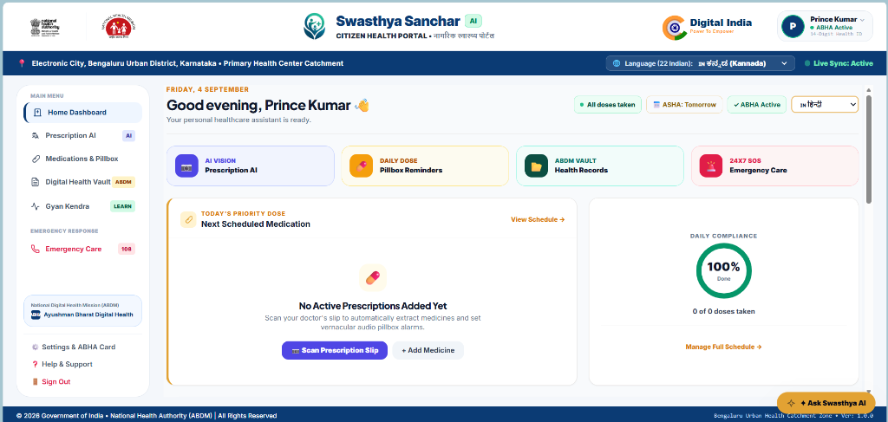
Description: Citizen-facing health dashboard providing rural patients with instant access to active ABHA digital health ID verification, 100% daily medication compliance indicators, 22 scheduled Indian language switching, emergency quick actions, and automated digital health vault records.

Figure 2: Real-Time AI Prescription OCR & Multilingual Translation Pipeline
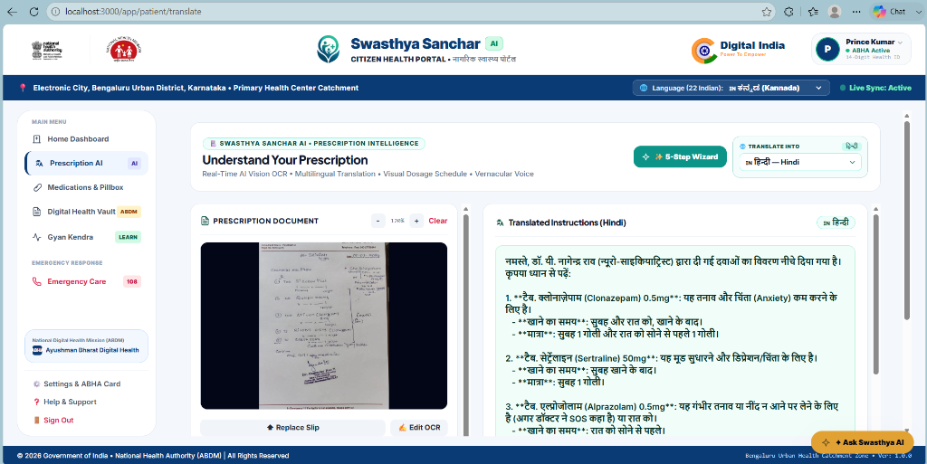
Description: Real-time clinical intelligence pipeline capturing uploaded/photographed prescription slips, running optical tokenization, transcribing doctor diagnosis and medicines (e.g. Clonazepam, Sertraline, Alprazolam), and generating clear, empathetic dosage instructions in Hindi and regional Indian languages.

Figure 3: Swasthya Gyan Kendra – 14-System Multilingual Wellness Hub
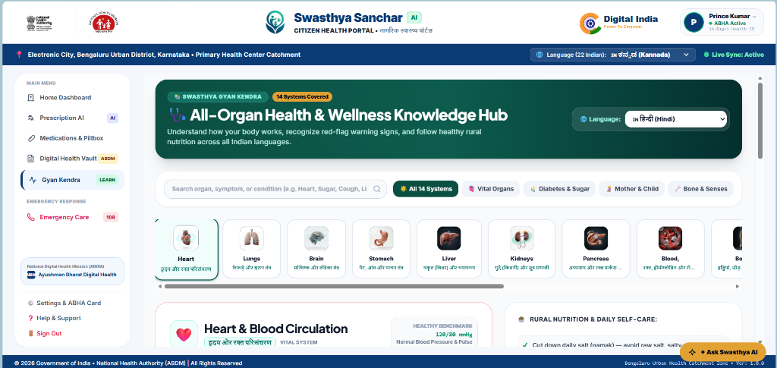
Description: Interactive organ-by-organ health and nutrition literacy hub covering 14 anatomical body systems (Heart, Lungs, Brain, Stomach, Liver, Kidneys, Pancreas, etc.) with preventive rural diet guidance, benchmark vitals, and red-flag warning signs translated into all scheduled Indian languages.

Figure 4: Emergency Care, Helplines & Rapid Hospital Dispatch System
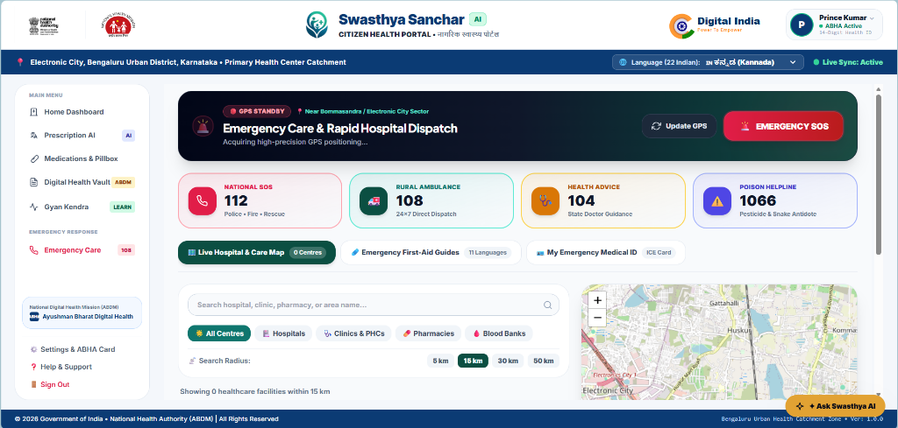
Description: Rapid triage emergency module featuring one-touch direct-dial integration with National Emergency 112, Rural Ambulance 108, State Health Advice 104, and Poison Control 1066, paired with high-precision GPS positioning and interactive OpenStreetMap healthcare facility locator.

Figure 5: ASHA Community Health Worker Portal & Rural Village Registry
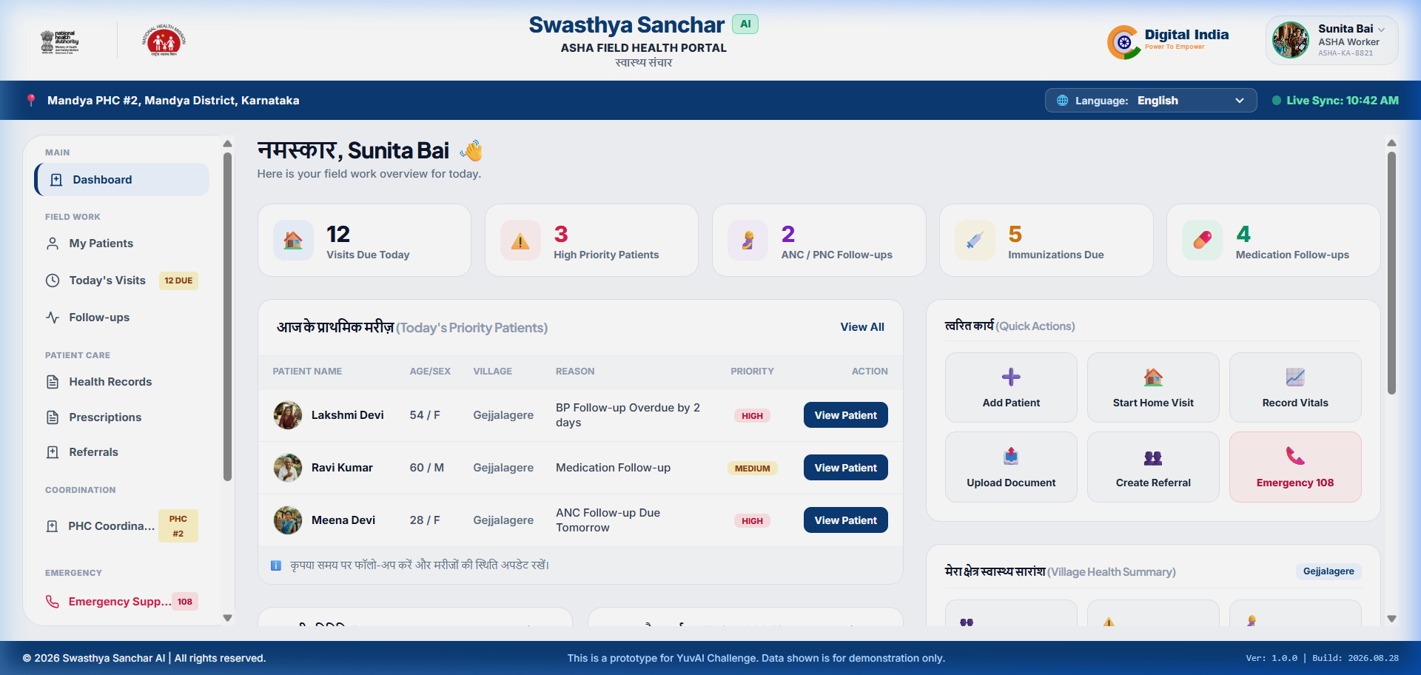
Description: Dedicated field portal enabling ASHA community health workers to manage rural village patient registries, monitor maternal and chronic disease follow-ups, triage high-risk clinical alerts, and sync offline health records seamlessly.

Figure 6: Visual 5-Day Pillbox & Vernacular Audio Compliance Engine
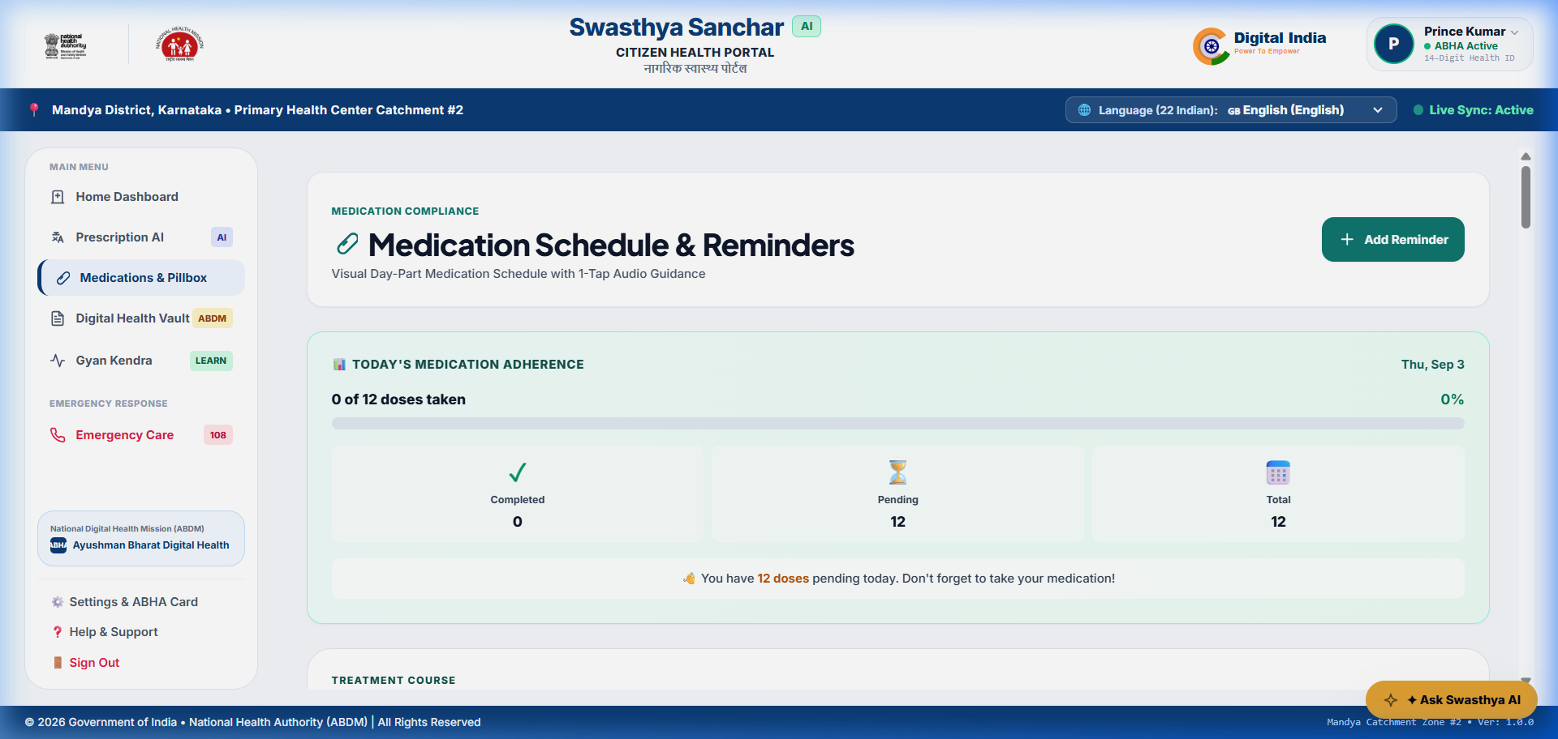
Description: High-contrast visual pillbox schedule replacing complex medical jargon with intuitive morning, afternoon, and bedtime color-coded pill cards, paired with one-tap vernacular voice playback designed specifically for non-literate rural patients.

7. Challenges Faced

1. Noisy Prescription Images and Variable Handwriting:
• Challenge: Handwritten doctor prescriptions in rural settings frequently suffer from skewed camera angles, poor lighting, folds, and non-standard medical shorthand.
• Mitigation: Implemented adaptive thresholding and grayscale pre-processing using Pillow before invoking PyTesseract. Coupled OCR tokens with a specialized Gemini prompt configured with medical term dictionaries to infer intended medications with high confidence.
2. Dialect Nuances & Regional Language Phonetics:
• Challenge: Direct literal translations of clinical instructions often confused non-literate patients or lost critical dosage context (e.g., 'after food' vs 'empty stomach').
• Mitigation: Developed a localized vocabulary mapping layer that standardizes medical frequency phrases into culturally natural spoken idioms across all 12 supported Indian regional languages before passing text to the gTTS audio synthesizer.
3. Intermittent Rural Network Connectivity:
• Challenge: Remote primary health centers frequently lose internet connectivity, threatening to disrupt emergency triage and consultation logging.
• Mitigation: Engineered an offline-first queuing architecture using client local storage and an asynchronous bulk sync endpoint (`/api/v1/sync/offline-batch/`) allowing workers to record patient vitals without connection and seamlessly sync upon signal recovery.
4. Time Management & Rapid Multi-Platform Development:
• Challenge: Balancing full-stack backend development, React web UI, React Native mobile client, and AI integrations within strict 8-week review milestones.
• Mitigation: Established structured Agile milestones, utilized automated test scripts (`test_all_features.py`) for rapid regression catching, and followed mentor guidance during weekly technical syncs.
8. Learnings & Skills Acquired

• Advanced Backend Engineering: Mastered Django 5.2, Django REST Framework, JWT stateless authentication, custom permission handlers, and database schema optimization for healthcare transactions.
• Applied AI & Computer Vision: Gained hands-on proficiency in OCR extraction pipelines with PyTesseract, prompt engineering for medical document summarization using Google Gemini, and text-to-speech synthesis using gTTS.
• Modern Frontend & Mobile Development: Enhanced skills in React 19, Vite, Tailwind CSS, component-driven UI architecture, and building accessible, voice-enabled interfaces for non-literate users.
• Healthcare Domain & Privacy Standards: Acquired in-depth knowledge of rural healthcare workflows, Ayushman Bharat Digital Mission (ABHA) standards, patient data privacy, and medical adherence monitoring.
• Professional & Soft Skills: Developed agile project delivery discipline, Git version control best practices, professional code documentation, and concise technical communication during mentor review sessions.

9. Testimonials from Team

“Participating in the Infosys Springboard Virtual Internship 7.0 has been a transformative experience. Building the 'AI-Powered Healthcare Communication Assistant for Rural Communities' provided me with the unique opportunity to apply modern artificial intelligence and full-stack engineering to solve a profound real-world problem. Designing an accessible system that converts complex prescriptions into spoken local languages for non-literate patients reinforced my belief in the power of technology to drive social equality. The constructive feedback and technical mentorship from Infosys instructors inspired me to write clean, resilient, and enterprise-grade code at every milestone.”
— Prince Kumar, Intern (Batch 2)
10. Conclusion

The 8-week Infosys Springboard Virtual Internship 7.0 has been an invaluable technical and professional milestone. Through disciplined execution across all scheduled milestones, I conceptualized, designed, and fully implemented a production-ready digital healthcare platform that addresses critical communication gaps in rural India.
The platform successfully demonstrates that modern AI, computer vision, and speech synthesis can be engineered into lightweight, offline-resilient tools that empower rural patients and community health workers. This internship has strengthened my core competence in full-stack Python and React development, enterprise API architecture, and responsible AI system design, aligning directly with my career aspiration of becoming a Full-Stack Software Engineer and AI Solutions Architect.
11. Acknowledgements

I express my deepest gratitude to Infosys Springboard for granting me the privilege to participate in the Virtual Internship 7.0 program. I am sincerely grateful to our respected internship mentors, guest lecturers, and technical coordinators for their invaluable guidance, insightful architectural reviews, and continuous encouragement throughout the 8-week journey. Their constructive feedback on Git best practices, AI integration, and presentation delivery greatly elevated the caliber of this project.
I also extend my thanks to my fellow intern peers for fostering an inspiring learning atmosphere, and to my family and friends for their unwavering encouragement throughout this endeavor.

