# **Blinkit: Data Analysis**

**#See all the data imported**

use Blinkitdb;

select * from blinkit_data;

**# Data Cleaning: following query has been used to use the database and then edit the wrong entries made in the Item_Fat_Content column**

blinkit_data

set Item_Fat_Content =

case

when Item_Fat_Content IN ('LF','low fat') then 'Low Fat'

when Item_Fat_Content In ('reg') then 'Regular'

else Item_Fat_Content

end

**#after cleaning check the data for the changes made**

select distinct Item_Fat_Content from blinkit_data;



**#Check for the KPI requirements**

-- total sales

select sum(Sales) as Total_Sales from blinkit_data

select cast(sum(Sales)/1000000 as decimal(10,2)) as Total_Sales_millions

from blinkit_data;

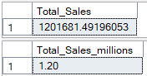

-- Average sales

select cast(AVG(Sales) as decimal(10,0)) as Avg_Sales from blinkit_data;



-- Number of items

select count(*) as No_Of_Items from blinkit_data;



-- Average rating

select cast(avg(Rating) as decimal (10,2)) as Avg_Rating from blinkit_data;



**#More requirements**

-- All KPIs by fat content

select Item_Fat_Content,

cast(sum(Sales) as Decimal(10,2)) as Total_Sales,

cast(AVG(Sales) as decimal(10,0)) as Avg_Sales,

count(*) as No_Of_Items,

cast(avg(Rating) as decimal (10,2)) as Avg_Rating

from blinkit_data

group by Item_Fat_Content

order by Total_Sales Desc

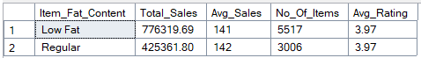

-- All KPIs by item type

select Item_Type,

cast(sum(Sales) as Decimal(10,2)) as Total_Sales,

cast(AVG(Sales) as decimal(10,0)) as Avg_Sales,

count(*) as No_Of_Items,

cast(avg(Rating) as decimal (10,2)) as Avg_Rating

from blinkit_data

group by Item_Type

order by Total_Sales Desc

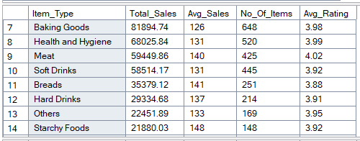

**#Gives top 5 Item_types**

select top 5 Item_Type,

cast(sum(Sales) as Decimal(10,2)) as Total_Sales,

cast(AVG(Sales) as decimal(10,0)) as Avg_Sales,

count(*) as No_Of_Items,

cast(avg(Rating) as decimal (10,2)) as Avg_Rating

from blinkit_data

group by Item_Type

order by Total_Sales Desc

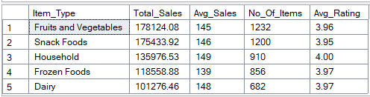

-- fat content by outlet location for all KPIs

select Outlet_Location_Type, Item_Fat_Content,

cast(sum(Sales) as Decimal(10,2)) as Total_Sales,

cast(AVG(Sales) as decimal(10,0)) as Avg_Sales,

count(*) as No_Of_Items,

cast(avg(Rating) as decimal (10,2)) as Avg_Rating

from blinkit_data

group by Outlet_Location_Type, Item_Fat_Content

order by Outlet_Location_Type

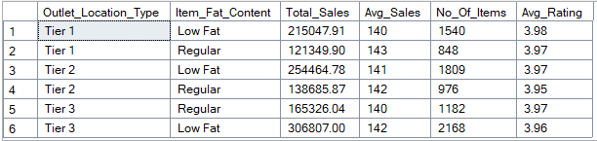

-- fat content by outlet location for total sales (fat content presented as column names)

select Outlet_Location_Type,

isnull([Low Fat],0) as Low_Fat,

isnull([Regular],0) as Regular

from

( select Outlet_Location_Type, Item_Fat_Content,

cast(sum(Sales) as decimal(10,2)) as Total_Sales

from blinkit_data

group by Outlet_Location_Type, Item_Fat_Content

)as SourceTable

pivot

( sum(Total_Sales)

for Item_Fat_Content in ([Low Fat],[Regular])

)as pivottable

order by Outlet_Location_Type;

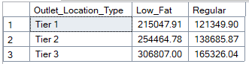

-- by outlet establishment

select Outlet_Establishment_Year,

cast(sum(Sales) as Decimal(10,2)) as Total_Sales,

cast(AVG(Sales) as decimal(10,0)) as Avg_Sales,

count(*) as No_Of_Items,

cast(avg(Rating) as decimal (10,2)) as Avg_Rating

from blinkit_data

group by Outlet_Establishment_Year

order by Total_Sales Desc

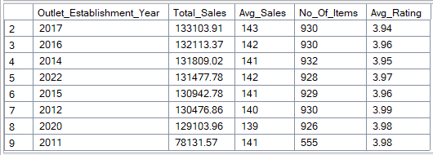

-- percentage of sales by outlet size

select Outlet_Size,

cast(sum(Sales) as Decimal(10,2)) as Total_Sales,

cast((sum(Sales)*100.0 /Sum(sum(Sales)) over()) as decimal(10,2)) as Sales_Percentage

from blinkit_data

group by Outlet_Size

order by Total_Sales Desc

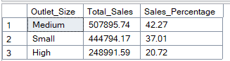

--by outlet location

select Outlet_Location_Type,

cast(sum(Sales) as Decimal(10,2)) as Total_Sales,

cast((sum(Sales)*100.0 /Sum(sum(Sales)) over()) as decimal(10,2)) as Sales_Percentage,

cast(AVG(Sales) as decimal(10,0)) as Avg_Sales,

count(*) as No_Of_Items,

cast(avg(Rating) as decimal (10,2)) as Avg_Rating

from blinkit_data

group by Outlet_Location_Type

order by Total_Sales Desc

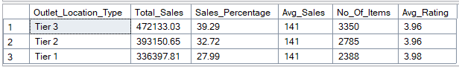

--by outlet type

select Outlet_Type,

cast(sum(Sales) as Decimal(10,2)) as Total_Sales,

cast((sum(Sales)*100.0 /Sum(sum(Sales)) over()) as decimal(10,2)) as Sales_Percentage,

cast(AVG(Sales) as decimal(10,0)) as Avg_Sales,

count(*) as No_Of_Items,

cast(avg(Rating) as decimal (10,2)) as Avg_Rating

from blinkit_data

group by Outlet_Type

order by Total_Sales Desc

