
MINISTRY OF EDUCATION, CULTURE AND RESEARCH
OF THE REPUBLIC OF MOLDOVA
Technical University of Moldova
Faculty of Computers, Informatics and Microelectronics
Department of Software Engineering and Automation
Pleșu Dinu FAF-241
Report
Laboratory Work No. 4
Operating Systems
Topic: The xv6 Shell from the Outside
Checked by: Reitman Patricia, university assistant
Chișinău – 2026

Contents
1. Purpose of the Work
2. Part 1 – Fix sleep for Current xv6
3. Part 2 – Bash versus the xv6 Shell
4. Part 3 – Who Expands *? The argv Program
5. Part 4 – Read the Shell
6. Conclusion

1. Purpose of the Work
Compare Bash with xv6's small shell, update sleep for the current xv6 API, observe how a shell passes arguments to a program, and inspect user/sh.c.

2. Part 1 – Fix sleep for Current xv6
The current user/user.h declares int pause(int);, so this revision uses pause() rather than sleep(). The updated sleep.c checks its argument count, reports usage to standard error, waits the requested number of ticks, and exits successfully. The xv6 Makefile registers $U/_sleep in UPROGS.
Build and test in xv6:
Commands / Output
$ sleep 20
$ sleep
usage: sleep <ticks>

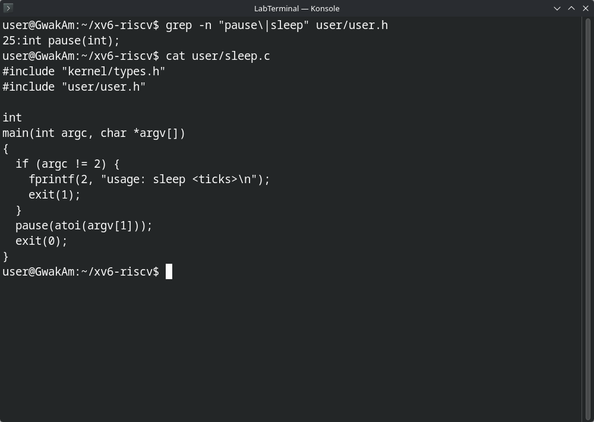
Figure 1.1 – pause declaration in user.h and the updated sleep.c
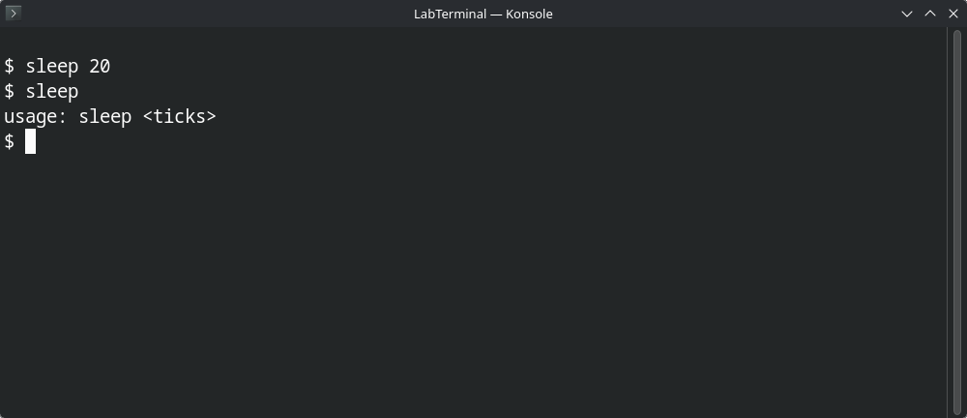
Figure 1.2 – sleep run with and without an argument in xv6

3. Part 2 – Bash versus the xv6 Shell
The table summarizes expected behavior. Capture local listing output in both environments. In xv6, user programs are stored at paths such as /ls and /cat.
Command | Bash on Linux | xv6 shell | Reason
echo hello > f ; cat < f | Writes hello to f, then prints hello. | Same. | Both support redirection and command lists.
ls | grep READ | Prints README in the prepared test directory. | Prints README if it exists in the xv6 root filesystem. | Both implement pipes.
(echo a; echo b) | wc | Counts the two lines. | Also sends both lines through the pipe to wc. | xv6 parses parenthesized blocks, lists, and pipes.
echo one ; echo two | Prints one then two. | Same. | ; creates a list command.
echo bg & | Prints asynchronously; Bash tracks the job and PID. | Starts in the background; no Bash-style jobs interface. | xv6 supports & but not full job control.
ls * | Expands * to matching names and lists them. | * is passed literally; ls reports it cannot open that path. | Bash expands globs; xv6 does not.
echo $HOME | Prints the value of HOME. | Prints literal $HOME. | Bash expands variables; xv6 does not.
echo "a b" | Prints a b as one argument, without quotes. | Quote characters are literal and the space splits words. | Bash implements quotes; xv6 tokenizes whitespace and operators.
mkdir d ; cd d ; ls .. | Creates d, changes into it, then lists its parent. | In this semicolon list, cd is treated as an external command and fails; ls .. then runs from the unchanged directory. | xv6's main() handles cd only when it is the whole input line. Enter cd d at its own prompt, then ls .. to see the relative ls failure; /ls .. works.
Up arrow, Tab, Ctrl+R | History, completion, and reverse history search. | No matching history or completion features. | These are interactive Bash/readline features.

Both shells support execution, basic redirection, pipes, command sequences, and background commands. Bash additionally provides variable and pathname expansion, full quote handling, history, completion, and job control. xv6's special cd handling is in the shell's input loop, so it works when typed as its own command. After changing into d, /ls .. works because the executable is addressed from the filesystem root. The feature I would miss most is history with Tab completion, because retyping long commands and absolute paths such as /ls is slow; the easiest to add is wildcard expansion, because the shell could reuse the directory-reading code from ls and substitute matching names before calling exec.
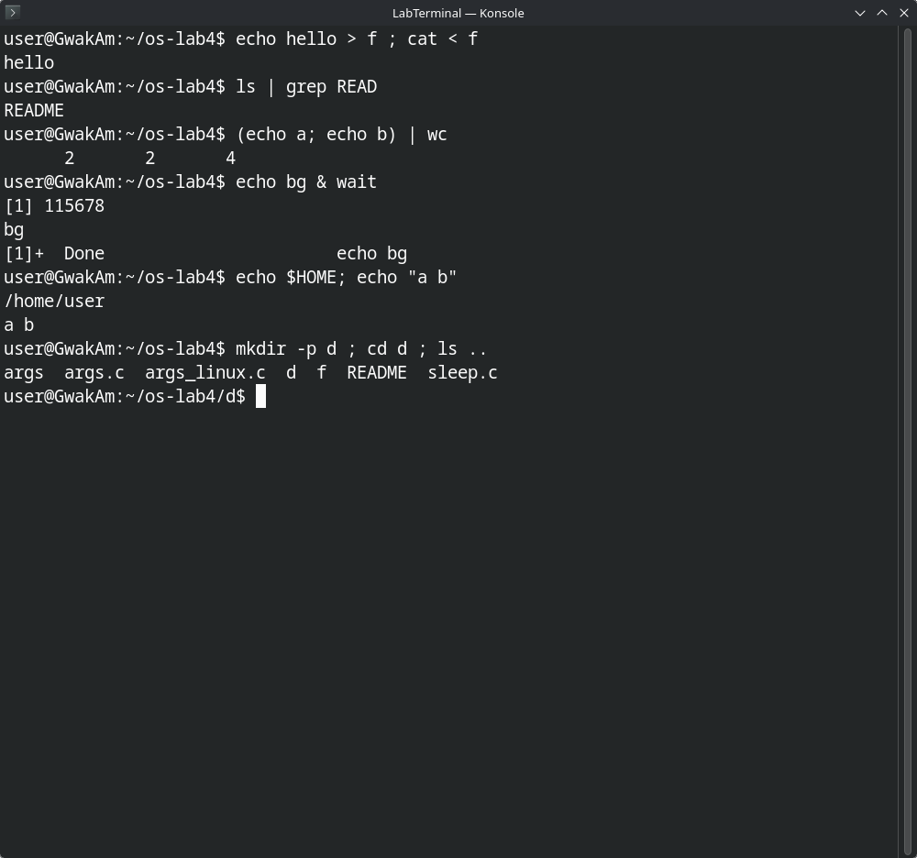
Figure 2.1 – The command comparison in Bash
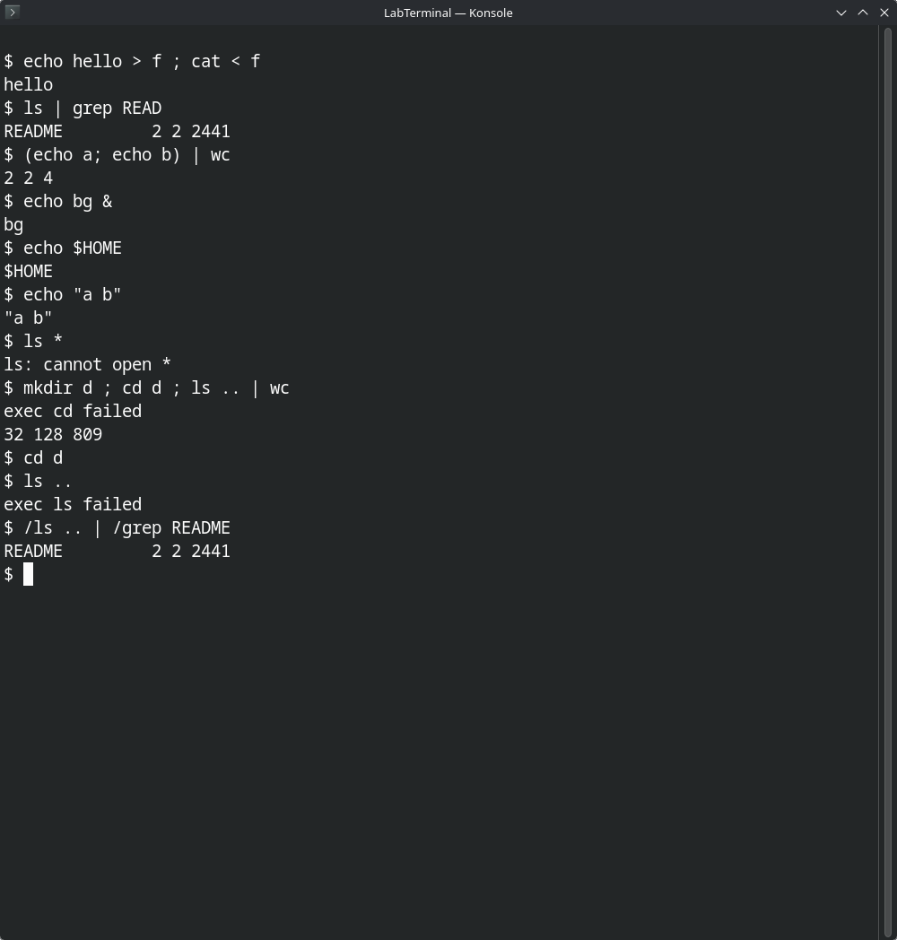
Figure 2.2 – The same commands in xv6, the ls failure after cd d, and the /ls alternative

4. Part 3 – Who Expands *? The argv Program
The xv6 program is args.c; the Linux version is args_linux.c. Both print argc and every argv entry. The xv6 Makefile registers $U/_args.
In Bash, the Lab4 folder contains three matching source files. The captured output is:
Commands / Output
argc = 5
argv[0] = [./args]
argv[1] = [args.c]
argv[2] = [args_linux.c]
argv[3] = [sleep.c]
argv[4] = [x y]

In general, if there are N matching source files, Bash reports argc = N+2: the executable name, N filenames, and the single argument x y. In xv6, *.c is not expanded and quotes are not syntax. The command passes four arguments: args, *.c, "x, and y", so argc = 4. Expected xv6 output is:
Commands / Output
argc = 4
argv[0] = [args]
argv[1] = [*.c]
argv[2] = ["x]
argv[3] = [y"]

The shell performs wildcard expansion and removes syntactic quotes before a program starts. The kernel supplies the argument vector but does not expand * or remove quotes. In args one two three, runs of unquoted whitespace are separators, so extra spaces do not become part of an argument. For args 'single quoted', Bash passes single quoted as one argument with no quotes; xv6 treats quotes as ordinary text and splits at the space.
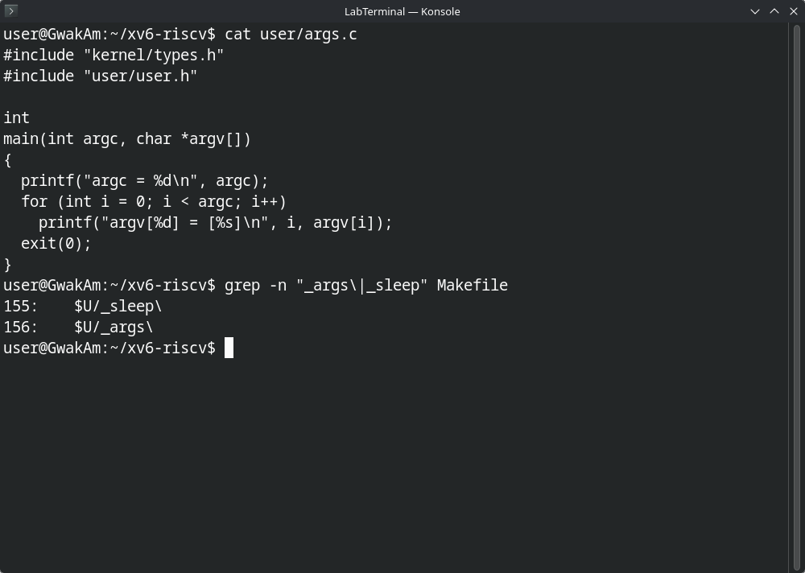
Figure 3.1 – args.c and its UPROGS line
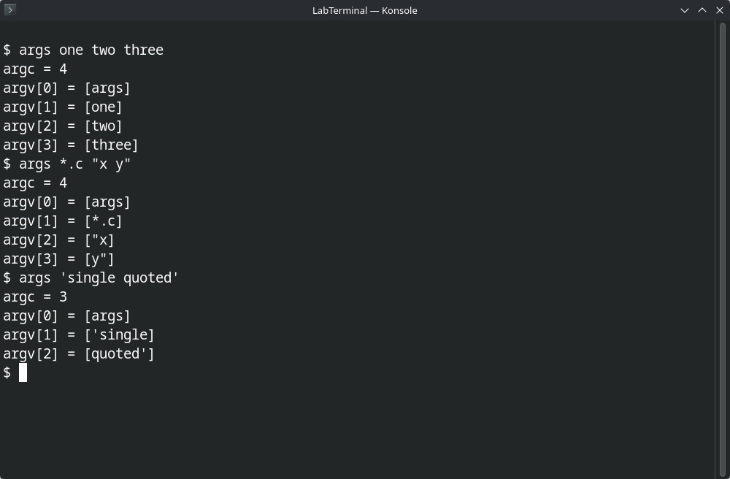
Figure 3.2 – args output in xv6
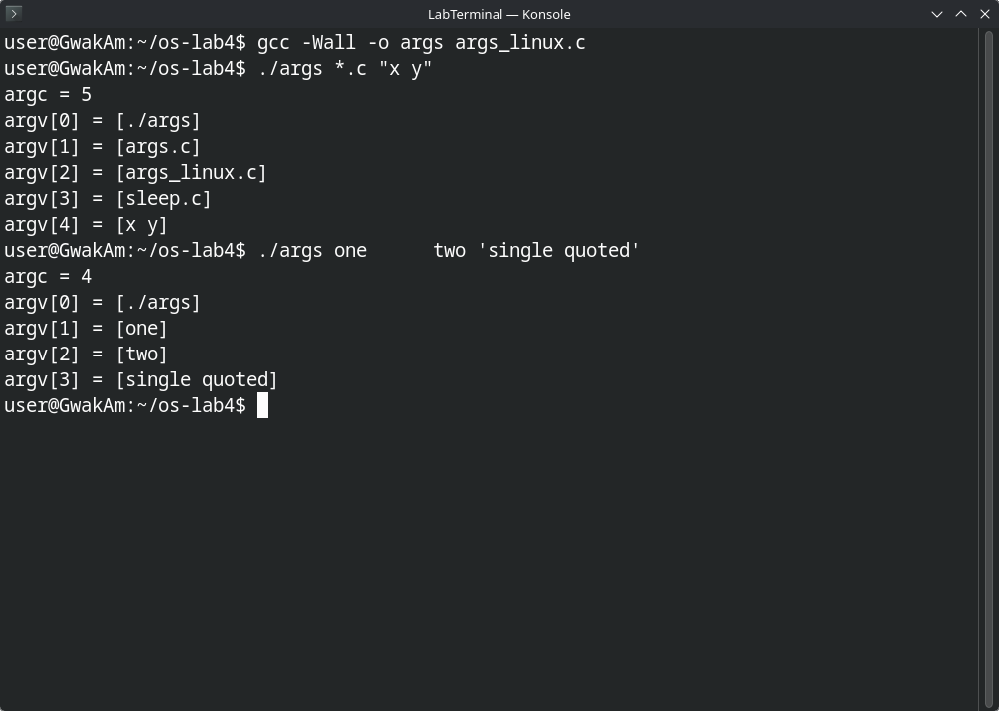
Figure 3.3 – args output in Linux (Bash)

5. Part 4 – Read the Shell
The five command kinds are EXEC (ordinary command), REDIR (<, >, >>), PIPE (|), LIST (;), and BACK (&). Parenthesized blocks group existing command kinds rather than defining a sixth executor type.
cd is handled in main() in user/sh.c; it calls chdir() in the shell process itself. It cannot run as an ordinary child because changing a child's working directory would leave the parent shell in the old directory. The runcmd() switch executes the command structures, and parseblock() handles parentheses.
There is no code in sh.c implementing pathname (*) or variable ($HOME) expansion. That explains why xv6 passes those characters to programs literally, unlike Bash.
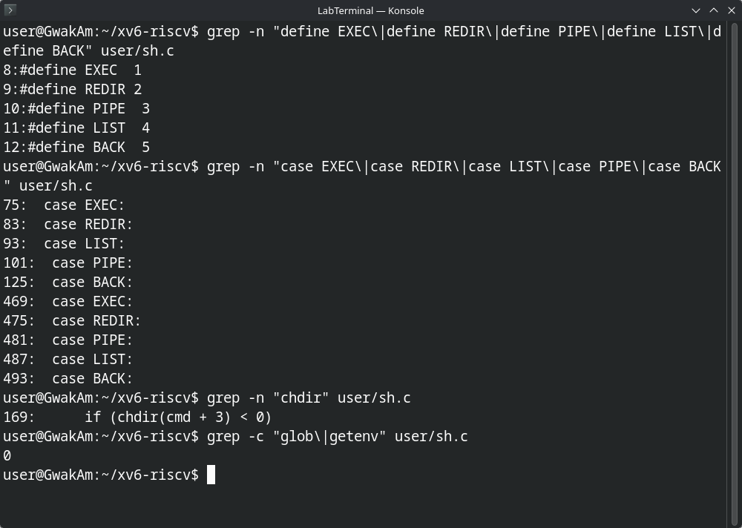
Figure 4.1 – Command-kind definitions, runcmd() cases, cd handling, and the absence of expansion code in sh.c

6. Conclusion
The xv6 shell demonstrates the core structure of a shell: parse a command, create processes, connect file descriptors, and execute programs. Comparing it with Bash shows that wildcard expansion, variables, quoting rules, history, completion, and job control are additional shell features rather than behavior supplied automatically by the kernel.

