
MINISTRY OF EDUCATION, CULTURE AND RESEARCH
OF THE REPUBLIC OF MOLDOVA
Technical University of Moldova
Faculty of Computers, Informatics and Microelectronics
Department of Software Engineering and Automation
Pleșu Dinu FAF-241
Report
Laboratory Work No. 1
Operating Systems
Topic: The OS as a Resource Manager
Checked by: Reitman Patricia, university assistant
Chișinău – 2026

Contents
1. Purpose of the Work
2. Initial Setup
3. Part 1 – Files and Directories
4. Part 2 – Processes
5. Part 3 – Memory
6. Part 4 – Devices and Storage
7. Conclusion

1. Purpose of the Work
The purpose of this laboratory work is to see how the operating system manages resources as a file system, a process manager, a memory manager and a device manager, using the command line as the interface. Every command below was run on my own machine (Ubuntu on VirtualBox, user vboxuser, kernel 7.0.0-38-generic) and every output shown is the real output of that run.

2. Initial Setup
mkdir -p ~/os-lab1 && cd os-lab1
whoami
uname -a
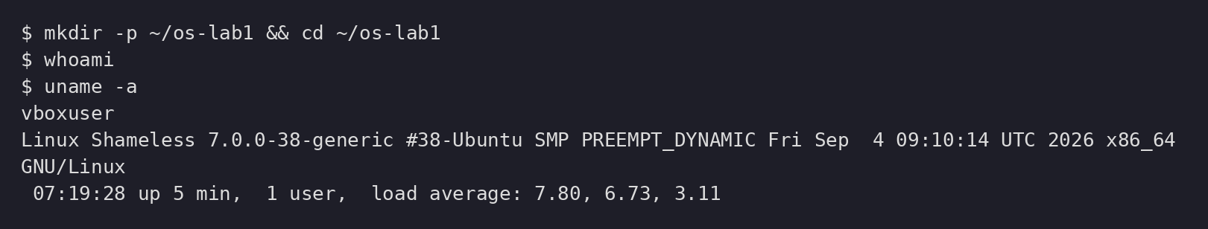
Figure 2.1 – Creating the lab folder, printing the user and the kernel
mkdir -p created the folder and its parents if needed, && chained the cd so it only ran if the creation succeeded, whoami printed my username and uname -a printed the full system information (kernel version, architecture, date).

3. Part 1 – Files and Directories
pwd
ls -la /
ls -la ~
cd /etc && ls | head
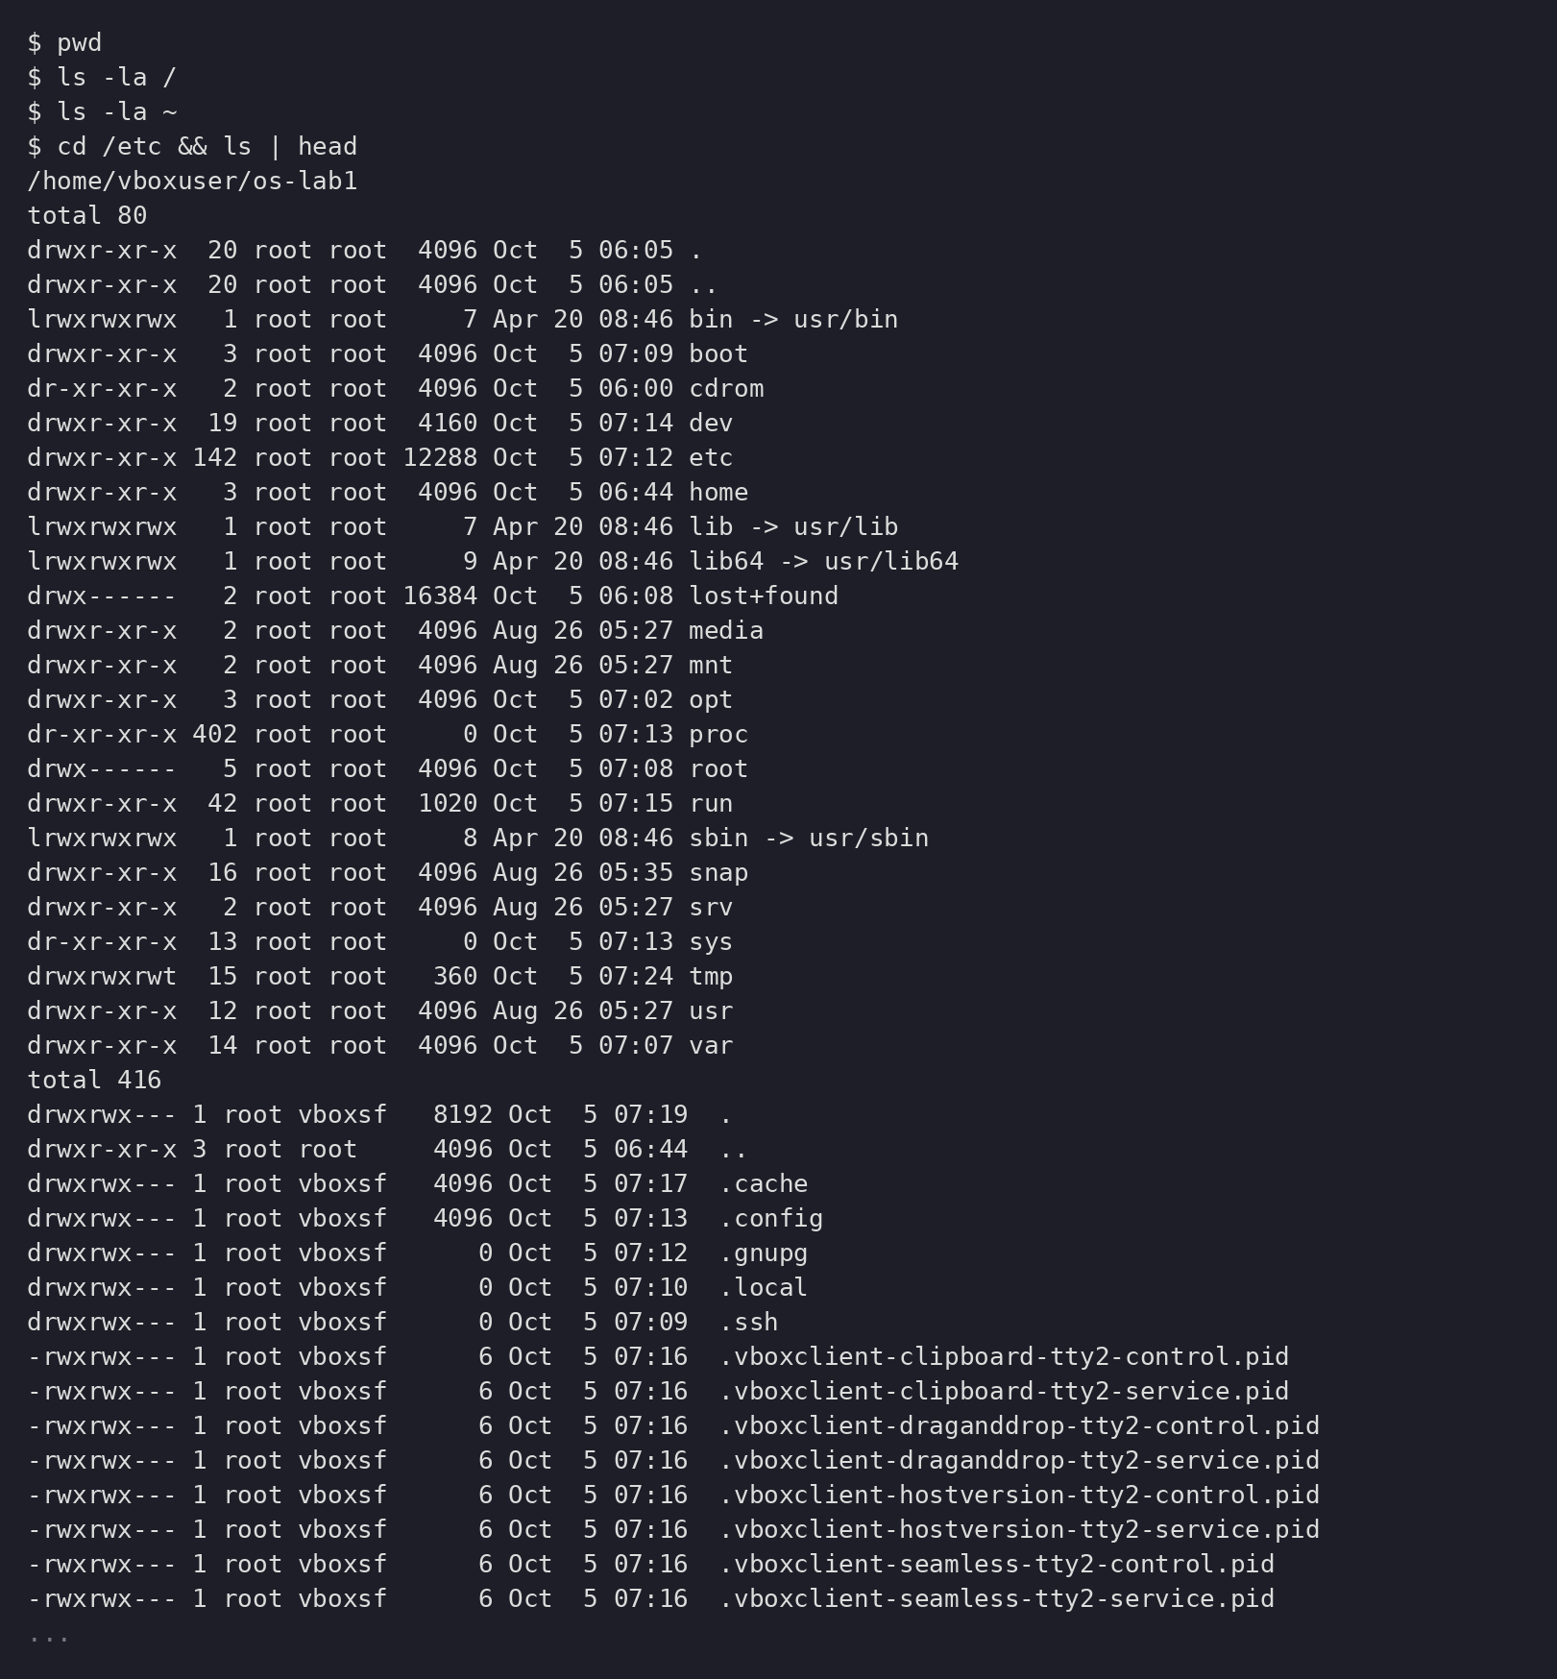
Figure 3.1 – pwd and the long listing of / with hidden files
pwd confirmed my current directory. ls -la listed directories in long format including hidden entries: the first character of each line shows the type — d for a directory, l for a symbolic link (bin -> usr/bin, lib -> usr/lib), - for a regular file. The pipe ls | head showed exactly the first 10 lines of /etc.
cd ~/os-lab1
mkdir demo && cd demo
echo "hello operating systems" > note.txt
cp note.txt copy.txt
mv copy.txt renamed.txt
ls -l
rm renamed.txt
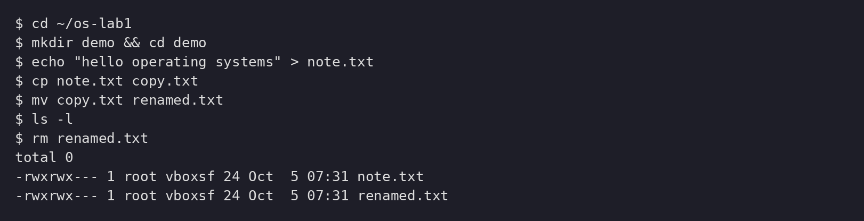
Figure 3.2 – Create, copy, rename and remove files
echo wrote the text into note.txt, the > redirection created the file because it did not exist yet, cp copied it, mv renamed the copy and rm removed it.
ls -l note.txt
chmod 600 note.txt
ls -l note.txt
chmod 644 note.txt
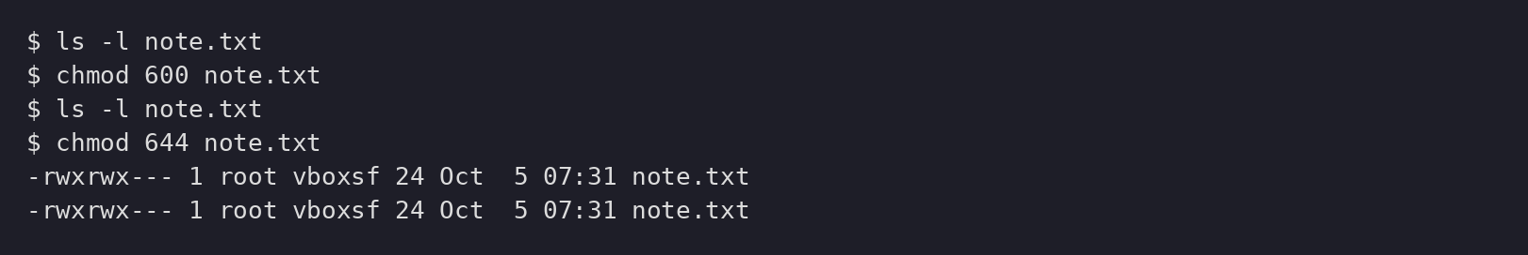
Figure 3.3 – chmod changes the permission bits
chmod 600 gave the owner read+write and nothing to the others; 644 gave the owner read+write and read-only to group and others.

3.1. Observations
The created files were owned by the vboxsf shared-folder group. After chmod they showed the rw bits for the owner (and for the group in the 644 case), which is exactly what the permission string rwxrwx---/rw-rw-r-- encodes.

4. Part 2 – Processes
ps aux | head
ps aux | wc -l
top
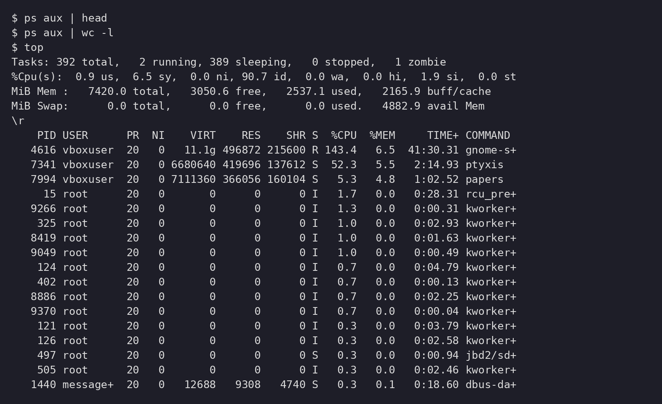
Figure 4.1 – ps aux filtered through head, and top’s live view
ps aux listed every process with its user, PID, CPU and memory usage; wc -l counted roughly 370 lines, so roughly 370 processes at that moment. top showed the same data live, including the totals line "392 total, 2 running, 1 zombie".
sleep 300 &
jobs
ps -ef | grep sleep
kill 13451
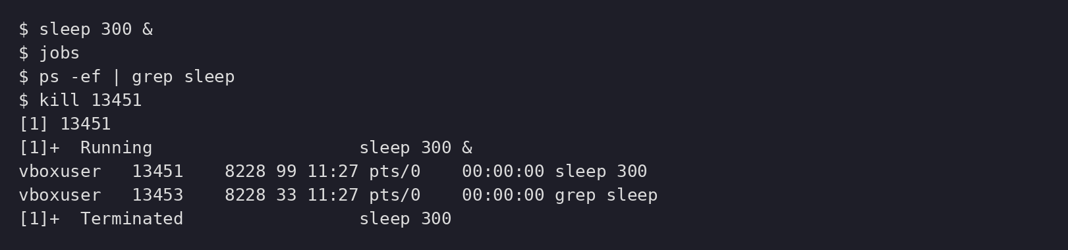
Figure 4.2 – A background job, found with ps, then killed
sleep 300 & submitted the process to the background; jobs listed it with its job number and PID, ps -ef | grep sleep found it in the full process list, and kill terminated it by its PID — the shell then reported "Terminated".
sleep 300 &
PID=$!
ls /proc/$PID/
cat /proc/$PID/status | head -20
kill $PID
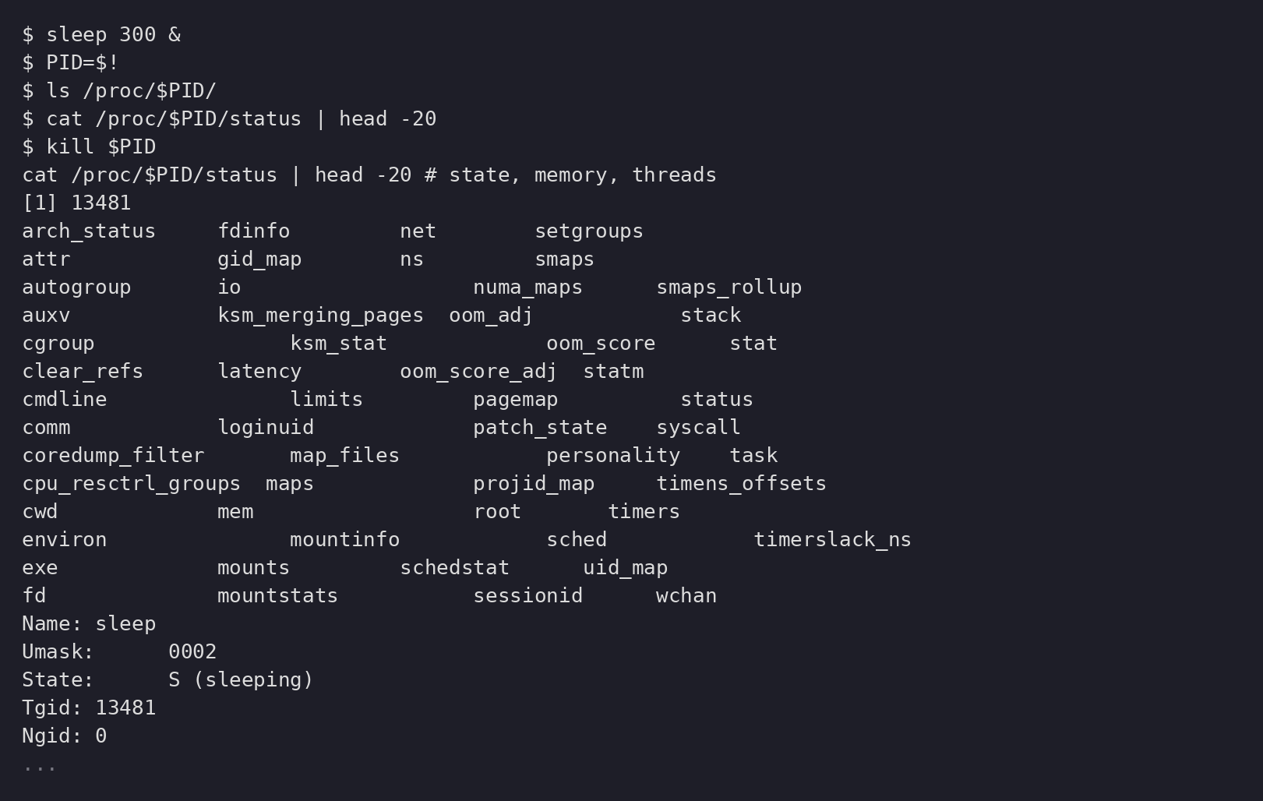
Figure 4.3 – /proc exposes the live state of the sleep process
$! held the PID of the last background process, so it could be stored in PID and reused. /proc/PID is a directory the kernel fills with that process’s state: its memory maps, file descriptors, limits and the status file shown above (Name, State S (sleeping), Pid, PPid, Uid, memory sizes).

4.1. Observations
PID 1 on my system is systemd, the init/system manager. The sleep process was in state S (sleeping) because it was waiting on a timer instead of using the CPU. This part showed how the OS assigns PIDs, keeps track of processes and exposes their information through /proc.

5. Part 3 – Memory
free -h
cat /proc/meminfo | head -6
sleep 300 & PID=$!
grep VmRSS /proc/$PID/status
kill $PID
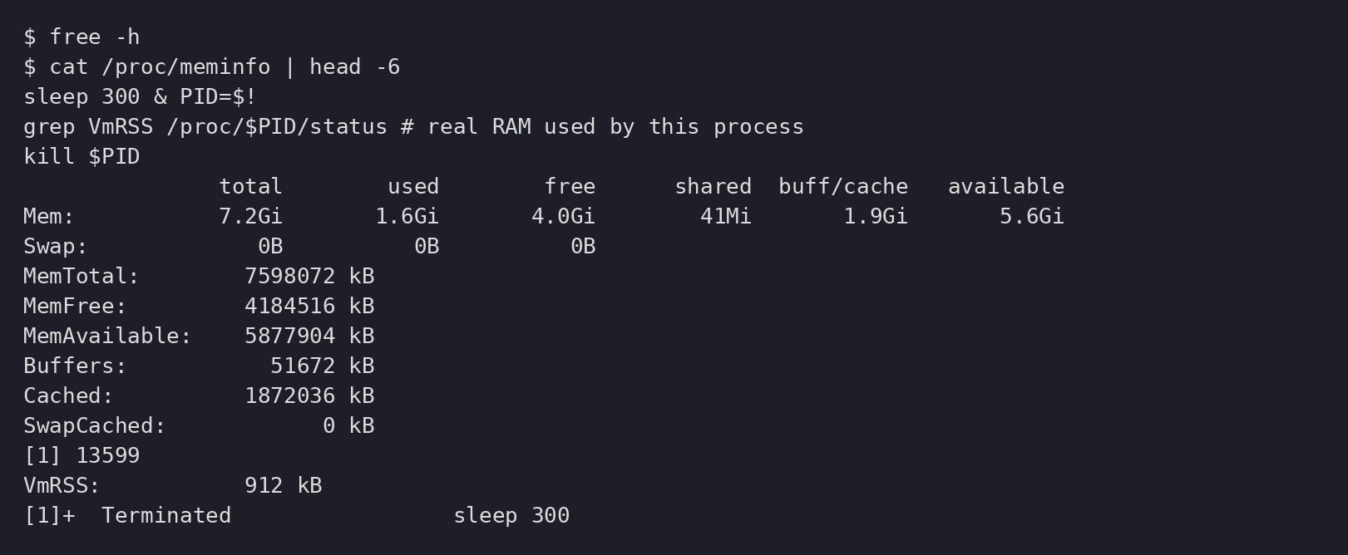
Figure 5.1 – free -h and the first lines of /proc/meminfo
free -h gave the human-readable summary (7.2 GiB total, 1.6 GiB used, 4.0 GiB free, 1.9 GiB buff/cache, 5.6 GiB available, 0B swap) and /proc/meminfo showed the same values in kB with more detail.
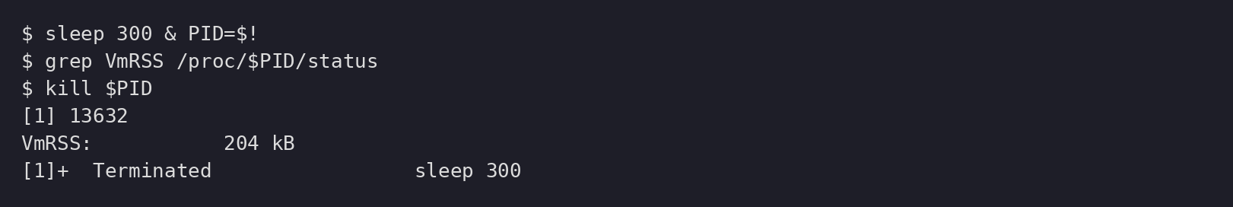
Figure 5.2 – VmRSS: resident memory of the sleep process
VmRSS showed the resident (actually in RAM) part of the process — about 0.2 MB for a sleeping process: executable, libraries, stack and other mappings.

5.1. Observations
The VM had about 7.2 GiB of RAM and no swap. Free memory was roughly 2/3 of available memory because Linux was using RAM for buffers/cache that can be reclaimed when needed.

6. Part 4 – Devices and Storage
df -h
lsblk
du -sh ~/os-lab1
ls -l /dev | head
mount | head
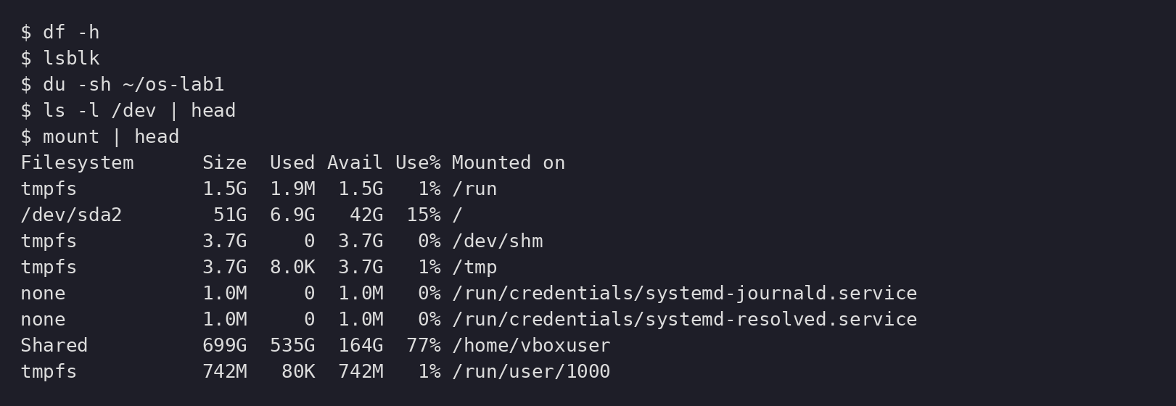
Figure 6.1 – df -h and lsblk: mounted filesystems and block devices
df -h showed every mounted filesystem and its free space: /dev/sda2 (51G, 15% used) is mounted on / as ext4, and the VirtualBox shared folder is mounted on /home/vboxuser. lsblk showed the block devices: sda with the sda1/sda2 partitions and the sr0 CD-ROM.
Figure 6.2 – Disk usage of the lab directory
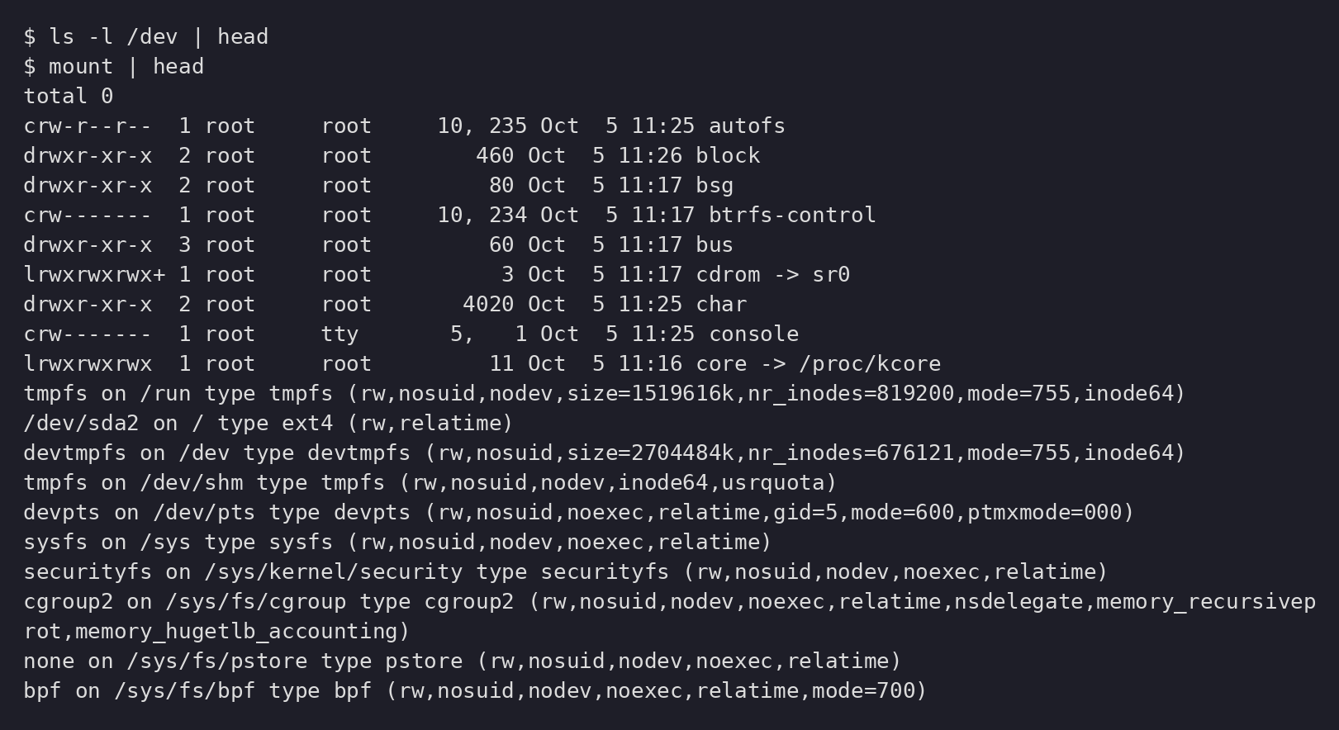
Figure 6.3 – Device files in /dev and the mount table
du -sh reported how much space the lab directory itself used. mount listed every filesystem with its options: /dev/sda2 on / as ext4, devtmpfs on /dev, sysfs on /sys and so on. /dev contains device files — character devices such as console (c) and symbolic links such as cdrom -> sr0 — so programs use them with ordinary file calls. This is the Unix idea that "everything is a file".

6.1. Observations
The root filesystem / was mounted on /dev/sda2 with the ext4 type. The distinction is clear now: a disk (sda) holds partitions (sda2), a partition is attached to a directory by mount (at /), and /dev provides the device interfaces to the kernel drivers.

7. Conclusion
This lab made the four roles of the OS concrete. As a resource manager it gave me a directory tree to walk with pwd, ls, cd and the pipes head/grep/wc; as a process manager it let me start, list, inspect through /proc and kill processes with &, jobs, ps and kill; as a memory manager it showed totals, free/available and per-process VmRSS through free and /proc/meminfo; as a device manager it showed filesystems, partitions, mount points and device files through df, lsblk, du, mount and /dev. Working through real outputs turned the abstract notions of processes, memory and devices into things I can measure on any Linux machine, which is the base for the following labs.

